**Docker Containerization of MIST Application**

1. Install Docker in your local machine if it’s not already available.
2. Download the mistwebapp tar file from the \\ftcs-app-dev-04.cs.boeing.com\tmp\Krupa

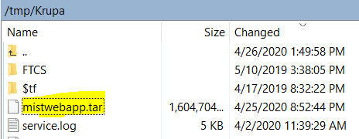

1. Once downloaded, execute the command **docker load -i <DOWNLOADED_TAR_FILE_LOC>** to load Docker image from a tar file.(This might take 2 to 3 minutes)



1. To cross verify, **docker images** will list down the images loaded to the host machine.

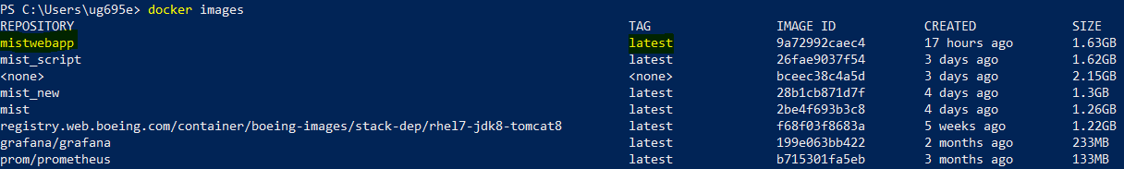

1. Run mistwebapp docker images,

**docker run -it --name <CONTAINER_NAME> -p <HOST_PORT>:<CONTAINER_PORT> -v <MIST_SRC_CODE_LOCATION>:/usr/mist/ <IMAGE_NAME>**

where,

name - To define name of the container

p - To define the port to expose the services running in the container

v - To define the data volumes

MIST_SRC_CODE_LOCATION should contain MISTWebApp and Orbeon 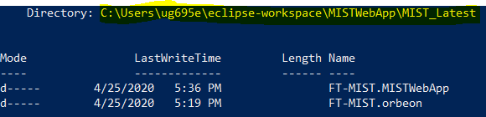

Run command sample,

docker run -it --name mistwebapp_container -p 8080:8080 -v C:\Users\ug695e\eclipse-

workspace\MISTWebApp\MIST_Latest:/usr/mist/ mistwebapp

1. Invoke deployApp script as below once the container is running,

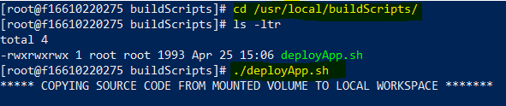

This script takes care of both build and deployment. Run time of script ~ 2 mins

1. Below logs indicates that the application is deployed successfully and can be accessed over invoker file



1. Repeat Step No.6 after making any changes and it requires deployment to reflect the changes in the application.

docker run -it --name mistwebapp_container -p 8080:8080 -v C:\Users\kh715e\Development\NEW_TFS_MIST_WORKSPACE:/usr/mist mistwebapp

