**Docker Containerization of CECFG and OAPI Application**

**Pre-requisite**

1. Update docker version to 2.2.0.3, from sres path path: osstools/docker/desktop/2.2.0.3.
2. Clone **FTCS.CECFG** and **FTCS.OAPI** code from TFS.

**Local Container Setup :**

We have created one image for both CECFG as well as OAPI configuration. In single image only both scripts have been placed.

**NOTE:** We have single image but will require two container to run OAPI and CECFG on different ports.

**STEPS:**

1. Download the **oapi_cecfg_image.tar** file from\\ftcs-app-dev-04.cs.boeing.com\tmp\abhi
2. Once downloaded, execute the command **docker load -i <DOWNLOADED_TAR_FILE_LOC>** to load Docker image from a tar file. (This might take 2 to 3 minutes) .



1. To cross verify, **docker images** will list down the images loaded to the host machine.



1. Once image is loaded, now it’s time to run the image (Create containers).
2. **For OAPI run :**

**docker run -it --name <CONTAINER_NAME> -p <HOST_PORT>:<CONTAINER_PORT> -v <OAPI_SRC_CODE_LOCATION>:/usr/oapi/ <IMAGE_NAME>**

where,

name - To define name of the OAPI container

p - To define the port to expose the services running in the container

v - To define the data volumes

OAPI_SRC_CODE_LOCATION should contain FTCS.OAPI source code path of your local.

Ex: ( docker run -it --name oapi_container -p 8080:8080 -v C:\Users\kh715e\Desktop\Work\DOCKER\workspace_oapi:/usr/oapi oapi_cecfg_image )



docker run -it --name oapi_container -p 8080:8080 -v C:\Users\kh715e\Desktop\Work\DOCKER\FTCS.OAPI:/usr/oapi cecfg_oapi_lat

1. Now once OAPI container is running, go inside **cd /usr/local/buildScripts** andrun **./oapiDeployApp.sh** script**.**

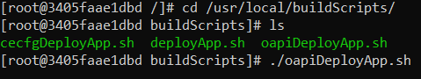

1. Below logs indicates that the application is deployed successfully and can be accessed over invoker file.



1. After it is deployed, just go and open CECFG_invoker.xml invoker file in any browser.
2. When you do any code changes, you need to mount again so repeat from step 5.
3. **For CECFG** ( NOTE : we need to change local port to run CECFG container)

**docker run -it --name <CONTAINER_NAME> -p <HOST_PORT>:<CONTAINER_PORT> -v <CECFG_SRC_CODE_LOCATION>:/usr/cecfg/ <IMAGE_NAME>**

**ex: (**

docker run -it --name cecfg_container -p **8081**:8080 -v C:\Users\kh715e\Development\NEW_TFS_CECFG_WORKSPACE:/usr/cecfg oapi_cecfg_image).



1. Now once CECFG container is running, go inside **cd /usr/local/buildScripts** andrun **./cecfgDeployApp.sh** script**.**

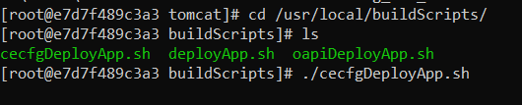

1. Once script starts running, it takes care of build and deployment. After it is deployed, just go and open OAPI_invoker.xml invoker file in any browser.
2. When you do any code changes, you need to mount again so repeat from step 9.