Abhishek MAIN POLICY - 500000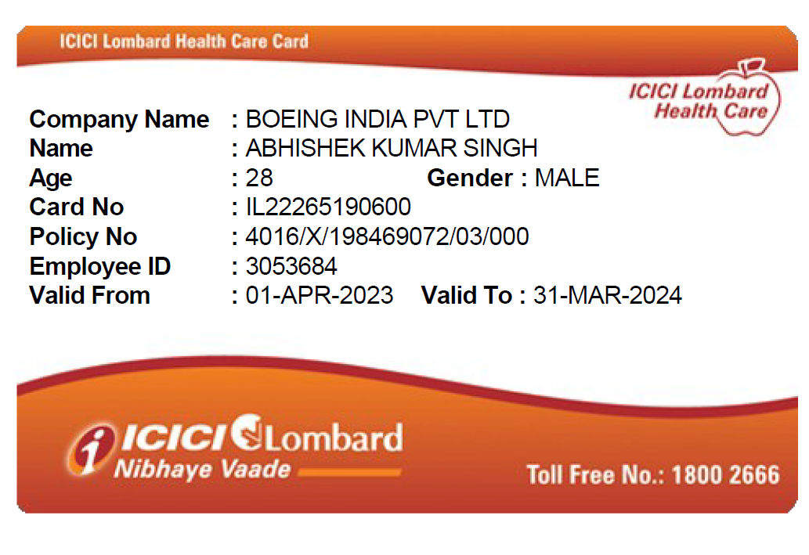

Abhishek TOP UP -1000000

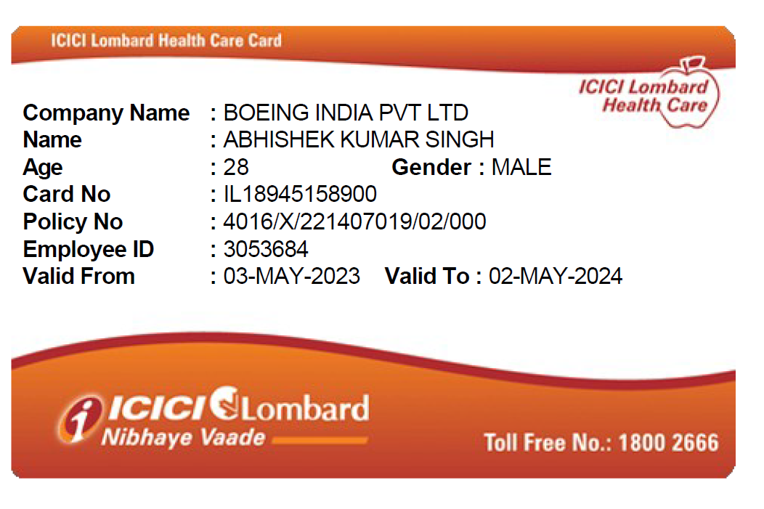

ASHOK KUMAR SINGH MAIN POLICY 500000

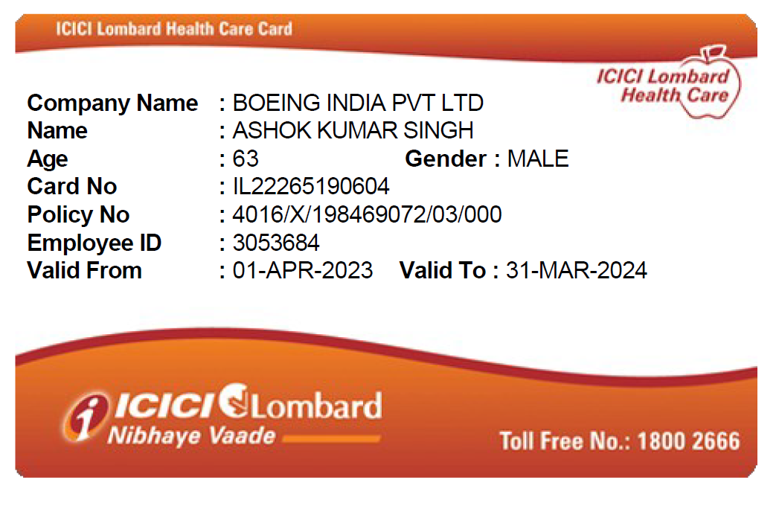ASHOK KUMAR SINGH TOP UP- Rs 1000000

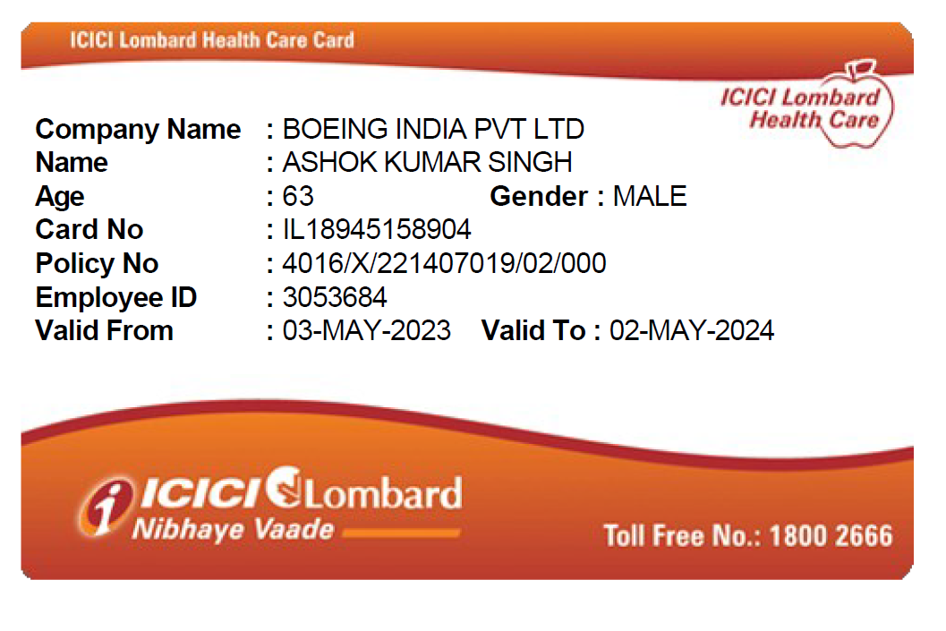

ANITA KUMARI MAIN POLICY 500000

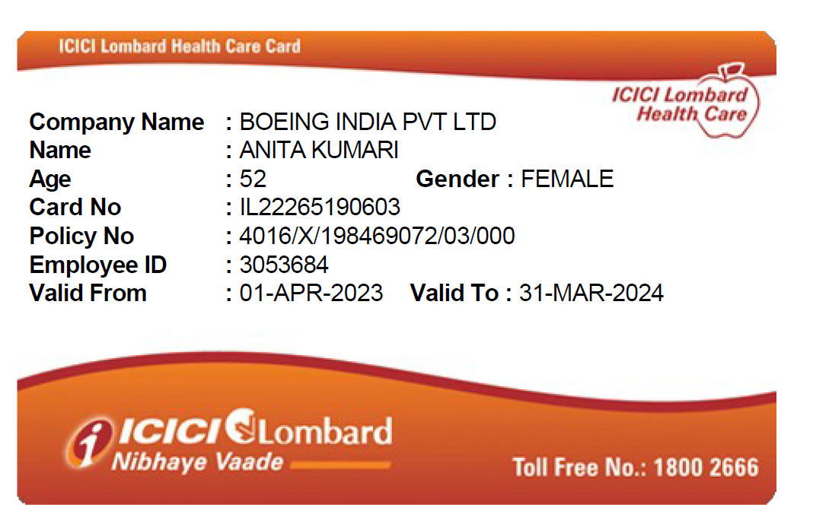ANITA KUMARI TOPUP POLICY 1000000

