**HDFC BANK**

**Account name – ANITA KUMARI**

**CUSTOMER ID - 254740612**

**BANK ACCOUNT NUMBER – 50100657363725**

1. **50300877303271**

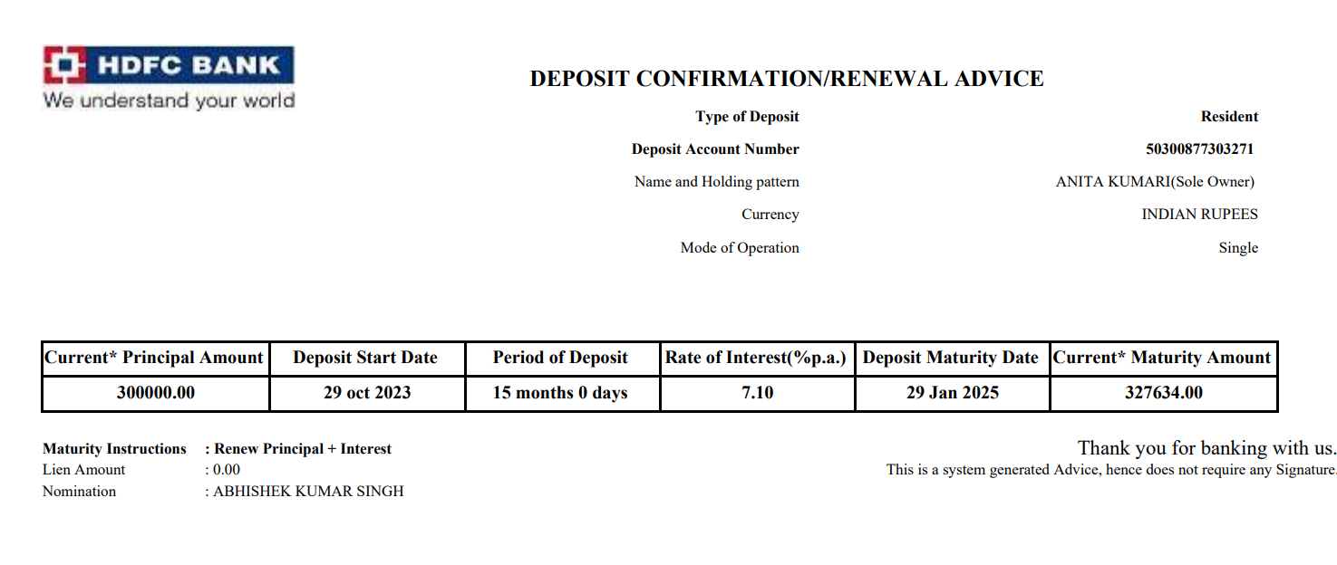

1. **50300883648539**

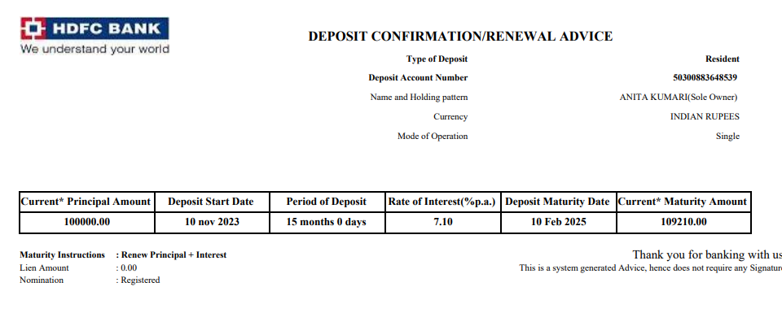

1. **50300887024641**

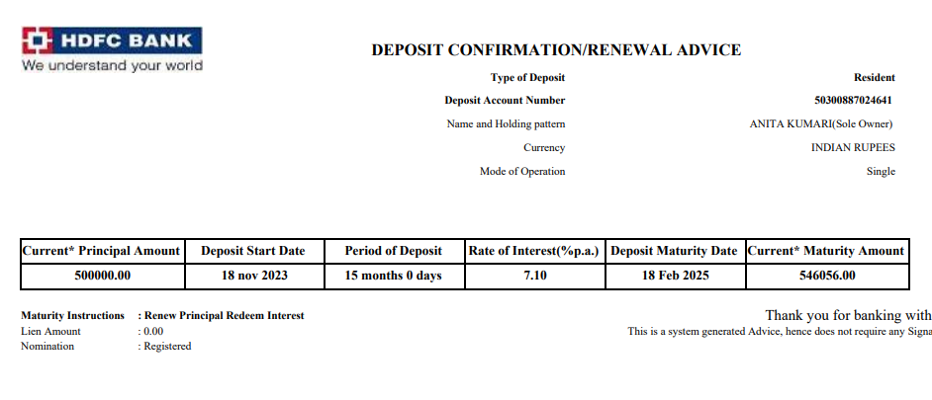

1. **50300887027781**

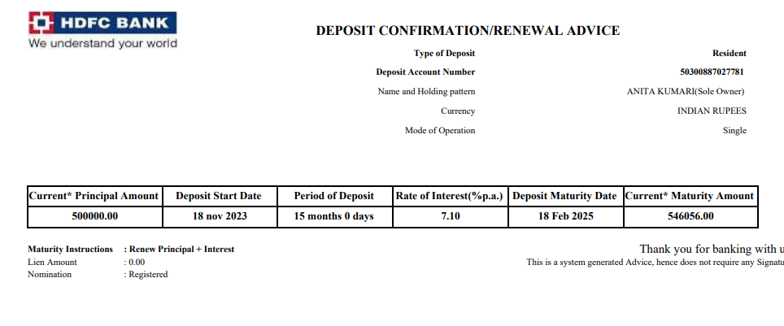

1. **50300887113501**

