**AMAZON Q**

AmazonQ is an artificial intelligence language model developed by Amazon. It is based on the GPT (Generative Pre-trained Transformer) architecture,. Here's a brief overview of its key features and functionalities:

1. **Natural Language Processing (NLP)**: Q can understand and generate human-like text based on the input it receives. It can engage in conversations, answer questions, and provide information on a wide range of topics.
2. **Pre-trained Model**: The model is pre-trained on a diverse corpus of text data from the internet, which helps it understand various topics and contexts. This pre-training enables the model to generate relevant and coherent responses.
3. **Interactive and Adaptive**: The model can adapt to the style and tone of the user's input, making interactions more personalized. It can also remember context within a conversation to maintain continuity.
4. **Versatility**: Amazon Q can be used for various applications, including customer support, content creation, tutoring, and more. It can generate code, help with brainstorming, and simulate dialogues.

**Access and connection:**

AWS IAM Identity Center, formerly known as AWS Single Sign-On (SSO), is a service provided by Amazon Web Services (AWS) that simplifies managing access to AWS accounts and applications for users.

**Functionality supported:**

1. **OPTIMIZATION**

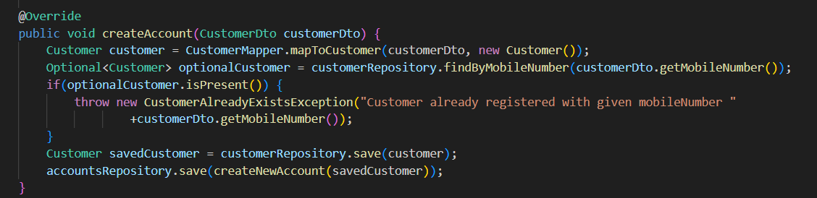

A simple service which will save the new customer and account details.

**Optimization suggested by Q:**

1. Use of Optional.orElseThrow instead of isPresent() check.

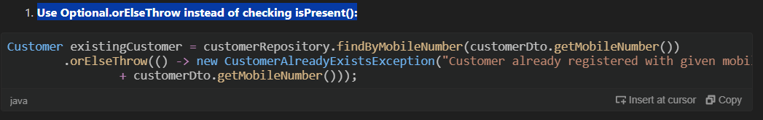

**Improvement**:

* Reduces lines of code and makes check in a chaining process.

1. ConsiderusingaDTOmapperlibrarylikeMapStruct.

**Improvement:**

* Instead of developer writing the mapper manually. We can use the **MapStruct library** that can reduce the boiler_plate code.

1. Use meaningful variable names:

The variable name optionalCustomer could be more descriptive, like existingCustomer.

**Improvement**:

* Helps in making the code more readable.

1. **EXPLAIN** existing code block.

Sample code send to Q for explanation.

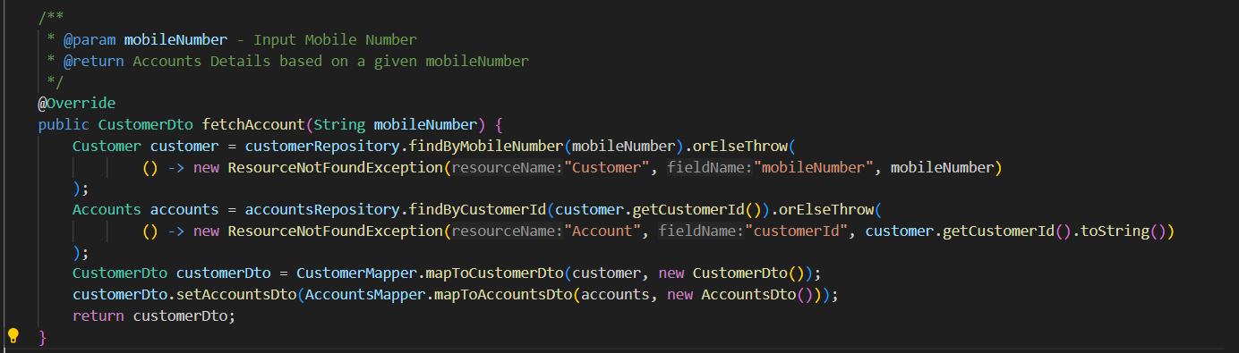

Amazon Q explanation:

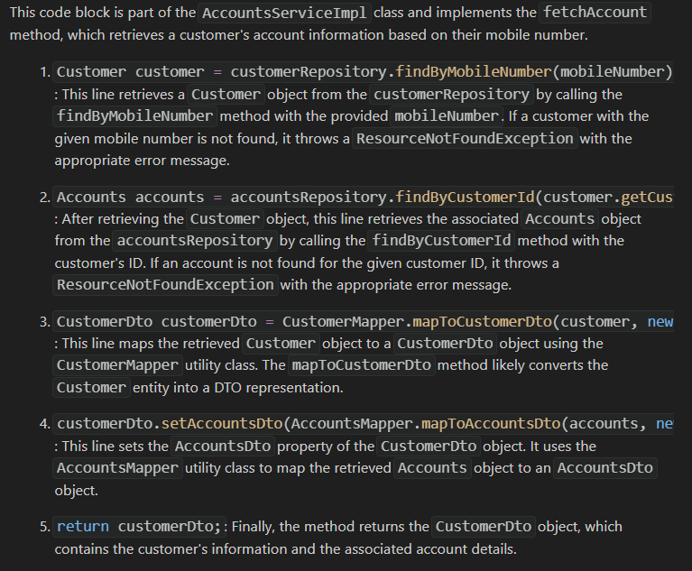

The explanation looks good as it is able to understand the mappers and repositories used in the code.

1. **DEV**

It is a functionality which will create a detailed plan for the new services that we are going to create.

We need to provide some context of how the service will look like in the prompt.

Ex:-

**PROMPT - STEPS**:

1. **Write a proper plan what new service we want to create.**

I had 3 microservice designed. I wanted to generate a new microservice whose structure will follow the existing microservice. Having controller,service,DTO,repo layer etc.

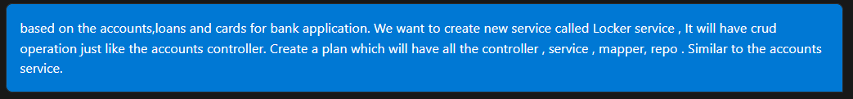

create a new service Stocks just like accounts ,loans etc in which it will do all basic layers like controller services etc and do all crud operation just like other services

RESPONSE:

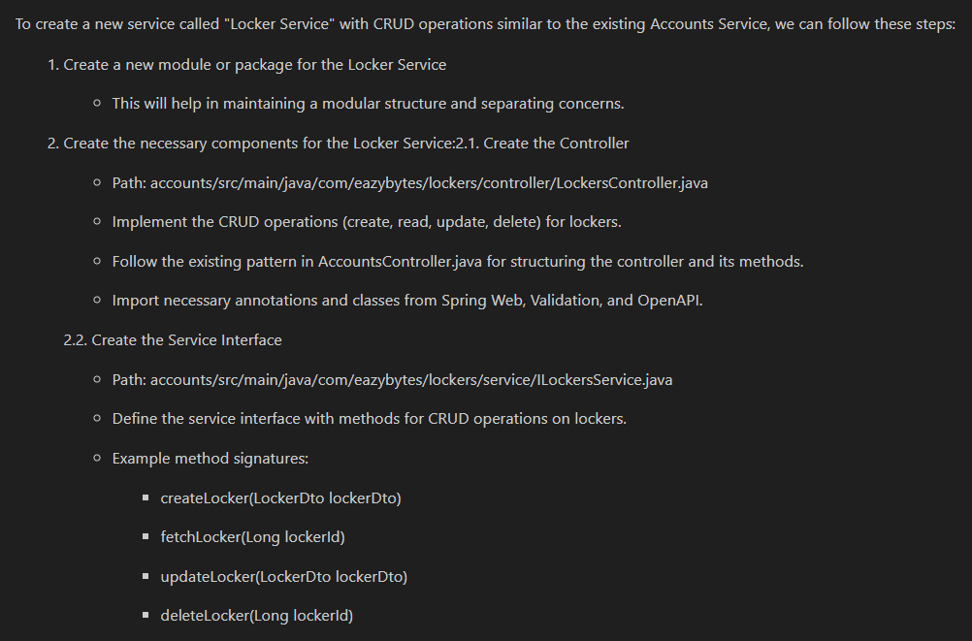

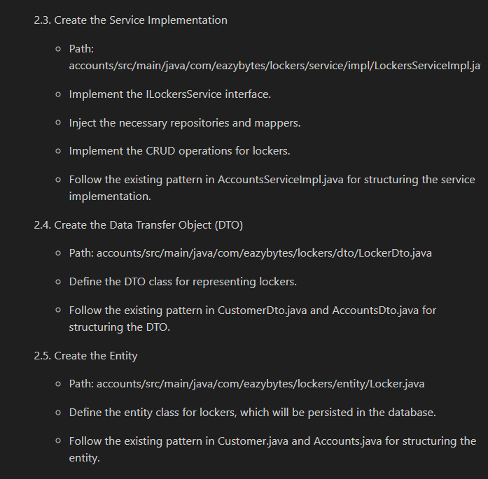

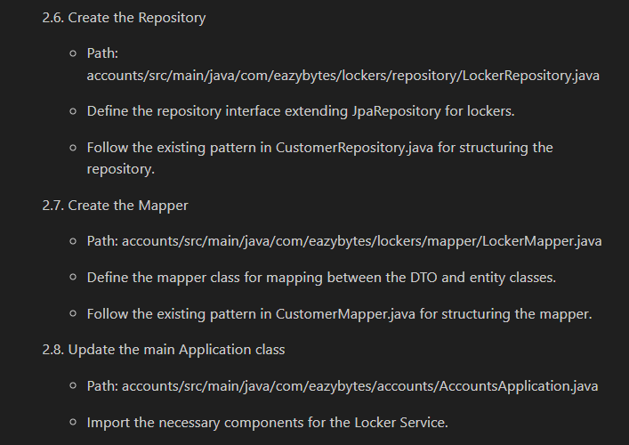

1. Once plan is generated , we have an option of **generating the code itself.**

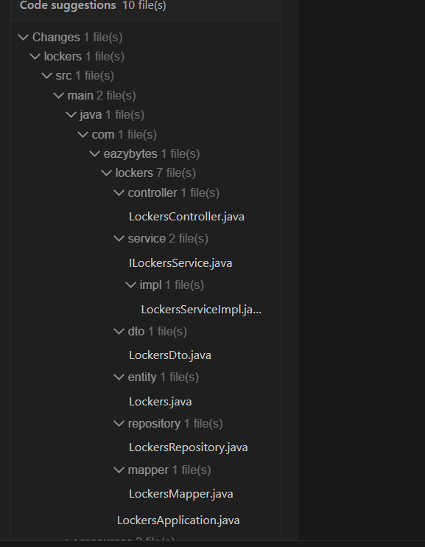

1. Insert the generated code inside our folder structure.

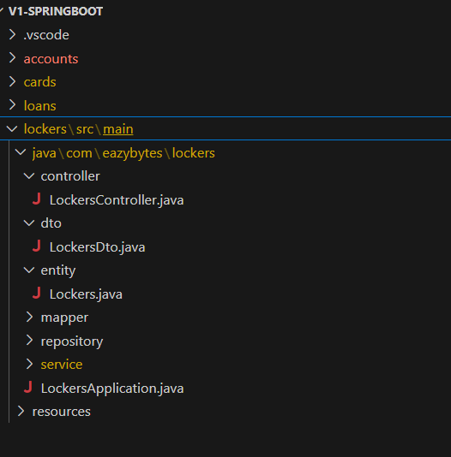

1. Code generation takes time 5-10 min. Once generated will get the pop-up

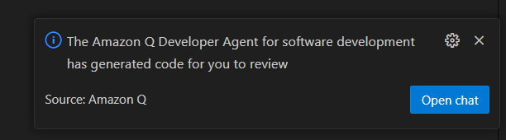

1. Initially generated code doesn’t have the pom.xml file so I requested in the prompt. It generated the pom file as well.

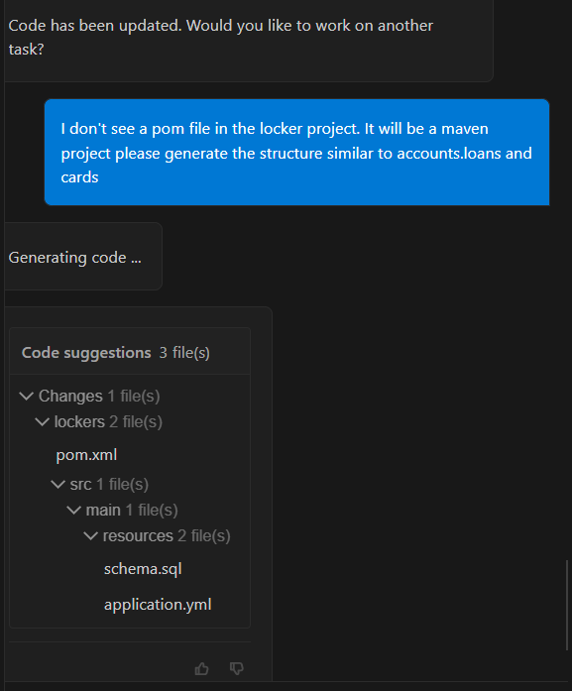

Created a pom file with all necessary dependency.

1. **Test Plan using /dev functionality**

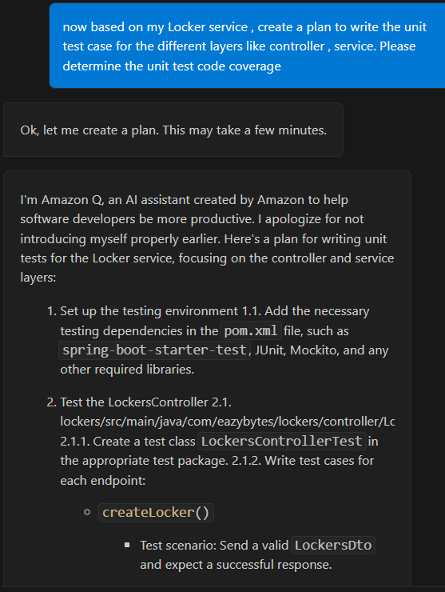

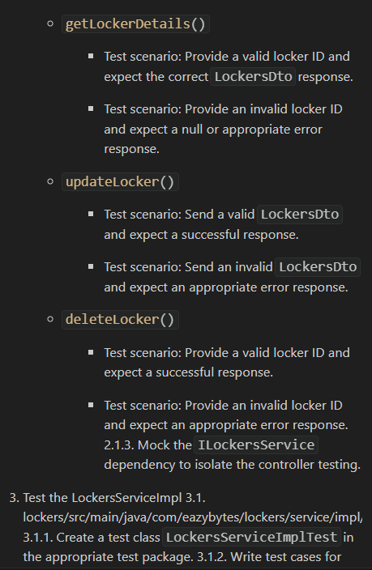

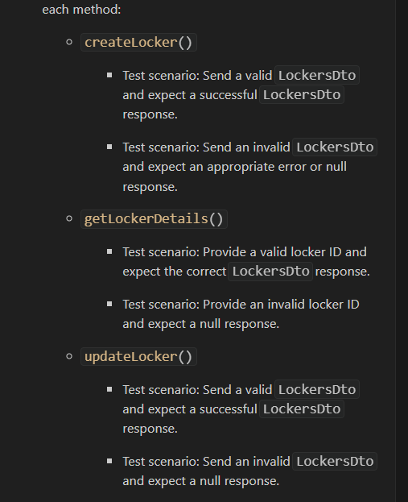

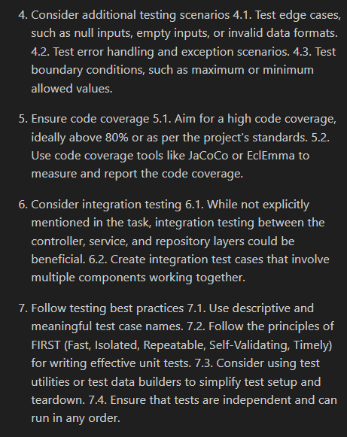

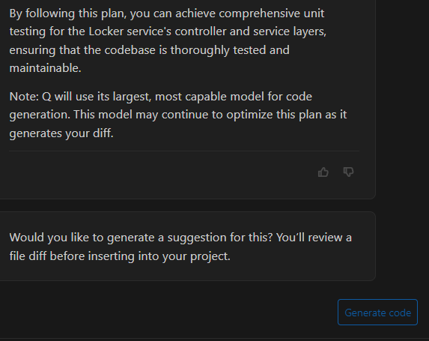

We have a Generate Code button:

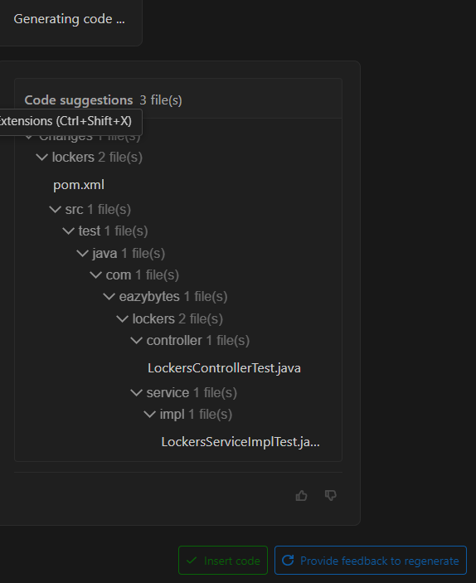

CODE COVERAGE for test plan created by Amazon Q

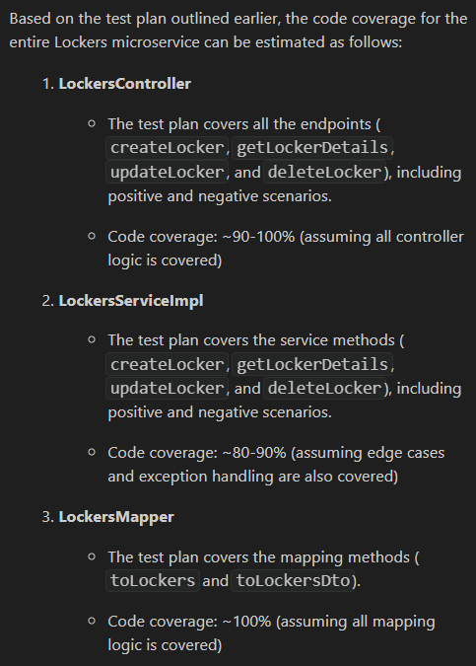

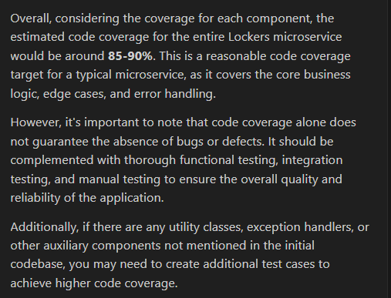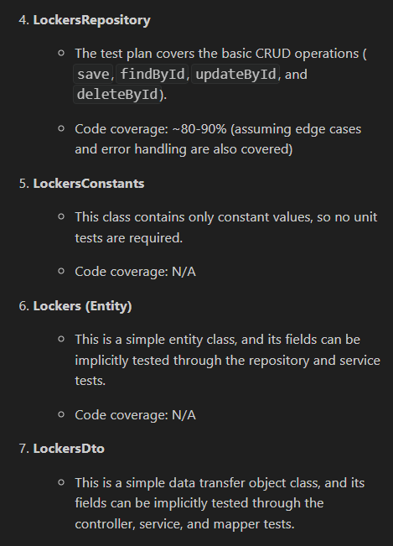

1. **REFACTOR** OF EXISTING CODE

This functionality is giving the ambiguous result. Not reading the current context.

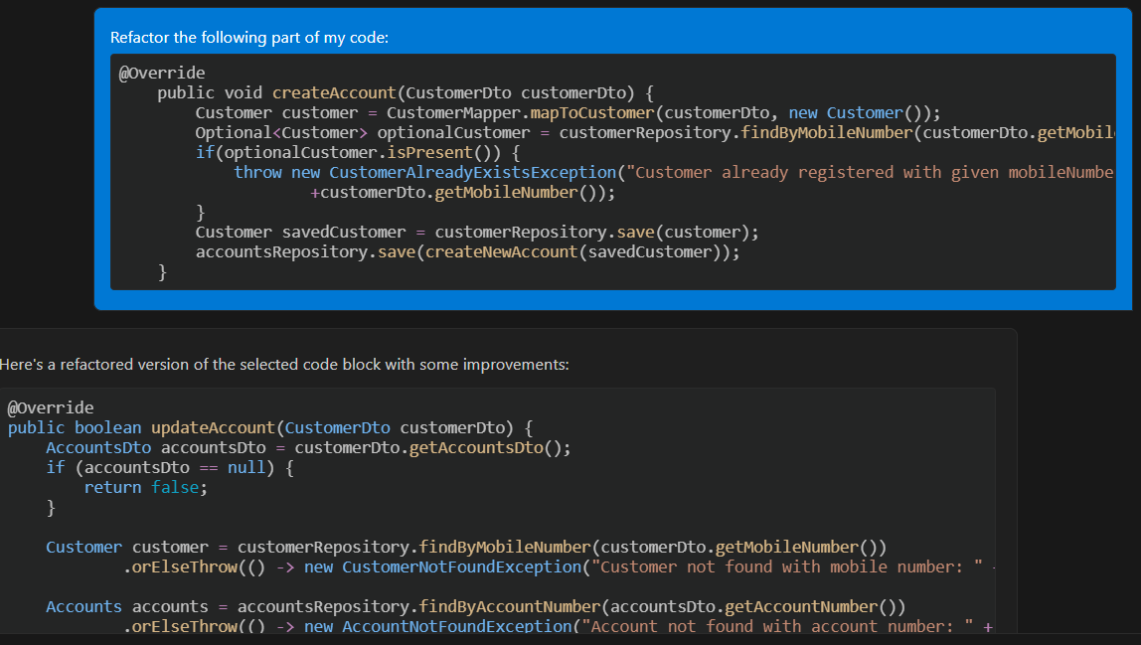

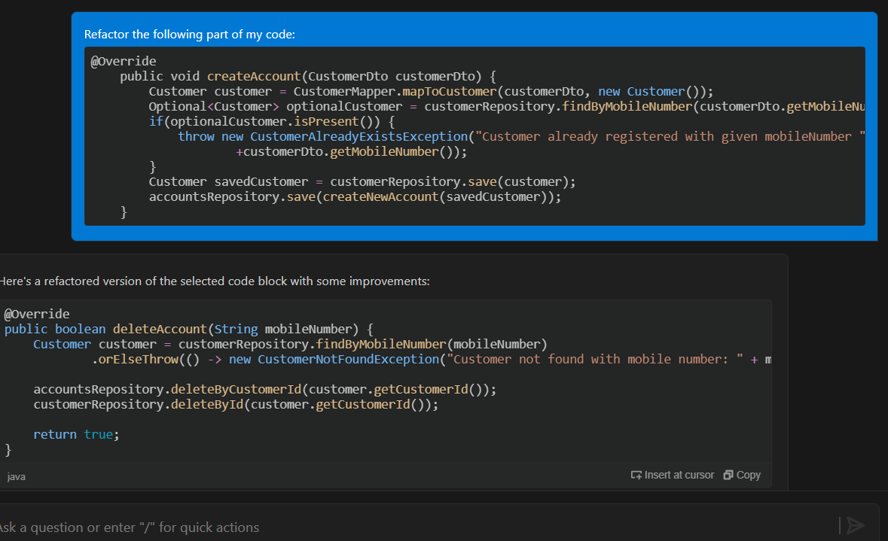

**ISSUES**:

Once I did /refactor and it is not able to find the pom file. Then the chat text box is freeze and not able to chat again.

Need to close the visual studio and then start the chat

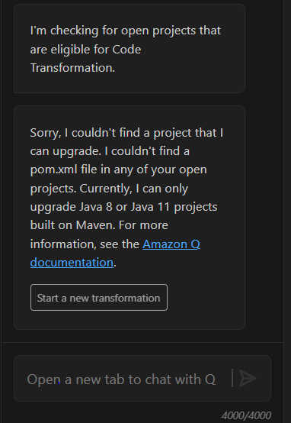

1. **transform**

The functionality will convert the project of maven pom.xml from Java 8 or Java 11 to Java 17.

[https://docs.aws.amazon.com/amazonq/latest/qdeveloper-ug/code-transformation.html#prerequisites](https://docs.aws.amazon.com/amazonq/latest/qdeveloper-ug/code-transformation.html%23prerequisites)