**DSO Maturity Assessessment Process Flow(MVP)**

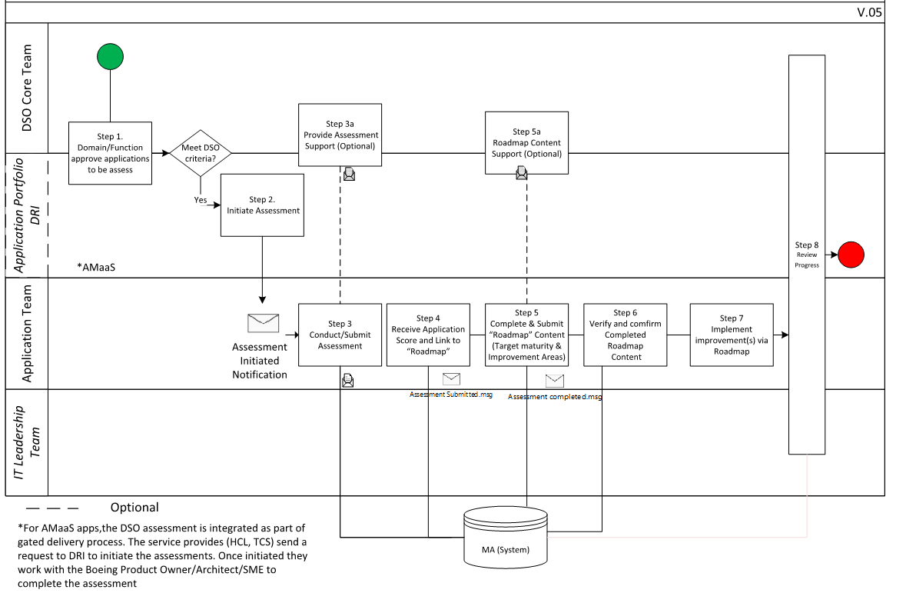

**DSO Maturity Reassessessment Process Flow(MVP)**