**EJB**

Enterprise Java Beans is a software element designed to build robust , scalable enterprise applications. It is a service side component which contains business logic.

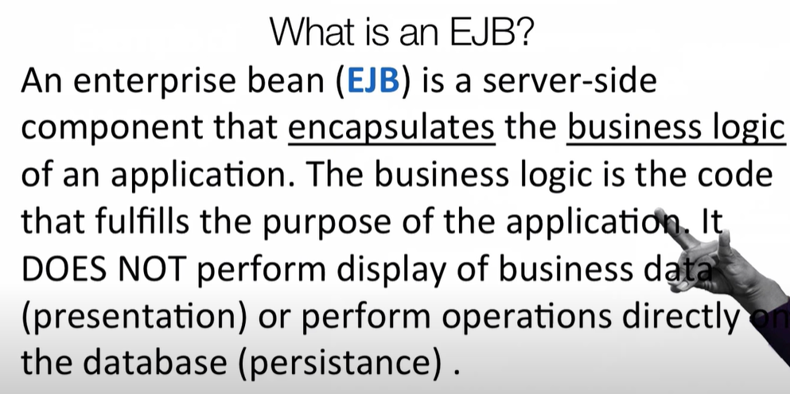

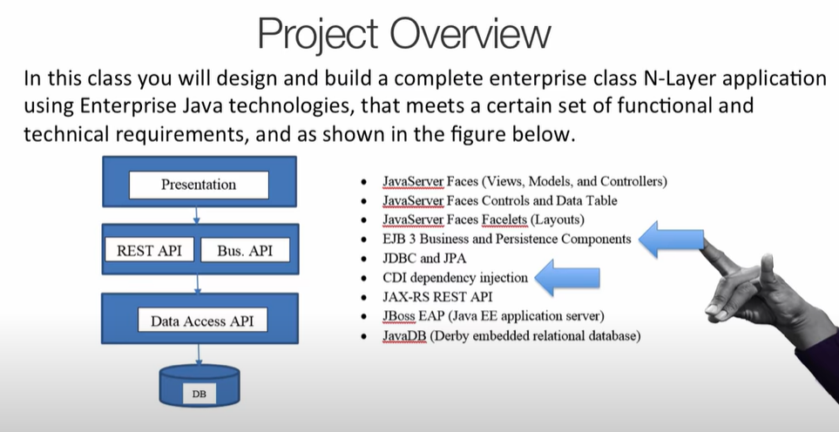

In enterprise application development EJB comes in middle layer which deals with actual business logics.

**What is business logic?**

**In our enterprise application business logic is actual thinking part. It is a portion which determines how data is transformed or calculated and how it is routed to people and software.**

**Examples:**

1. **Workflow behind a courier service or order service**

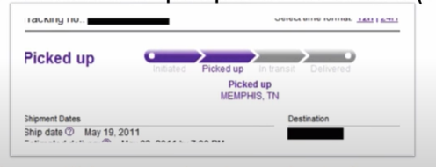

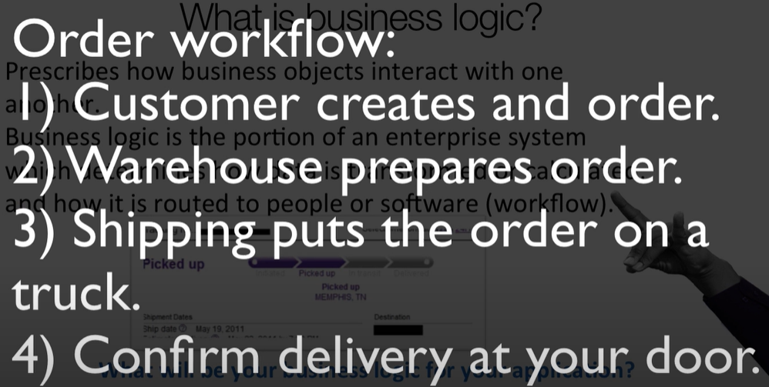

Now all 4 steps above need to be calculated somewhere.

**Why business logic is not written in presentation or front end layer?**

Presentation layer or front end can be different, we can use apps or website both UI is different. Vender UI can be different but all these needs to connect to a business logic to track the workflow.

We have multiple way to access our business. Website, apps or and API exposed so that other application can use it.

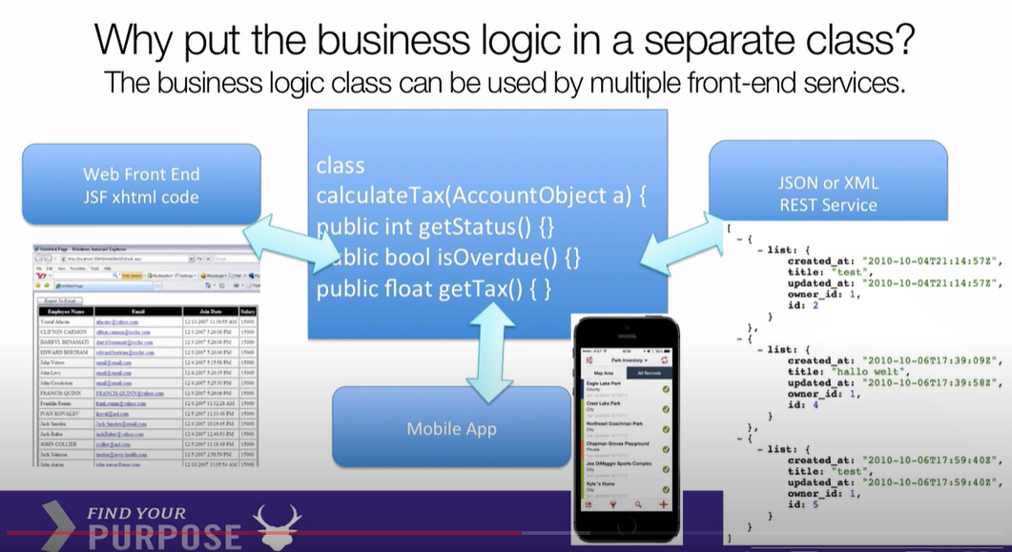

1. **E-commerce business logic**

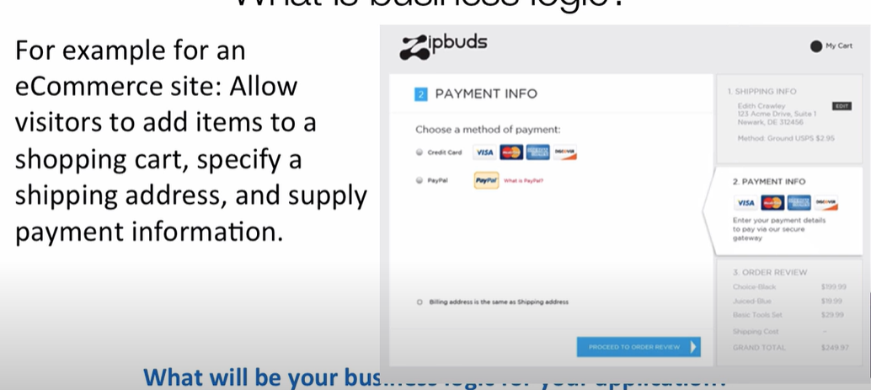

1. Decision making

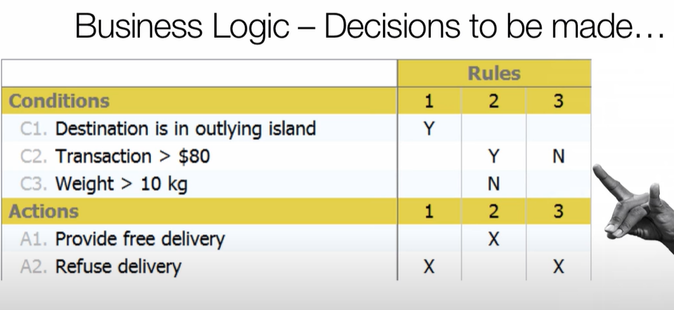

A simple if else statement will do the task and the code which is running this is called business logic.

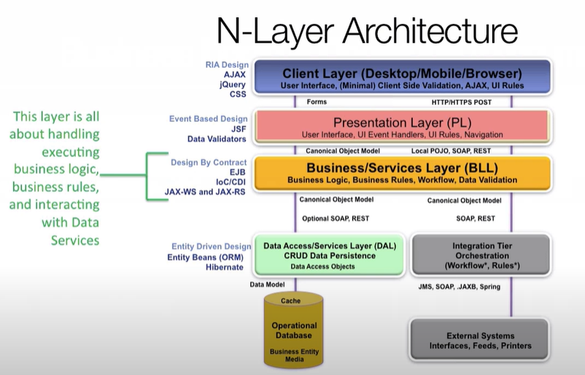

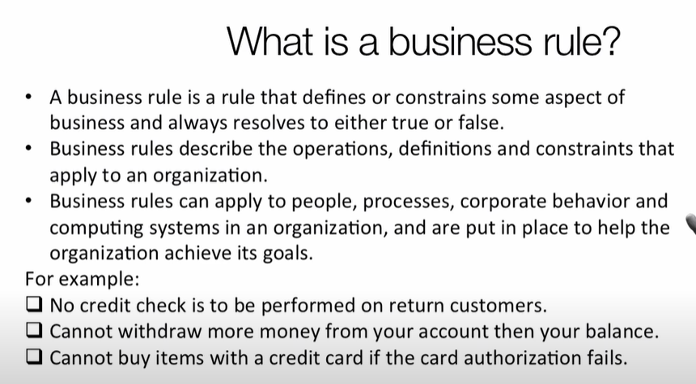

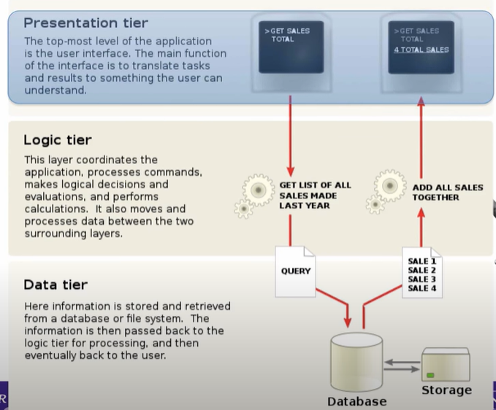

**EJB CONTAINER**

**It is a piece of software which manages enterprise beans assigned to it.**

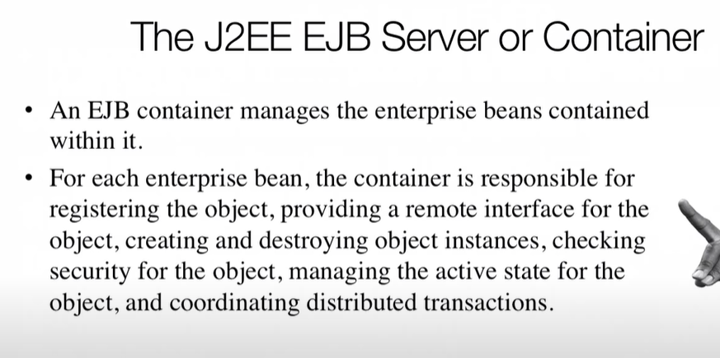

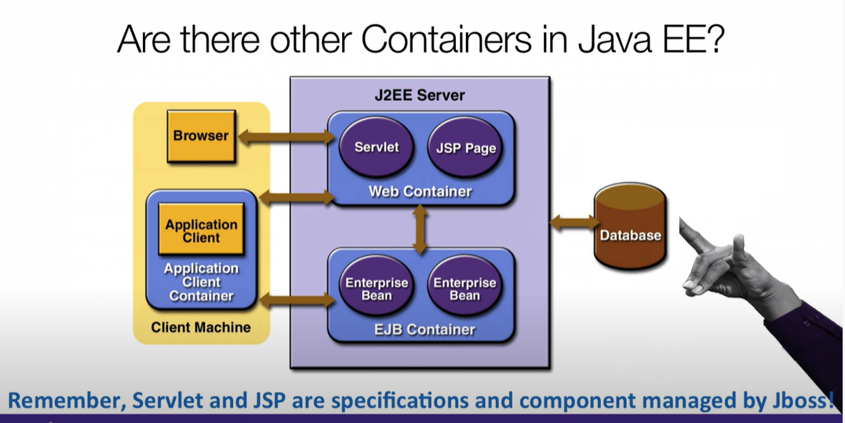

Job of web container is to bind the data coming from logic layer to pages and forms.

INVERSION OF CONTROL

