**Task Completion and Accomplishments 2020**

* **Build Domain knowledge :**

**FDS/ HDF5 -** Invested time in understanding FDS technology and different application inside it. As our team had little knowledge and expertise in this area. Involve various team members along with me to have a good grasp on FDS.

HDF5 technology is widely used across high computational and scientific areas in which data I/O is very huge and fast.

* + - Understand the design and implementation of HDF5 tech**.**
    - **Build pipeline** for FDS application**.**
    - Introduced HDF5-HPC concept and gave demo on functional and technical aspect of it.

**TP, DRQ Module -** Working on PR-CR(PR923 and PR932) developed more understanding on TP and DRQ module.

* **Operate with Excellence :**

1. **PR-923 - DRQ-DDR error** on RC686 airplane. It was a CR rather.

We identify **2 issue**:

* + Multi meas HS category meas which has reference meas number are getting wrong data source id in view DB.
  + DRQ application code is not handling error and exception well.

**Contribution**:

* Debug the code flow of DRQ for MDT generation through DRQ application.
* Identified the issue with respect to data source id inRIP_MDTD_MULTIMEAS_HSRCD_VW view.
* Provide solution and tested by submitting DRQ request for XMA,RMUX nodes.

**Feedback received:**

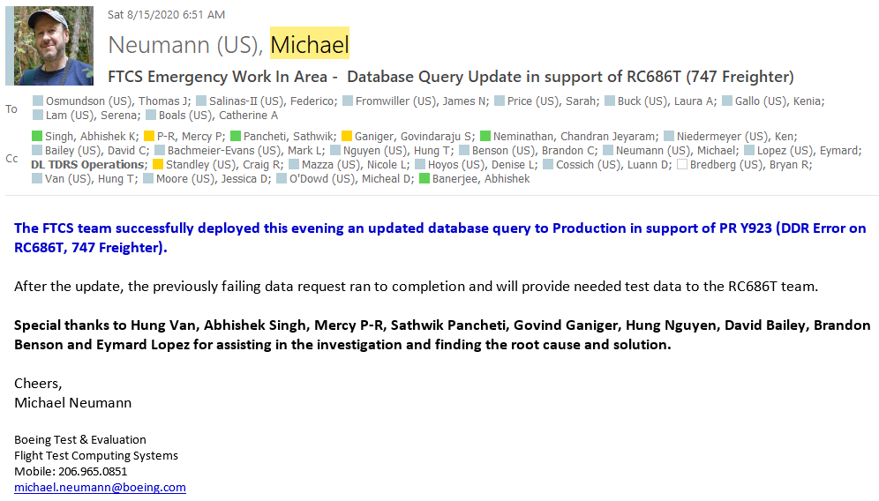

1. **PR- 932 - TIRLMOD**

**Issue**- When BEAMSCE UML is added to WH001 and DAISY32 airplane then in total Meas list extra measurement is coming from config id - CN000065.

**Contribution**:

* + - Analyzed and debug the TIRL code flow.
    - Identified the root cause coming from TIRL_MEAS_DETAILS_TEMP_FN.
    - Identified the process of deleting measurement from FTCS.
    - Gave multiple demos to make user understand the issue.
    - Provided different solutions to the user to resolve the issue.

**Feedback** – From **Mike** “great work in finding out the root cause, this issue existed since long but never being noticed cause its rare scenario but the detective and detailed work done by development team is great.”

1. **PR- 916- DRQ** **job failed at DDR** due package details missing for node id (3310) measurement (5915672).

**Contribution:**

* + - Analyzed the issue and code flow in MIST side as well.
    - Gave workaround for the issue as this is a CR change.

1. As FTCS being legacy application, there are >20k coverity warning are coming which includes high, medium and low severity.

Objective is to resolve 10% high coverity issue each sprint. Currently working on incorrect regular expression security vulnerability.

**Contribution:**

**Functional Grouping of coverity** **issue** based on different FTCS modules so that when we make code changes it is easy to perform regression test on functionality.

**Solution for high Priority cov issue** –

* + - **CSRF issue** – FTCS application had very high severity CSRF issue which is one of the most vulnerable when it comes to web application.

**Contribution**-

Identified and documented the CSRF issue existed in all our web application.

Make team aware about the challenges and limitation of CSRF on our projects.

Proposed solutions to mitigate CSRF issue as per coverity.

* + - **Adding salt to FTCS password**(SHAE Encryption)-

Currently FTCS application is using SHA-512 to store user password in our database. But as per coverity one-way hash without salt is not a secure way to store password.

**Contribution-**

* + - * Identified the places where we are storing password in FTCS.
      * Documented and demoed the impact of storing password without salt.
      * Proposed solution to Meghana and Bryan (Architects).

**Feedback-**

**From Architects – “**Nice work done in identifying the high severity issues in terms of design. This analysis will be really helpful when we will migrate to next-gen architecture”.

1. **WSSO implementation for MIST-**

**Contribution**:

* + - Created a new service CommonWebServices for WSSO implementation.
    - CommonWebService Script and property file creation  for all the environment.
    - Handled FTCS side code changes to restrict the generation of invoker file from FTCS code base and it will directly invoke mist URL and invoker file will be generated by commonWebService code.

1. **Oracle 12c upgrade from 11g version**-

As our database is migrating from Oracle 11g to 12c we need to do impact analysis with respect to FTCS code.

**Contribution:**

Working closely with DBA Hung N in understanding and documenting the deprecated and desupported features.

From code perspective looking at impact of deprecated features in SQL codes ,TYPES and queries.

1. **TIMADD Transaction Error WH001** –

User is not able to enter start time against WH001 airplane 003-59 test no for specific TIRL in TIMADD transaction.

**Contribution**-

Analyzing the issue, debugging TIM transaction code flow.

Identifying the proposed solution to the issue.

* **Delivery excellence & compliance- meet business goals and commitments**

1. **Insure first time quality** **in Kraken** **development** – Implemented 2nd phase of Kraken development by insuring we are not introducing new coverity issue and resolving as and when it comes.

**Contribution:**

* + - As senior members from Kraken team has gone, involved in designing and implementation of Kraken 2nd phase implementation.
    - Architect the Low-level flow of 2nd phase services.
    - Actively participating with Architects in designing features like On-Demand MDT, Notification service, Query services for partial/Full MDT creation.
    - Created LLD design and technical part of P200 document for Kraken interface.
    - Regression testing for Query services.

1. **IP website creation for PS** - Within a short span of time (as stretch activity), involve in designing and backend implementation of IP website incorporating all Boeing standards.

**Contribution** –

* + - Active member in making bridge between UI and backend services.
    - Involve in designing of database schema for backend services.
    - Conducting dev meetings and organizing the development flow and documentations.
    - Written code for idea submission flow.
    - Involve in preparing smooth demo for entire PLM capability team.

**Feedback** - From senior Management(Srini, Jeniffer) and other managers .

1. **Involve in High-criticality (L3)** - Production issues-support from Boeing India.

* **Drive Innovation/ Excellence thru Collaboration**

1. **Docker for webapplication:**

Collaborated in containerization of web application using Docker. Ideally, it requires 4 to 6 hours for local environment setup and Productivity over user-story of developer starts from Day2.

With docker images, developers can only focus on writing quality code without worrying about the initial configuration/setup required.

**Contribution**

* + - Create images for OAPI and CECFG application.
    - Written scripts which will handle all dependencies and properties of OAPI and CECFG application and will build/deploy application.
    - **Docker implementation demo in workshop** which showed the potential of removing limitation of current CI/CD pipeline and synergy server which will ease and uniform build and deployment in all env.

**Feedback – From Mike:**

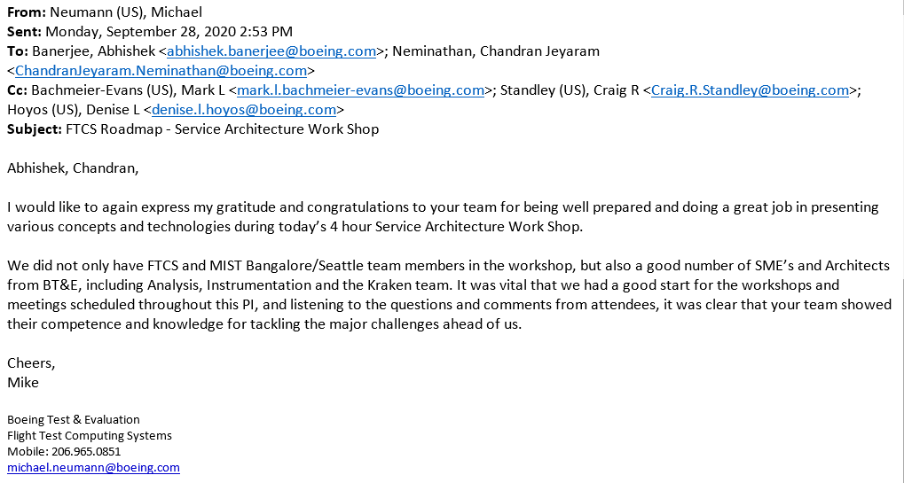

**From Mark:**

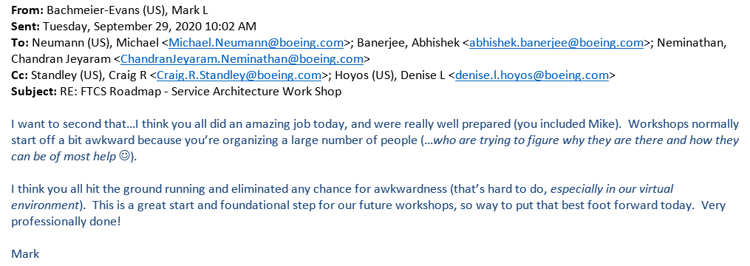

**From Chandran:**

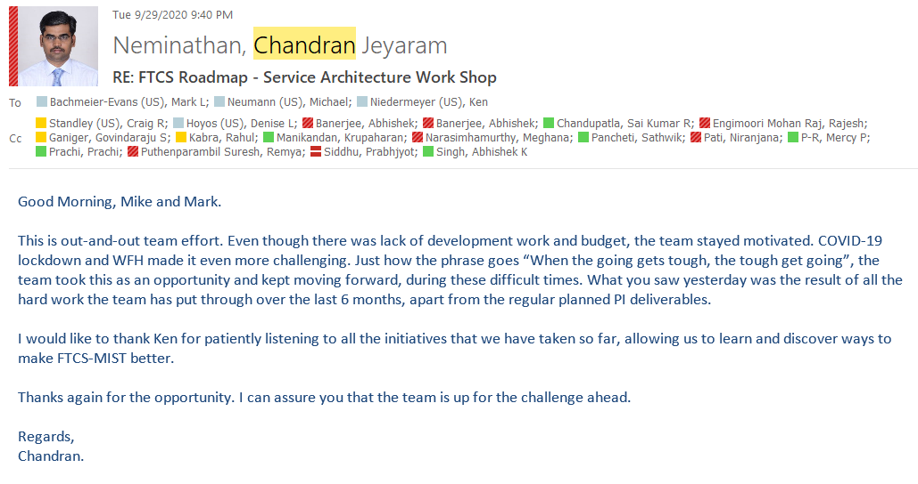

1. **Demo in coming workshop with all cutting-edge tech**-

Actively involved in designing an application which combines all DevOps best practice strategy and showcase demo in Roadmap meeting. Tech likes: Test automation (UI & API), SPLUNK, KAFKA, DOCKER, DEPLOY to PCF.

**Contribution:**

Taking care of Kafka and Docker integration.

1. **BTEC idea submission and selection** (Real Time Flight Data Analytics enabled by Cloud Infrastructure and Services) -

Out of many ideas from product system, just 3 idea got selected and ours was one of the innovative one.

**Contribution:**

* Analyzing the problem statement and limitation of current process.
* Pitching in with ideas on how we can perform different analytics over real time data.
* Gone through various IEE papers and journals on real time flight and cloud computing on Aviation and Aerospace.
* Implemented a POC on Octave tool for performing predictive analytics on real time data for Multivariate Altitude and Hydraulic flow vs temp using Gradient-decent and Linear regression concepts of ML.

**Feedback on BTEC paper**:

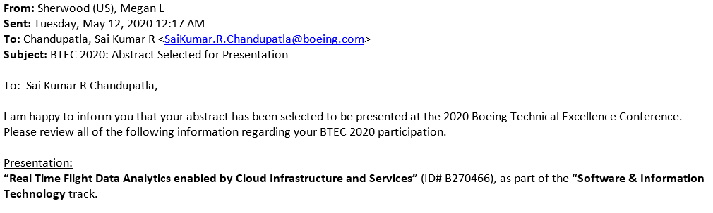

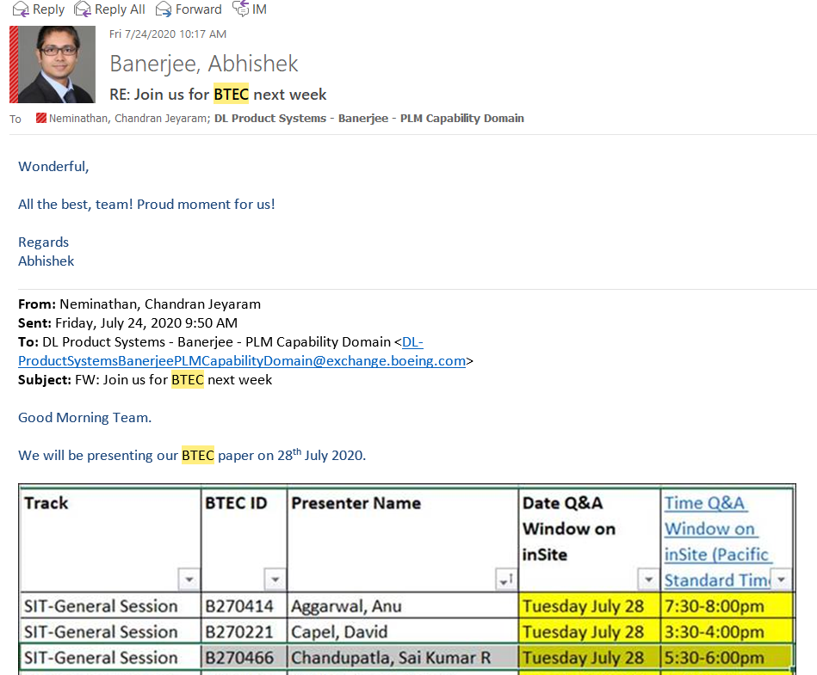

* **Employee Engagement & Growth**

**Contribution**

* Actively involved in team building activities. Focal for organizing different events within team.
* During covid time and WFH conducting weekly team building activity.
* Involving and encouraging other team members to participate in organizing activities and events.
* Helped different team members in grooming them technically by knowledge sharing and build confidence to take crucial responsibility and own some modules within FTCS.
* Technically learned a lot about UNIX from writing scripts for various build and deploy tasks.
* Learned/ refreshed topics like Hibernate, Springboot, Docker.
* Being involve in various low-level design increased the capability of speedy turnaround on converting abstract requirements to high quality implementations.
* **Contribution to Organization Initiatives**
  + Actively participated in voice of Product systems events and encouraged other members to equally participate.
  + Leaded my team in Quiz competition happened for product system team and qualified till semis.
  + Innovation week initiative- Active member of PS innovation website creation and participated in quiz as well.
  + Participated in Idea Generation Workshop happened in Feb,20.