**OKR**

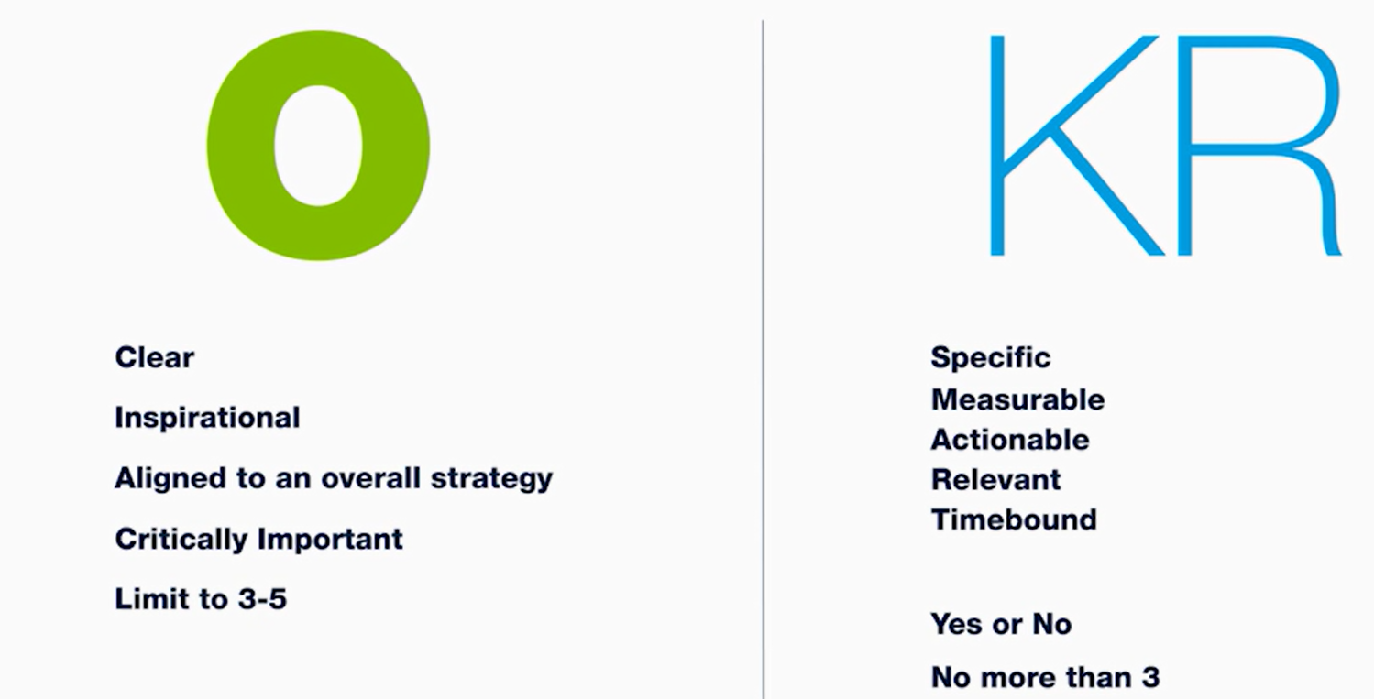

**Everyone should be able to see each other OKRs.**

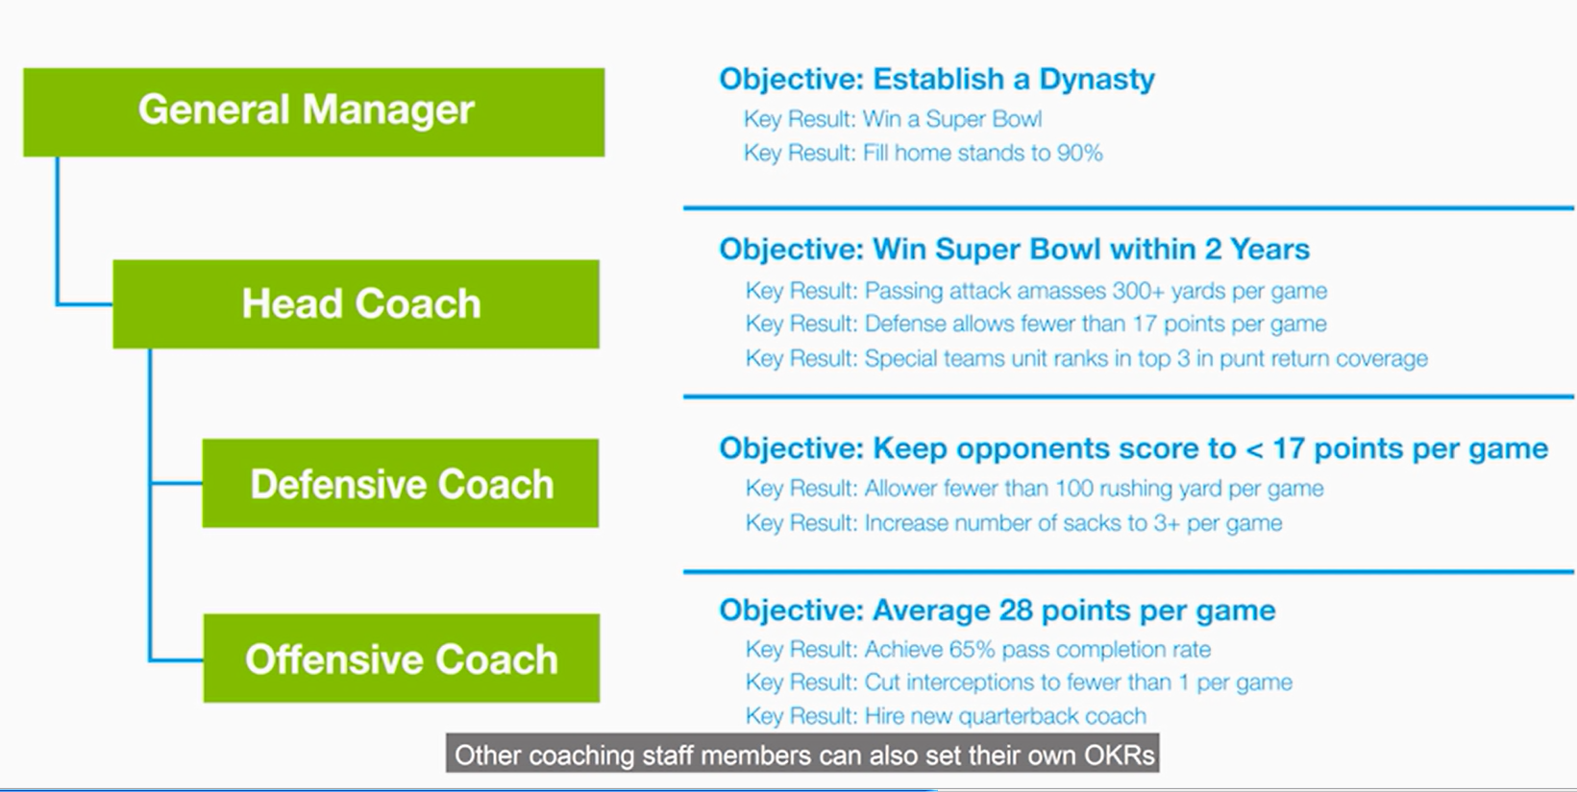

**3 QUESTIONS**