

#401, 4th floor, Mohali Bypassm, Sector, - 66, Industrial Area, Phase 9, Sahibzada Ajit Singh Nagar, Punjab 160066, India

# EMPLOYMENT AGREEMENT

1. **Identification of Employer and Employee.**

**Puja Singh**

**B/38 MM colony , Saket vihar Anishabad, Patna-800002, Bihar**

Dear Puja Singh,

This letter agreement (“Agreement”) will confirm our employment offer with DevelopTech IT Solutions Pvt. Ltd. (hereinafter “the Company”).

# Position and Location.

In accordance with the terms and conditions set forth in this Agreement and in any attachments thereto, the Company hereby employs Employee as:

Job Title: Network Engineer

Location: Mohali Punjab, India

Reporting to: Information Technology Manager – Global Collaborations Services

Job Description: A job description of Employee’s position is attached hereto as Schedule 1.

The Company shall have the right to assign Employee other tasks as may be necessary for the Employee to effectively carry out his/her duties. The Company shall further be entitled to change the location of the place of work, and to modify his/her reporting or organizational structure as may be reasonably necessary to respond to changing business needs. The Company further retains the right to transfer the Employee to any of its divisions or undertakings, affiliates and/or subsidiaries currently in existence and/or which may be established in the future as the Company may think appropriate.



# Employment Term and Effective Date.

Employee’s employment under this Agreement will become effective as of <TBD, 2018>, and subject to what is stated hereunder in accordance with the terms of this Agreement.

Employee’s employment with the Company is subject to Employee satisfactorily completing an initial probationary period of six months, during which period either party is entitled to terminate this Agreement without notice or any additional liability, including compensation due to such termination.

# Hours of Work.

Employee’s hours of work will be determined in accordance with India’s employment laws and any applicable collective labor agreement, as well as Company’s work rules and other guidelines. As of the effective date of Employee’s employment under this Agreement, Employee’s typical hours of work each work week are from 9:00 am to 6:00 pm, Monday through Friday.

The Company reserves the discretion to change Employee’s hours of work, and Employee may be required to work longer or alternative hours as may be required by business necessity. Employees must discuss hours of work with their managers*.*

# REMUNERATION.

**Annual Compensation**

The Employee's annual gross compensation is INR 414,352 (INR Four Lakh Fourteen Thousand Three Hundred and Fifty-Two Only) per year. The details of your annual compensation and related benefits are enclosed in Annexture 1.



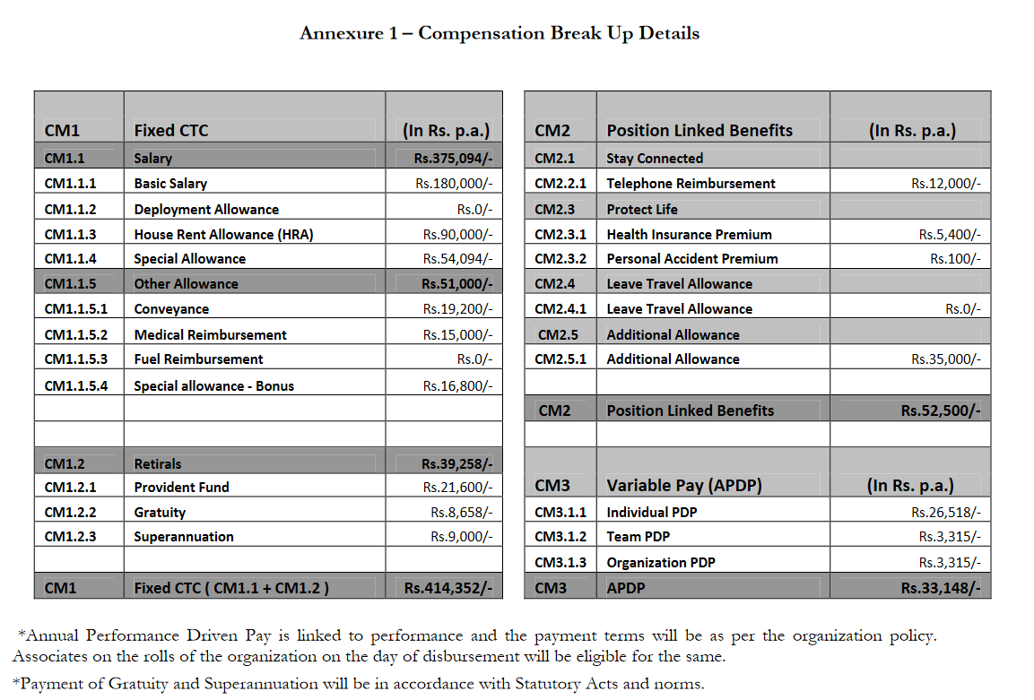

# Provident fund

The Employee will be eligible to participate in the Company’s Provident Fund (PF). The employee will contribute 12% of basic salary per month to the Provident Fund, with a matching equal amount contributed by the Company to the Provident Fund.



# Gratuity

The Employee will be entitled to a gratuity payable at the time, in the amount and under the circumstances provided in the Payment of Gratuity Act 1972, as amended (the “Gratuity Act”) if and to the extent he/she meets the requirements for payment. Generally, the gratuity is payable on termination of employment to an employee with at least five years of continuous service with the Company (or to an employee with fewer years of continuous service, if his or her termination is due to his or her death or disablement),

in an amount equal to fifteen days’ Basic Salary multiplied by the Employee’s whole and partial years of continuous service with the Company, up to the maximum gratuity specified in the Gratuity Act. Notwithstanding the foregoing, a partial year of continuous service will be counted only if it exceeds six months. If the Employee is terminated for any act, willful omission or negligence causing damage, loss to or destruction of the Company’s property, the Employee will forfeit the gratuity to the extent of that damage, loss or destruction.

The Company will provide Employee with those benefits required from time to time during the term of this Agreement by applicable local statute.

The Company will provide Employee with a salary statement giving details of earnings and any deductions made. The Employee’s annual gross compensation will be periodically reviewed and may be adjusted, at the sole discretion of the Company.

The Company shall have the right to deduct from the Employee's remuneration package any inadvertent overpayment of compensation. In addition, the Company shall have the right to amend the distribution of the remuneration package as described above if the Company implements group benefits or perquisites.

Remuneration received by the Employee by virtue of his/her employment with the Company will be subject to all deductions required by law, including but not limited to those required under the Income Tax Act, 1961 or its successors, the rules of the Employee‘s remuneration schemes and any other agreed deductions.



# Incentive Compensation

The Employee will be eligible to participate in such annual Company incentive plans as may be applicable to the Employee’s classification and which provide the opportunity to receive incentive pay based upon the Company’s and/or the individual employee’s performance as determined by the Company from time to time. The Employee’s participation in such annual Company incentive plans is subject to the terms of the plans as amended from time to time. Payments under annual incentive plans are entirely discretionary on the part of the Company, and the Employee will have no legal, acquired or implicit right to such payments, even if they are made over the course of more than one annual period and the Company has not declared a reservation of rights with regard to each such payment. The Company also reserves the right to amend, modify, replace or discontinue these incentive plans at any time. Incentive plan payouts will be subject to all deductions required by law, the terms of the incentive plan, and any other applicable deductions.

# Employee Benefits.

The Company periodically reviews the package of benefits it provides to its employees in each jurisdiction, taking into account factors including, amongst others, local legal requirements, local market conditions, the state of the Company's businesses and the cost and benefit of providing the relevant benefits. Employees have no contractual right to the benefits provided by the Company from time to time and the Company retains the right at any time at its sole discretion to cease to provide, vary or replace some or all of the benefits provided by it, without any liability for paying additional compensation to employees who were receiving such benefits. All benefits provided by the Company are provided subject to the terms and conditions imposed by the Company and/or the third party provider. Employees shall not be entitled to any compensation for the loss, or prospective loss, of benefits arising from any employment action taken by the Company, including, without limitation, dismissal and the Company's rights to take such employment actions shall not be restricted or fettered by the existence of any benefit policy.

In some jurisdictions, because of the small number of employees and other factors, it is not practicable and/or cost-effective for the Company to provide some or all of the employee benefits which it would otherwise offer. In those jurisdictions, the Company may at its sole discretion provide relevant employees with a benefits allowance ("Benefits Allowance") in lieu of providing some or all of the relevant benefits. Where a Benefits Allowance is paid, the following terms and conditions shall apply: (1) the Employee shall be solely responsible for arranging, maintaining and funding his/her own benefits; (2) the Company may at any time terminate all or part of the Benefits Allowance in order to provide some or all of the benefits which are intended to be covered by the Benefits



Allowance; (3) the Company shall not be responsible for, and shall have no liability for, any claims, losses or damages which an Employee may suffer or incur as a result of the Employee's failure to arrange, maintain or fund his/her own benefits or as a result of the terms and conditions of the benefits purchased by the Employee; (4) the Company shall not be responsible for any losses which the Employee may suffer in respect of any benefits purchased by him/her as a consequence of any employment action taken by the Company and nothing in the terms and conditions of any benefits purchased by the Employee shall restrict or fetter the Company's rights in respect of the Employee's employment; (5) the Benefits Allowance will be subject to local laws relating to tax, social security and other similar contributions and withholding obligations; and (6) the amount of the Benefits Allowance may be varied (both upwards or downwards) at any time at the Company's sole discretion and with or without the Company taking responsibility for providing any additional benefits, in accordance with its assessment of local market conditions, the state of its business (locally, regionally or globally) and such other factors relevant to its remuneration structure. The Employee's acceptance of the Benefits Allowance will constitute acceptance of these terms and conditions.

# Paid Time Off (Holidays and Vacation).

Employee is entitled to applicable national Indian holidays and applicable regional and religious holidays recognized under the policies of the workgroup.

In addition to the paid holidays referenced above, Employee is entitled to twenty

(20) Working days of paid vacation for each full calendar year of employment. Vacation days will accrue in accordance with applicable statutory requirements and the Company’s guidelines on vacation.

The Employee is entitled to take vacation at such times as management may approve in advance.

# Illness and Injury.

In the event of absence due to illness or injury (but not otherwise), the Company will pay Employee such statutory pay as he/she is entitled to under applicable law.

# Data Privacy.

Employee agrees that personal data about him/her can be processed by the Company and its agents for purposes associated with the employment relationship, however excluding any use of such personal data for direct marketing purposes. Employee understands that he/she can review such personal data, and can request correction or deletion of any incorrect, incomplete or irrelevant data by a signed and dated request.



Employee authorizes the Company to transfer all or part of such personal data to other enterprises of the corporate group of which the Company is a part, for the purposes described above, and expressly consents to the transfer of such personal data to The Company.

Employee agrees to not use the Internet and/or the Company’s official email address for purposes that, under the laws of India, are illegal, unethical, harmful to the Company, or nonproductive. Examples (which are non-exhaustive) of unacceptable use are:

Sending or forwarding chain e-mail, i.e., messages containing instructions to forward the message to others.

Conducting a personal business using Company resources.

Transmitting any content that could be deemed to be offensive, harassing, or fraudulent under the Laws of India.

# Termination

Employment is contingent upon verification of information Employee provided on the employment application (including information from Employee’s resume and other sources), and a background check. The Company has the right to terminate the Employee’s employment with the Company if this verification and background check cannot be successfully completed.

The Company has the right to terminate the Employee’s employment with the Company after giving one month’s notice or payment of salary in lieu of notice. The Employee can resign from the Company after giving one month’s notice or payment of salary in lieu of notice. In the event of termination for cause, the Employee’s services may be terminated with immediate effect without the requirement of any notice period or salary in lieu thereof.

Upon the termination of the Employees employment with the Company or upon the Company's request at any time, the Employee shall promptly deliver to the Company, any office equipment (including computers, mobile phones, badge, internet cards or dongles) and any documents, material or information mentioned in Clause K.2(c) and any copies, excerpts, summaries, compilations, records, or documents made by the Employee or that came into his/her possession during his/her employment with the Company. The Employee will not, without the Company's consent, retain copies, excerpts, summaries, or compilations of the foregoing information and materials.



Termination of the Employees employment ends his/her employment with the Company but does not end his/her obligation to comply with the provisions of this letter, which survive such termination.

It is hereby agreed between the Company and the Employee that the Employee shall not be entitled to claim any compensation in the event that his/her services are terminated, whether such termination is with or without cause, except to the extent as provided above.

# Additional Clauses

* 1. **INDEMNIFICATION**

Employee agrees to indemnify and hold the Company harmless from all losses, liabilities, claims and damages (including the lawyer's fee) which may arise out of or as a result of any unauthorized act by Employee or any act caused by Employee in contravention of this Employment Agreement.

# EMPLOYEE COVENANTS

Employee acknowledges that during the course of his/her Employment he/she will obtain unique training by the Company and have access to confidential documents, materials and information owned by the Company and its customers, and thus agrees to comply with the covenants below, for which the Employee has received full compensation from his/her salary and benefits:

* + 1. Full-Time Work. Employee acknowledges that he/she is employed as a full-time employee of the Company and agrees that he/she shall accept no other work, for which compensation (whether in the form of cash or otherwise) is received, without the prior approval of the Company during the term of his/her employment.



* + 1. Non-competition. The Employee agrees that he/she shall not during the term of his/her Employment by the Company engage or otherwise assist any person/entity in any activities in Mohali, India, including without limitation, provision of services or consultation or making investment in a business, which competes with the business of the Company, solicitation of business from any person or company who used to be a customer of the Company during the period of one year immediately prior to expiration or termination, or solicitation of any employee of the Company.
    2. Confidentiality. Employee acknowledges that he/she shall have access to documents, materials and information relating to the transactions, business, and financial condition of the Company and agrees to keep such documents, material and information confidential whether during the period of his/her Employment or thereafter; the Employee shall further use his/her best efforts to prevent disclosure of any of the above documents, material and information during his/her Employment. Employee shall have the same confidentiality obligation with respect to other documents, materials and information relating to the transactions, business, and financial condition of any related person/entity. Employee understands that these documents, materials and information are commercial and industrial secrets of the Company, disclosure of which is prohibited by the Laws of India.
    3. Intellectual Property Right. Employee acknowledges that the inventions, creations, work products or whatever forms of objects that may be protected under the Copyright Law, Patent Law or Trademark Law or other laws of the India ("Products") shall be considered the property of the Company, if the Products are produced during the employment and are related to his/her employment by the Company.

# RULES AND REGULATIONS

The Employee agrees to observe and abide by the Company's rules and regulations, as amended from time to time by the Company, as well as any other regulations issued in the future by the Company. The Employee also acknowledges that he/she has carefully reviewed the work rules of the Company, which shall be deemed part of the Employment Agreement.

# Severability, Integration and No Modification Clauses.

**Severability.** In the event that any provision of this Agreement should be held to be void, voidable, and unlawful or for any reason unenforceable, the remaining portions of this Agreement shall remain in full force and effect.



**Integration.** This Agreement is a single, integrated written contract expressing the entire agreement of the parties to this Agreement about the subject matter herein. The parties acknowledge that no other promises, agreements, representations, or warranties, whether express or implied in law or in fact, have been made about the subject matter herein by any party to this Agreement, except as specifically set forth in this Agreement. All prior and contemporaneous discussions and negotiations about the subject matter herein have been and are merged and integrated into, and are superseded by, this Agreement.

**No Modification.** No modification, amendment or waiver of any of the provisions contained in this Agreement, or any future representation, promise, or condition in connection with the subject matter of this Agreement, shall be binding upon any party hereto unless made in writing and signed by such party or by a duly authorized officer or agent of such party.

# Governing Law and Jurisdiction.

The terms of this contract have been executed and delivered and shall be interpreted, construed and enforced in accordance with the Laws of India.

Any discrepancies that may arise in connection with the interpretation and performance of this contract shall be submitted to Human Resources.

# Signatures & Date Signed.

IN WITNESS WHEREOF both parties have read this agreement and understood its contents, which they deem suitable and accept by their signature.

Signed: Dated: Abhishek Kumar Singh

ID: TBD

Signed: Dated:

Authorized Signatory