**NIRANKARI HEALTH CLUB**

**THE GYM**



# 1st Floor, Lal Market, Police Colony,

# Duke Killer showroom,

# Anishabad, Patna- 800002, BIHAR

# Contact No - 9304898343

# 

**Invoice**

**Abhishek Kumar Singh Customer Id :** 4201128

B-38, MitraMandal colony, **Invoice Number :** #PTN2021567

Saket Vihar, Anishabad, **Invoice Date :** 25th June,2021

Patna- 800002

|  |  |  |  |
| --- | --- | --- | --- |
| **DESCRIPTION** | **TYPE** | **DURATION** | **TOTAL CHARGES** |
| Gym Executive Membership | Workout + Zumba Training | 3 months  **Gym** - 7 Days/week  **Zumba** - 6 Days/week (Sunday off) | |  |  | | --- | --- | | Gym Fee | ₹9,000 | | Zumba Fee | ₹ 4,500 | | Membership  Fee (One time) | ₹ 1000 | | Sub Total | ₹ 14,500 | |

**Payment Ref No** :N-2021**-**4475

**Sales Person** : Bablu

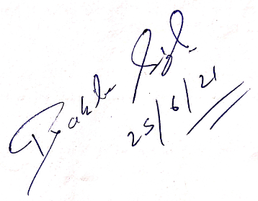 **Total Invoice in Figure** : ₹ 14,500

**Total Invoice in Word** : Fourteen thousand five hundred only

**Mode of Payment** : Cash

**Terms & Conditions:**

1. Payment once made is Non Refundable / No cancellation.
2. All Member should abide by the club rules as mentioned in the membership form.