Linux Training

Table of Contents
Architecture 2
Setup in AWS 2
Command 8
Installation 9
Shell Scripting 10
Commands 13
SSH & SCP 13
If Else Condition 16
Loops 18
Functions 19
How to take a Backup Of Folder 19
Disk Check → Trigger Alert 20
While Loop 22
Alert Script on Disk Usage 22
CronJob Crontab 22
23

Architecture
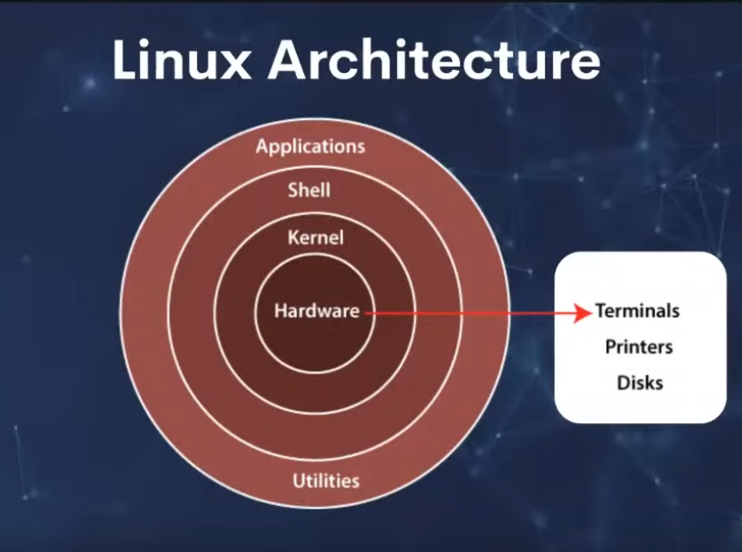

Setup in AWS

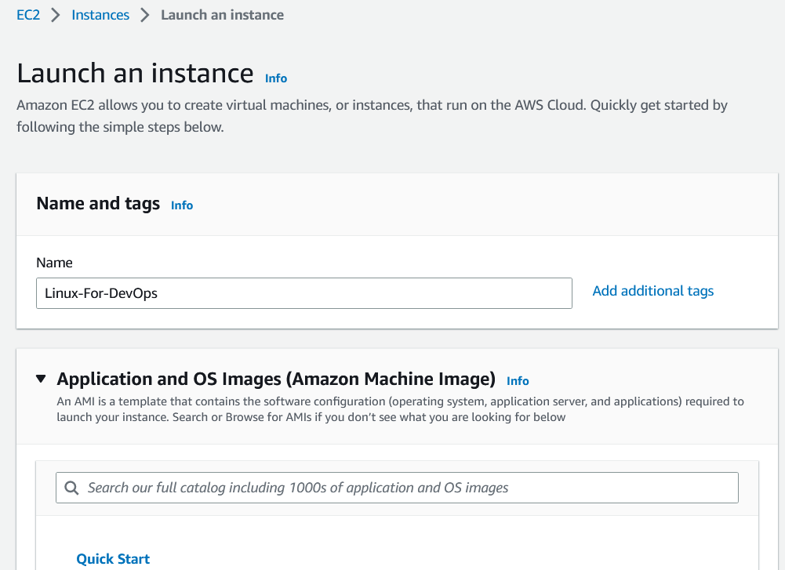
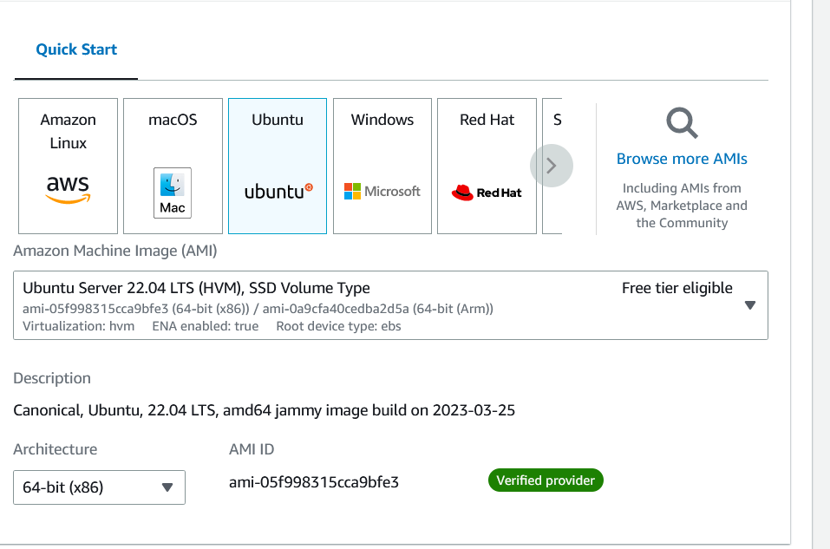
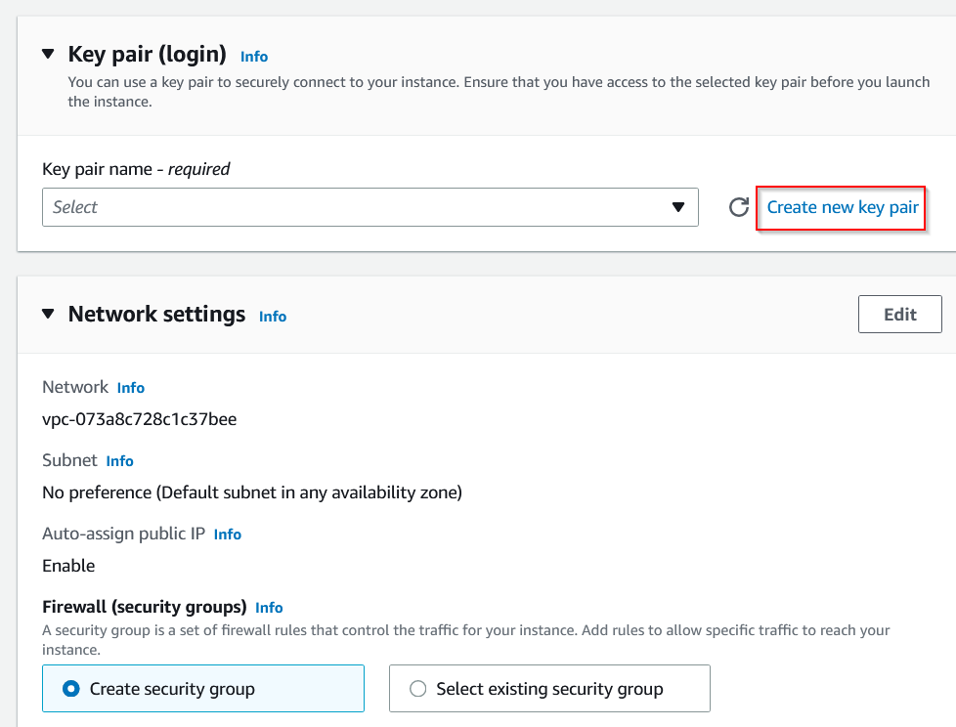

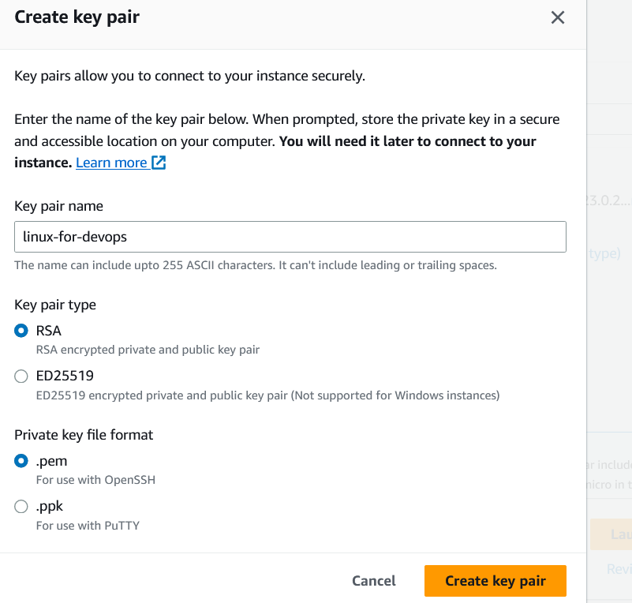

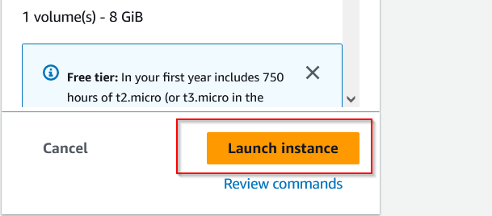
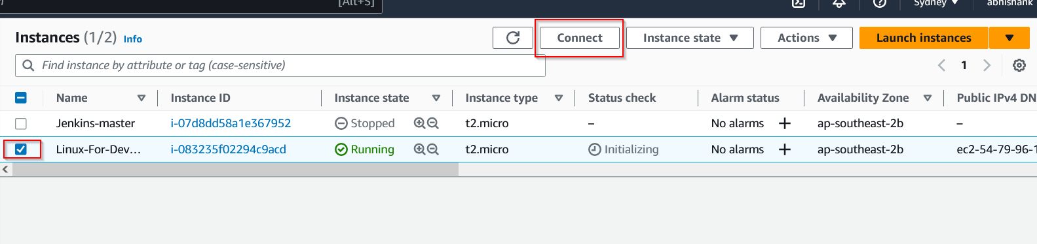
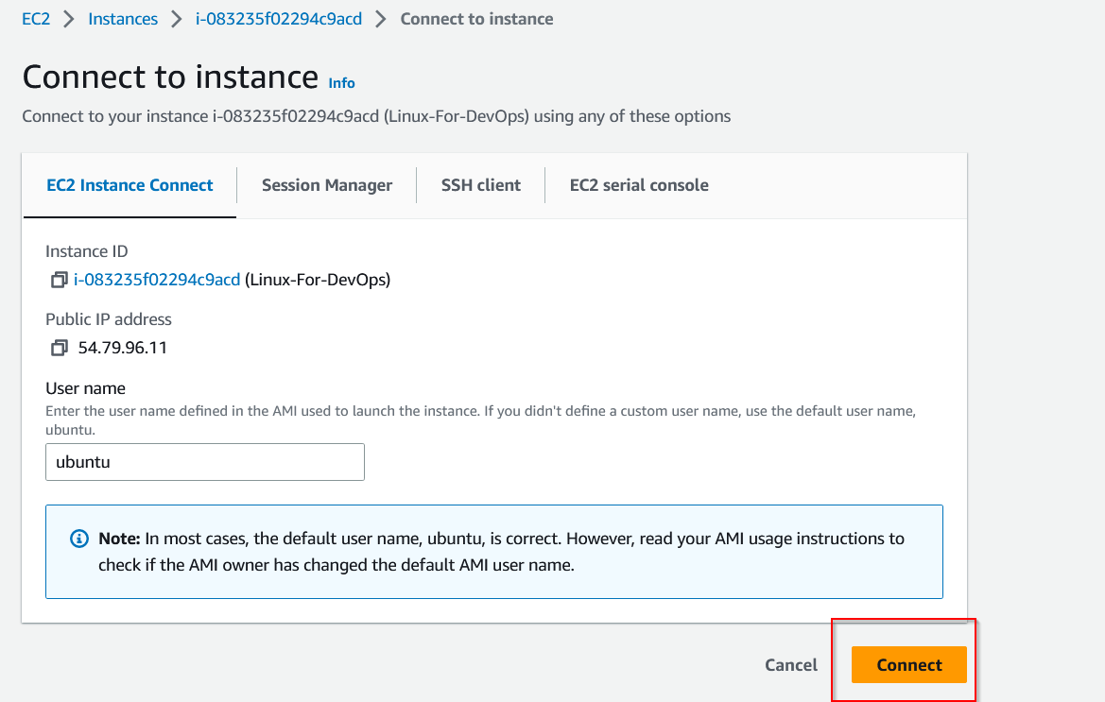
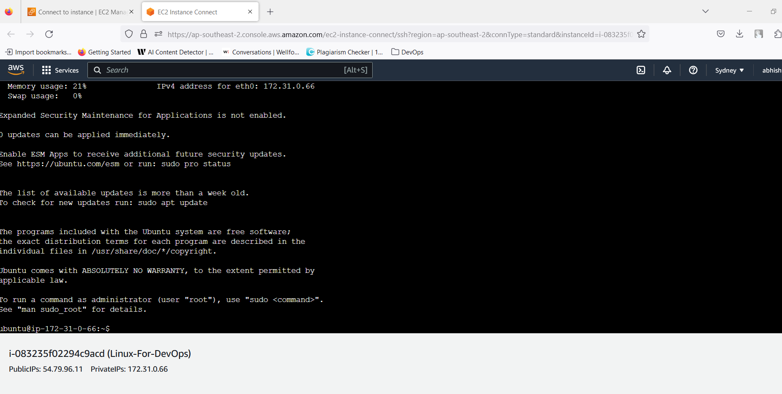

Command

Tips: Do not use spaces in folderNames. Use either Caps before each word or underscore

- Create Directory → mkdir LinuxForDevops
- Create File in directory → touch filename
- Edit file → vim filename
  - write in file → press I to activate insert mode then write anything
  - press Esc then write :wq to write&quit from filename

- To view file content → cat filename
- Create multiple file using touch → touch file{1..5}.txt
  - This will create file1.txt file2.text file3.txt file4.text file5.txt
- How to delete/remove any file starting with file name → rm file* ( files starting with file name file )
- Copy all content from folder1 to folder2 → cp folder1/* folder2/
- How to rename/move a folder or file name → mv oldfoldername newfoldername
- How to check if internet is working in system → ping -c <number> 8.8.8.8
  - ex: ping -c 2 8.8.8.8
  - Here 2 can be number of packets to be transferred. It can be any value.

How to download any file from internet →wget <hyperlink>

WGET vs CURL
WGET can have option of read or download
CURL can implement HTTPS methods like GET , POST, DELETE. (Read,write, update & Delete)

Update: sudo apt update ;
sudo apt update - -upgrade
To see upgradable components: apt list --upgradable
Switch to root user → sudo su
Come out of super user → exit

Installation

Docker installation commands : https://www.digitalocean.com/community/tutorials/how-to-install-and-use-docker-on-ubuntu-20-04

How to check status of any service (application) in linux → service <appname> status
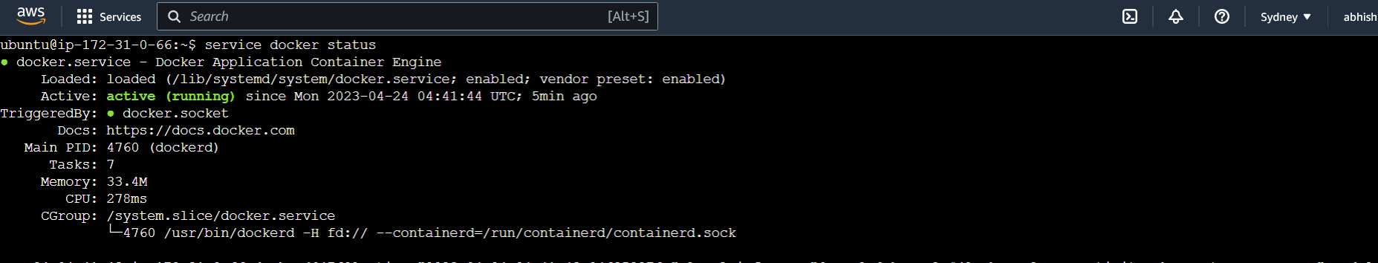
How to stop any active service in Linux → service <appname> stop
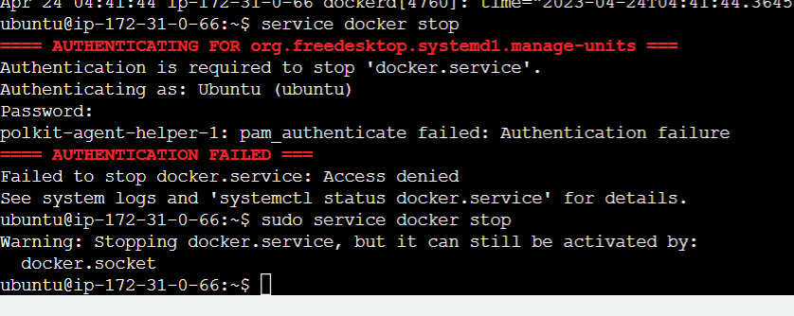

Shell Scripting

Shell command files end with extension .sh
Execute shell file with bash → bash <filename>
OR execute like → ./<filename>

How to give permission to user → chmod XXX (XXX → represent numbers, refer cheat sheet)
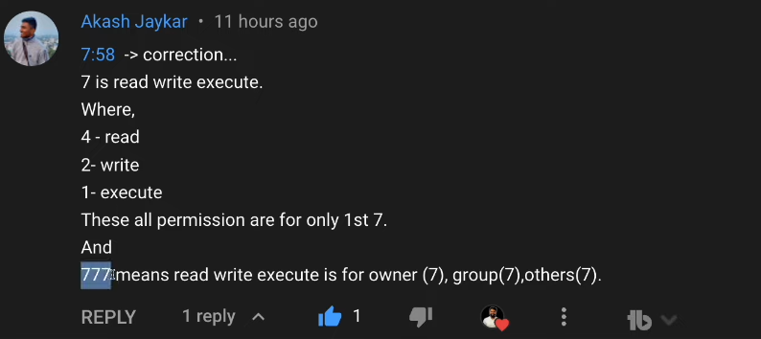
CHMOD → Change Modify
To print → echo “statement”

create script for below set of commands:
- mkdir testfolder
- cd testfolder
- touch testfile.txt
- echo “insert with redirection” > testfile.txt

How to check disk command → df – h
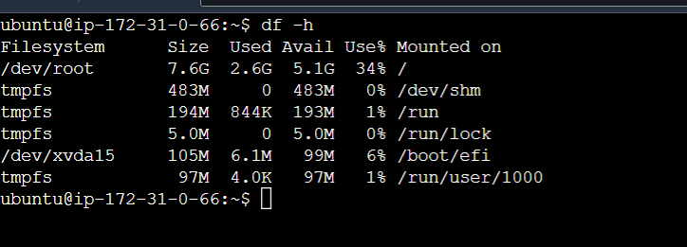
Now print only first column only.
| → will pass df -h output to
awk → initiate filtering, everything should be under ‘{}’
$1 → first column
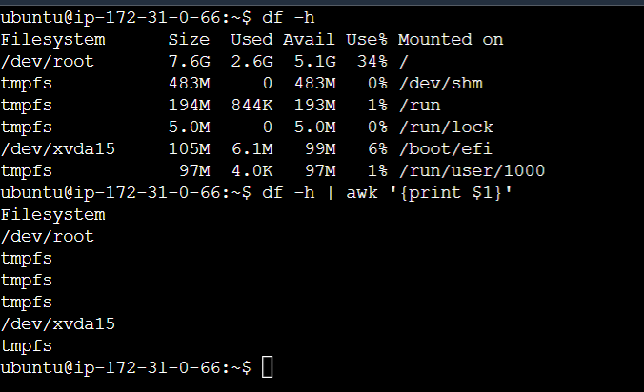

Now print first 3 columns from above result set
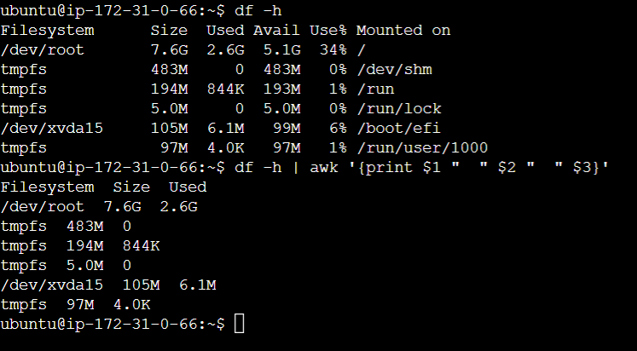

df -h | awk '{print $1 " " $2 " " $3} NR==3{exit}' → will limit top 3 records only

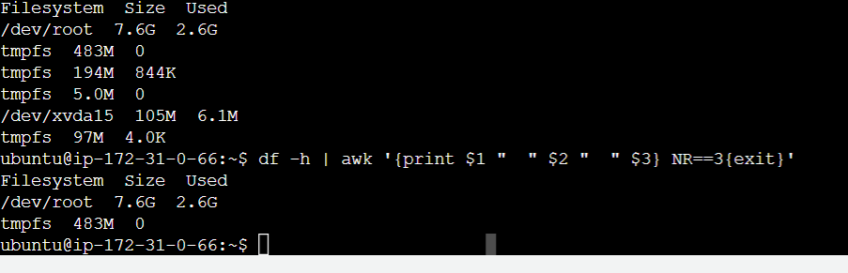

Commands
https://www.notion.so/Linux-For-DevOps-Masterclass-2556811c239142cf99c4cec6548df01a

SSH & SCP

it stands for Secure Shell, a protocol typically used for connecting to Linux servers. The command-line SSH tool lets you log into your server and run commands remotely to perform any required task.

Check if SSH is already installed on windows machine . Open CMD → type SSH and press Enter
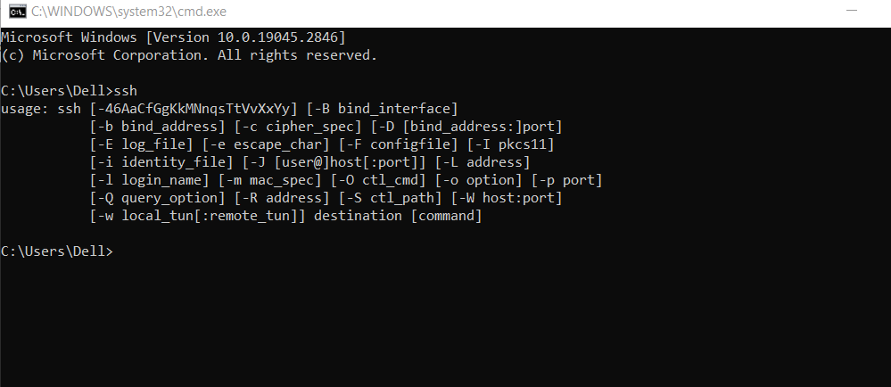
If above message is not displayed then install it separately.
Enable SSH on window machine : https://winbuzzer.com/2021/08/25/how-to-enable-and-use-ssh-commands-on-windows-10-xcxwbt/

Past below shown command and this will connect local windows machine to your AWS instance machine . Make sure pem key file exist in the same location
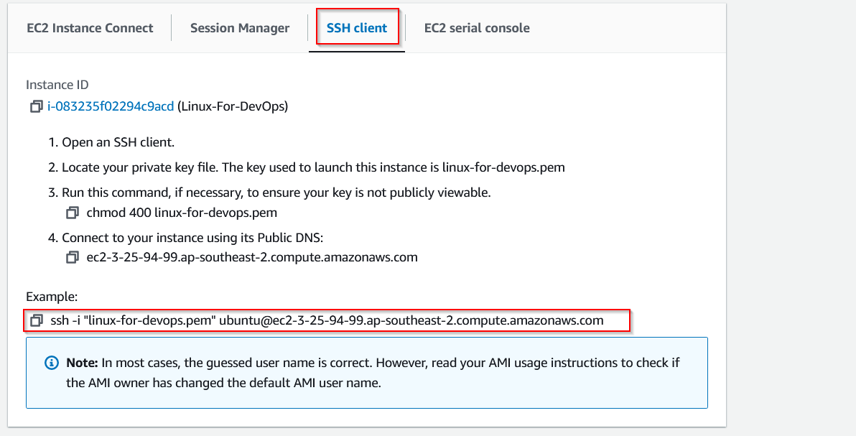
ssh -i "linux-for-devops.pem" ubuntu@ec2-54-253-159-81.ap-southeast-2.compute.amazonaws.com

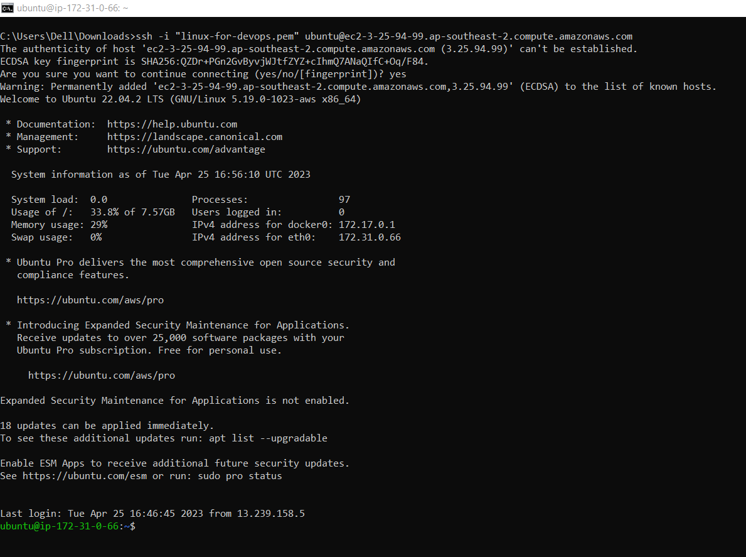
What is Processing triggers for man-db line means after any installation ?
This mean manual db is created. If you want to know any information about that software then simply type command man <software name>
eg: man ssh or man docker

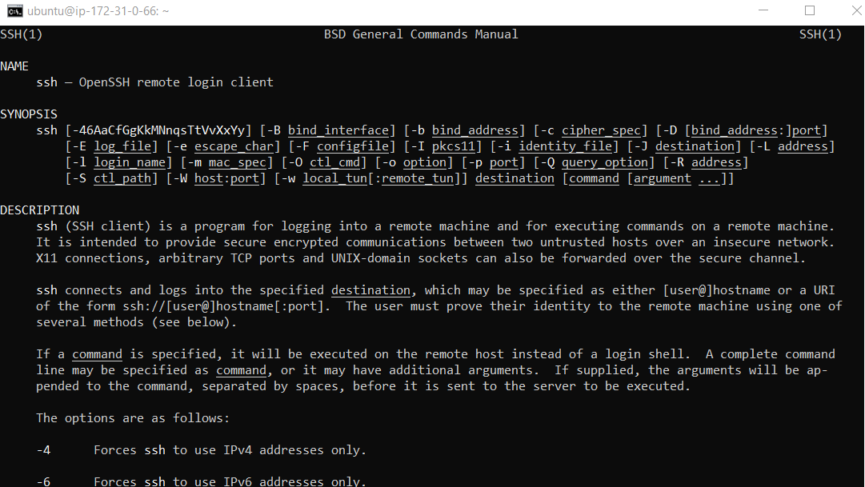
How to copy file from local to remote machine ?
1. navigate to folder where pem key file is located
2. In local terminal, type below command-line
sudo scp -i <pemkeyfilename> <filename> <remotemachineaddress>:path

filename → if file is in same directory then directly provide file name otherwise entire path
path: → remote system path in which file needs to be copied (use pwd for entiere path)

How to copy file from remote server to local machine ?
SCP → secure copy

If Else Condition
Note: Space after if
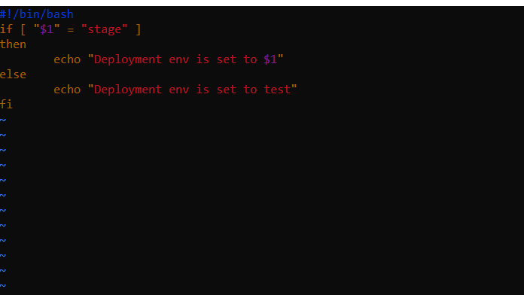
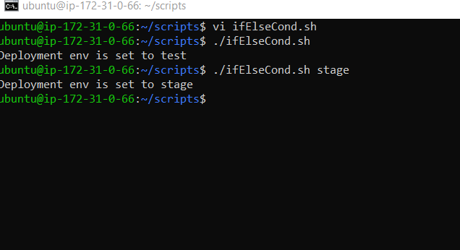
Output:
Multiple If → elIf
Q. Find biggest in 3

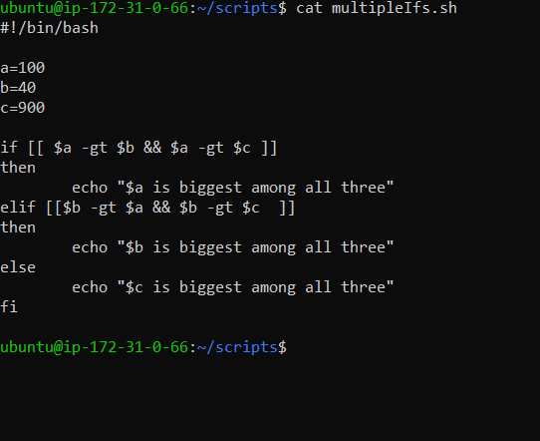

Loops

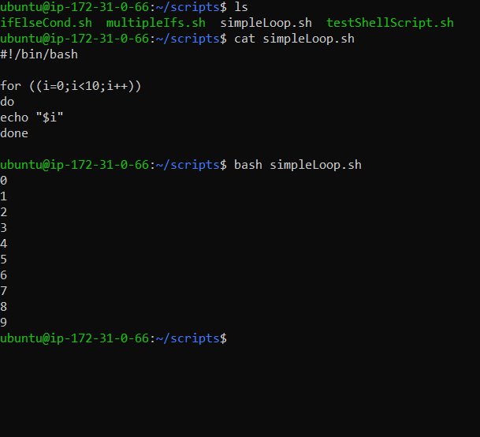

Functions
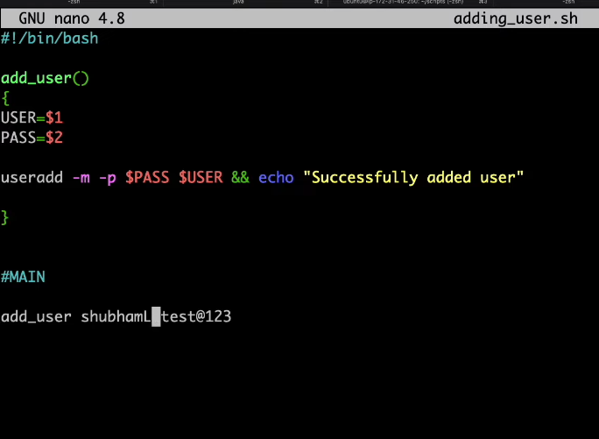

How to take a Backup Of Folder
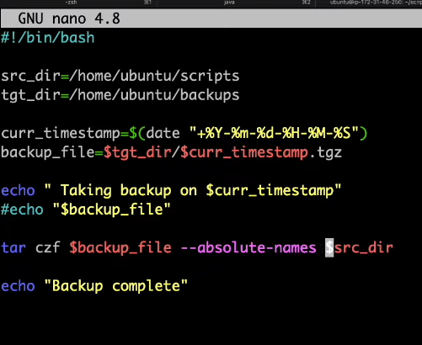
here backup file is the name of the zip that is going to be created.

To unzip use tar xf filename

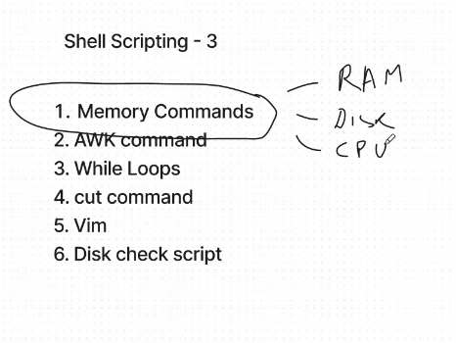

Disk Check → Trigger Alert

Disk file df -H
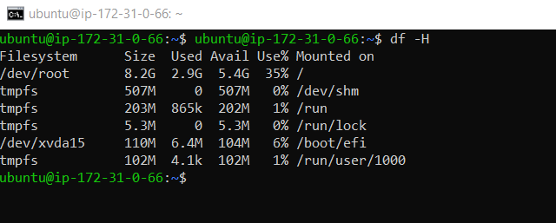

filter above output: AWK command

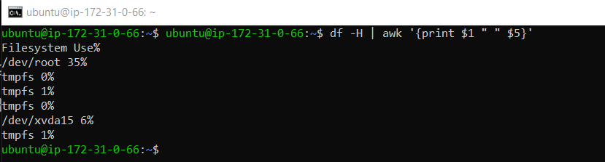
Disk usage script file
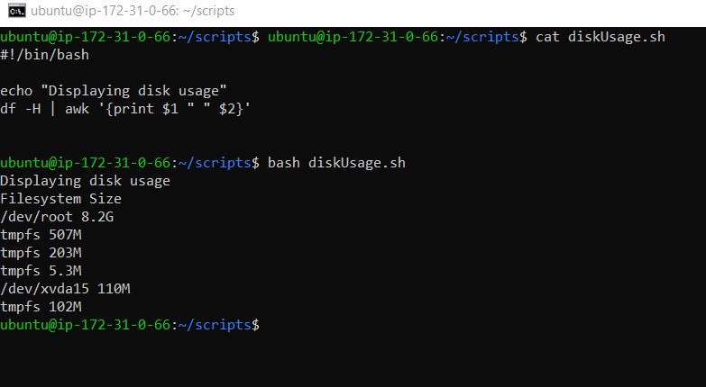

While Loop

Alert Script on Disk Usage
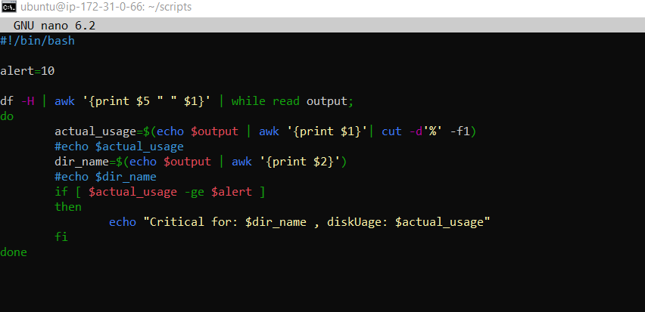

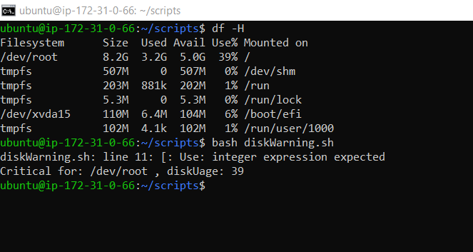

CronJob Crontab
How to schedule any file execution
bash /home/ubuntu/scripts/diskWarning.sh

crontab -e will open crontab file under which we can schedule execution of any shell file

