Selenium Grid Setup

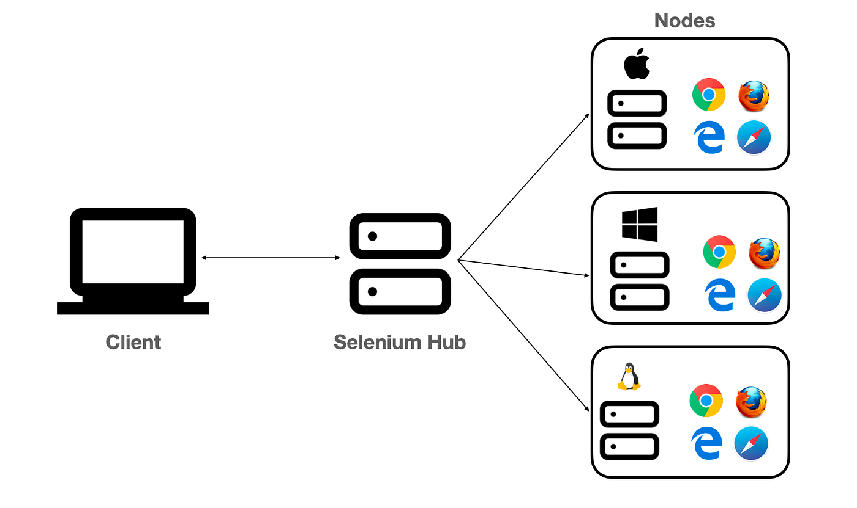

Standalone Setup (Single machine):
- Download selenium-server-4.20.0.jar and place it somewhere.
- Run below command to start Selenium Grid
java -jar selenium-server-4.20.0.jar standalone
- URL to see sessions: http://localhost:4444/

Hub & Node Setup (Multiple machines):
- Download selenium-server-4.20.0.jar and place it somewhere in both (hub & node) the machines.
- Run below command to make machine as hub
java -jar selenium-server-4.20.0.jar hub
- Run below command to make machine as node
java -jar selenium-server-4.20.0.jar node --hub http://<hub-ip>:4444

Example:
java -jar '/home/pavan/Desktop/selenium-server-4.20.0.jar' node --hub http://192.168.1.6:4444 --selenium-manager true

- URL to see sessions: http://localhost:4444/

public class SeleniumGrid {

public static void main(String args[]) throws MalformedURLException, InterruptedException
{

// The URL will be IP Address of Hub Machine + Hub Port + /wd/hub
//http://192.168.13.1:4444/wd/hub or http://localhost:4444/wd/hub

String huburl = "http://localhost:4444/wd/hub";

DesiredCapabilities cap = new DesiredCapabilities();

cap.setPlatform(Platform.WIN11); //cap.setPlatform(Platform.MAC);
cap.setBrowserName("chrome"); //cap.setBrowserName("MicrosoftEdge")

WebDriver driver = new RemoteWebDriver(new URL(huburl), cap);

driver.get("https://www.google.com");
System.out.println(driver.getTitle());
driver.quit();
}

}

