# Dialdeal system proposal



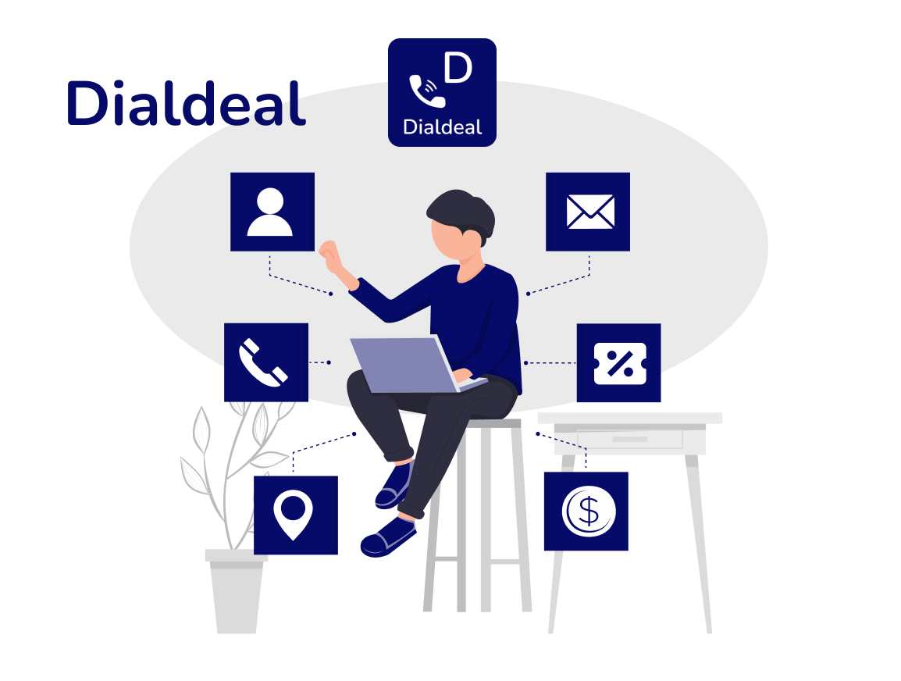

Dialdeal system proposal

# Group-3:

Questions made by:

Abhishek Sharma (Question 1&5)

Vaidik Kakadiya (Question 6&8)

Harikash (Question 4&Intro.)

Lovepreet Singh (Questions 3&7)

Abhishek Choudhary(Question 2)

# Table of Content

# Introduction_____________________________

# 1.What is your system idea(in a nutshell)? ……..

# 2.What information will be offered to the user?....

# 3.What data will be stored by the system ……..

# 4.Where will you get this data? ……..

# 5.Uses cases provided by the system ……..

# 6.The target user of the system ……..

# 7.Which are the Similar Systems of our system? …

# 8.Problem Domain Sketch ……..

Introduction

* This system provides a original idea which will be explained in terms of input data, queries, target users and different from other similar products.
* Dialdeal is no.1 local search destination. It provides comprehensive updated information on B2B and B2C products and services. This unique local search service is available on Phone, Web, WAP, and SMS. The mission and vision of DialDeal is we are going to promote businesses on our venture and provide offers to customers for attraction to build up traffic on site.

1. What is your system idea(in a nutshell)?

DialDeal aim to provide fast and free access to company’s large database, which will attract more search queries, and which in turn will attract more paid business listings. This provides information on various businesses in new Zealand and allow to search for services by visiting our website along with this users can compare the prices of services that will be given by vendors whereas some users can also buy free coupons as offer and can redeem by visiting to their outlets in which categories like hotels, restaurants, hair saloon, spa, and activity area for playing game for kids.

Moreover businessman can create their own listing and share their contact details so user can dial their and grab the deals. However, this platform will be quite beneficial for our vendors and users. In case of vendors “this idea can increase their online visibility and reach more customers by this smart move of promotion.

Secondly, users can check reviews about their services whether its fine good or bad. So that they won’t waste their money on their first experience.

# 2. What information be offered to the user?

Business contact information: Dialdeal provides users with phone numbers, addresses, name, website, email address, password and other contact details of local businesses, making it easier for users to get in touch with them.

Reviews and ratings: Dialdeal also provides users with reviews and ratings of businesses from other users who have used their services. This helps users to make informed decisions when choosing a business.

Business listings: Dialdeal has a comprehensive database of businesses, which can be filtered by category, location, and other criteria to help users find the business they are looking for.

Deals and offers: Dialdeal often features deals and offers from businesses in various categories, allowing users to save money while availing of the services they need.

# 3. What data will be stored by the system?

User data: When users register on the Dialdeal platform, they are required to provide personal information such as their name, email address, phone number, and location. This information is stored in dialdeal database and is used to provide personalized search results and to enable communication between users and businesses.

Business data: Dialdeal stores a large amount of data related to businesses such as their name, address, phone number, email address, website URL, and other contact details. This information is used to provide users with accurate and up-to-date information about businesses in their area.

Search data: Dialdeal collects data about users' search queries, including the keywords they use, the location they search in, and the type of business they are looking for. This data is used to improve the search experience and to provide personalized recommendations to users.

Review data: Dialdeal allows users to post reviews and ratings of businesses on its platform. This data is stored in dialdeal database and is used to provide users with helpful feedback about businesses and to help businesses improve their services.

# 4. Where will you get this data?

DialDeal will actually gets data from partnerships with businesses and crowd sourced information from users.

Partnerships with businesses:

It collect data directly from business people.

Automatically pull data from their database.

Manually updating their information through a business portal.

Crowd sourced information:

Users can add listings, reviews, ratings, and photos which are then verified by dial deal being published

# 5. Uses cases provided by the system

* Search for local businesses:

User can search for local producers based on location categories.

* Book appointment:

User can book appointment by the helpful contact details such as hotels, saloons, Spa, and restaurants.

* Check deliveries:

User can also able to check whether restaurants provided the door to door deliver options.

* Navigation:

This system can also provide direction to user for their shop.

# 6. The target user of the system

The target users of Dialdeal are primarily businesses located in New Zealand who are searching for promote their business and get more costumers for their businesses. Businesses will make a listing on the system and provide information. Dialdeal serves as a platform for users to search and discover information about businesses in their local area, including contact information, reviews, ratings, and more.

Dialdeal's target users are people who are seeking information about some services in their local area. Those who are looking for Foods & drinks, Saloon & Entertainment services. Dialdeal also caters to businesses who want to promote their products and services to potential customers in their area.

Overall, Dialdeal is a platform that connects local consumers with local businesses, making it easier for people to find the products and services they need and for businesses to reach their target audience.

# 7. Which are the Similar Systems of our system?

Our system is differ from other search engines because our system not only information to users but also provide various facilities like direction to customer to the destination along with this we also provide offers and coupons on bases of promoting their services on cheap rates , which is beneficial for all users who are looking for different type of services as well as vendors also reach to more and more consumers last but not least consumers rely on rating and reviews that our systems key strength for the betterment of user for comparing reasons to other service providers.

# 8.Problem Domain Sketch

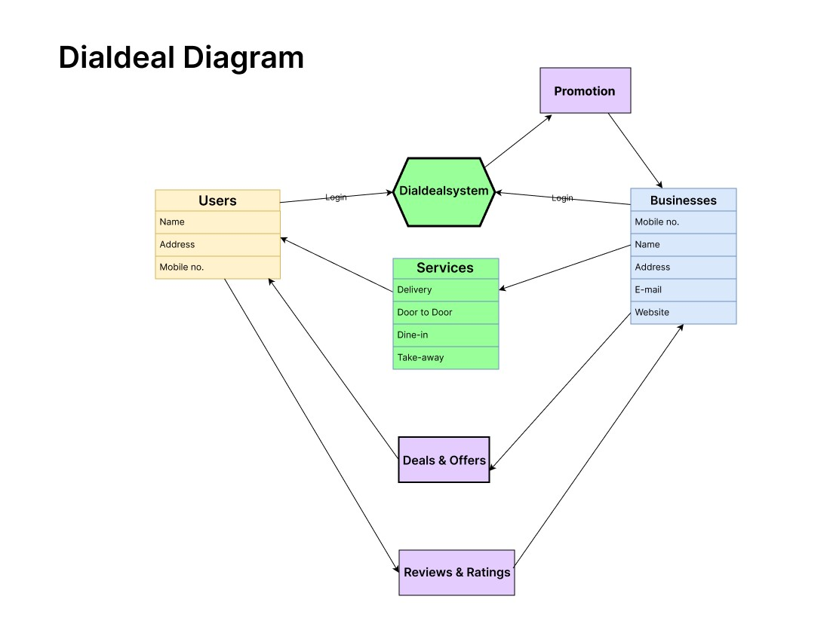

Thank You!