CONTENTS

|  |
| --- |
| Existing System without Software |
| Problem Definition |
| Proposed System |

**1.Introduction**

|  |
| --- |
| Integrated Development Environment  Introduction To Visual Basic 6.0  About Visual Basic 6.0  Connectivity Introduction To Django |

**2. Technology Details**

|  |
| --- |
| Software Requirements |
| Hardware Requirements |

**3. Software Requirement Specification**

|  |
| --- |
| E-R Diagram |

**4. System Analysis and Design**

|  |
| --- |
| (Snap – Shots) Showing Snap – Shots Of Project |

**5. Deploying the Project**

|  |
| --- |
| Conclusion |

**6.Conclusion**

INTRODUCTION

Existing System :- Traditional record maintenance in any system uses a lot of paper work, which is really hard to maintain and work with.

Problem Definition:- This causes a lot of problem in record maintenance and in kind of many process like searching record, updating and deletion of data. To keep it simple and easy a computer based system can really do a magic. It will definitely decrease memory overhead.

Proposed System:- Every Organization has its own Product sale, Product Maintains, procedure and administrative methods to develop and implement this methods and Items. Every organization or institution has made several departments employees of this departments have to be trained or to provide training it their at to improve their efficiency. Ice Ceram Parlour System is designed under graphical user interface (GUI) environment of Microsoft VB-6 as front end and back end support is given by MS-Access. This software is basically meant for the Abstract report and Customer record. Ice Cream Parlour System is fastening the whole process thus extremely increasing the efficiency and effectiveness of work ability.

Technology Detail’s

INTRODUCTION TO VISUAL BASIC VISUAL BASIC is the Graphical User Interface (GUI) language. It is the language that many developers including Microsoft themselves are using to write new applications software, Microsoft Corporation created it in 1991. It is a high level language. With the help of Visual Basic we can communicate with other applications running under windows. It is an internet based and an object oriented programming. Visual Basic is substantially different from traditional Basic, though there are similarities. Visual Basic requires a different approach to developing programs and to learning the language. But in Basics, we can develop a program line by line, testing each command as we write it. With Visual Basic we must develop our programs and we can understand across a broader front. In Visual Basic we can write a program by assembling the object that we will use for screen displays and interaction with the users, adjusting the properties of those objects, determining which events we will respond to, thinking through the variables we need for holding data and for passing information from one part of the program to another, and writing the command lines that will run when events are activated. At each stage of development we may add to or change any aspect of the program, but it must be done with an awareness of how it will affect the other aspects.

So Visual Basic is a collection of files. It is a very easy language and flexible to use. This language also contains all the features of basic language. It is an event driven programming. It is also called a friend of a user. One of the advantages of visual basic is that it is a grammar free language. It provides both compiler and interpreter

Programming in Visual Basic

Programming in Visual Basic was written around Visual Basic 3.0, standard edition but virtually all of the techniques and concepts apply equally well to Visual Basic 2.0.It doesn’t have advanced feature or development of free standing commercial applications, for which the professional edition is necessary. There was another version of Visual Basic that is Visual Basic for DOS. This version was out of use. Windows is the natural medium for Visual Basic. Then come more advanced version like Visual Basic 4.0, Visual Basic 5.0, and Visual Basic 6.0 at present the latest the Visual Basic 6.0.

EVENT DRIVEN PROGRAMMING

Visual Basic is Object Oriented, i.e. it revolves around ready made objects and it is called as EVENT DRIVEN, i.e. all the activities in a program are triggered by one event or another. Each object has its own properties, determining its position, size, color, the appearance and nature of its text, and much more. Each object also has its own event handling procedures. ( 6 ) In an event driven application the code doesn’t follows a predefined path, it executes different code section in response to events. Events can be triggered by the user action, by message from the system of other application or even from application itself. The sequence of this event determines the sequence in which codes executes. Thus the path through the application code written each time the program runs Visual basic system knows all about event handling procedures. It knows what a button is and how it works. It also knows how to handle images, menus, dialog boxes, driven and directory lists, and much else. The programmer’s job is to determine where, how and when an object appears on screen, what its caption reads and what happens when an event occurs. The event might be the opening of a form, the user clicking on a box. The programmer does not have to write code to trap these events the system does that automatically. Because the program code runs in response to event, as at any point whole range of event might be possible. The flow of execution is not as fixed as in a traditional program.

About Visual Basic :-

Visual Basic is the most Popular Object Oriented event Driven Programming language. It revolves around readymade objects, and it is event driven i.e. all the activities in a program are triggered by one event or another .The main advantage of visual Programming languages is that we can concentrate on what we want our program to do, not how to get the programming language to do it. Some Visual Basic features are: -

1/ Compatibility: Visual Basic is capable of producing software as sophisticated as any other data access techniques available.

2/ Flexibility: It not only provides database access but can also be used to link it with other word processor, spreadsheets software etc.

3/ Familiarity: Because it can be said as an extended version of Basic, which is very easy to learn and work with, its syntax seems to be more familiar.

4/ Features: Various Additional Features like ADO reports and other various types of Active X controls are supported by this application, which helps widely in development of the Project.

Software Requirement Specification

*HARDWARE & SOFTWARE REQUIREMENT* :- ***The following are the minimum requirement for the smooth and successful running of the module***.

Hardware: -

**Microprocessor - 166 MHz or Higher**.

**MB Min RAM – 32 MB (Min) as the package is developed using MS Office 2000 it requires 32.**

**Display - CGA/VGA or higher.**

**Key Board - 84/109 Keys use.**

**Mouse - Any Standard Mouse.**

**Software:-**

**Operating System - MS Windows 95 or Higher.**

**GUI Tool - Visual Basic 6.0**

**Framework:- Django.**

**Browser:- Chrome, MicroSoft Edge etc.**

SYSTEM ANALYSIS

**System Analysis:-**

*A system is a set or arrangement of functionally dependent component or working together to attain a predefined goal by processing information. It is the process of examine of a business situation with the intent of improving it through better procedure and method. It is the process of gathering and method. It is process gathering and interpreting facts. Timing problems and using the information to recommend improvement to the system. Analysis is used gained and understanding of the conclusion of the system there is a system description and as set of requirement for a new system. It there is on existing system, then the analysis only defines the requirement. The step, which follows, will propose a new system that meets these requirements. The new system may be built a fresh or by changing the existing system. Development being by defining a model of new system an continuous by converting these model to a system in a short analysis specifies what the system should do.*

**Analysis objective:-**

*An efficient system analysis always plays the role of strong foundation for development of any proposed system. Information play key role, as the horizon of knowledge keep on expending, since this project is anaphor to convert the manual in to computer based system, a through knowledge of the day-to-day functions of present system of mandatory the objective of this study comprise.*

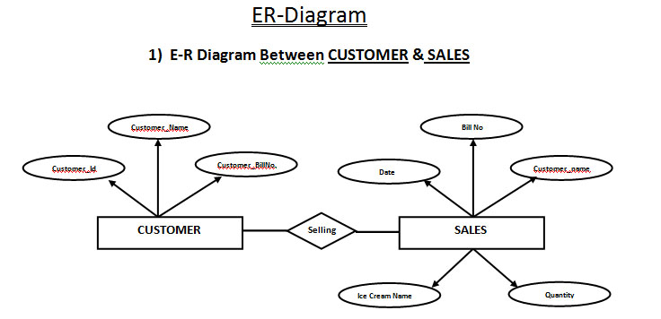E-R DIAGARAM

***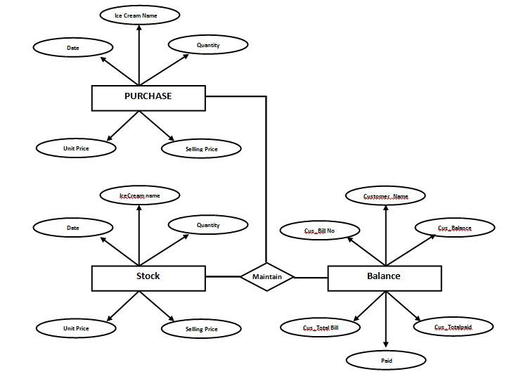*2) E-R Diagram Between Purchase & stock-balance**

SNAP SHOT’S

*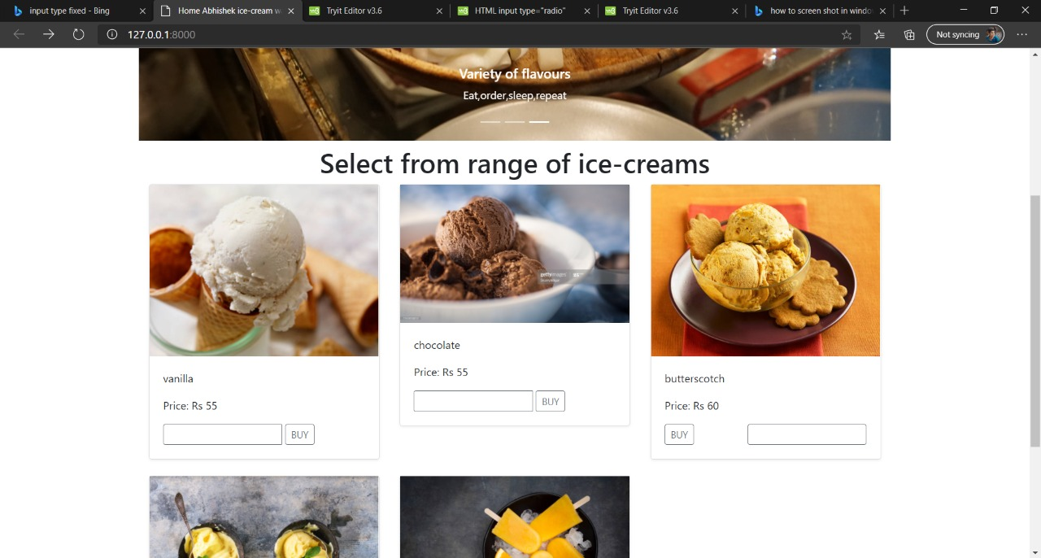***Welcome screen**

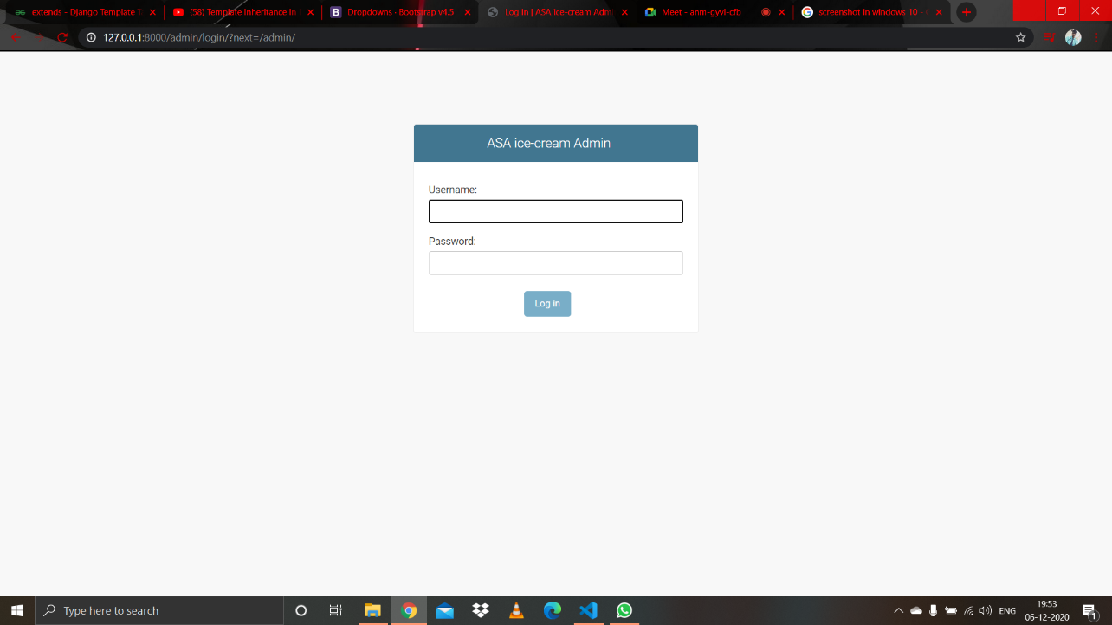**login form**

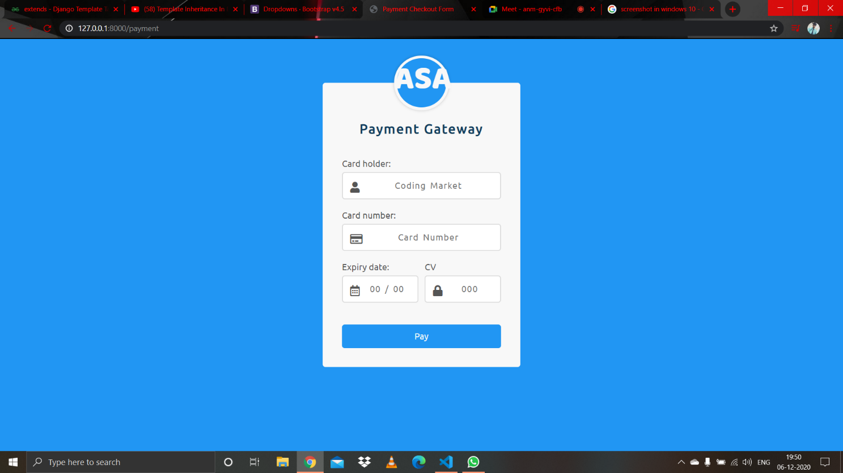SALES & BILLING FORM

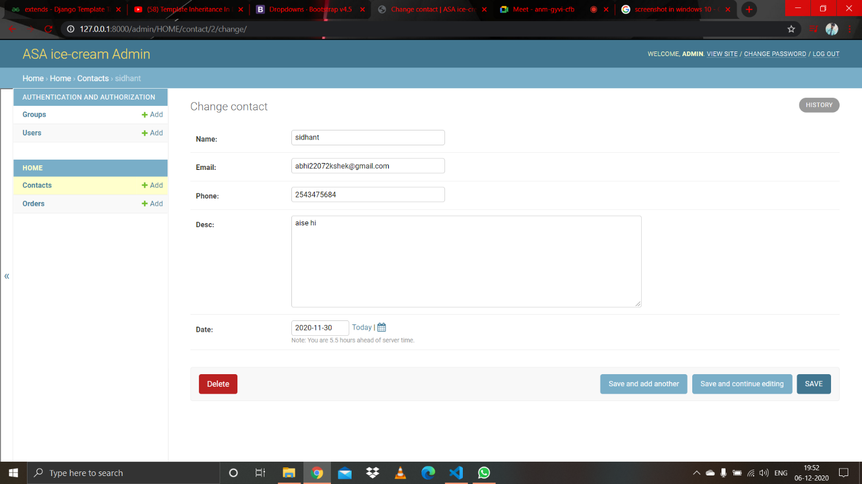Contact and Support

Conclusion

**Designed system provides an easy way to interact with user and administrator. This GUI based system gives a system with less paper work and less memory overhead. It is also a fast and interactive system.**