**Insertion Attack**

1. **10% Insertion**
2. **20% Insertion**
3. **30% Insertion**
4. **40% Insertion**

1. **50% Insertion**
2. **60% Insertion**
3. **70% Insertion**
4. **80% Insertion**
5. **90% Insertion**
6. **100% Insertion**

**Deletion Attack**

1. **10% DELETION**
2. **20% DELETION**
3. **30% DELETION**
4. **40% DELETION**
5. **50% DELETION**
6. **60% DELETION**
7. **70% DELETION**
8. **80% DELETION**
9. **90% DELETION**

**UPDATION ATTACK**

1. **10 %updation**
2. **20 %updation**
3. **30 %updation**
4. **40 %updation**
5. **50 %updation**
6. **60 %updation**
7. **70 %updation**

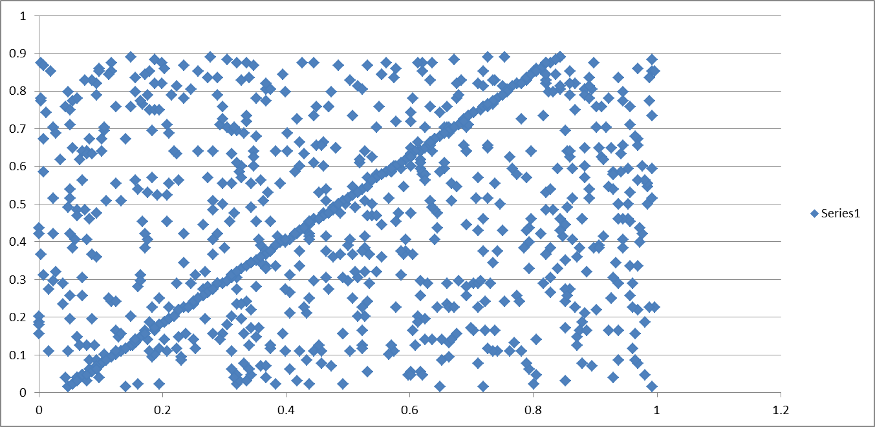

1. **80 %updation**

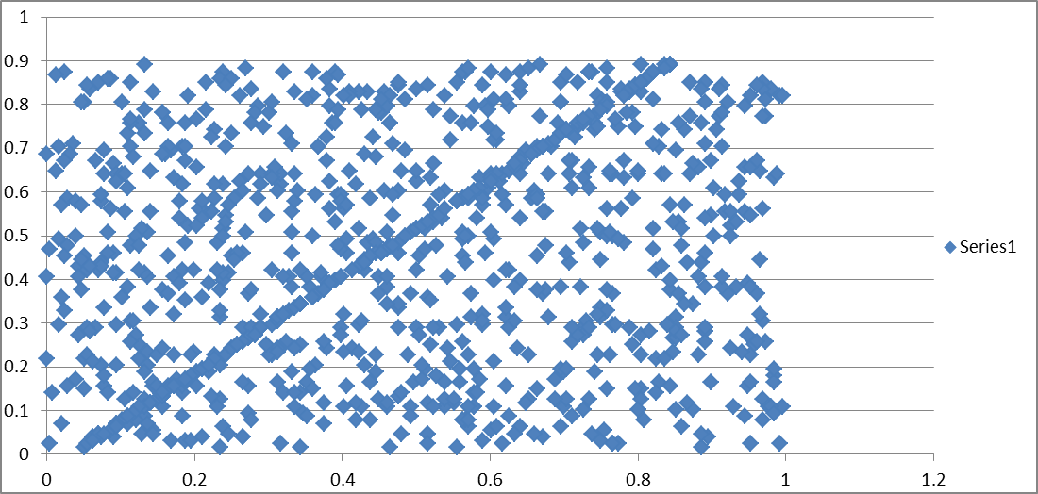

1. **90 %updation**

