Case Write Up: L’Oréal China

**Brief Assessment:**

* Yue Sai, once a prestigious Chinese cosmetics brand founded by Yue-Sai Kan, had strong national roots but lost momentum and relevance by the time L’Oréal acquired it in 2004.
* Multiple failed repositionings led to brand confusion; its customer base is now mostly older women, with low awareness among younger consumers.
* L’Oréal faces the challenge of reviving a faded local brand in a competitive market shaped by rising local players, national pride, and digital consumption.
* Younger Chinese consumers are wealthier, career-focused, digitally engaged, brand aware and favor skin care—especially when rooted in tradition—over cosmetics.
* Competitor domestic brands like Herborist thrive by blending traditional Chinese medicine with modern, culturally resonant branding.
* TV ads are expensive and less effective; digital platforms like Weibo and Youku, paired with experiential retail, offer better engagement.
* L’Oréal’s city-tier strategy must align with clearer brand identity and adapt to evolving consumer expectations.
* Successful positioning will require a narrative that connects modern aspirations with cultural heritage, especially for today’s working yet family-oriented women.

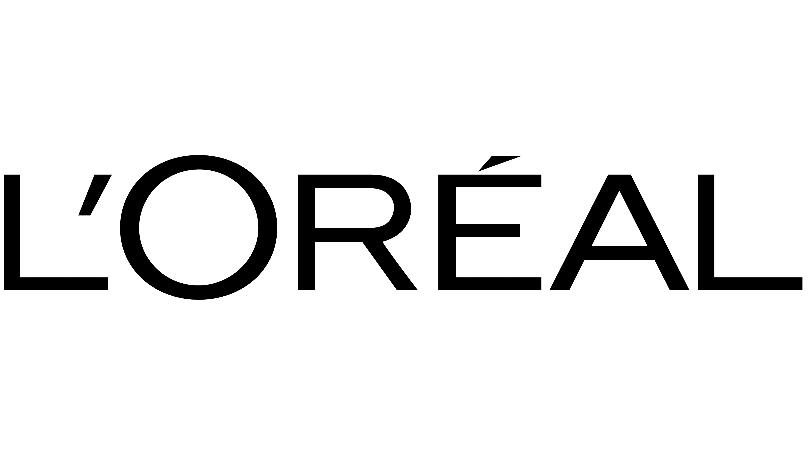

Figure An image showing the company logo.

**Decision Problem**:

How should L'Oréal reposition Yue Sai to regain relevance and market share in China's cosmetics market?

**Criteria:**

1. **Sales:** Represents the projected revenue performance of Yue Sai’s products. Assessment: Tracked through sales data over time and across channels.
2. **Product-Market Fit:** Measures how well each alternative aligns with the needs and preferences of its target segment. Assessment: Market research insights, calculating local relevance score, the responsiveness of key demographics to targeted marketing efforts.
3. **Strategic Fit:** Evaluates how closely the alternative aligns with L’Oréal’s overall brand vision and mission. Assessment: Score each alternative based on how well it aligns with L’Oréal’s brand values
4. **Risk of Attrition:** Refers to how well the product retains its existing customer base while also bringing in new customers. Assessment: Customer retention metrics, purchase patterns, and demographic shifts in the customer base.
5. **Execution Complexity:** Reflects the level of difficulty involved in implementing the proposed alternative. Assessment: Costs associated with resources, budget constraints, production and logistics costs.

**Alternatives:**

|  |  |  |
| --- | --- | --- |
|  | **Alternative 1 - Yue Sai for Modern Young Women** | **Alternative 2 - Yue Sai For All** |
| **Target Audience** | 18-35 affluent women | 18-59 women and men |
| **Positioning** | Luxury | - Yue Sai (YS) Select - luxury  - Yue Sai (YS) Essentials - value |
| **Messaging** | - Downplay link with L’Oreal (distinctive colors and brand identity)  - Combining benefits of TCM and modern science for the modern Chinese woman  - Supermodels / famous actresses as brand ambassadors | Downplay link with L’Oreal across the board  - YS Select - Luxury - Combining benefits of TCM and modern science, supermodels as ambassadors  - YS Essentials - Value - Benefits of TCM for all, less famous models |
| **Product Line(s)** | Skincare  Premium price points | Skincare and make-up  Multiple price points |
| **Channels** | - E-commerce  - Standalone stores in tier - 1 cities | - YS Select - E-commerce, standalone stores in tier - 1 cities  - YS Essentials - class - 2 department stores, small local shops |

**Evaluation:**

|  |  |  |
| --- | --- | --- |
|  | **Alternative 1 - Target Modern Young Women** | **Alternative 2 - Yue Sai for All** |
| **Sales** | **High** Potential of Sales and Profitability via premium skincare, aligned with modern lifestyle aspirations. | **High** Potential of Sales and Profitability as broad coverage across segments**.** |
| **Product Market Fit** | **Excellent** **fit** with modern, urban women seeking authenticity, TCM benefits, and digitally engaging luxury. | **Moderate fit** - covers more segments, but risks brand identity. |
| **Strategic Fit** | **Strong fit** - Reinforces L’Oreal’s luxury strategy with culturally rooted skincare innovation via TCM. | **Fits** L’Oreal’s inclusive “beauty for all” vision. |
| **Attrition Risk** | **Moderate Risk** - alienates older loyalists, highly competitive digital space with strong local rivals i.e., Herborist, Chando. | **Low** - appeals to a wider demographic; smoother retention path but risks dilution of brand prestige. |
| **Execution** | **Moderate -** Requires focused digital campaigns, TCM R&D and expansion in premium tiers. | **Very High** - managing multiple channels increases complexity and cost substantially. |

**Recommendation: Alternative 1 - Yue Sai for Modern Young Women**

We recommend Alternative 1 as it offers a clear and focused strategy to rebuild Yue Sai’s brand and achieve both luxury appeal and cultural relevance through TCM, thus helping it stand out from its competition. It connects strongly with modern, health-conscious young women - China’s most influential skincare consumers. It also allows Yue Sai to tap into a growing segment of digitally-engaged, and culturally proud customers who value skincare rooted in TCM.

This alternative provides Yue Sai a unique position in L’Oreal’s portfolio. It is distinct from the L’Oreal brand and from other L’Oreal luxury brands such as Lancome, due to its price point and cultural relevance to the Chinese market respectively. This focused repositioning offers the best path to regain relevance and long-term sustainable growth.