Documentation

Database details :Modification related to database can be made in db.php

username=”root”
password=””
database=”ABC”

Users : Users need to be added to table in phpmyadmin.

Database structure: Table Structure

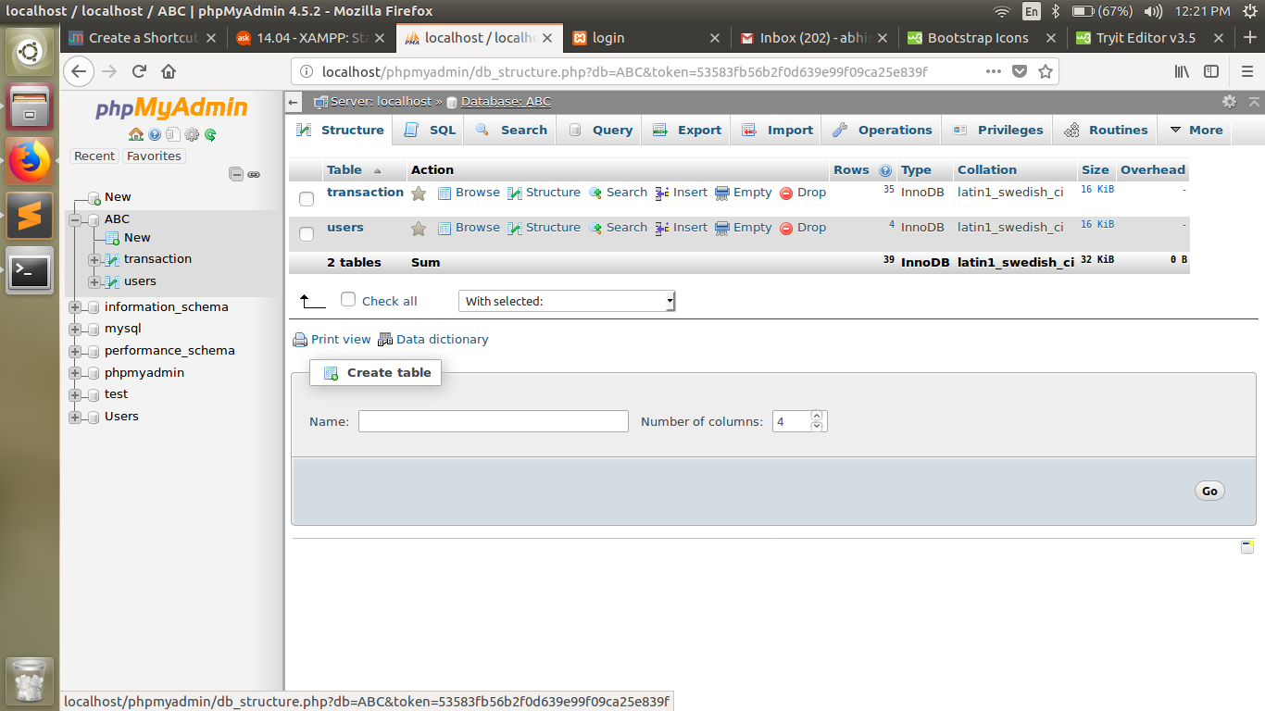
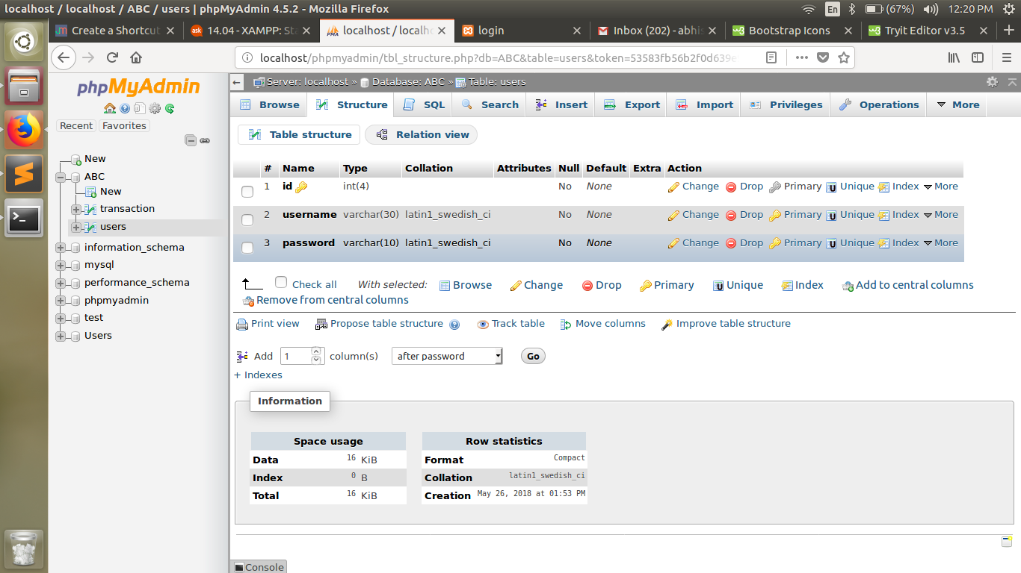
users table:

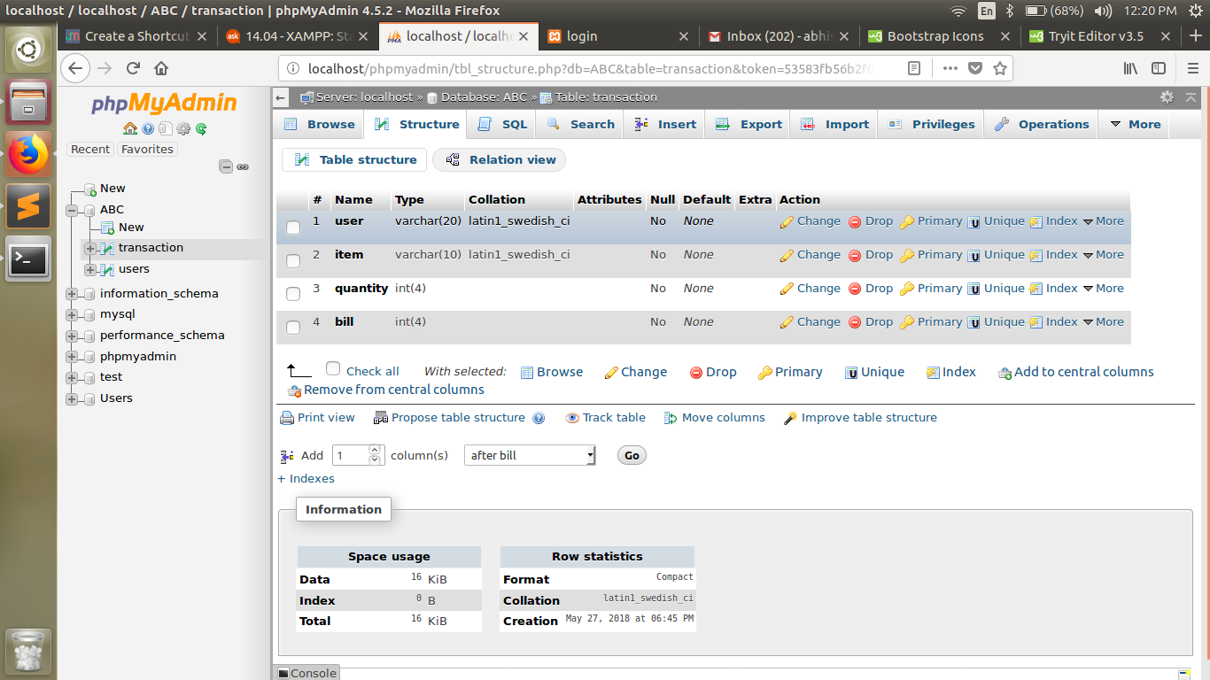
transaction table:

