***LAB 1***

**QUESTION 1:** Program that prompt the usrer to enter five words. If the length of any word is less than 6 characters, then ask the user to renter the string. However, if word is of more than 6 character, then display it on the screen.

**Implementation:**

a = input("enter a string = ")  
while True:  
 l = a.__len__()  
 if l<6:  
 a = input("enter string again = ")  
 else:  
 print("string = " + a)  
 break

**output:**

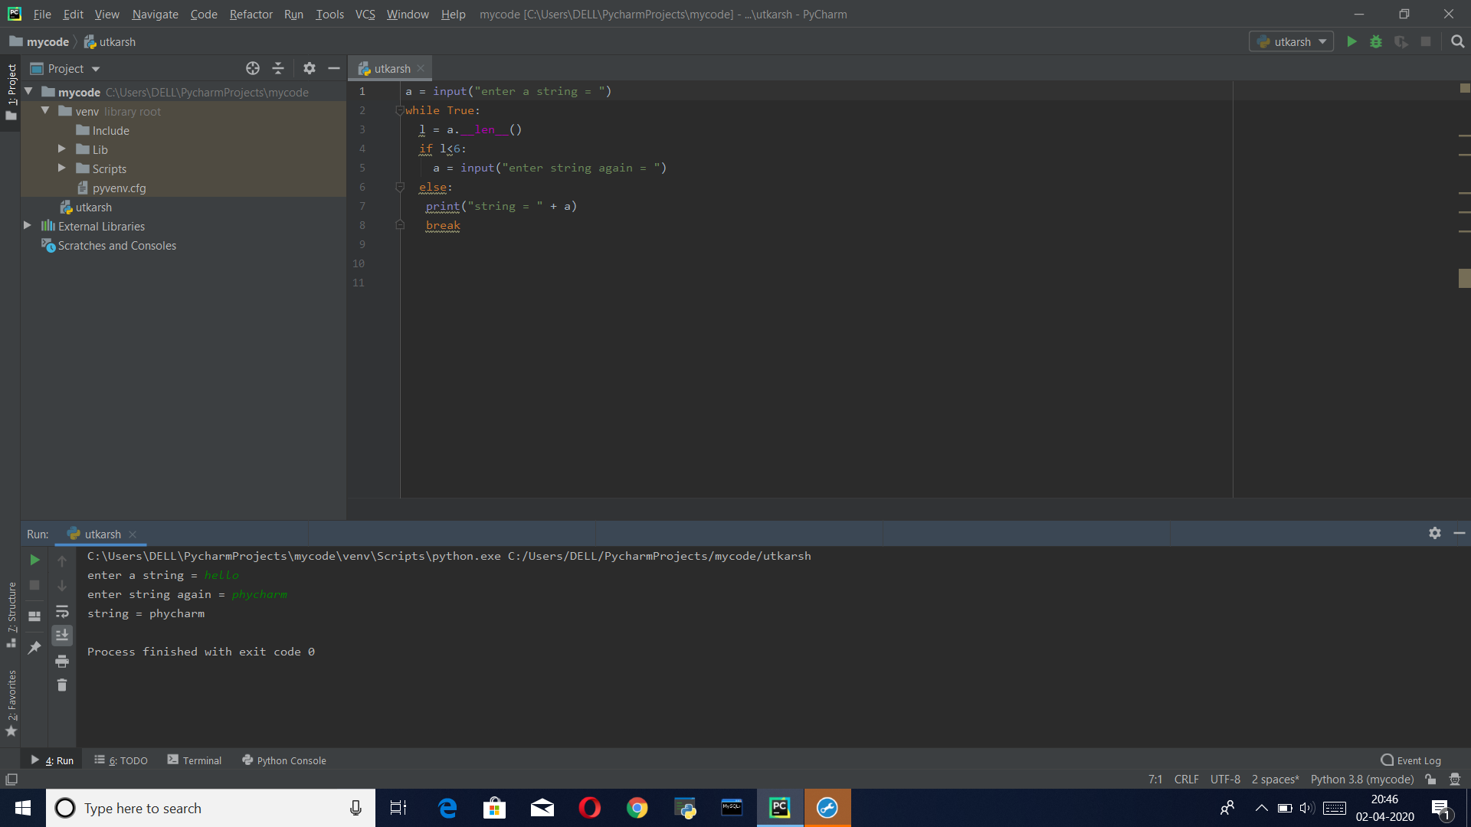

**Question 2:** Program to print following operation on the string zfill(), max(), split(), min(), join(), isidentifer(), strip()

**Solution 2:**

number = "6041"  
print("Functioning of zfill function: ",number.zfill(8))  
str =input("Enter a string: ")  
print("The minimum value character is : " + min(str))  
print("The maximum value character is : " + max(str))  
text =input("Enter a sentence: ")  
print("Functioning of split function: ",text.split())  
list1 = ['1','2','3','4']  
s = "-"  
s =(s.join(list1))  
print("Functioning of join function",s)  
string=input("Enter a string: ")  
print("isidentifier function",string.isidentifier())  
string = ' Example '  
print("Function of strip function: ",string.strip())

**Output:**

