**SUBMISSION PARTICULARS**

This form needs to be filled and sent along with your final submission. Please go through it carefully and fill out the details. Please fill out individual forms for each individual submission.

1. **Title, Team ID**

Tracking Universal Immunization

We

1. **Sector**

Health

1. **Summary of your idea**

This project is about tracking universal immunization. This includes immunization to children between the age of 0 – 5 years and even pregnant women during the course of their pregnancy. The children on their birth would be enrolled by the ASHA workers in the system. The system would then automatically generate the immunization schedule for each child. The ASHA workers would be sent intimation for the children in their area who are due for immunization in next couple of days. The workers would adhere to the schedule and this way all the enrolled children would be immunized. Same would be the case with pregnant women. They would be enrolled upon detection of their pregnancy. The system would generate pregnancy immunization schedule for the women which would be tracked and acted upon by the ASHA workers.

I have developed this system as a web/mobile based application using open source J2EE technologies and HTML5.

1. **Intended audience**

This project is targets ASHA workers, Children between the age of 0 -5 years and pregnant women.

1. **Datasets used by you**

<https://www.google.co.in/url?sa=t&rct=j&q=&esrc=s&source=web&cd=2&cad=rja&ved=0CDoQFjAB&url=http%3A%2F%2Fmohfw.nic.in%2FNRHM%2FImmunization%2FRoutine%2520Immunization%2520Programme_Brief%2520status.pdf&ei=e_1gUdiRO46SrgeahYCADQ&usg=AFQjCNEt3aw0C8wV52RPLkW4Uk1NNyQQrw&sig2=xXFG5SjiXtZzu1x0m_B0cw&bvm=bv.44770516,d.bmk>

<https://www.google.co.in/url?sa=t&rct=j&q=&esrc=s&source=web&cd=4&cad=rja&ved=0CE0QFjAD&url=http%3A%2F%2Fdelhigovt.nic.in%2Fdept%2Fhealth%2Fdfw%2Funiversal_program.htm&ei=e_1gUdiRO46SrgeahYCADQ&usg=AFQjCNH3lBAun7Qj3RDOqa5X36MjXb2juw&sig2=2hsYFzlJ27YZql2fzoKCeg&bvm=bv.44770516,d.bmk>

1. **Limitations or Assumptions**

**Limitations While Creating the Submission:**

Health ministry site was down. Lack of Rapid Application

Development tools for Java web application development

**Assumptions:**

Internet data connection availability as the data is stored on.

**Known Limitations of the Submission:**

The system is not secured by any login credentials. The data is available to everybody who accesses the website. The system needs to be extended to include module related to ASHA worker enrolment.

1. **Project inspiration**

My career objective is to use technology for betterment of the society. This small application would serve the purpose by minimizing neo-natal and maternal mortality rate, which is one of the objectives of Health sector of 12th Five Year Plan.

1. **Similar projects**

I did not explore any.

1. **Software used**

Java, J2EE, HTML5, Eclipse

1. **Screen shots**

**Enrolment form**

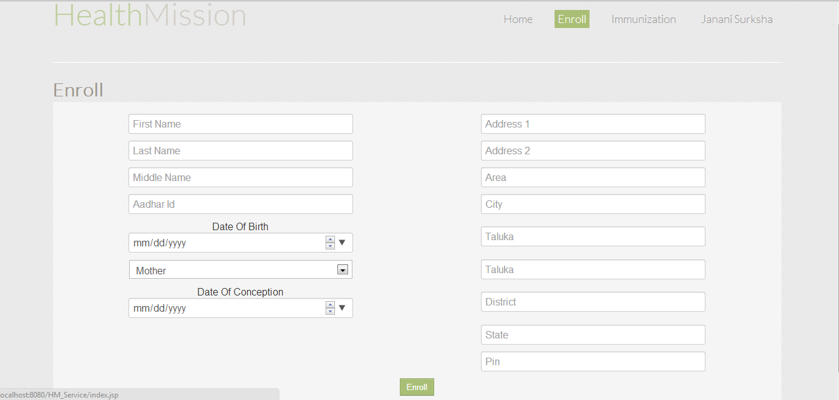

**Enrolling child**

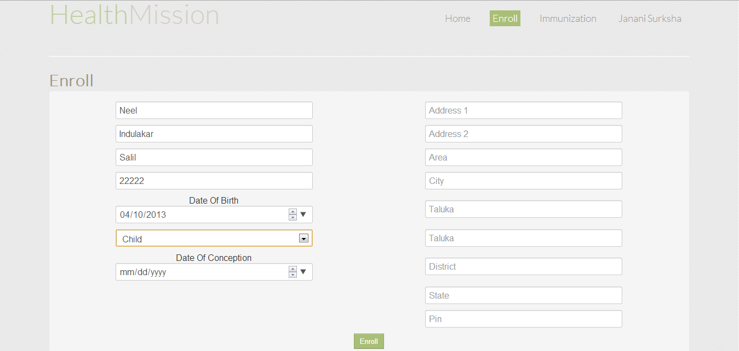

Notifications of immunization due children on home page

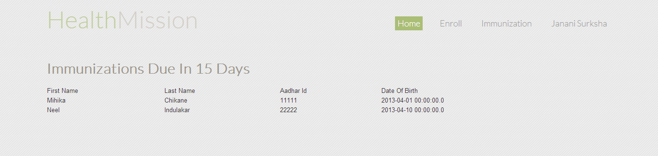

Immunization schedule