**Technovation**

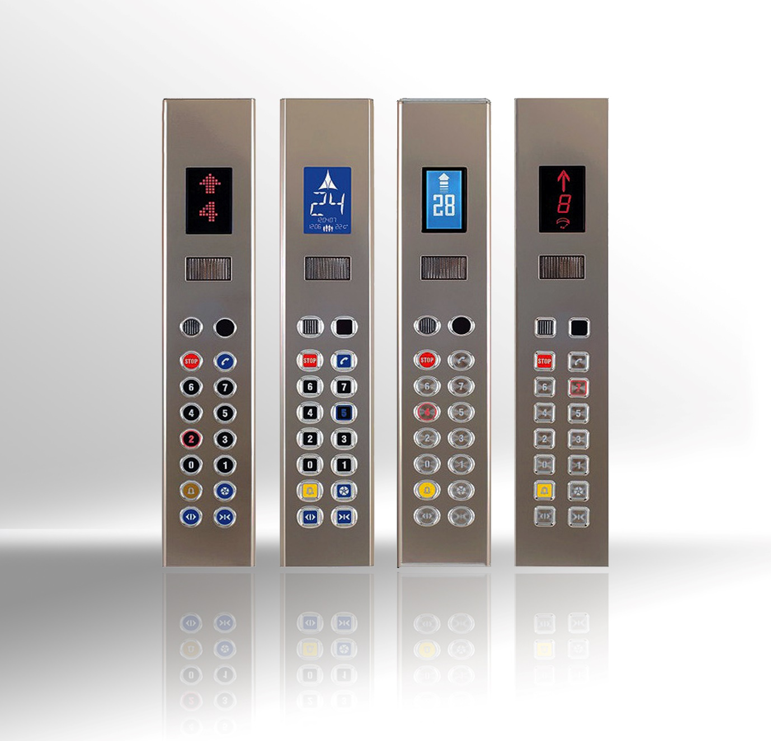

**INTRODUCTION**

Technical Skills can get you a job but Soft Skills can make you the Manager.

**Problem Statement**

In this event you have to present your idea and logic implementation of elevator system using only logic gates (AND, OR, NOT, NAND, NOR etc.), multiplexers, encoders, encoders, flip-flops and 7-segments displays and LEDs/buzzers. You can use any logic device mentioned above to build your system and 555timer IC for clock generation.

**Specifications**

In this you have to design the complete control system of elevator using logic elements. Where elevator system consist of its control mechanism and driving mechanism. Where the last location of elevator should be determined and should be controlled after a call instruction is given and thus its drive direction needs to be determined and controlled.   
Elevator gate also needs to be controlled after an elevator reaches at certain floor level and thus you need to design its control mechanism.  
If you wish to incorporate any other feature in the lift extra points will be awarded.

**Judging Criterion**

All participants will be judged based on how efficient and effective your circuit is.

Points will be awarded for flexibility of your design.

Your presentation skills and how simply can you explain your design.

Your knowledge and how well you respond to queries of judges and the audience.

Creative modifications/ideas provided all basic specifications are met.

All decisions taken by the organizing team shall be deemed as final.

**Resources**1. <http://www.electrical-knowhow.com/2012/04/elevator-control-system.html>

2. <http://www.docircuits.com/learn/know-your-stuff-elevators/>

**Contacts**

**Archit Sharma**

**+91 9672163206 sharma.2@iitj.ac.in**

**Divyanshu Agrawal**

**+91-9462245799** [agrawal.2@iitj.ac.in](mailto:agrawal.2@iitj.ac.in)