**1914091 | Abhishek Jha | b1**

**Selecting automobile dataset (works better for linear regression as have multiple predicate variables)**

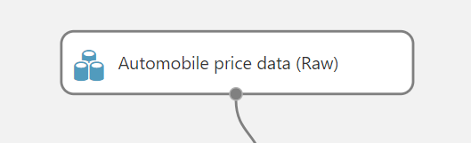

**Column selection**



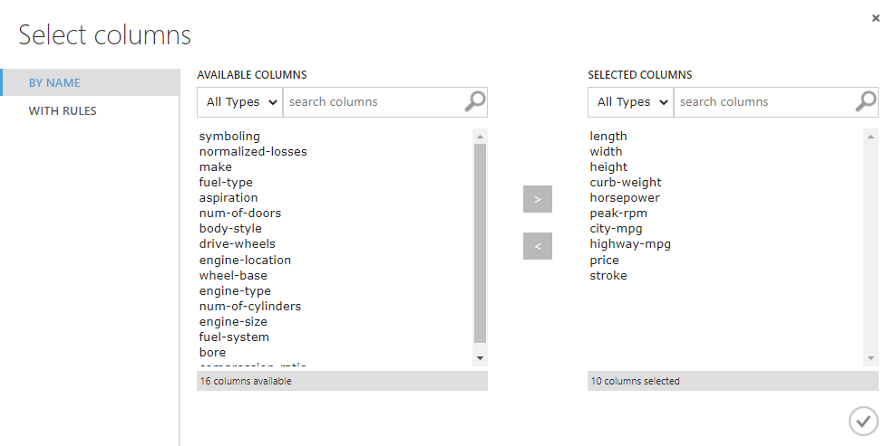

**Normalizing column values**

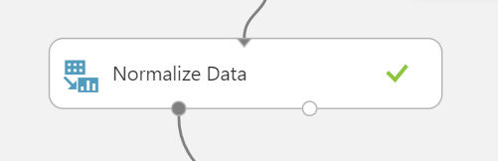

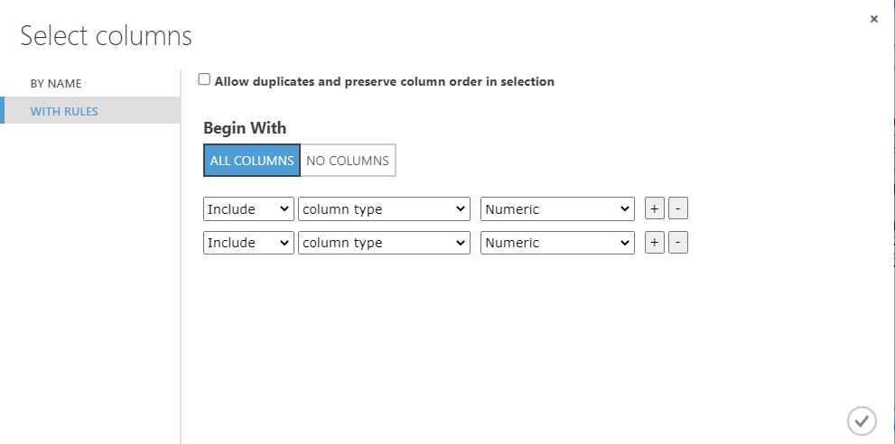

**Split data**

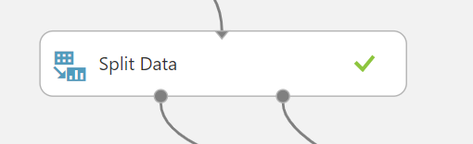

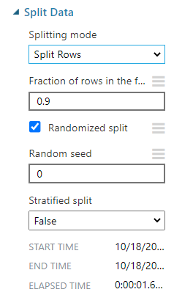

**Using linear regression in form of multiple linear regression**

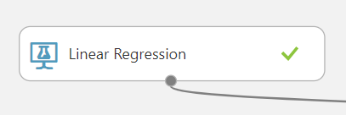

**Choosing the the target variable y**

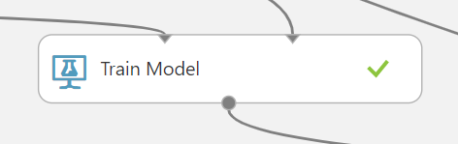

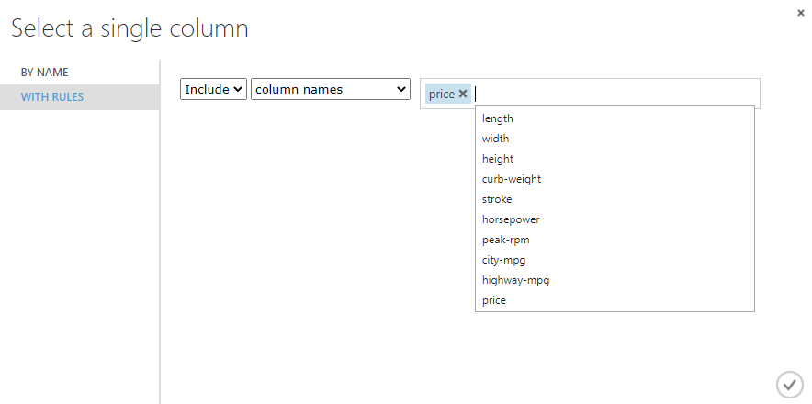

**Score model and model evaluation**

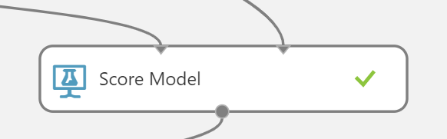



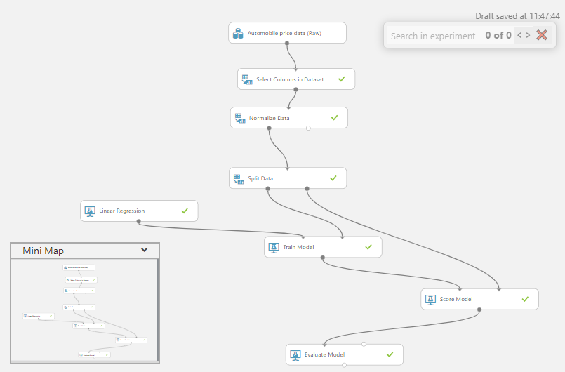

**Evaluation Summary:**

