**Working of an Android APP**

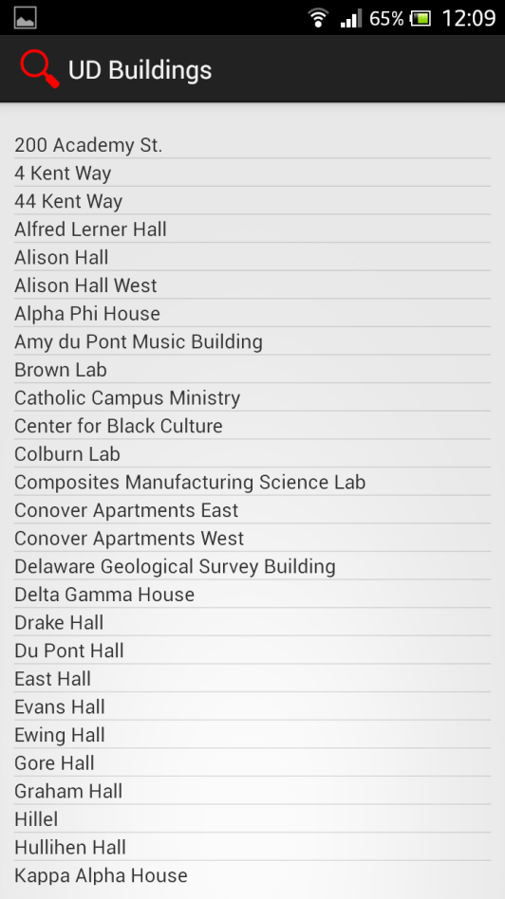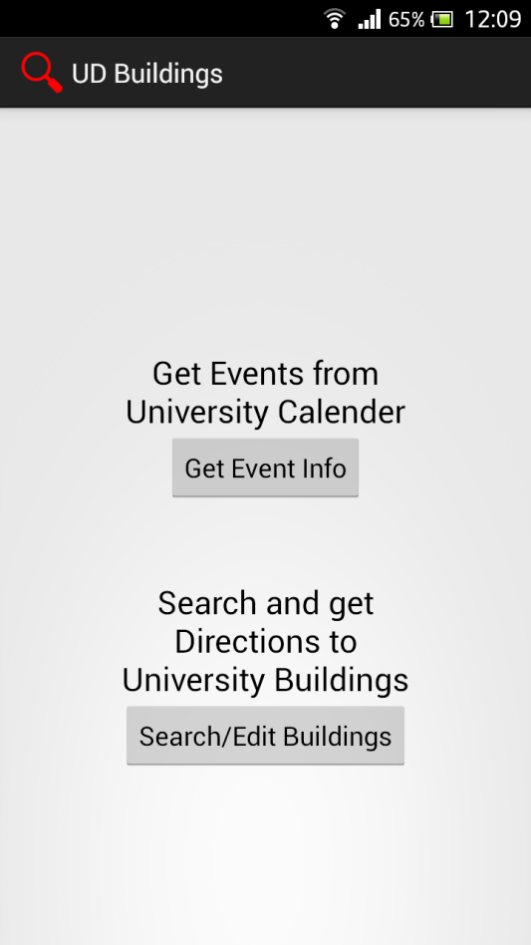

**Homepage to select an action Select a building to plot the directions**

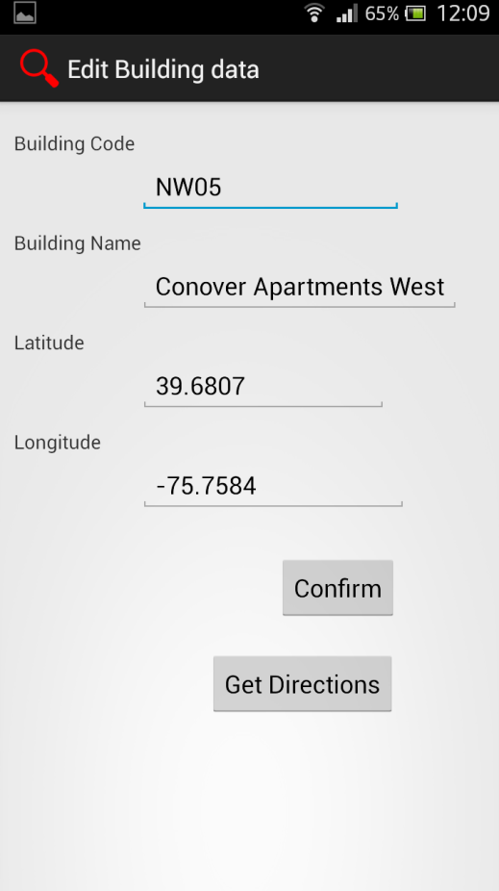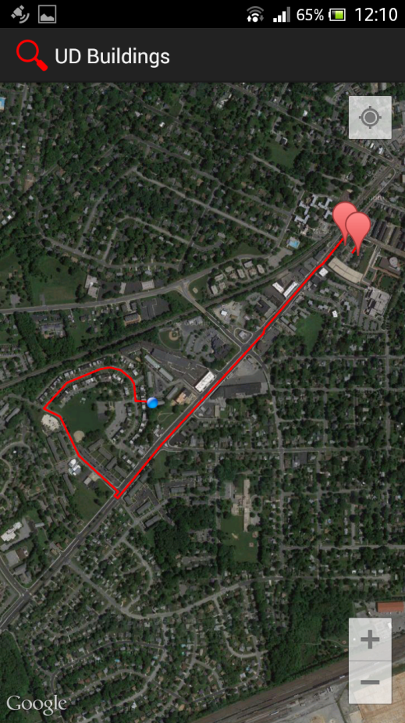 **Building DB is stored using SQLite**

**This is a confirmation page A page with the directions using GPS**