Centralized Hostel Allotment System

In the email attachment you will find two folders ‘Database’ and ‘Centralized Hostel Allotment System’.

- Please copy the database folder somewhere on the server machine where it is safe and may not be deleted accidentally. (It need not be in the inetpub/wwwroot folder)

- Next, you will need to create a system DSN. To do this,

  - Goto Control Panel > Administrative Tools > Data Sources (ODBC). You get a Screen Like this: 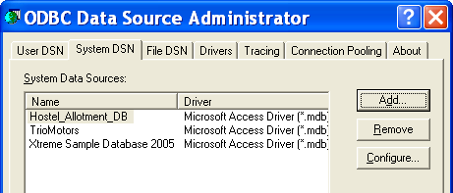
  - Click On Add and select Microsoft Access Driver (mdb) and click Finish
  - Set the following options:
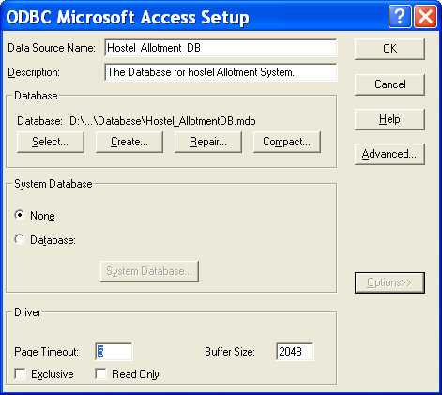
Select the database that u just copied
  - Select OK and restart the system.
- Now Copy the other folder ‘Centralized Hostel Allotment System’ into the inetpub/wwwroot folder.
- Now test the software by navigating to
http://localhost/ Centralized Hostel Allotment System/index.asp
- Please check the software for errors by trying out all wrong inputs / improper links etc
- Note that when you fill up the details in the database make sure that
  - New students have a Room Number of 0 (this is the default value)
  - New students have Hostel as Null (please check the table ‘students’)
  - New hostels have a status of null (null, as in “”, not “null”)
  - You can provide preference number for each hostel separately.
  - You might need to enable ‘Script and source access’ property:
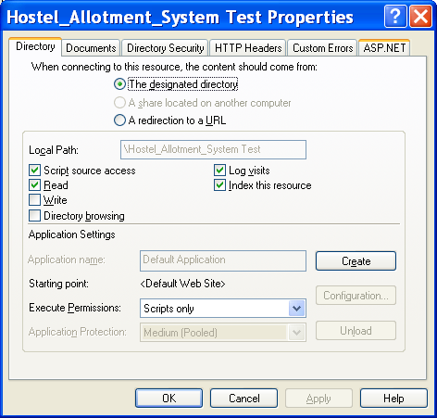
- Please contact me at 0484-2662801 for any problems etc.

