***Project Report***

***On***

***A.I Real Time Voice Assistant***

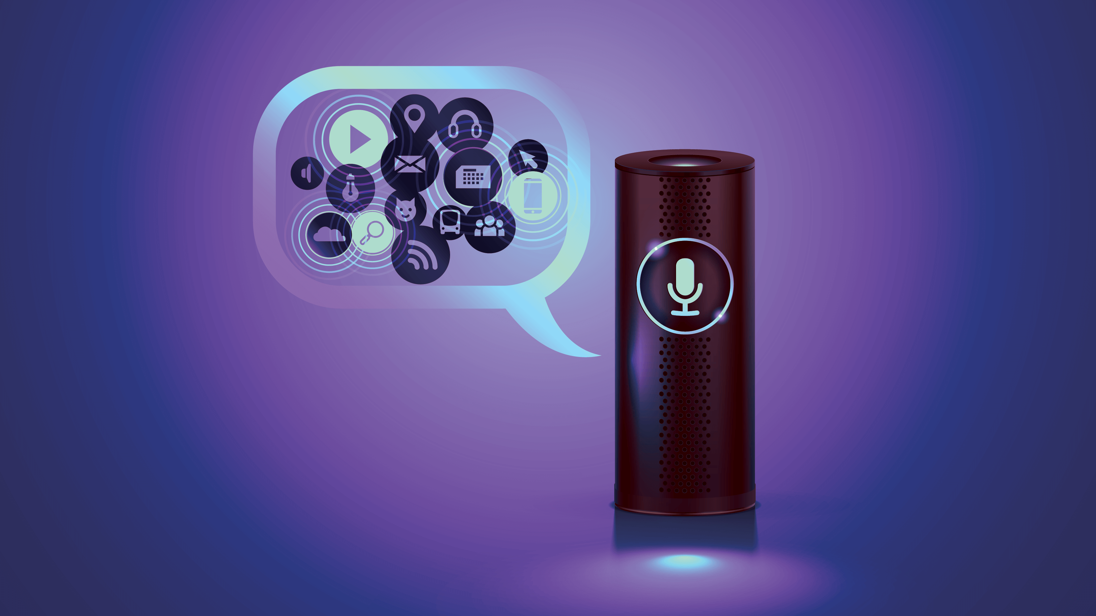

***by - Abhishek kumawat***

***Semester – 6th***

***Session – 2018***

***Title of Project***

Artificial intelligence Real Time Voice Assistant



***Problem statement?***

In today’s world as the technologies taking place and the world is moving and adapting the A.I depending upon machines or say digital world. For every Problem we need a short way to solve it or say a simple and easy way to do it. So i develop a **real time voice assistant** that can help user to play music, do searches, mark locations, find on Wikipedia, tells News etc.

***OBJECTIVE***

It is a technology that makes interactions between man and machines using natural language possible and speech recognition module i.e. Voice *Assistant* it can give quick responses from the input given by user according to current conversation

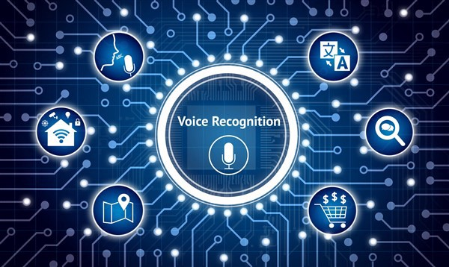

***Introduction***

How cool is it to build your own personal assistants like Alexa or Siri? It’s not very complicated and can be easily achieved in Python. Personal digital assistants are capturing a lot of attention lately. Chat bots are common in most commercial websites. With growing advancements in artificial intelligence, training the machines to tackle day-to-day tasks is the norm

Voice based personal assistants have gained a lot of popularity in this era of smart homes and smart devices. These personal assistants can be easily configured to perform many of your regular tasks by simply giving voice command

**key libraries used in this program**

* **Speech Recognition library** allows Python to access audio from your system’s microphone, transcribes the audio, and save it.
* **Pyttsx3** **text-to-speech package** converts your audio questions to text. The response from the look-up function that you write for fetching answer to the question is converted to an audio phrase. This package interfaces with Google Translates API.
* **Numpy - Pandas** is used to do the calculation and other mathematical tools.
* **Web browser package** provides a high-level interface that allows displaying Web-based pages to users. Selenium is another option for displaying web pages. However, for using this you need to install and provide the browser-specific web driver.
* **Wikipedia** is used to fetch a variety of information from the Wikipedia website.
* **Selenium** is used for displaying web pages. However, for using this you need to install and provide the browser-specific web driver
* **Pyjokes** is used for telling the random jokes.
* **Time –Date time** is used for getting the real time date and year information.
* **Wolfram Alpha** is a computational knowledge engine or answer engine that can compute mathematical questions using Wolfram’s knowledge base and AI technology. You need to fetch the API to use this package.

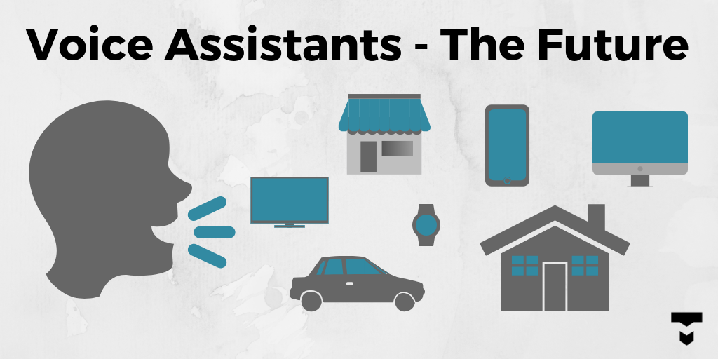

***Current Products***

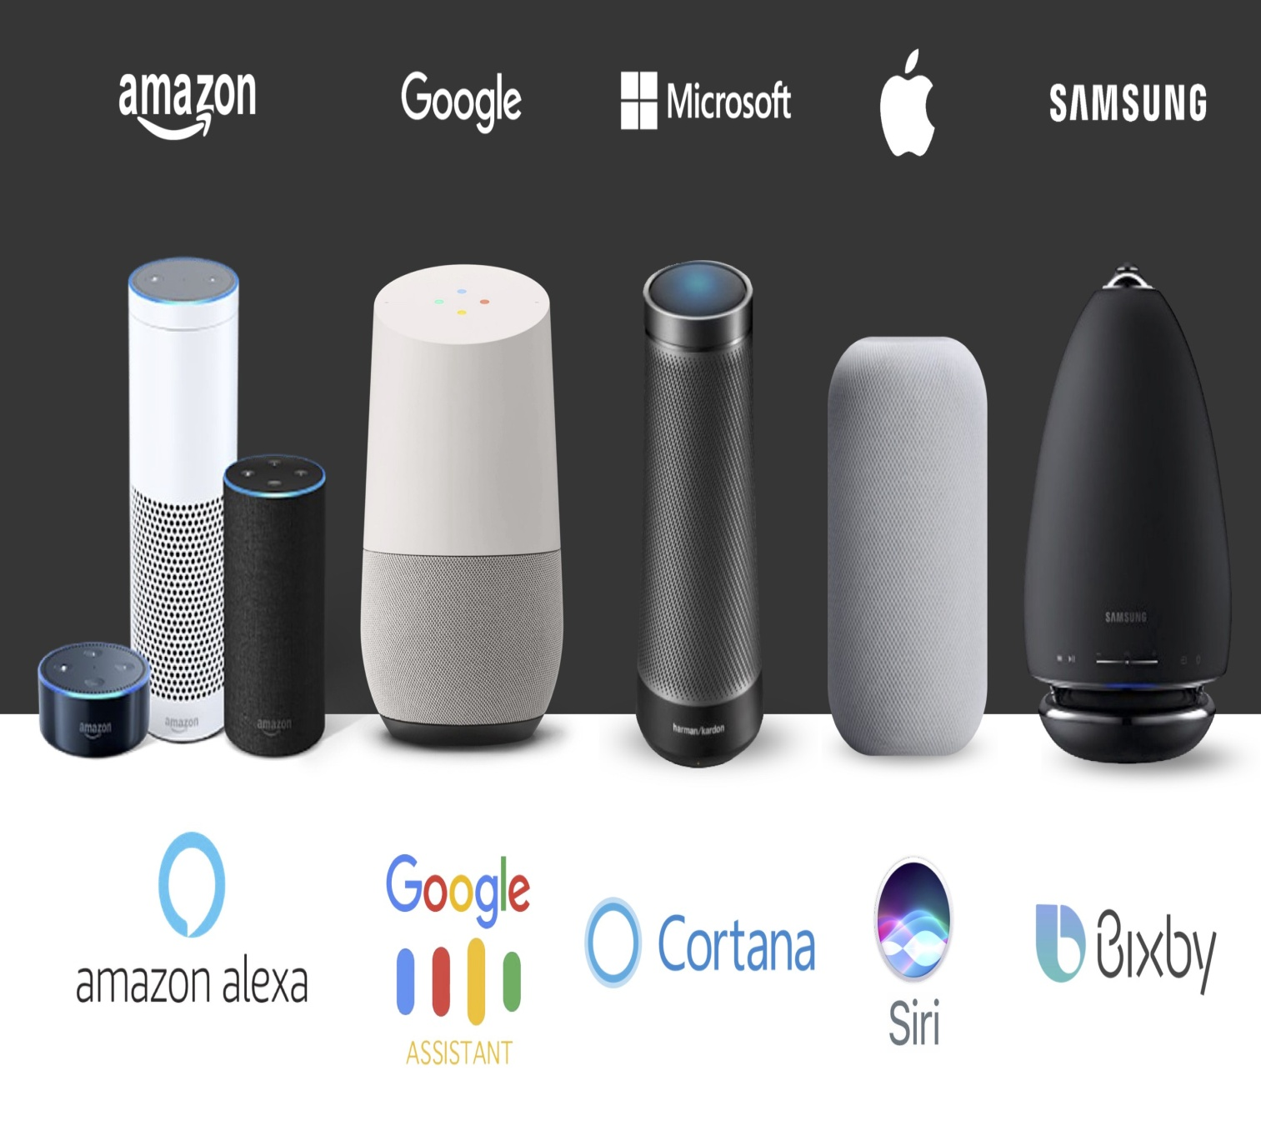

***WORKING***

Speech Recognition

**Voice assistant applications work based on Automatic Speech Recognition (ASR) system.**

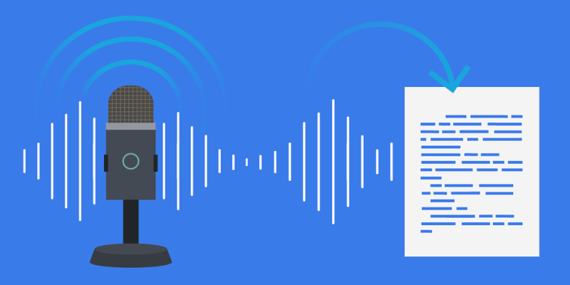

* **ASR systems record the speech and then break it down into phonemes, which are later get processed into text.**
* A phoneme is a basic unit of measurement for human speech recognition. No matter what kind of speech recognition software you may use all the magic happens in its ASR.

The **process starts with the device gathering audio with the microphone. Recorded speech waveforms get straight to acoustic analysis**, which is performed on three different levels

# *Conclusions*

With the emergence of **Artificial Intelligence (AI)**solutions for enterprises, speech technology has many applications in all sectors, including**law, healthcare, security, finance, enterprise, and personal use.** Personal use voice assistants such as **Siri, Google Home, and Amazon Alexa**are devices that offer individualized speech technology experiences.

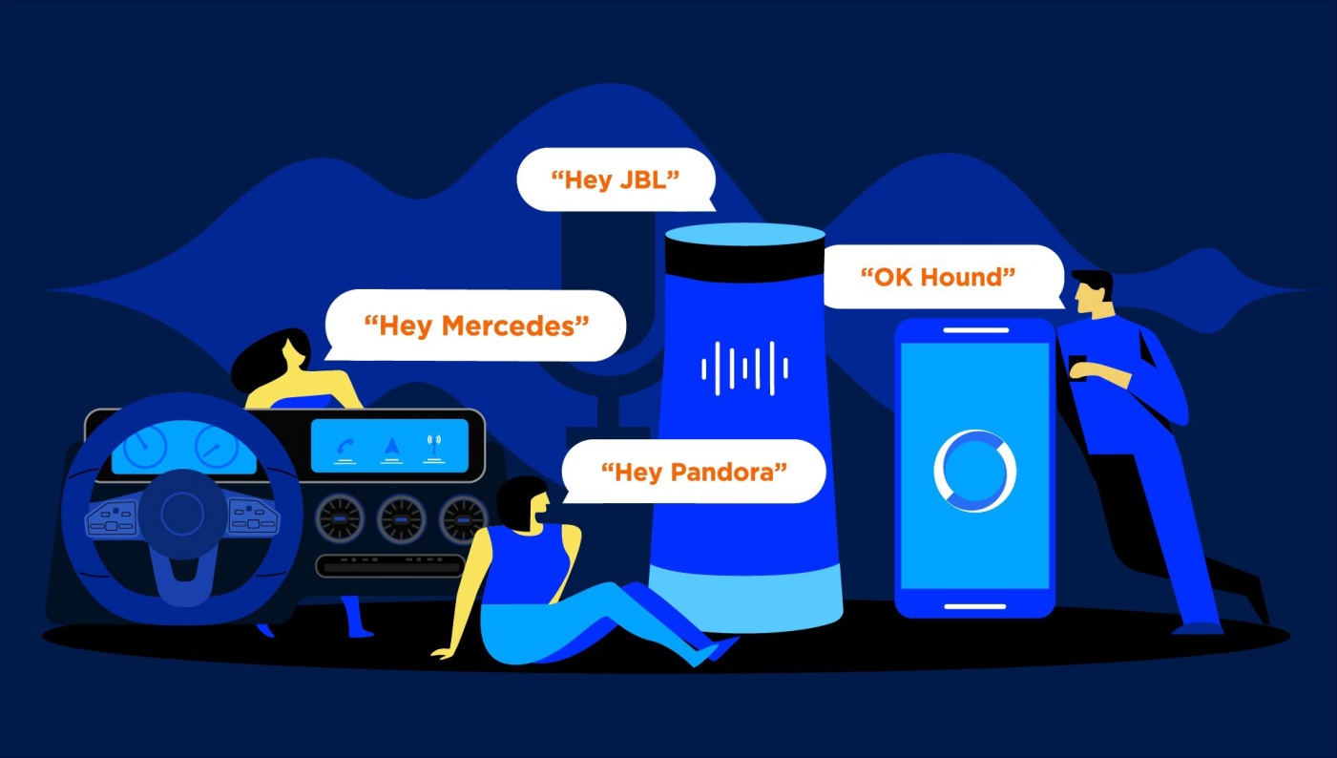

**These Intelligent Personal Assistants (IPAs) made our day-to-day lives easy and more comfortable.** Smart businesses never pause the search for better user experience for their clients. **Voice recognition technology is all about getting more out of the devices users already own.** Big companies like Apple, Google, Amazon, and Microsoft are doing a remarkable job to improve the voice assistants.

***REFERENCES***

[1] G. Bohouta, V. Z. Këpuska, "Comparing Speech Recognition Systems (Microsoft API Google API And CMU Sphinx)", Int. Journal of Engineering Research and Application 2017, 2017.

[2] Artificial intelligence (AI), sometimes called machine intelligence. <https://en.wikipedia.org/wiki/Artificial_intelligence>

[3] B. Marr, The Amazing Ways Google Uses Deep Learning AI.

[4] Cortana Intelligence, Google Assistant, Apple Siri.

[5] Hill, J., Ford, W.R. and Farreras, I.G., 2015. Real conversations with artificial intelligence: A comparison between human– human online conversations and human–chatbot conversations. Computers in Human Behavior, 49, pp.245-250.

[6] K. Noda, H. Arie, Y. Suga, T. Ogata, Multimodal integration learning of robot behavior using deep neural networks, Elsevier: Robotics and Autonomous Systems, 2014.

[7] "CMUSphnix Basic concepts of speech - Speech Recognition process". <http://cmusphinx.sourceforge.netlwiki/tutorialconcepts>

[8] Huang, J., Zhou, M. and Yang, D., 2007, January. Extracting Chatbot Knowledge from Online Discussion Forums. In IJCAI(Vol. 7, pp. 423-428).

[9] Thakur, N., Hiwrale, A., Selote, S., Shinde, A. and Mahakalkar, N., Artificially Intelligent Chatbot.

[10] Mohasi, L. and Mashao, D., 2006. Text-to-Speech Technology in Human-Computer Interaction. In 5th Conference on Human Computer Interaction in Southern Africa, South Africa (CHISA 2006, ACM SIGHI) (pp. 79-84). [11] Fryer, L.K. and Carpenter, R., 2006. Bots as language learning tools. Language Learning & Technolog