Referral System – Backend Dev Assignment

# 1. Introduction

This document describes the backend architecture, functionality, APIs, and real-time components of the Multi-Level Referral and Earnings System. It includes technical implementation details on database design, Model-View-Controller architecture, security, api responses, and visualizations.

# 2. System Overview

The backend system supports a multi-level referral network with real-time earnings distribution and updates. Users can refer others and earn a commission on qualifying purchases:  
- 5% from Level 1 (direct) referrals  
- 1% from Level 2 (indirect) referrals  
Only purchases greater than ₹1000 qualify for profit sharing.

# 3. MVC Architecture

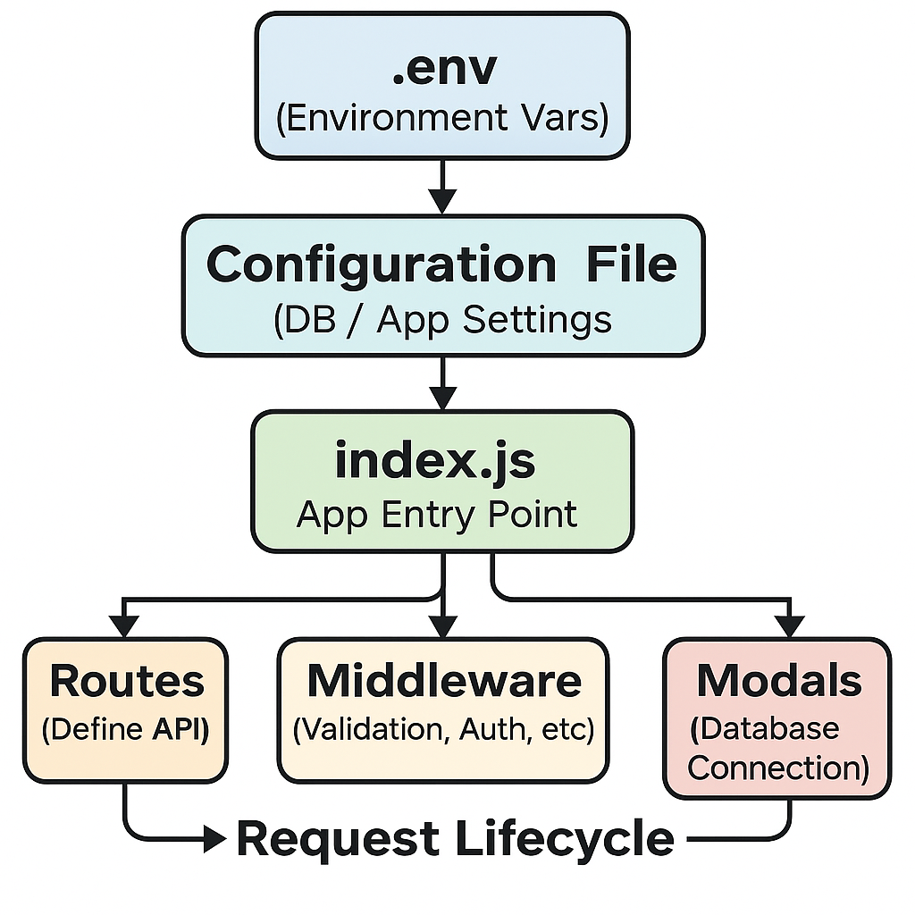

Fig 3.1

The system is implemented using the MVC pattern as shown in the Figure 3.1 :  
- Model: Manages database connection  
- View: (Optional frontend integration)  
- Controller: Contains route logic for user registration, purchases, and earnings  
- Routes: Defines API endpoints and attaches controllers  
- Middleware: for authentication and logging  
- Server (index.js): Sets up Express, routes, and WebSocket integration  
- Socket Layer: Manages real-time events and connections

# 4. Database Design

Key tables:  
- Users: Stores user info, referral relationships, active status

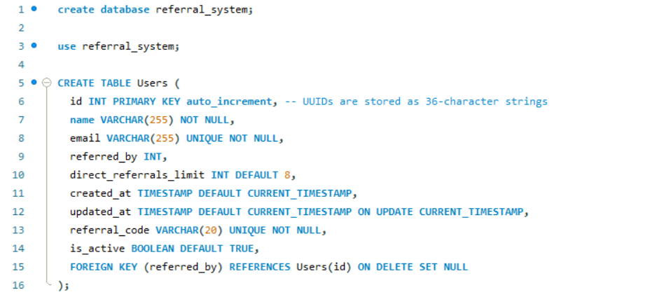

Figure 4.1 SQL code for users Table

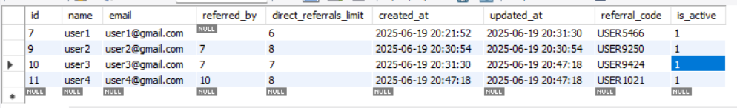

Figure 4.2 Users Table

- Purchases: Records user purchases

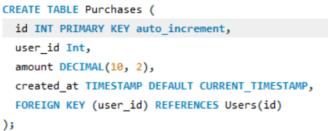

Fig 4.3 SQL code for the purchases table

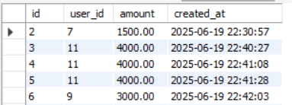

Fig 4.4 Purchases Table

- Earnings: Logs earnings by level and transaction

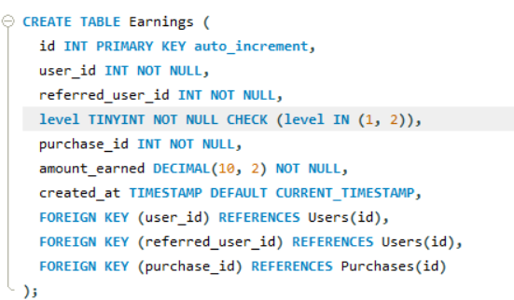

Figure 4.5 SQL code for Earning Table

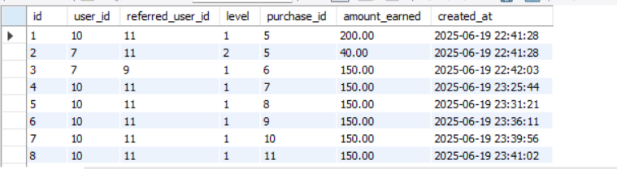

Fig 4.6 Earning Table

# 5. API Endpoints

User Management:  
POST /api/users/register - Register user

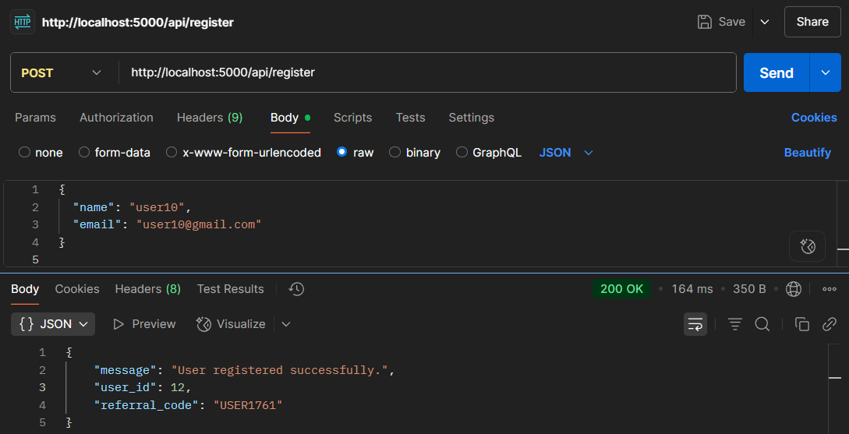

Fig 5.1 Registering User

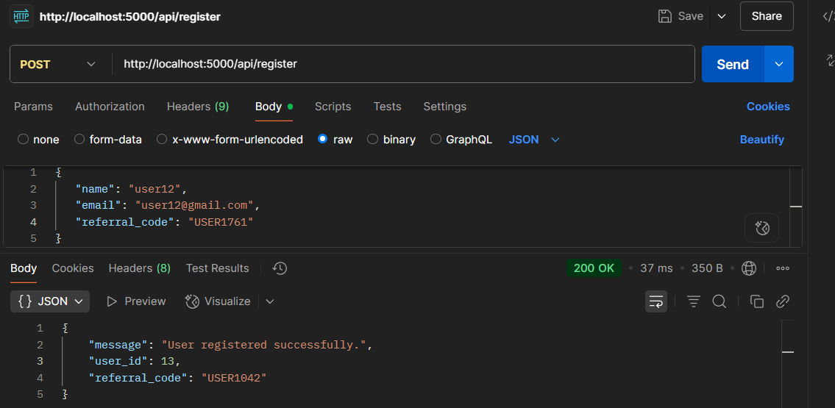

Fig 5.2 Registering user with referral

Purchases:  
POST /api/purchases - Record a purchase and distribute earnings

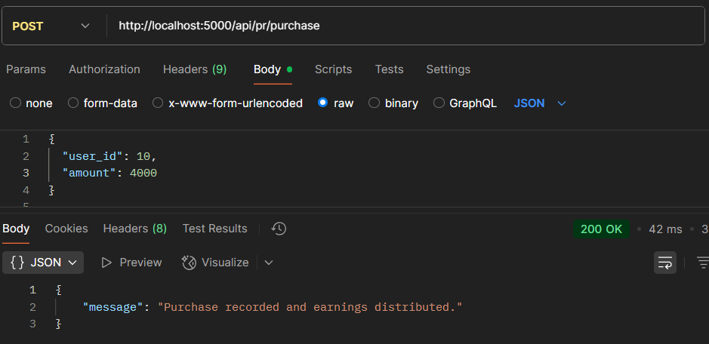

Fig 5.3 Submitting the purchase for the user

Earnings:  
GET /api/earnings/:user_id - Get user’s earnings summary

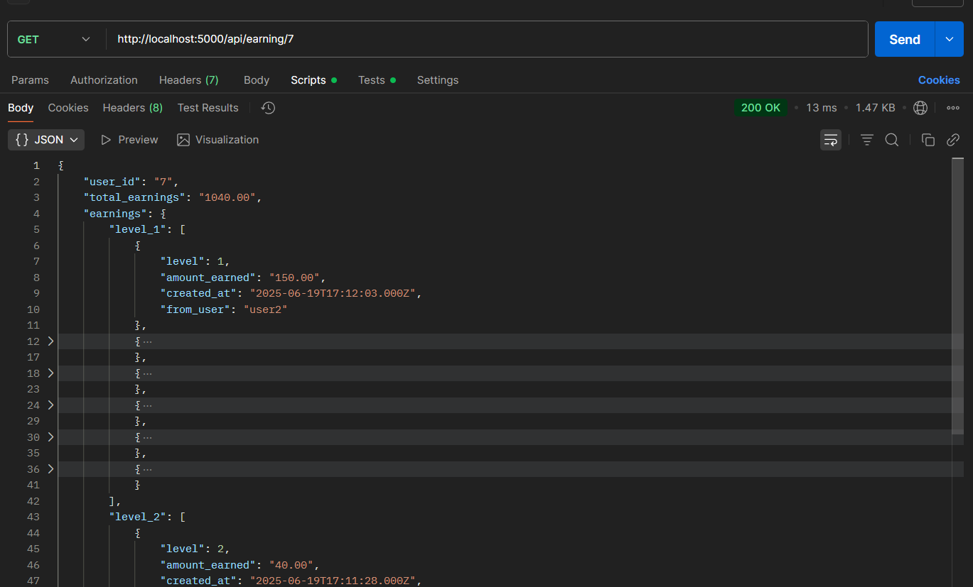

Fig 5.4 Getting the user earning

Referrals:  
GET /api/users/:user_id/referrals - View Level 1 and Level 2 referrals

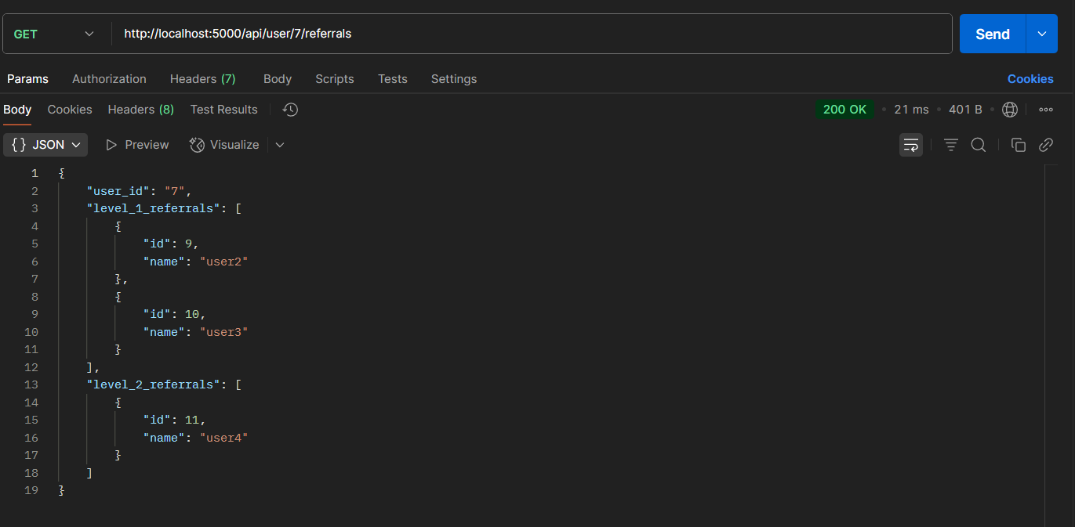

Fig,. 5.5 Users level 1 and level 2 referrals

# 6. Real-Time Notification System

Users receive live updates using Socket.IO:  
- Register via socket.emit('register', userId)  
- Listen for socket.on('new_earning', data)  
- Backend emits notifications after qualifying purchases

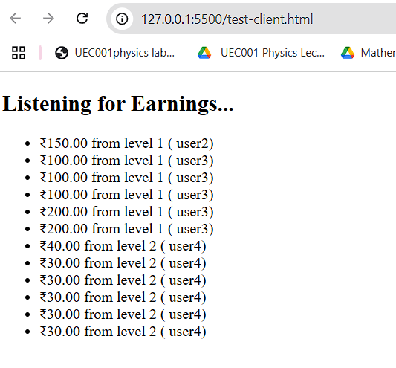

Fig 6.1 Real time updates for Earning

# 7. Chart Visualization

The frontend uses Chart.js to show:  
- Referral-Based Earnings (Doughnut Chart)  
- Earnings per Referral (Bar Chart)

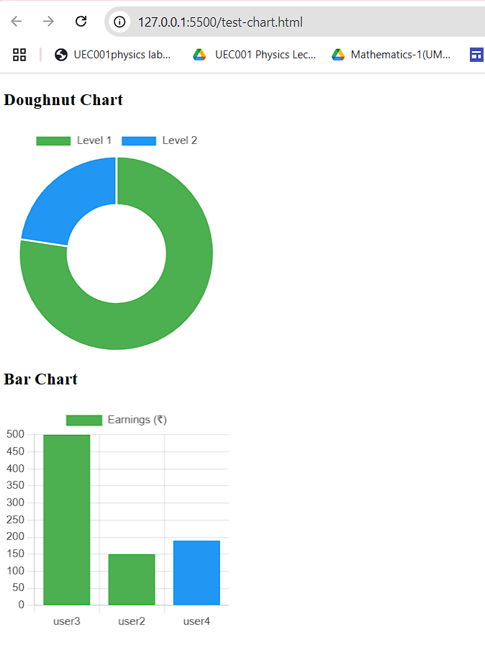

Fig 7.1 Visualization of earning for user

# 8. Validations and Edge Cases

- Validate purchases > ₹1000 for earnings

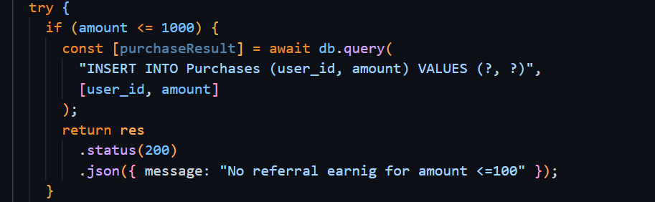

Fig 10.1 Validation for earning >1000 for earnings

- Limit 8 direct referrals per user

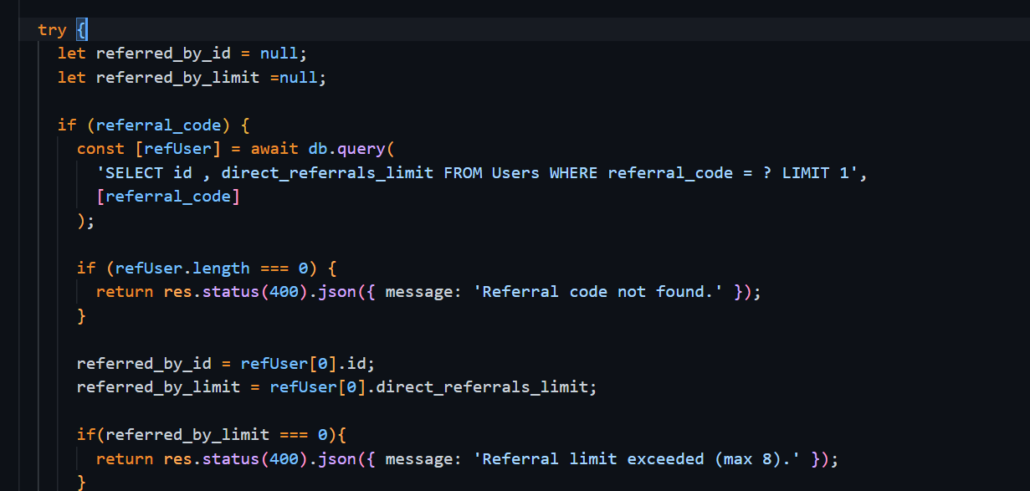

Fig 10.2 Limiting referrals by 8

- Skip earnings for inactive users

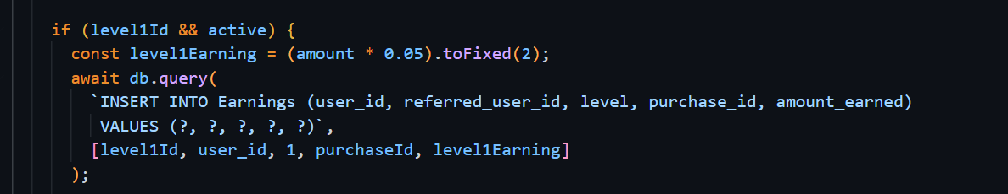

Fig 10.3 Skipping inactive users

- Return proper error for an invalid referral code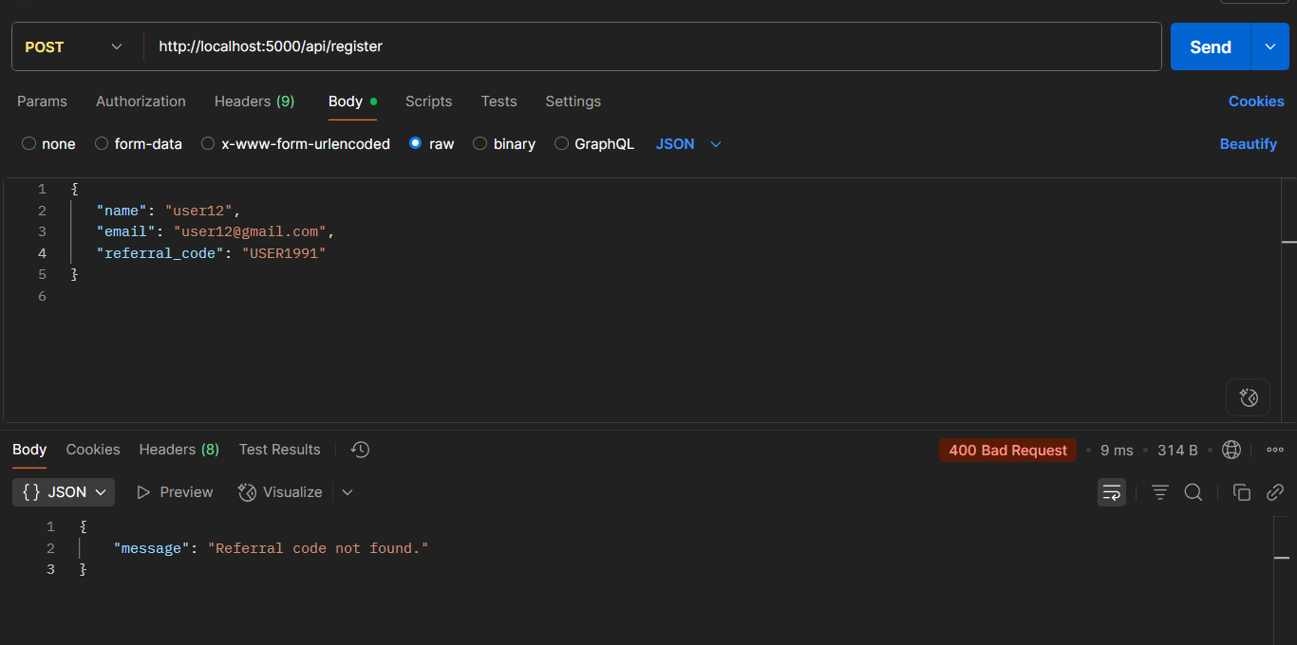

Fig 10.4 Giving error for invalid referral code