COMPREHENSIVE REVIEW ON DETECTION OF CORD INJURIES

Bhuvan U Kadlasa, Dheemanth Gowda S N b, D.S Yashwanth c, Abhishek L d, H.T. Chethana e

A,b,c,d B.E Students, Department of Computer Science and Engineering, Vidyavardhaka College of Engineering, Mysore, India

e Associate Professor, Department of Computer Science and Engineering, Vidyavardhaka College of Engineering, Mysore, India

**Abstract**

Spinal injuries pose significant diagnostic and therapeutic hurdles due to their correlation with debilitating conditions such as myelitis, an inflammation of the spinal cord requiring prompt identification to prevent irreversible neurological damage. This survey paper explores the efficiency of deep learning (DL) models in detecting myelitis within the context of spine injuries. Drawing upon diverse clinical records and imaging data sourced from Kaggle datasets, DL algorithms are used accurately to predict the presence of myelitis. These datasets encompass a comprehensive set of patient demographics, injury types and clinical presentations, providing a robust foundation for model training and validation. This research survey delves into various DL architectures and methodologies, including convolutional neural networks (CNNs), recurrent neural networks (RNNs), and hybrid models, addressing preprocessing techniques, feature extraction, and model optimization strategies tailored to the unique challenges inherent in spine injury datasets. Furthermore, assessment of various performance metrics of these DL models, comparing sensitivity, specificity, and accuracy against traditional diagnostic methods. This survey aims to furnish a comprehensive resource for researchers and healthcare practitioners interested in deploying DL techniques for spine injury diagnosis, specifically in the realm of myelitis detection, with the overarching objective of enhancing patient outcomes and streamlining clinical decision-making processes. Comparative study of detection of spine injuries with the existing works are discussed in this research paper. It is observed that CNN provides a recognition accuracy of 92 percent and outperforms better than existing algorithms for myelitis detection.

**Keywords:** Myelitic, Deep Learning, Convolutional Neural Networks, Medical MRI, Spine trauma, Healthcare.

# Introduction

Spinal injuries are globally recognized as significant public health issues, often leading to severe physical and neurological repercussions, with myelitis emerging as a particularly complex condition due to its inflammatory impact on the spinal cord, necessitating swift and precise diagnosis to prevent irreversible neurological damage and optimize patient outcomes. Traditional diagnostic methods, like clinical assessments and standard imaging techniques, may face limitations in promptly and accurately identifying myelitis, driving increased interest in utilizing advanced computational techniques, notably deep learning (DL) models, to address these diagnostic challenges within the context of spinal injuries. DL models, a subset of artificial intelligence (AI) algorithms, have showcased remarkable capabilities in efficiently analyzing intricate medical imaging data, such as MRI scans, with heightened accuracy. Leveraging DL models for myelitis detection offers the advantage of autonomously learning and discerning complex patterns and features from extensive medical imaging data, surpassing traditional manual feature extraction and interpretation methods, and excelling in identifying abnormalities and variations indicative of myelitis, even in cases with intricate presentations or subtle manifestations. Furthermore, DL models offer the potential for continuous learning and refinement through exposure to diverse datasets, facilitating adaptation to evolving clinical scenarios and enhancing diagnostic precision over time. By employing DL models to analyze MRI scan copies in PNG format, clinicians and researchers can expedite the diagnostic process, enabling earlier interventions and more effective management of myelitis-linked spinal injuries. The integration of DL-based myelitis detection systems into clinical practice holds promise in overcoming existing challenges, including limited access to specialized expertise and resources, particularly in underserved areas, thereby enabling timely interventions and improving patient care outcomes. This survey paper aims to explore the utilization of DL models for myelitis detection in the context of spinal injuries, emphasizing the benefits of these techniques and their potential to address ongoing challenges in diagnosis and treatment, offering insights into current state-of-the-art approaches and future research directions in spinal injury management.

The research paper presents an in-depth exploration of the application of DL models in spinal cord detection, aiming to contribute to the ongoing advancements in medical technology and improve healthcare practices in the field of Neurologists

* 1. **Myelitis**

Myelitis, characterized by inflammation of the spinal cord, can be precipitated by a variety of factors encompassing viral infections, autoimmune disorders, bacterial infections, and non-infectious inflammatory conditions such as transverse myelitis. This inflammatory process disrupts the normal transmission of nerve signals, leading to a spectrum of symptoms including limb weakness or paralysis, sensory disturbances, bladder and bowel dysfunction, pain, and in severe cases, respiratory complications.

The importance of early detection of myelitis cannot be overstated, as it allows for prompt intervention to prevent further spinal cord damage and optimize patient outcomes. Timely diagnosis facilitates the implementation of targeted treatment strategies tailored to the specific underlying cause of the condition. Whether the myelitis is viral, autoimmune, or bacterial in nature, identifying the root cause enables healthcare professionals to initiate appropriate therapies aimed at minimizing long-term disability and maximizing patient recovery.

Treatment for myelitis typically involves a multifaceted approach aimed at addressing both the underlying cause of inflammation and managing associated symptoms to improve overall quality of life. In cases of viral myelitis, antiviral medications may be prescribed to inhibit viral replication and reduce inflammation. For autoimmune-related myelitis, corticosteroids and immunosuppressive therapies are commonly employed to dampen the inflammatory response and prevent further damage to the spinal cord. Additionally, physical therapy and rehabilitation play integral roles in the treatment process, assisting patients in regaining strength, mobility, and function.

In summary, myelitis poses a complex clinical challenge requiring a comprehensive approach to diagnosis and treatment. Early detection is crucial for timely intervention and optimal patient outcomes. By identifying the underlying cause and implementing targeted therapeutic strategies, healthcare providers can mitigate neurological damage, alleviate symptoms, and facilitate patient recovery. The Cross-Sectional view of Spinal cord is shown in Figure 1.

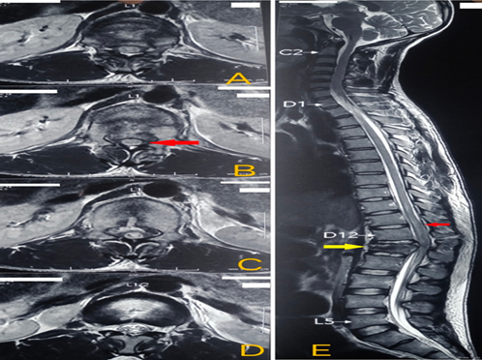

Figure 1. Cross-Sectional view of Spinal Cord

## Factors Affecting Myelitis

Myelitis, characterized by spinal cord inflammation, can result from various influences including infectious agents, autoimmune processes, genetic predisposition, environmental triggers, and demographic factors. Understanding these conditions is the vital role for comprehending myelitis mechanism and developing effective treatment and prevention strategies.

* + - Infectious Agents: Human T-cell lymphotropic virus (HTLV), herpes simplex virus, varicella-zoster virus, enteroviruses, TB, Lyme disease, and bacteria can all cause inflammation of the spinal cord. These pathogens can harm tissues and disrupt neurological function either by directly infecting the spinal cord or by inducing an immune response.
    - Autoimmune Processes: The central nervous system, especially the spinal cord, is the focus of immune system dysfunction in disorders such as multiple sclerosis (MS), neuromyelitis Optica (NMO), acute disseminated encephalomyelitis (ADEM), and transverse myelitis. Demyelination and inflammation can occur in autoimmune myelitis when immune cells and cytokines target myelin, axons, or other parts of the nervous system.
    - Genetic Predisposition: Genetic factors influence susceptibility to myelitis and spinal cord-affecting autoimmune diseases. Certain genetic variations contribute to the risk of conditions like MS, NMO, and hereditary spastic paraplegia, with myelitis as a primary symptom.
    - Environmental Triggers: Factors such as viral infections, toxin exposure, smoking, diet, and stress can impact myelitis development. These triggers may interact with genetics and immune dysfunction, exacerbating inflammation and influencing disease onset or progression.
    - Demographic Characteristics: Factors like age, sex, ethnicity, and location affect myelitis incidence and presentation. Autoimmune disorders like MS and NMO show prevalence variations among different demographic groups. Additionally, disparities in environmental factors and healthcare access may influence disease outcomes and treatment effectiveness.
    - Neurological and Systemic Diseases: Underlying neurological conditions, systemic autoimmune disorders, and comorbidities can heighten myelitis risk or worsen existing inflammation. Conditions such as systemic lupus erythematosus, sarcoidosis, Behçet's disease, and vasculitis may involve the spinal cord, contributing to myelitis pathogenesis.
    - Understanding these influences is crucial for accurate diagnosis, prognosis, and treatment planning in myelitis patients. Multidisciplinary approaches integrating clinical, immunological, genetic, and environmental factors are essential for tailoring therapeutic interventions to individual patient needs. Ongoing research efforts into mechanisms and therapeutic targets offer hope for improving outcomes and quality of life for those with myelitis.

The organization of the paper is as follows. Section 2 discusses about existing techniques using predictive algorithms to analyze numerous features. Literature survey is discussed in section 3. Section 4 discusses the advantages of using DL in prediction and detection of myelitis. Section 5 concludes by discussing the application of DL algorithms and approaches for detection of myelitis.

# Existing Techniques

In this section, a summary of existing techniques for myelitis detection is discussed.

Various techniques and algorithms have been employed for the detection of myelitis, aiming to facilitate early diagnosis and to improve patient outcomes:

* + Commonly used Conventional Imaging Techniques: Myelitis is often diagnosed using conventional imaging techniques such as computed tomography (CT) and magnetic resonance imaging (MRI). Spinal cord inflammation and related anatomical abnormalities can be seen using these methods.
  + Clinical Evaluation: Healthcare providers rely on clinical assessments to predict myelitis. Symptoms such as limb weakness, sensory impairments, and bladder dysfunction are evaluated to identify potential cases.
  + The capacity of advanced algorithms, such as recurrent neural networks (RNNs) and convolutional neural networks (CNNs), to analyze complex medical imaging data has gained interest in the field of deep learning models. These algorithms enable accurate myelitis identification by automatically learning complicated patterns from MRI data.
  + The use of machine learning algorithms allows for the prediction of myelitis using techniques such as Support Vector Machine (SVM), Decision Trees, and Random Forest. These algorithms sort patients into those with and without myelitis based on clinical and imaging data that they detect.
  + Biomarker Analysis: Research explores biomarkers like cytokine levels in cerebrospinal fluid or blood as potential indicators of myelitis. Such analysis offers insights into the inflammatory mechanisms underlying myelitis, aiding in prediction and diagnosis.
  + Pattern Recognition Approaches: Pattern recognition methods, including texture analysis and shape-based features, are investigated for their ability to identify distinctive patterns of spinal cord inflammation characteristic of myelitis on medical images.
  + Integrated Diagnostic Systems: Studies propose integrated diagnostic systems that amalgamate various modalities, such as clinical data, imaging results, and biomarker assessments, to enhance the accuracy of myelitis prediction and diagnosis.

## General Architecture of Myelitis Detection:

The general architecture of Myelitis detection is described in sex steps and same is shown in Figure 2.

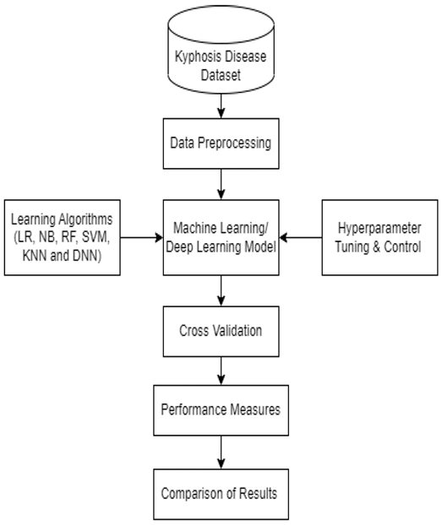

**Fig 2:** Flowchart of general architecture of myelitis detection. [5]

The comprehensive design of the detection of the myelitis is presented in Figure 2. The steps are as follows:

* + - Data Collection: Acquire diverse medical imaging datasets comprising MRI scans and related medical data concerning spinal cord injuries and myelitis
    - Data Preprocessing: Clean, organize, and standardize the collected data to ensure consistency and prepare it for input into the Deep Learning model, addressing issues such as noise reduction and normalization.
    - Feature Extraction: Extract relevant features from the pre-processed data, such as specific patterns or characteristics indicative of spinal cord injuries or myelitis, to enhance the model's ability to make accurate diagnoses.
    - Deep Learning Model Development: Design and train the Deep Learning model, incorporating advanced techniques and architectures suited for analyzing medical imaging data and detecting spinal cord issues with precision.
    - Model Validation and Optimization: Validate the model's performance using rigorous testing procedures and optimize its parameters to ensure high accuracy and reliability in diagnosing spinal cord problems.
    - Real-time Integration and Deployment: Integrate the trained model into a real-time decision support system, ensuring seamless deployment in clinical settings for prompt interventions and aiding healthcare professionals in diagnosing spinal cord issues effectively.

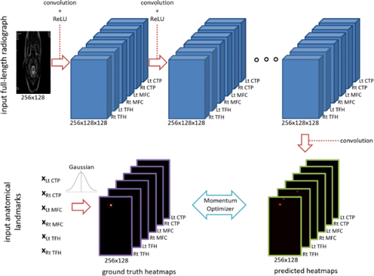

**Fig 3**: Schematic representation of the image processing steps and model of CNN for identification.[1]

The schematic representation of the image processing steps and the model of Convolutional Neural Network (CNN) for identification is shown in Figure 3. It involves preprocessing input images, applying convolutional and pooling layers for feature extraction, and utilizing fully connected layers for classification. This visual representation outlines the flow of information through the network, illustrating how raw image data is transformed and processed to make accurate identification predictions.

## Existing Datasets for Myelitis Detection

In this section existing datasets for Myelitis Detection is discussed and same is tabulated in Table 1. **Table 1**: Existing Datasets

|  |  |  |  |
| --- | --- | --- | --- |
| SL  No. | Name | Source | No. of Samples |
| 1 | Myelitis Images | Kaggle | 1373 |
| 2 | CKD Dataset | Kaggle | 3085 |

The above table1 interprets the datasets containing CT images that are utilized for training and testing of the model. The datasets are sourced from Kaggle.

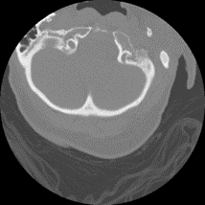



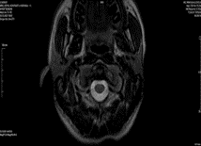

**Fig 4:** Sample CT scans from the datasets

Sample CT scans from a dataset comprises cross-sectional images generated by computed tomography method. These scans serve as crucial input data for training and evaluating the Deep learning models as shown in Figure4.

# Literature Survey

The survey discusses about the various methodologies used for myelitis prediction and detection. In this section a brief discussion about the existing literature review on myelitis prediction and detection is examined.

## 3.1 Existing DL Models for Myelitis Detection

Sinan Tatli and Gulay Macin et al. [1] proposed an approach to offer the best SVM parameters for data categorization. By comparing it to the most recent approaches, researcher can see how well the suggested algorithm performs. In terms of accuracy, the suggested technique outperformed other than the current algorithms by 3.37% and 9.17%, respectively, and by a substantial margin of 34.12%.

In order to find the optimal combinations that might improve accuracy and detection rate, Linta Antony et al. [1] suggested a technique to apply unsupervised algorithms and compare their performances. The five unsupervised algorithms used in this study are Autoencoder, DB-Scan, I-Forest, and K-Means Clustering. The clinical data of CKD and non-CKD were classified with an overall accuracy of 99% by integrating them with various feature reduction and selection approaches with the K-Means Clustering algorithm.

MRI scans are analysed from 1008 people, with a mean age of 37.7 years ± 9.7 with 730 of those people being women. Out of 519 individuals, at least one had an amplifying lesion. Across all five test sets, the average sensitivity for slice-wise prediction was 78% ± 4.3 and the average specificity was 73% ± 2.7. There was a 72% ± 9.0 and a 70% ± 6.3 corresponding to the participants. The area under the curve (AUC) for slice-wise enhancement prediction was 0.82 ± 0.02 and for participant-wise enhancement prediction it was 0.75 ± 0.03. Potential textural elements that give tissue properties of the spine area in ultrasound images can be extracted from the despeckled pictures. Two features are extracted: the Grey Level Co-occurrence Matrix (GLCM) and the run length texture. The k-Nearest Neighbour classifier (k-NN) are used which divide the pictures into two categories: normal and cystic. For picture categorization into cystic and normal states, the GLCM derived characteristics are very important

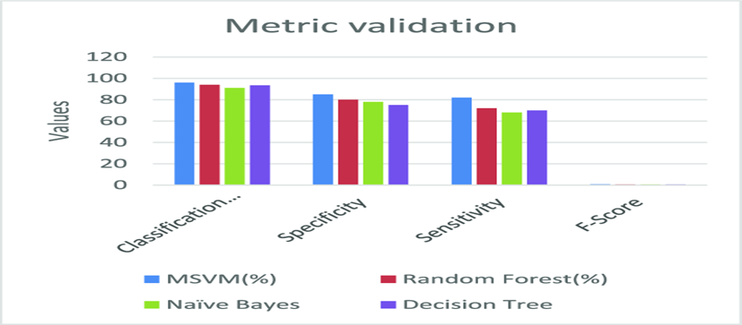

Figure 5: Classification accuracy for various classification methods [3]

The performance analysis of existing approaches with the proposed framework is shown in the Figure 5. In this plot, value in X-axis denotes different methods and a value in Y-axis denotes the recognition accuracy and determines the performance measurements for various classification methods involving metrics such as accuracy, precision, recall, and F1-score, assessing the model's ability to correctly classify instances across different classes. These evaluations help to quantify the effectiveness and reliability of classification algorithms, aiding in the selection and optimization of models for specific applications.

Classification accuracy measures the effectiveness of different classification methods in correctly assigning labels to

instances, with higher accuracy indicating better performance. The classification accuracy can vary depending on the

dataset, the nature of the problem, and the quality of the features used. Different algorithms may perform better or

worse in different scenarios

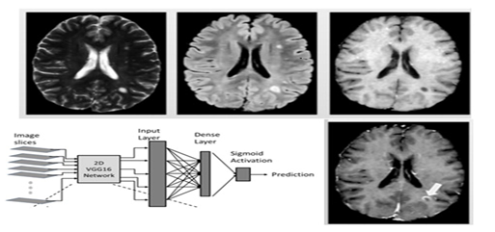

Figure 6: “Illustration of the training of the deep learning models: feature extraction and selection, hyperparameter tuning, and model validation.” [3]

Figure6 depicts the illustration of training six shallow deep learning models involves initial steps of feature extraction and selection, followed by hyperparameter tuning to optimize model performance. The process concludes with model validation, ensuring robustness and effectiveness in handling diverse datasets and tasks. The comparative study of the performance of six shallow deep learning models for myelitis detection is discussed in Table3 and Figure 6.

**Table 3:** Comparison of the performance of six shallow machine learning models according to the data type.[8]

|  |  |  |  |  |  |  |  |  |  |
| --- | --- | --- | --- | --- | --- | --- | --- | --- | --- |
| Classifier |  | Surface |  |  | Section |  |  | Mixed |  |
| Precision | Recall | F1 | Precision | Recall | F1 | Precision | Recall | F1 |
| SVM | 0.83 | 0.86 | 0.84 | 0.76 | 0.86 | 0.80 | 0.79 | 0.77 | 0.78 |
| AdaBoost | 0.83 | 0.86 | 0.84 | 0.81 | 0.85 | 0.83 | 0.81 | 0.81 | 0.81 |
| Bagging | 0.76 | 0.76 | 0.76 | 0.77 | 0.77 | 0.77 | 0.75 | 0.76 | 0.75 |
| MLP | 0.86 | 0.91 | 0.88 | 0.80 | 0.64 | 0.71 | 0.84 | 0.86 | 0.85 |
| R. Forest | 0.87 | 0.82 | 0.84 | 0.82 | 0.82 | 0.82 | 0.91 | 0.91 | 0.91 |

Classification accuracy measures the effectiveness of different classification methods in correctly assigning labels to instances, with higher accuracy indicating better performance. The metrics are essential tools for evaluating the performance of classification models and are often used in conjunction to gain a comprehensive understanding of a model’s effectiveness.

Table 4: “Comparison study of deep learning models for myelitis detection

|  |  |  |  |
| --- | --- | --- | --- |
| **SL No.** | **Authors** | **Methodology Used** | **Accuracy** |
| 1. | J.E. Small  (2021) | Deep  Learning | 77.36% |
| 2. | Elsevier Inc  (2023) | CNN | 92.75% |
| 3. | Raghavendra et al.  (2021) | Crow Search-Rider optimization | 88.82% |
| 4. | Naofumi Tomita  (2020) | Deep Learning (CNN) | 89.28% |
| 5. | A.B. Paul and M. Kunst (2021) | Convolutional Neural Network (CNN | 92% |
| 6. | S. Benetos and John Vlamis (2020) | ANN (Artificial neural networks) | 85.1% |
| 7. | Showmick Guha Paul (2021) | Deep learning, Computed tomography | 90.75% |
| 9. | Saman Ebrahimi | CNN | 84% |
| 10. | Sunanda Biradar  (2020) | Support Vector Machines  (SVM), Random  Forests,  CNNs | 98.5% |

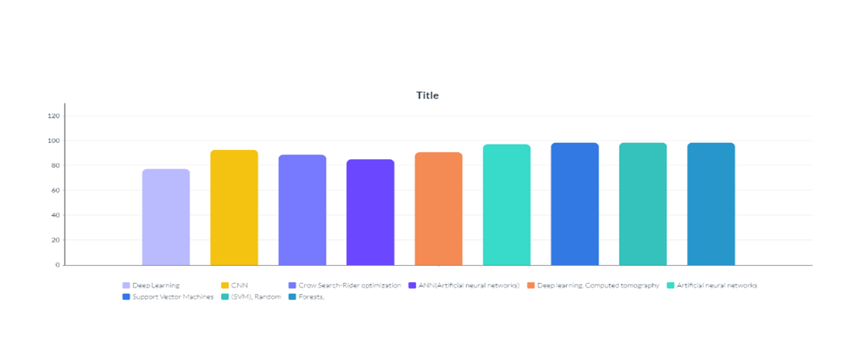

Fig 6: Comparative study of six shallow deep learning models for myelitis detection

It is observed from the Figure 6 that CNN provides a recognition accuracy of 92 percent and outperforms better than existing algorithms for myelitis detection.

# Advantages of Machine Learning Models for Myelitis Detection

Utilizing deep learning models for myelitis detection offers numerous benefits that contribute to more precise, efficient, and scalable diagnostic procedures:

* + Automated Detection: Deep learning models automate the identification of myelitis lesions on medical imaging scans, reducing the reliance on manual interpretation by radiologists and healthcare providers. This automation accelerates diagnostic processes, leading to quicker turnaround times and timely interventions for patients suspected of having myelitis
  + Improved Sensitivity and Specificity: Deep learning models utilize intricate neural architectures to learn distinctive features and patterns indicative of myelitis on magnetic resonance imaging (MRI) scans. These models can achieve heightened sensitivity and specificity in detecting lesions, surpassing traditional image analysis techniques and decreasing the likelihood of false positives or negatives.
  + Quantitative Analysis: Deep learning models enable the quantitative analysis of myelitis lesions, offering objective metrics such as lesion volume, distribution, and spatial extent. This quantitative assessment facilitates longitudinal monitoring of disease progression, treatment response evaluation, and detection of subtle changes in lesion morphology over time.
  + Early Detection and Intervention: By facili
  + tating early identification of myelitis lesions, deep learning models empower healthcare professionals to initiate timely treatment and implement preventive measures to mitigate disease-related complications. Early intervention can enhance patient outcomes, minimize neurological deficits, and prevent irreversible spinal cord damage.
  + Personalized Treatment Planning: Deep learning models facilitate personalized treatment planning by stratifying patients based on the severity and extent of myelitis lesions, along with other clinical factors like disease subtype, comorbidities, and treatment response. Personalized treatment algorithms optimize therapeutic decisions, tailoring interventions to meet individual patient requirements and maximize treatment efficacy.
  + Data-driven Insights: Deep learning models generate data-driven insights into the pathophysiology and radiological characteristics of myelitis, offering valuable information on disease mechanisms, biomarkers, and prognostic factors. These insights enhance our understanding of myelitis a etiology, inform clinical decision-making, and drive research endeavors aimed at developing innovative diagnostic and therapeutic approaches.

Overall, the application of deep learning models in myelitis detection holds immense promise for revolutionizing diagnostic practices, improving patient care, and advancing our understanding of spinal cord inflammation and related neurological disorders. As research and development efforts continue, deep learning-based approaches are poised to play a pivotal role in the management of myelitis and other neuroinflammatory conditions in clinical settings.

# Conclusion

The incorporation of deep learning models in myelitis detection marks a significant progression in medical imaging and diagnostic methodologies. These models present automated, highly sensitive, and specific approaches to identify inflammatory lesions within the spinal cord, thereby simplifying diagnostic processes and facilitating prompt interventions. Deep learning's ability to offer quantitative analysis and personalized insights enables early detection, individualized treatment planning, and continual monitoring of myelitis patients. Additionally, insights derived from deep learning contribute to our comprehension of myelitis pathophysiology and guide research endeavors aimed at refining diagnostic and therapeutic approaches. As deep learning algorithms continue to advance, their role in myelitis detection is expected to broaden, leading to improved clinical decision-making, optimized patient care, and ultimately better outcomes for those affected by spinal cord inflammation. Sustained research efforts and collaborative initiatives are vital to further develop and validate these models for widespread clinical. This research paper showcases the transformative potential of AI and ML in revolutionizing medical diagnostics, improving patient outcomes, and enhancing efficiency of the healthcare.

# References

[1]. J E Small, P Osler, A B Paul, M Kunst,” CT Cervical Spine Fracture Detection Using a Convolutional Neural Network”, Apr,2021.

1. Showmick Guha Paul, Arpa Saha, Md Assaduzzaman, “A real-time deep learning approach for classifying cervical spine fractures”, Dec,2023.
2. Munavar Jasim, Thomas Brindha, “Spinal cord segmentation and injury detection using a Crow Search-Rider optimization algorithm”, Dec,2020.
3. Naofumi Tomita , Yvonne Y Cheung , Saeed Hassanpour, “Deep neural networks for automatic detection of osteoporotic vertebral fractures on CT scans”, May,2018.
4. Themistoklis Tragaris, Ioannis S Benetos, John Vlamis, and Spyridon Pneumaticos, “Deep Learning Applications in Spine Surgery”, Oct,2023.
5. Anu Jacob, Brian G. Weinshenker, “An Approach to the Diagnosis of Acute Transverse Myelitis”, Dec,2018.
6. Lee YJ, Terbrugge KG, Saliou G, Krings T. “Clinical features and outcomes of spinal cord arteriovenous malformations”, Oct,2019.
7. Samir Alkabie , Courtney S. Casserly , Sarah A. Morrow , Juan M. Racosta, “Identifying specific myelopathy etiologies in the evaluation of suspected myelitis”, Jul,2023.
8. Yo Huh, Eun-Jung Park, Ju-Won Jung, Sungho Oh, Sang-Cheon Choi, “Clinical insights for early detection of acute transverse myelitis in the emergency department”, Mar,2018.
9. V P Chandnani, J Beltran, C S Morris, S N Khalil, C F Mueller, J M Burk, W F Bennett, P B Shaffer, “Acute experimental osteomyelitis and abscesses: detection with MR imaging versus CT”, Mar,2019.
10. Divyanshu Dubey, MD1,2; Sean J. Pittock, MD1,2; Karl N. Krecke, “Radiologic, Features of Myelitis Associated with Myelin Oligodendrocyte Glycoprotein Autoantibody”, Dec,2018.
11. Zajicek JP, Scolding NJ, Foster O, “Central nervous system sarcoidosis: diagnosis and management”. Mar,2020.
12. Birnbaum J, Petri M, Thompson R, Izbudak I, Kerr D, “Distinct subtypes of myelitis in systemic lupus erythematosus”, May,2018
13. Gailloud P, Gregg L, Galan P, Becker D, Pardo C. Periconal, “Arterial anastomotic circle and posterior lumbosacral watershed zone of the spinal cord”, Jun,2015.

Li J, Jiang B, Fine JP, “Multicategory reclassification statistics for assessing improvements in diagnostic accuracy. Biostatistics”, May, 2013