1. Summary
The discussion focused on onboarding Databricks Unity Catalog into the existing Starburst ecosystem through Citi Voyager, while ensuring that users can access Databricks data without introducing a separate, complicated access process.
The agreed initial approach is:
- Use JDBC connectivity as the currently certified integration mechanism.
- Create a dedicated Databricks service principal for Starburst.
- Grant that principal the required catalog-level read-only access.
- Store its credentials in HashiCorp Vault.
- Whitelist the necessary Starburst clusters.
- Configure Starburst to retrieve credentials from Vault and connect to the Databricks workspace and Unity Catalog through its SQL endpoint.
- Explore user-level entitlement propagation and Ranger-based filtering after the basic connectivity POC is operational.
The meeting also highlighted that this is the first Databricks Unity Catalog onboarding POC of this kind for the teams involved. Some technical details, especially entitlement mapping and performance, remain to be validated.

2. Proposed integration architecture
The following represents the connectivity flow discussed during the meeting. It distinguishes the credential-management path from the metadata and data-access path.

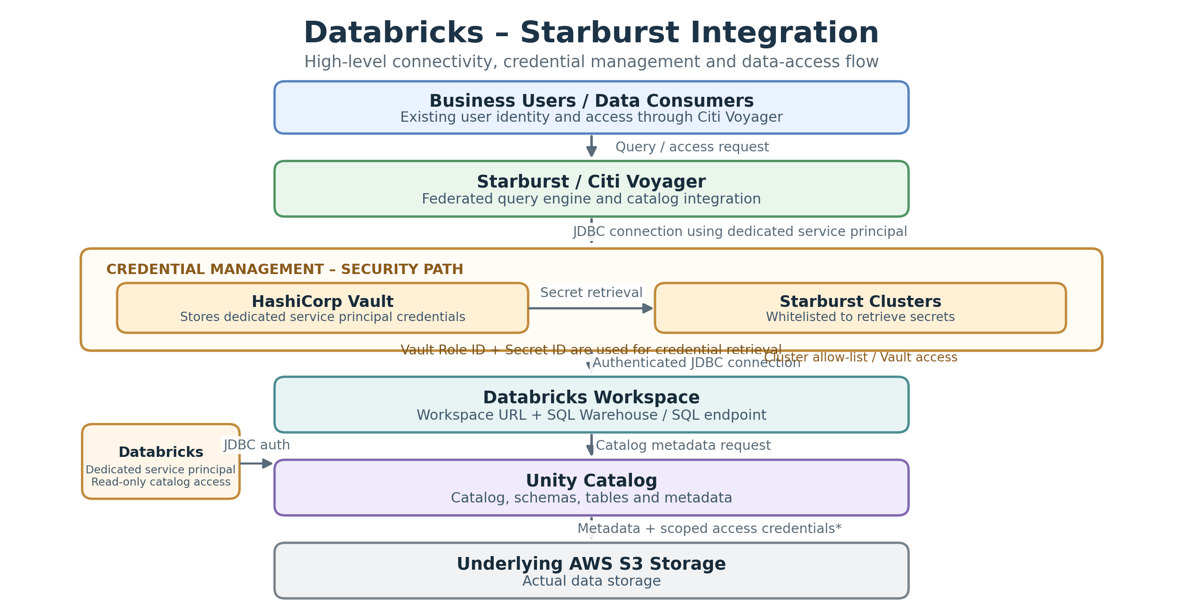

3.Integration sequence – step by step
The meeting established the following implementation sequence.
- Prepare Databricks Unity Catalog
  - Catalog is already created.
  - SQL endpoint is available.
  - Workspace URL is available.
  - Unity Catalog will be referenced directly by Starburst.
Reported ready
- Create a dedicated service principal
  - Create a separate service principal specifically for Starburst.
  - Grant it read-only permissions.
  - Access can be granted at catalog level or restricted to selected schemas, depending on the data team's decision.
Pending
- Onboard credentials into HashiCorp Vault
  - Store the service principal credentials in Vault.
  - Whitelist the relevant Starburst clusters.
  - Provide Vault Role ID and Secret ID to Starburst.
- Configure Starburst connectivity
  - Starburst retrieves the service principal credentials from Vault.
  - It uses those credentials to connect to the Databricks workspace.
  - JDBC is the currently certified connection mechanism.
- Access Unity Catalog metadata
  - Starburst references Unity Catalog.
  - The SQL endpoint is used in the described integration to retrieve catalog metadata.
  - Metadata and the associated access credentials are returned for query processing.
- Validate data access and entitlements
  - Test table discovery and query execution.
  - Validate access restrictions.
  - Explore Ranger policies and LOB/country-level filtering.
  - Confirm whether existing Voyager entitlements can be propagated seamlessly.
4. Important technical discussions and decisions
A. Authentication and service principal
One of the key clarifications was that the Databricks team needs to create a separate service principal for Starburst.
This is similar to the dedicated role-based approach used earlier for AWS S3 onboarding.
Component | Responsibility
Databricks team | Create service principal
Databricks team | Assign catalog/schema read-only permissions
Databricks team | Provide workspace URL and SQL endpoint
Data/platform team | Onboard credentials into Vault
Data/platform team | Whitelist Starburst clusters
Starburst team | Configure Vault access and JDBC connectivity
An important distinction: the dedicated service principal is an additional integration identity. It is not necessarily the same identity as the individual business user's identity.
B. Unity Catalog versus Hive Metastore
The discussion explicitly clarified that the earlier AWS/HMS refresh mechanism is not required for this Unity Catalog integration.
Earlier AWS/HMS approach | Databricks Unity Catalog approach
Hive Metastore maintained | Unity Catalog referenced directly
Metadata refresh required | No separate HMS refresh expected
Metadata synchronization involved | Catalog metadata accessed directly
Previous catalog integration model | New Unity Catalog integration model
The expectation is that metadata changes become visible through Unity Catalog without manually refreshing HMS in Starburst. This should be validated during the POC.
C. Access management and entitlements
This was one of the most important unresolved discussions.
The business expectation is:
A user who already has access through Citi Voyager should ideally be able to access the corresponding Databricks catalog data without raising a completely new access request.
However, there are two separate authorization layers to consider:
- Integration-level authorization: The dedicated Starburst service principal has permissions to access Databricks.
- User-level authorization: The actual business user's LOB, country, role and other entitlements must be respected when querying through Starburst.
The meeting did not establish how these two layers will be mapped.
The following areas require validation:
- How will the Voyager user identity map to the Databricks service principal?
- Will an additional principal or user group be needed?
- How will Unity Catalog grants interact with Starburst/Ranger policies?
- How will LOB and country-code filtering be implemented?
- Will users need new access requests?
The team agreed to explore these after basic connectivity is operational.
D. LOB and country-code filtering
An important technical point was raised concerning the data model.
The Starburst team requested that LOB and country code be available as separate columns, with the derivation logic not hidden or embedded in a way that makes filtering difficult.
The discussion also mentioned that these attributes existed previously, but small-file partitioning concerns had limited their use.
Recommendation from the discussion: Validate the attribute availability and filtering strategy as part of the entitlement POC, rather than assuming that existing policies will automatically work.
E. JDBC connectivity and performance
Potential limitation
JDBC is the currently certified approach.
The Starburst team highlighted that JDBC catalog connectivity may not provide the same performance characteristics as more advanced parallel catalog integration mechanisms.
The Snowflake experience was cited as an example: performance improved when advanced parallel catalog support became available.
The expectation is that future Starburst-supported integration mechanisms may improve this situation without requiring major changes to the consumer-facing configuration.
However, this is not yet confirmed for Databricks.
The team also mentioned that native Iceberg support and other integration options are still going through certification.
5. Open questions and risks
Area | Open question / risk | Priority
Service principal | Is the dedicated principal created and correctly permissioned? | High
JDBC connectivity | Can Starburst successfully connect to Unity Catalog? | High
SQL endpoint | What exact endpoint configuration and permissions are required? | High
Vault | Are credentials onboarded and Starburst clusters whitelisted? | High
User identity | How does Voyager identity map to Databricks authorization? | Critical
Entitlements | How are LOB and country-level restrictions enforced? | Critical
Ranger | Can existing Ranger policies be applied to the new catalog? | High
Performance | What is the JDBC query and metadata retrieval overhead? | Medium
Future connectivity | When will parallel catalog/native Iceberg support be certified? | Medium
Important architectural observation: Successful JDBC connectivity does not automatically establish transparent user-level authorization. This needs to be treated as a separate acceptance criterion for the POC.

6. Action items and ownership
Based on the discussion, the following actions can be tracked.
# | Action | Owner | Status
1 | Create dedicated Starburst service principal | Databricks / Data team | Pending
2 | Grant read-only catalog-level permissions | Databricks / Data team | Pending
3 | Confirm SQL endpoint and workspace URL | Databricks team | Reported ready
4 | Onboard service principal credentials into Vault | Starburst onboarding team | Pending
5 | Whitelist Starburst clusters | Platform / Starburst team | Pending
6 | Configure Vault Role ID and Secret ID | Starburst team | Pending
7 | Establish JDBC connectivity and validate catalog discovery | Starburst + Databricks teams | Pending
8 | Validate Voyager identity and entitlement propagation | Architecture + Security + Data teams | Open
9 | Explore Ranger policies for LOB/country filtering | Starburst + Data teams | Open
10 | Conduct performance testing and document JDBC limitations | Starburst team | Open
The discussion also identified David as an architecture coordination contact and CTi as the source of technical clarifications. The team agreed to use the shared Databricks Unity Catalog onboarding group for questions and coordination

7. Other points discussed
Terraform versus DAB
- Databricks infrastructure provisioning and automation were discussed.
- There was uncertainty about Terraform versus DAB.
- It was clarified that these activities are on the Databricks/AWS infrastructure side.
- They are not additional Starburst integration requirements.
- The only specific additional Starburst requirement discussed was a dedicated service principal with read-only access.
Additional Notes
How the complete setup works
The meeting described the following sequence:
Step | Activity | Explanation
1 | Create service principal | Databricks team creates a separate identity for Starburst.
2 | Grant permissions | Service principal receives read-only catalog-level permissions.
3 | Onboard into Vault | Service principal credentials are stored in HashiCorp Vault.
4 | Whitelist clusters | Relevant Starburst clusters are allowed to access Vault.
5 | Configure Vault access | Starburst is provided Vault Role ID and Secret ID.
6 | Retrieve credentials | Starburst retrieves service principal credentials from Vault.
7 | Establish JDBC | Starburst connects to Databricks using the workspace URL and SQL endpoint.
8 | Read Unity Catalog | Unity Catalog provides table metadata and associated S3 scoped credentials.
9 | Access S3 data | Starburst uses the returned credentials for underlying data access, as described in the meeting.
10 | Return results | Results flow back through Starburst and Voyager to the user.

