

INTERNSHIP REPORT

On

Prompt Engineering Research and Integration

Submitted in partial fulfilment of the requirement for the award of the degree of
Bachelor of Technology in Computer Science and Engineering

Submitted To
School of Computer Science and Engineering
IILM University, Greater Noida, U.P.

By

ABHISHEK RAJ BHARTI
Roll Number: 25SCS1003004568
Program: B.Tech CSE | Semester: 3rd | Section: 2CSE9

2026–27

CANDIDATE'S DECLARATION

I, Abhishek Raj Bharti, Roll Number 25SCS1003004568, do hereby declare that the internship report titled “Prompt Engineering Research and Integration” has been completed by me to fulfil the requirement for the award of the degree of Bachelor of Technology in Computer Science and Engineering. All the references have been quoted, and I have not taken as such any material from any other source. I affirm that this report is my own work and has not been submitted to any other institute for any degree/diploma requirement, and I shall be solely responsible for any kind of copyright violation in this regard.

Signature: _______________________
Student Name: Abhishek Raj Bharti
Roll No.: 25SCS1003004568

ACKNOWLEDGEMENT

I am using this opportunity to express my gratitude to everyone who supported me throughout the Internship Program. I am thankful for their aspiring guidance, invaluably constructive criticism and friendly advice during this work. I am sincerely grateful to them for sharing their truthful and illuminating views on a number of issues related to this work.
I would like to thank Excelerate for providing me the opportunity to undertake this remote internship on Prompt Engineering Research and Integration, and for the guidance and evaluation support extended throughout its duration. I also extend my sincere thanks to the faculty of the School of Computer Science and Engineering, IILM University, for their continuous support and encouragement.
I express my gratitude to my parents for their blessings.

Signature: _______________________
Student Name: Abhishek Raj Bharti
Roll No.: 25SCS1003004568

TABLE OF CONTENTS

Chapter No. | Chapter Name | Page Nos.
 | Cover Page | —
1. | Candidate's Declaration | i
2. | Acknowledgment | ii
3. | Internship Completion Certificate | iii
4. | Project Description
 | 4.1 Introduction
 | 4.2 Organization Profile
 | 4.3 Problem Statement
 | 4.4 Project Objectives
 | 4.5 Scope of the Project
 | 4.6 Technologies and Tools Used
 | 4.7 System Architecture
 | 4.8 Methodology
 | 4.9 Expected Outcomes
 | 4.10 Certificates of Completion and Other Communication Mail Proof
5. | Bibliography/References

INTERNSHIP COMPLETION CERTIFICATE

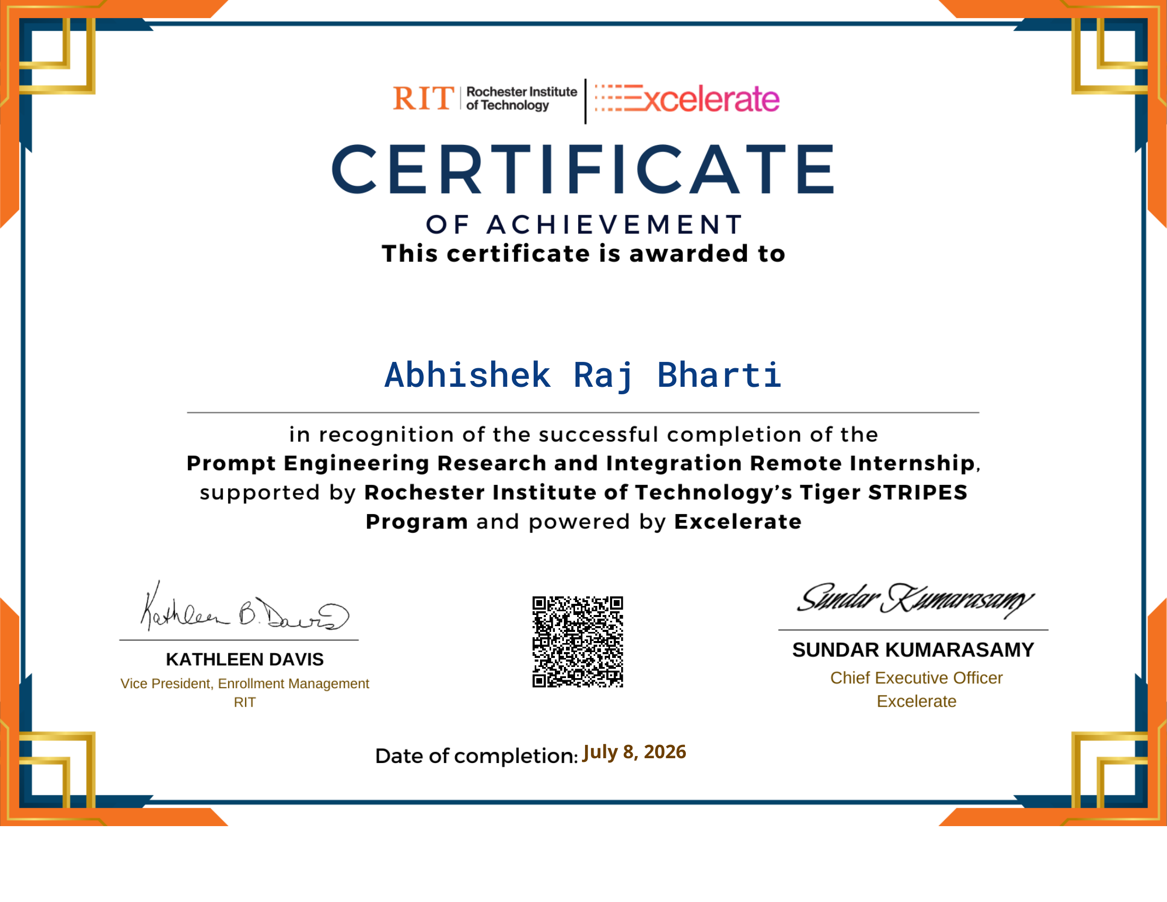
Organization: Excelerate (in partnership with Rochester Institute of Technology – Tiger STRIPES Program)
Internship Role: Prompt Engineering Research Intern
Duration: June 08, 2026 – July 08, 2026

4. PROJECT DESCRIPTION

4.1 Introduction
Large Language Models (LLMs) have become central to modern AI-assisted applications, and the quality of their output is determined largely by how the input instructions, or “prompts”, are constructed. Prompt engineering is the discipline of systematically designing, testing, and refining these inputs to elicit accurate, relevant, and consistently structured responses from an LLM. This internship, undertaken remotely with Excelerate under the role of Prompt Engineering Research Intern, focused on applying prompt engineering principles to a real-world domain: AI-assisted digital learning platforms.
The internship was structured across four weekly deliverables — literature research and use-case identification, prompt template design and iterative refinement, prompt evaluation and performance benchmarking, and a final consolidated prompt suite with strategic recommendations. Over the course of the internship, five distinct AI use cases were identified, designed, tested across three prompt versions each, and evaluated using a structured, multi-criteria scoring matrix, resulting in a production-ready prompt framework.

4.2 Organization Profile
Excelerate is a global talent-development and virtual internship platform, headquartered with operations spanning Dubai and the USA, that connects students and early-career professionals with structured, mentor-guided remote internship programmes across a range of domains including AI, data, business, and technology. The platform emphasises outcome-based learning, structured weekly deliverables, and a 360-degree feedback and evaluation process that assesses interns on both technical output and professional competencies such as ownership, communication, and time management.
As part of its AI-assisted learning initiatives, Excelerate hosts internship tracks focused on prompt engineering, where interns research, design, and evaluate structured prompt templates intended for deployment in AI-powered educational products.

4.3 Problem Statement
The internship addressed four key problems identified through literature review and platform analysis in AI-assisted learning environments:
- Inconsistent Quality of AI-Generated Learning Content: Unstructured prompts produce outputs with variable accuracy, inappropriate reading levels, and factual errors (hallucination), eroding learner trust.
- Limited Personalisation and Declining Learner Engagement: Generic, one-size-fits-all AI content fails to adapt to individual learner profiles, reducing intrinsic motivation and increasing drop-off.
- Poorly Structured and Non-Sequential Learning Pathways: Without explicit structural constraints, AI-generated pathways lack prerequisite logic and scaffolded progression, causing cognitive overload.
- Inconsistency in Opportunity and Programme Descriptions: Ad hoc AI drafting of scholarship and programme announcements produces tonal inconsistency, missing fields, and added editorial burden.

4.4 Project Objectives
- To research established prompt engineering techniques (zero-shot, few-shot, Chain-of-Thought, role/persona, constraint-based, and iterative refinement) and their applicability to educational AI systems.
- To design structured prompt templates for five representative AI use cases relevant to an AI-assisted learning platform.
- To iteratively evolve each prompt from a vague, unstructured draft (Version A) through an intermediate constrained version (Version B) to a fully refined, schema-compliant final version (Version C).
- To evaluate each prompt version against a multi-criteria rubric (Clarity, Personalisation, Engagement, Learning-Outcome Alignment, and Consistency) using a standardised scoring matrix.
- To consolidate findings into a production-ready prompt suite with strategic, phased recommendations for platform deployment.

4.5 Scope of the Project
The scope of the project was limited to prompt design, experimentation, and evaluation — it did not involve building or deploying a live software application. The work covered five use cases: an Adaptive Quiz Generator, a Concept Explanation Generator, a Structured Learning Pathway Generator, a Programme/Opportunity Description Generator, and a Badge & Visual Identity Content Generator. For each use case, three prompt versions were drafted and tested, and outputs were assessed using a fixed rubric across 18 documented test runs. The project also produced strategic, phased recommendations (immediate, short-term, and strategic horizons) for integrating the finalised prompts into Excelerate's AI-assisted learning platform.

4.6 Technologies and Tools Used
- Large Language Models (LLM) accessed via conversational AI interfaces for prompt testing and output generation.
- Prompt engineering techniques: zero-shot, few-shot, Chain-of-Thought (CoT), role/persona prompting, constraint-based prompting, and self-validation instructions.
- Structured output formats: JSON schemas and fixed multi-section templates for programmatic parsing and format compliance.
- Bloom's Taxonomy as a framework for tagging and validating pedagogical/cognitive alignment of generated content.
- Microsoft Excel, for compiling and analysing the 18-record Performance Dataset and multi-criteria Evaluation Matrix.
- Microsoft PowerPoint, for consolidating research, design, and evaluation findings into a final stakeholder-facing prompt suite presentation.

4.7 System Architecture
Although this project did not involve building a deployed software system, the prompt-based workflow designed for each use case follows a consistent conceptual architecture:
- Input Layer: Raw contextual data (learner profile, competency goal, opportunity details, badge context, etc.) is captured as structured variables.
- Prompt Template Layer: A fixed template combines a Role definition, Task instruction, explicit Constraints (format, length, reading level), and — where needed — Chain-of-Thought reasoning steps and few-shot examples.
- LLM Processing Layer: The composed prompt is submitted to the language model, which generates the response.
- Output Validation Layer: The response is checked against the expected schema (JSON fields or section headers); a self-validation instruction embedded in the prompt asks the model to confirm all required fields are present before finalising output.
- Consumption Layer: The validated, structured output (quiz JSON, pathway JSON, formatted description, or badge brief) is ready for direct use in a downstream application without manual reformatting.

4.8 Methodology
The internship followed an empirical, iterative methodology modelled on software debugging practice — draft, test, analyse failure modes, and revise:
- Week 1 — Research & Use-Case Identification: Literature review of prompt engineering principles and AI-in-education research; identification of four core problems and five corresponding use cases.
- Week 2 — Prompt Design & Experimentation: For each use case, a Version A (zero-shot, unstructured) prompt was drafted first, followed by a Version B (role + basic constraints) and a Version C (role + few-shot/CoT + structured output schema). Each version's output was observed and annotated.
- Week 3 — Prompt Evaluation & Insight Documentation: Representative outputs were generated for each use case and scored across five criteria — Clarity, Personalisation, Engagement, Learning-Outcome Alignment, and Consistency — on a 1–5 scale, producing an 18-record Performance Dataset and Evaluation Matrix.
- Week 4 — Consolidation & Strategic Recommendations: Findings were synthesised into a final, production-ready prompt suite, with prompting strategies ranked by impact and phased deployment recommendations (immediate, short-term, strategic) proposed for the platform.
This structured version-comparison approach (A → B → C) allowed the isolated effect of each technique — role prompting, output schemas, Chain-of-Thought reasoning, few-shot examples, and self-validation — to be observed and measured rather than assumed.

4.9 Expected Outcomes
- A validated, reusable prompt suite covering five high-value AI use cases, each rated 4.4/5 or higher in the final evaluation (overall average improvement from 1.5 to 4.7 across versions).
- Demonstrated evidence that output schema specification and role/persona prompting are the highest-impact, lowest-effort techniques for improving format consistency and tone.
- A documented, ranked framework of prompting strategies (schema specification, role prompting, Chain-of-Thought, Bloom's tagging, few-shot examples, self-validation, length constraints) that can guide future prompt design work.
- Identification of personalisation as the current ceiling for prompt-only solutions, with a clear recommendation that runtime learner-profile variables be integrated at the system level.
- A phased roadmap for Excelerate to deploy the Programme Description and Quiz Generator prompts immediately (highest ROI, ~85% reduction in editorial review time), with pathway personalisation and governance processes planned for the short and strategic term.

4.10 Certificates of Completion and Other Communication Mail Proof
The Internship Completion Certificate and the 360-Degree Evaluation Report issued by Excelerate are attached as part of this report (see Chapter 3 and the annexure that follows). The 360-degree evaluation, conducted between June 08, 2026 and July 08, 2026, recorded an overall performance score of 69%, with a self-evaluation score of 88%, and peer and manager evaluation scores of 60% each, along with qualitative feedback on ownership, time management, quality of work, and communication.

5. BIBLIOGRAPHY / REFERENCES
Ausubel, D. P. (1968). Educational Psychology: A Cognitive View. Holt, Rinehart and Winston.
Bender, E. M., Gebru, T., McMillan-Major, A., & Shmitchell, S. (2021). On the Dangers of Stochastic Parrots. Proceedings of FAccT '21.
Brown, T. B., et al. (2020). Language Models are Few-Shot Learners. Advances in Neural Information Processing Systems (NeurIPS) 2020.
Cornelissen, J. P. (2020). Corporate Communication: A Guide to Theory and Practice. SAGE Publications.
Deci, E. L., & Ryan, R. M. (1985). Intrinsic Motivation and Self-Determination in Human Behavior. Plenum Press.
Luckin, R., Holmes, W., Griffiths, M., & Forcier, L. B. (2016). Intelligence Unleashed: An Argument for AI in Education. Pearson.
Sweller, J. (1988). Cognitive Load During Problem Solving: Effects on Learning. Cognitive Science, 12(2), 257–285.
Tomlinson, C. A. (2001). How to Differentiate Instruction in Mixed-Ability Classrooms. ASCD.
VanLehn, K. (2011). The Relative Effectiveness of Human Tutoring, Intelligent Tutoring Systems, and Other Tutoring Systems. Educational Psychologist, 46(4), 197–221.
Wei, J., et al. (2022). Chain-of-Thought Prompting Elicits Reasoning in Large Language Models. Advances in Neural Information Processing Systems (NeurIPS) 2022.

