|  |  |
| --- | --- |
| A picture of a winding road and trees  Executive Summary | Team: The Good Karma  Abhishek Saha, Aman Jiddewar, Pooja Adiseshu & Prajwal Kuchangi |

**Answer 1:** Poison pill defense, also known as a shareholder rights plan, is used by the company's board of directors to guard against a hostile takeover. This works as follows, if anyone shareholder buys a large chunk, for instance, 20%, of the company shares he is a bidder now who can take over the company. In reaction to this, the board issues new shares at a discounted price and the other shareholders have the right to buy newly released shares. If the other shareholders can buy the recently issued shares at a discounted price, the percentage of that one shareholder dilutes and the cost of bid increases. Under these circumstances, the bidder will be less inclined to take over the corporation without the board's approval.

We argue that it is good from the shareholders perspective.

[1]Since the board has the power to activate the poison pill, this avoids the bidder from negotiating with other shareholder and getting into an alliance or make malicious attempt to gain control over shares. The poison pill also gives the management buy more time to find competing offers from other bidders to maximize the selling price if the board comes to a consensus of allowing the takeover. The poison pill pressurizes the bidder to present their best proposal. Since the board works more closely with the managers than the shareholders do, the board is in a better position to access the prospective growth of the company.

Below are few numbers to consolidate our argument:

1. [2]Research at J.P Morgan showed that since 1997, corporations which had poison pill defense mechanism in place has received on average 4 percent premium at takeover over companies without poison pill.

2. 283 companies enacted poison pill defense in 2001, much higher from 167 in 2000.

3. The adoption of poison pill provision serves Yahoo's desire to be independent, and this has allowed Yahoo to make deals with multiple partners, giving shareholders higher returns. It also survived mergers of Internet company mergers era, the time when AOL-Time Warner Wall Street happened.

In addition to shareholders benefits, The present employees or shareholders who are wishing for long term gains will have the confidence to invest in the company, increasing firm-employee bonding. Poison pill ensures long term innovation which is necessary for the development and well-being of the society overall.

**Answer 2.a:** According to the Willis Report, UGG board identified six significant risks which seem feasible to focus on an estimate.

1. Weather - Impact on harvested yields.
2. Environmental Liability - Inadvertent release of toxic substances to the external environment.
3. Counterparty - Failure of another company, such as a supplier, will not meet contractual obligations, such as the delivery of inventory to sell.
4. Credit - Failure of another company to pay money owed to UGG.
5. Inventory - Spoilage of inventory.
6. Commodity - Price falls while holding in inventory.

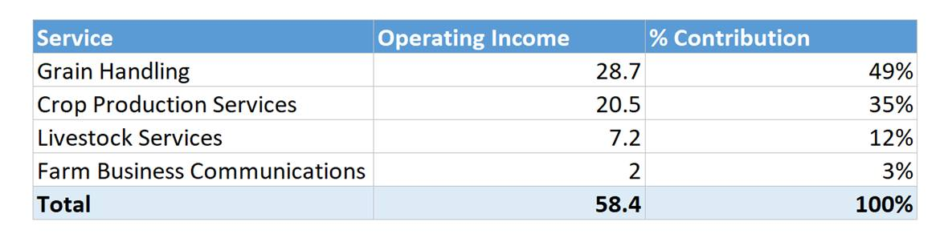Weather, Inventory, and Commodity are risks that would vary with the type of grain. We should also note that the impact and variance would be high in weather factor relative to inventory and commodity. To consider this in calculating a more accurate Earnings at Risk (EaR), we propose to segment by business function, board grain or not, and individual grain type, in that order. The explanation for this is as follows.

Table .1

To calculate EaR due to weather, first, we will segment the business based on the business function. From the 1998 data, we can estimate the % contribution to revenue of each business function and allocate risk accordingly. From table 1.1, we can see that grain handling contributes to almost half the operating income. Next, we can see the variation of board grains and non-board grains within the business functions. The idea behind this is that since the government issuing a floor price regulates the board grain prices, its price fluctuation will be less and the impact on UGG’s revenue also will be less. Though, UGG is still not immune to the effect on its income by the change in the quantity of the board grains which could differ due to weather conditions. We can safely assume that risks associated with board and non-board grains are significantly different and need to be calculated separately

Ideally, we would have the price variation of each crop within the business functions, because the weather conditions will affect each yield differently for instance lack of rain affects wheat differently as opposed to barley or corn. Which would adversely affect the quantity of the crop produced which in turn affects UGG’s revenue and operations.

Therefore, by analyzing the distribution, we can assign the risk associated with each crop using probability. Also, we know that there is only a 10% chance that the plants might be destroyed due to adverse weather. We can overlay this probability to the price variations.

**Answer 2.b:** Since the business needs to buy significant quantities of corn, it can hedge against rising corn price by taking up a position in the corn futures market.

A long hedge can be used to secure a purchase price for a supply of corn that they will require some time in the future. To implement the long hedge, enough corn futures are to be purchased to cover the quantity of corn needed for the business.

The price of corn as of Dec 3rd, 2018 was 3.72 USD per bushel. The price as of Jan 20, 2019, is 3.82 USD per bushel. A 60% corn portfolio implies a USD 300mn portfolio. A price rise of 10 cents would impact the portfolio negatively by nearly USD 8mn. To protect against this price rise, an extended futures position can be entered at 3.72 USD per bushel or lower if possible. Also, the corn must be stored for more than a month. This would imply quality risks which have to identify and consider the extended position would have to be entered into at a price lesser than 3.72 USD per bushel to offset these risks. By entering into this agreement, USD 8mn or more can be saved.

The price of wheat is 202 USD per bushel as of Dec 3rd, 2018. It rose to a cost of 204 USD per bushel as of Jan 20th, 2019. The ideal hedging strategy would again be an extended futures position. Still, the quality risk associated with wheat could be evaluated to enter a strike price lesser than 202 USD per bushel. USD 1.98mn can be saved by entering at a strike price of 202 USD.

Therefore, a total of approximately $10mn can be saved by entering into a futures contract with a long hedge.

**Answer 3:** While UGG was analyzing weather risks, they found that four variables - precipitation in June & July, and average temperatures in February & September, explained 85% variation in crop yields. The crop yields, i.e., the yields as a function of the four variables, were then used to model the variation in earnings of UGG’s grain handling. In the model which explains the earnings, crop yields are explaining 94% of the variation in the earnings.

1. There are multiple pitfalls to a model that explains earnings
   1. The uncertainty of earnings increases for each year in the forecast

If we were to project earnings for future years, then for each outer year of earnings projection, we would build in more uncertainty in the model. [3]The further the projection, the more uncertain the earnings. More so, as per the model, the earnings are based on yields, which are in turn based on precipitation and average temperatures. The projection of precipitation and average temperatures for a given year is based on previous years’ values. Hence the more futuristic the earnings projection, the less the values are based on available data.

* 1. The sensitivity of growth rate assumption

The projections of variables in the model are usually based on previous values +/- the growth rate. The assumption on growth rate can impact the projections quite significantly. Moreover, assuming a single growth rate for all years could also lead to incorrect earnings projections.

1. Improving the model to explain earnings better

The earnings model can be improved by utilizing the previous earnings themselves[4]. This means the predicted earnings are a function of current earnings too. This would bring the model closer to explain the variations in the earnings.

1. Conditions for an insurer to provide unlimited protection for a crop

[5]Crop insurance requires several conditions to be fulfilled, like results of some events outside the control of the insured party, farmers facing a pure risk – a risk not offset by hope of gain & affordable premium for the party seeking coverage. To be able to provide unlimited protection, all these conditions would need to be fulfilled to the fullest levels. First, all risks must be accounted for, assuming negative results of all events outside control. Secondly, the risks to the crop should not be speculative, thus not making profits from those risks. Thirdly, the premium should be affordable, which typically happens through government subsidies. If these conditions are fulfilled, an insurer could provide unlimited protection for a crop.

1. Takeover Defenses Work. Is That Such a Bad Thing? Mark Gordon
2. Pearce, John & Jr. Robinson, Richard. (2004). Hostile takeover defenses that maximize shareholder wealth. Business Horizons. 47. 15-24. 10.1016/j.bushor.2004.07.004.
3. Top 3 Pitfalls of Discounted Cash Flow Analysis (www.investopedia.com)
4. An Improved Earnings Forecasting Model, Richard D.F. Harris & Pengguo Wang (April 2013)
5. The Strange Economics of Crop Insurance (www.niskanencenter.org/blog/the-strange-economics-of-crop-insurance/)