
Business Question and Visualization Report

Date | 18 September 2026
Team ID | N/A
Project Name | India's Agricultural Crop Production Analysis
Maximum Marks | 5 Marks

Visualization development refers to the process of creating graphical representations of data to facilitate understanding, analysis, and decision-making. The goal is to transform complex datasets into visual formats that are easy to interpret, enabling users to gain insights and make informed decisions. Visualization development involves selecting appropriate visual elements, designing layouts, and using interactive features to enhance the user experience. This process is commonly associated with data visualization tools and platforms, and it plays a crucial role in business intelligence, analytics, and reporting
Business Questions and Visualisation
The process involves defining specific business questions to guide the creation of meaningful and actionable visualizations in Tableau. Well-framed questions help in identifying key metrics, selecting relevant data, and building visualisation that provide insights.

Business Questions and Visualisations
1. What is the overall agricultural production and yield recorded in the dataset?
Visualization: KPI cards showing Total Production and Total Yield.
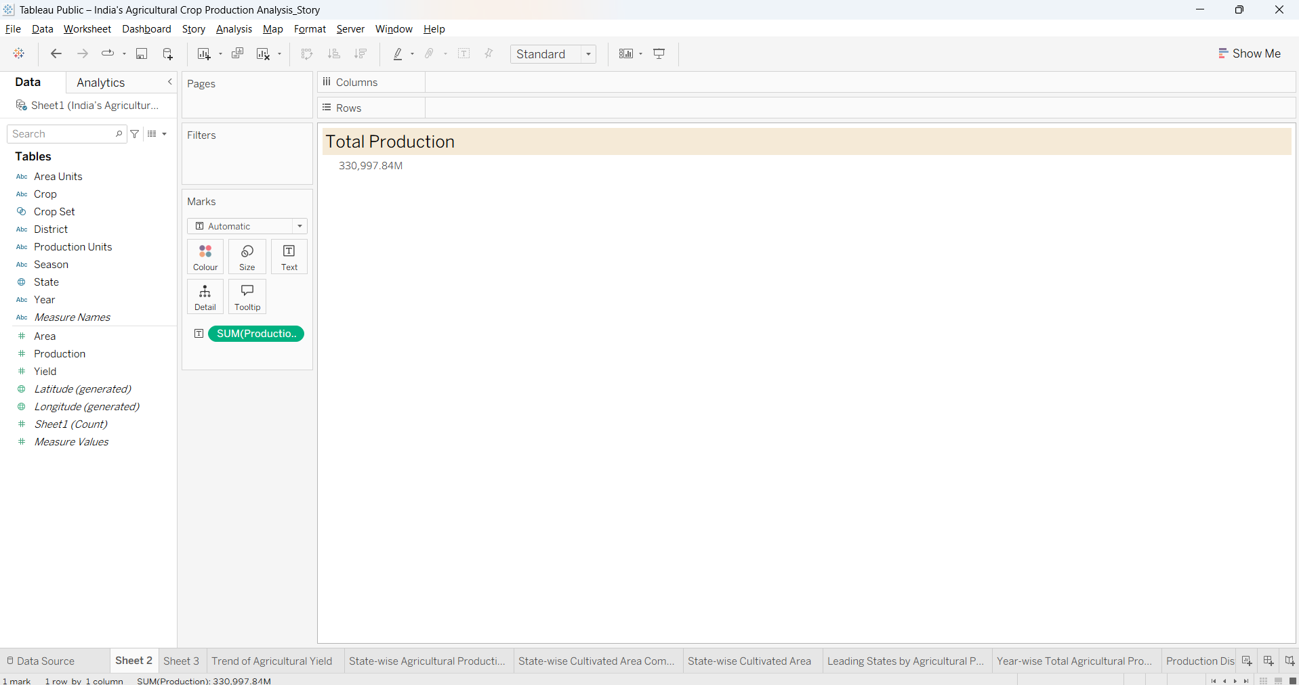

2. How does agricultural yield vary across the agricultural years?
Visualization: Line chart showing the Trend of Agricultural Yield over time.
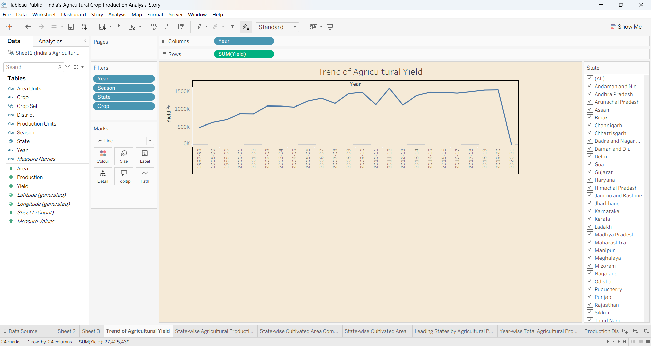
3. How is agricultural production distributed across Indian states?
Visualization: India map showing state-wise agricultural production.
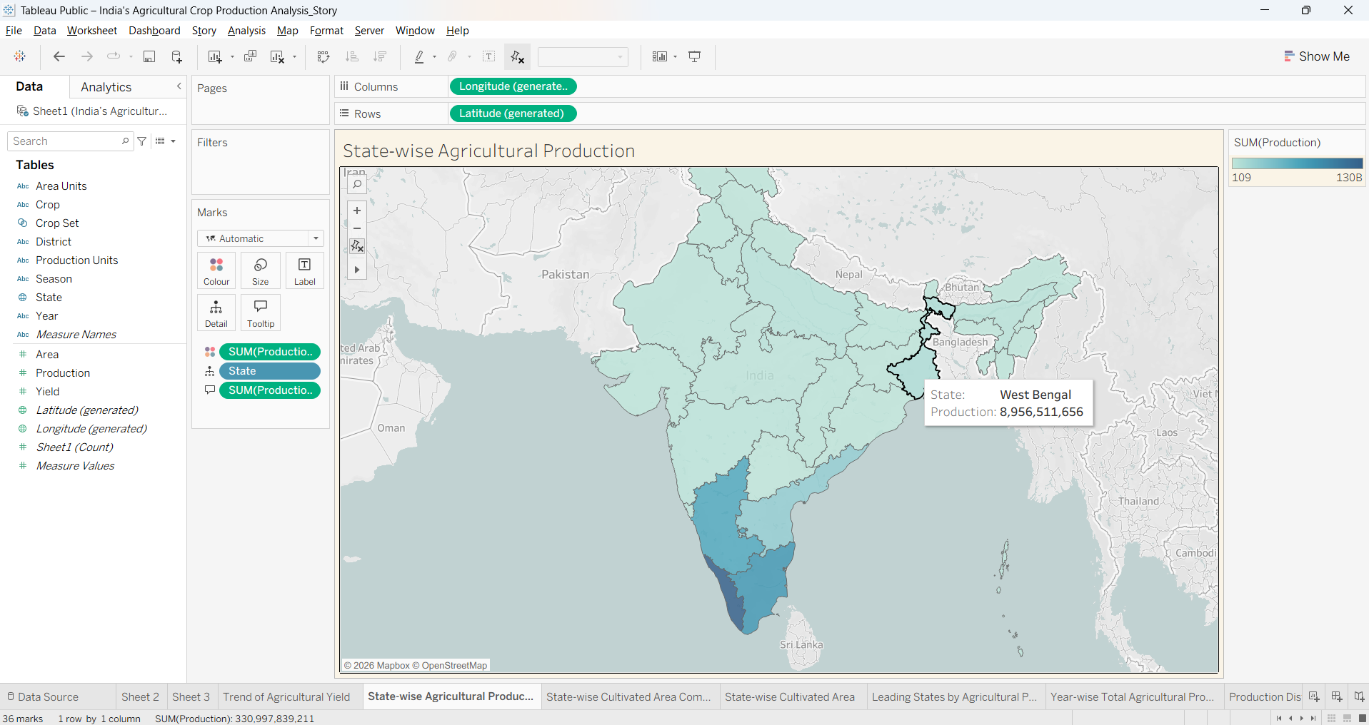

4. Which crops occupy the largest cultivated areas?
Visualization: Horizontal bar chart comparing cultivated area by crop.
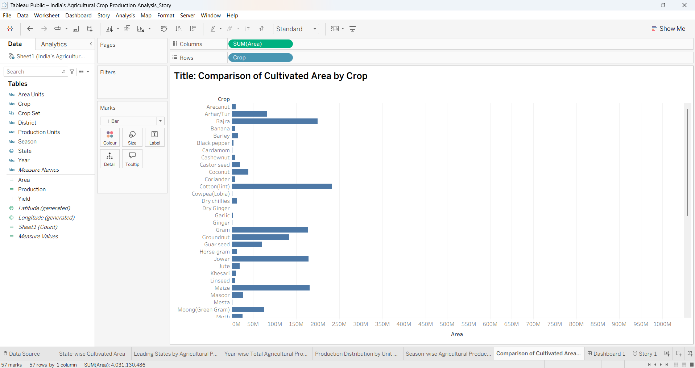
5. How does cultivated area vary among Indian states?
Visualization: Treemap showing State-wise Cultivated Area Comparison.
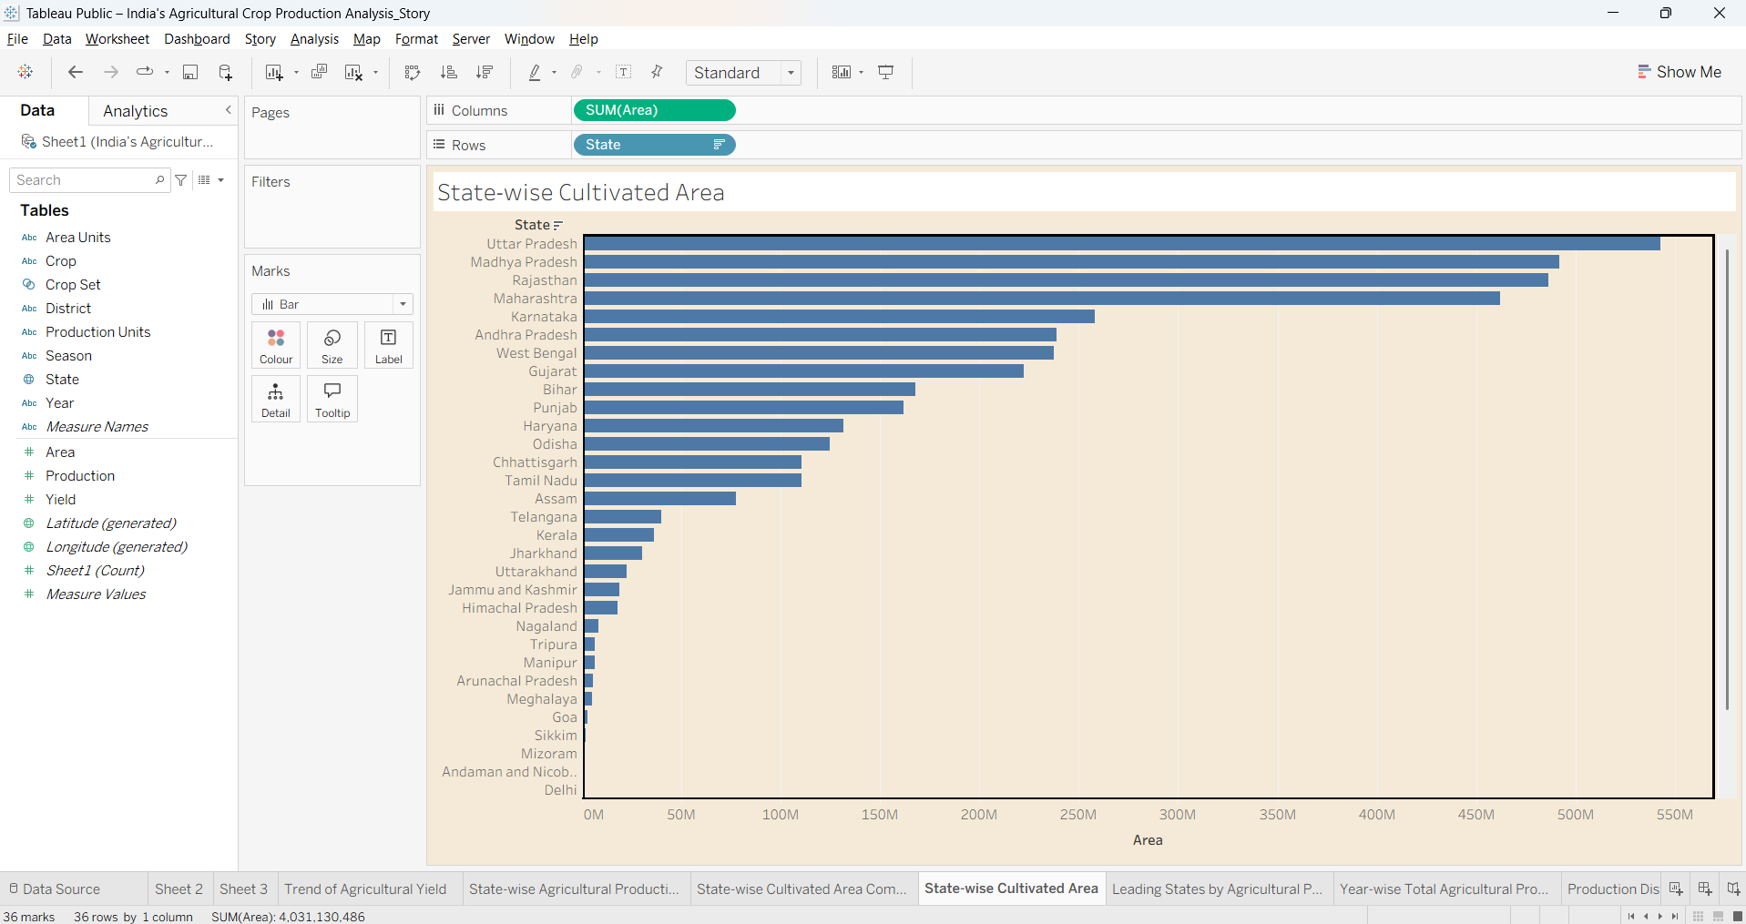

6. Which Indian states are the leading agricultural producers?
Visualization: Packed bubble chart showing leading states by agricultural production.
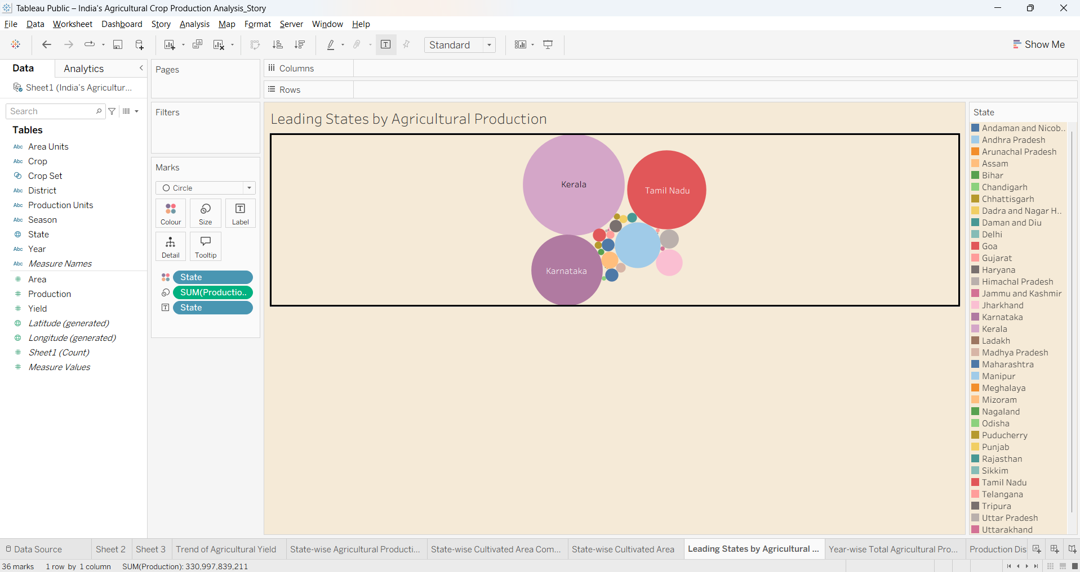
7. How does total agricultural production change across agricultural years?
Visualization: Line chart showing Year-wise Total Agricultural Production.
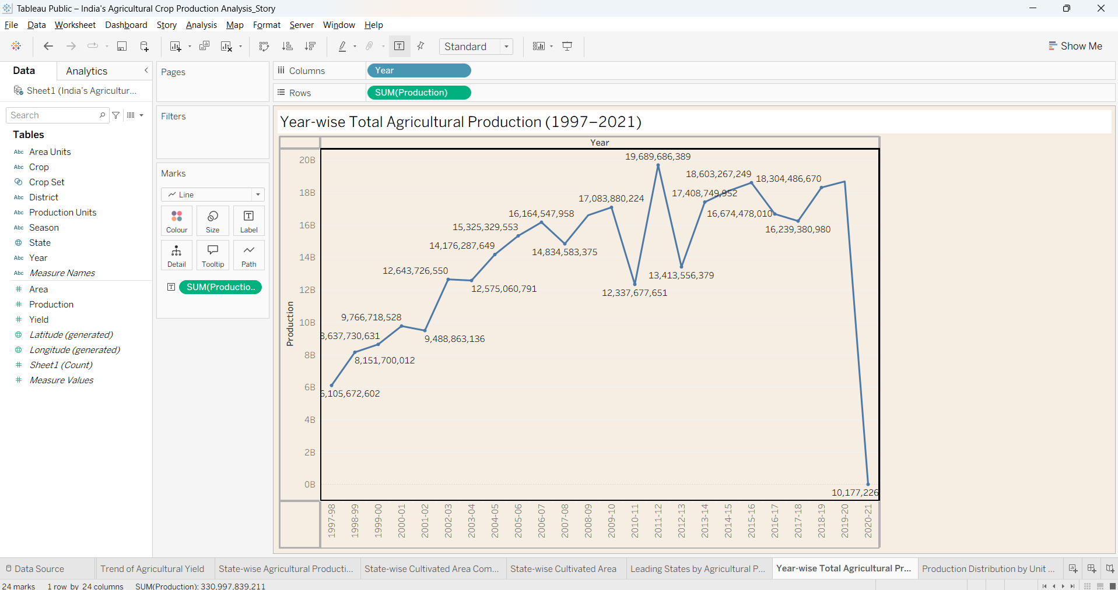

8. How is agricultural production distributed across seasons and production-unit types?
Visualization: Season-wise Agricultural Production Share pie chart and Production Distribution by Unit Type pie chart.
