FINAL PROJECT REPORT
India's Agricultural Crop Production Analysis
Detail | Value
Student Name | Abhishek Sutar
Roll No. | A61
Department | AIDS
Date | 30 September 2026
Team ID | N/A
Project Type | Tableau Data Analytics Project

1. Introduction

1.1. Project Overview
India's Agricultural Crop Production Analysis is a Tableau-based data analytics project developed to analyze agricultural crop production across Indian states, districts, crops, seasons and agricultural years. The project transforms a large agricultural dataset into interactive visualizations, a consolidated dashboard and a Tableau Story.
The dataset contains approximately 345,408 records including the header, covering 36 states/UTs, 729 districts, 57 crops, 24 agricultural years from 1997-98 to 2020-21, and six seasons: Kharif, Rabi, Autumn, Winter, Summer and Whole Year.

1.2. Objectives
- Analyze agricultural production and yield patterns across agricultural years.
- Compare cultivated area across crops and Indian states.
- Identify states with high agricultural production.
- Study production distribution across seasons and production-unit types.
- Develop clear Tableau visualizations and an interactive dashboard.
- Present findings through a Tableau Story.

2. Project Initialization and Planning Phase

2.1. Define Problem Statement
Agricultural data contains information across many states, districts, crops, seasons and years, making it difficult to identify meaningful production patterns from raw tabular data. The project aims to organize and visualize this information so users can understand production, yield, cultivated area, geographic distribution and seasonal patterns effectively.

2.2. Project Proposal (Proposed Solution)
The proposed solution is a Tableau analytics solution. The agricultural dataset is prepared and explored, business questions are framed, and relevant charts are created. These charts are combined into an interactive dashboard and a multi-point Tableau Story.

2.3. Initial Project Planning
- Collect and inspect the agricultural dataset.
- Identify fields, data types, missing values, zero values and measurement units.
- Clean and standardize field names.
- Frame business questions.
- Develop Tableau visualizations.
- Build dashboard and Story.
- Publish to Tableau Public.
- Document observations and performance testing.

3. Data Collection and Preprocessing Phase

3.1. Data Collection Plan and Raw Data Sources Identified
The project uses an agricultural crop production dataset containing state, district, crop, year, season, cultivated area, production, production units and yield information. The prepared spreadsheet dataset was imported into Tableau.
Attribute | Detail
Records | Approximately 345,408 including header
States/UTs | 36
Districts | 729
Crops | 57
Agricultural Years | 1997-98 to 2020-21
Seasons | 6
Measures | Area, Production, Yield
Production Units | Tonnes, Bales, Nuts

3.2. Data Quality Report
- No blank/null cells were identified in the prepared dataset.
- No negative Area or Production values were identified.
- 1,024 records had Production equal to zero and were retained as valid observations rather than deleted automatically.
- Production contains different unit types: Tonnes, Bales and Nuts; these should not be treated as physically equivalent.
- Potential outliers were retained unless there was a clear reason to remove them.

3.3. Data Exploration and Preprocessing
- Standardized 'season' to 'Season'.
- Renamed 'Production Units.1' to 'Yield'.
- Area, Production and Yield were treated as numeric measures.
- State, District, Crop, Season, Area Units and Production Units were treated as categorical fields.
- Year was retained as an agricultural-year label such as 1997-98.
- Prepared data was used for Tableau worksheets, dashboard and Story.

4. Data Visualization

4.1. Framing Business Questions
No. | Business Question
1 | What is the overall agricultural production and yield recorded in the dataset?
2 | How does agricultural yield vary across the agricultural years?
3 | How is agricultural production distributed across Indian states?
4 | Which crops occupy the largest cultivated areas?
5 | How does cultivated area vary among Indian states?
6 | Which Indian states are the leading agricultural producers?
7 | How does total agricultural production change across agricultural years?
8 | How is agricultural production distributed across seasons and production-unit types?

4.2. Developing Visualizations
Visualization | Type | Purpose / Result
Total Production KPI | KPI card | 330,997.84M units
Total Yield KPI | KPI card | 27.43M
Trend of Agricultural Yield | Line chart | Year-wise yield trend
State-wise Agricultural Production | India map | Geographic production distribution
Comparison of Cultivated Area by Crop | Horizontal bar | Crop-wise cultivated area
State-wise Cultivated Area | Treemap / bar | State-wise cultivated area
Leading States by Agricultural Production | Packed bubbles | Leading producing states
Year-wise Total Agricultural Production | Line chart | 1997-98 to 2020-21 trend
Production Distribution by Unit Type | Pie chart | Tonnes, Bales and Nuts
Season-wise Agricultural Production Share | Pie chart | Seasonal production share

5. Dashboard

5.1. Dashboard Design File
The dashboard titled "India's Agricultural Crop Production Analysis" combines KPI cards, geographic visualization, comparison charts, trend charts and distribution charts.
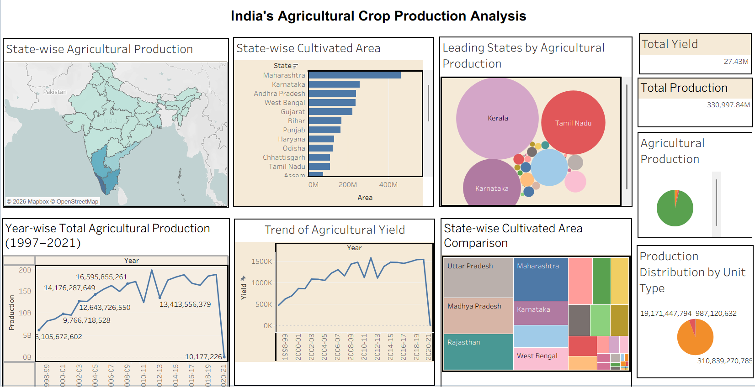
Figure 1. Final Tableau Dashboard
The dashboard includes the state-wise production map, state-wise cultivated area, leading-state bubbles, Total Yield KPI, Total Production KPI, production-unit pie, year-wise production trend, yield trend and cultivated-area treemap.
Tableau Public Dashboard: https://public.tableau.com/views/Dash_17905757110220/Dashboard1?:language=en-US&:sid=&:redirect=auth&:display_count=n&:origin=viz_share_link

6. Report

6.1. Story Design File
A single Tableau Story was created with eight Story Points covering overall performance, geographic distribution, cultivated area, leading states, yearly production, yield, seasonal production and production-unit distribution.
- Agricultural Performance
- Geographic Distribution / State-wise Agricultural Production
- Cultivated Area Across Indian States
- Leading States by Agricultural Production
- Year-wise Agricultural Production
- Trend of Agricultural Yield
- Season-wise Agricultural Production
- Production Distribution by Unit Type
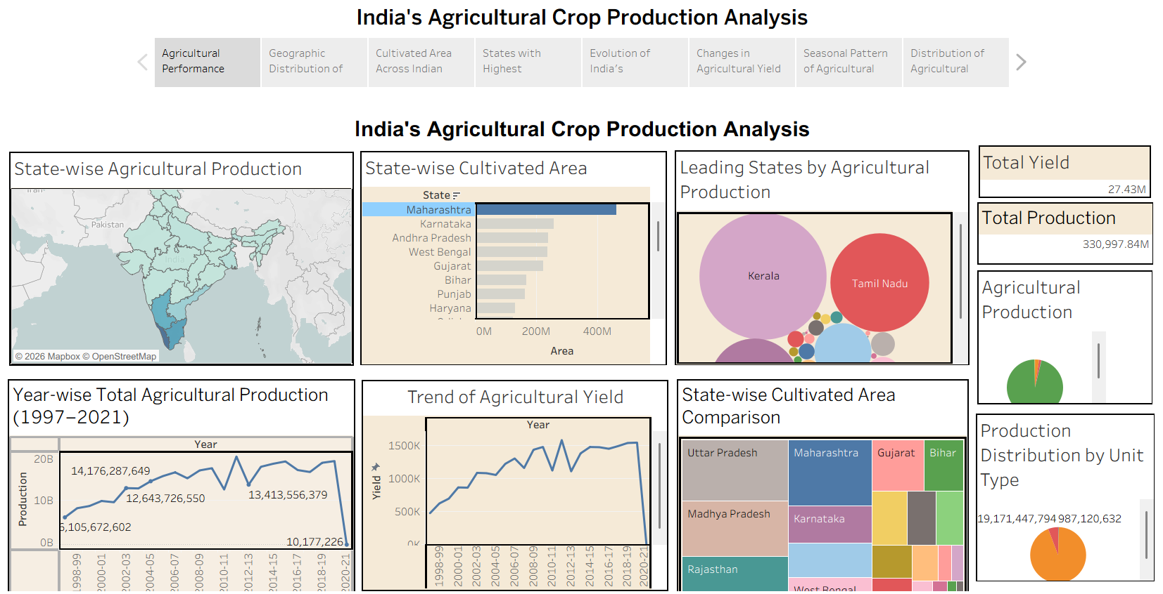
Figure 2. Final Tableau Story with eight Story Points
Tableau Public Story: https://public.tableau.com/views/IndiasAgriculturalCropProductionAnalysis_Story/Story1?:language=en-US&:sid=&:redirect=auth&:display_count=n&:origin=viz_share_link

7. Performance Testing

7.1 Utilization of Data Filters
The workbook uses categorical dimensions such as State, District, Crop, Season and Year for interactive analysis. Dashboard selections and filters allow users to focus on relevant portions of the agricultural data.

7.2 No. of Calculation Field
No separate complex calculated fields were required for the final analysis. The project mainly uses Tableau aggregations such as SUM of Area, Production and Yield with categorical dimensions.

7.3 No. of Visualization
There are 10 main analytical visualization/KPI views: 2 KPI cards, 2 line charts, 1 map, 1 horizontal bar chart, 1 treemap, 1 packed bubble chart and 2 pie charts.

8. Conclusion / Observation
- The project successfully converts a large agricultural dataset into an interactive Tableau analytics solution.
- The dashboard makes comparison of production, yield and cultivated area easier.
- Year-wise charts help identify temporal production and yield patterns.
- State-wise views show geographic differences in agricultural activity.
- Crop-wise area comparison highlights differences in cultivated area.
- Season-wise analysis shows variation in production contribution.
- Tonnes, Bales and Nuts must be interpreted separately because they are different measurement units.
- The Tableau Story provides a structured narrative of the major findings.

9. Future Scope
- Add newer agricultural years when compatible data becomes available.
- Add crop-wise and state-wise forecasting.
- Integrate rainfall, weather, soil and irrigation information.
- Add market price, revenue, cost and profitability data where reliable sources are available.
- Add more drill-down and interactive filtering options.
- Embed the Tableau analytics solution into a web application or institutional portal.

10. Appendix

10.1. Source Code (if any)
Not Applicable. This is a Tableau-based analytics project and no separate source-code repository is provided.

10.2. GitHub & Project Demo Link
GitHub: Not available.
Project Demo: Not available.
Tableau Public Dashboard: https://public.tableau.com/views/Dash_17905757110220/Dashboard1?:language=en-US&:sid=&:redirect=auth&:display_count=n&:origin=viz_share_link
Tableau Public Story: https://public.tableau.com/views/IndiasAgriculturalCropProductionAnalysis_Story/Story1?:language=en-US&:sid=&:redirect=auth&:display_count=n&:origin=viz_share_link

