
Story

Date | 30 September 2026
Team ID | N/A
Project Name | India's Agricultural Crop Production Analysis
Maximum Marks | 5 Marks

By using stories in Tableau, you can effectively communicate complex data in a way that is both interactive and engaging, making it easier for the audience to follow along and understand the insights. It’s a tool for data storytelling, allowing you to present insights in a cohesive, engaging way that takes viewers through a logical progression of findings or analyses.
In Tableau, Story is a feature that allows you to create a sequence of dashboards, visualizations, and text to present data insights in a cohesive and narrative-driven way. It's like a slideshow within Tableau that guides the audience through a series of data points, helping them understand key insights, trends, or outcomes of your analysis.

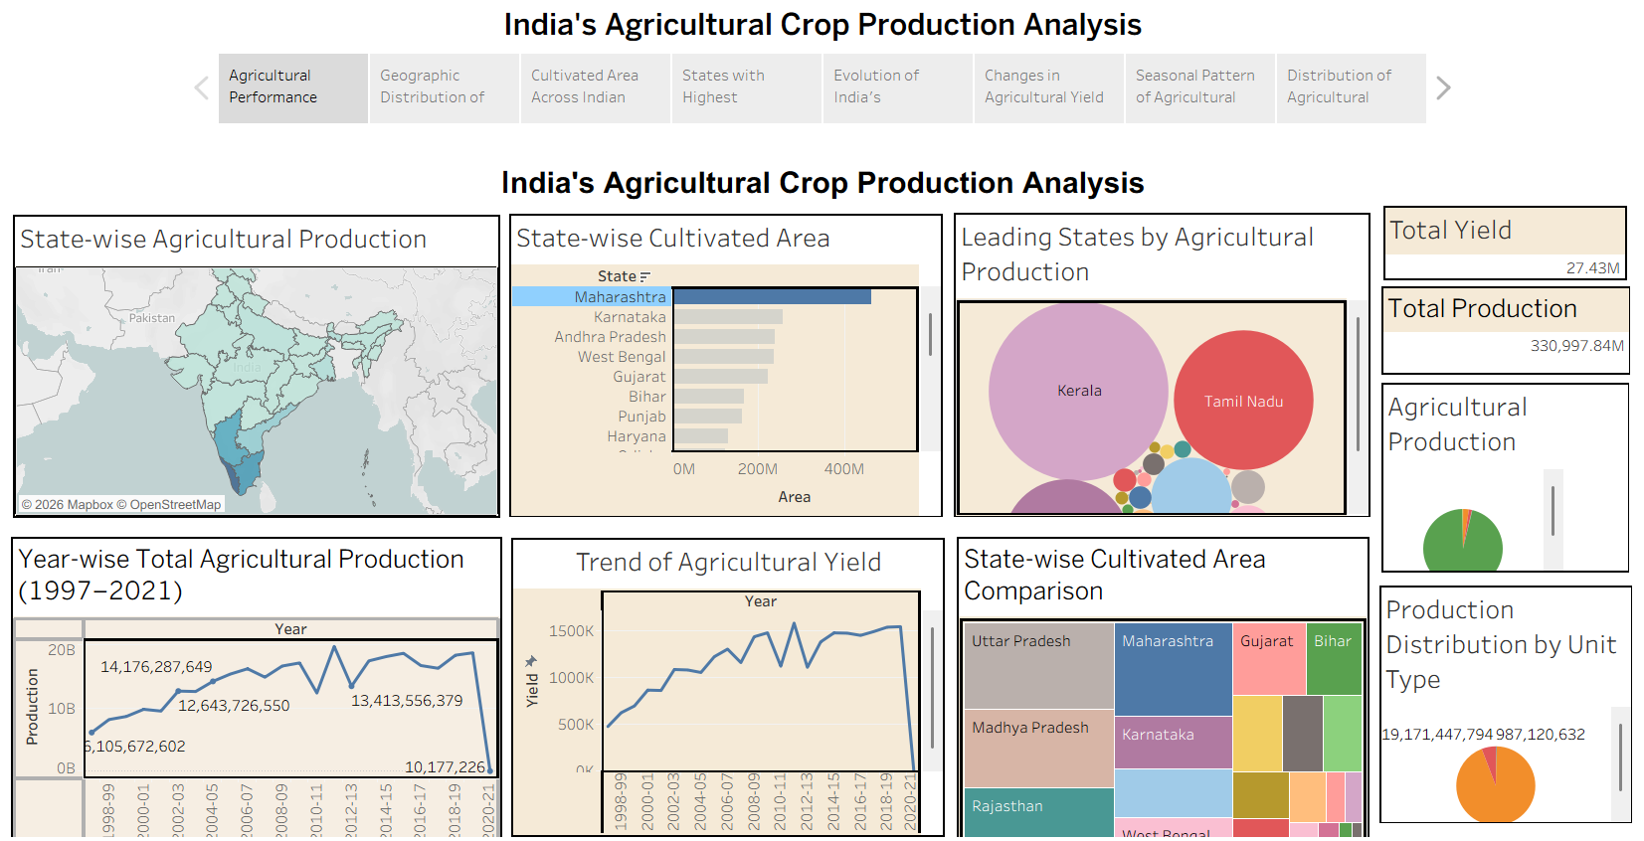
Observations:
• Agricultural Performance Overview: The story begins with an overall view of India's agricultural performance, including total production of approximately 330,997.84M and total yield of approximately 27.43M.
• Geographic Distribution: The state-wise production map shows how recorded agricultural production is distributed geographically across Indian states.
• Cultivated Area Across States: The cultivated-area visual highlights differences in agricultural area across Indian states and makes larger cultivated areas easy to identify.
• Leading Producing States: The packed-bubble view highlights major agricultural producing states and supports quick comparison of their recorded production.
• Production Evolution: The year-wise production story point shows changes in recorded agricultural production across agricultural years from 1997-98 to 2020-21.
• Agricultural Yield Trends: The yield trend visual shows changes in recorded agricultural yield over the agricultural years.
• Seasonal Pattern: The season-wise view shows the distribution of recorded agricultural production across Autumn, Kharif, Rabi, Summer, Whole Year and Winter.
• Production Unit Distribution: The unit-type view shows recorded production across Tonnes, Bales and Nuts; these different units should not be treated as physically equivalent measurements.
Activity 2:
Publish Story on Tableau Public and Paste Public link below
https://public.tableau.com/views/IndiasAgriculturalCropProductionAnalysis_Story/Story1?:language=en-US&:sid=&:redirect=auth&:display_count=n&:origin=viz_share_link

