Search Engine using Learning To Rank system

Abhishek Vasudevan

Master’s in Computer Science  
University of Illinois at Chicago

[avasud8@uic.edu](mailto:avasud8@uic.edu)

**ABSTRACT**

In this report, we explore the topic of web crawling and searching using an intelligent component called Learning To Rank (LTR) systems. Although, the implementation tried out was not very successful, a lot of valuable insight is gained through the experimentation process, providing scope for future work.

**General Terms**

Algorithms, Measurement, Performance, Design, Reliability

**Keywords**

Search Engines, Similarity, Page Rank, Learning To Rank,

# INTRODUCTION

Web crawling and search engines form a vital part of the World Wide Web, making web content easily accessible to the user’s demands. Search engines have been explored extensively over the years. However, with the advent of machine learning, several new methods have been tried and implemented by top search companies like Google, Microsoft, etc. One major concept is that of a Learning To Rank system which is widely adopted by all the top search engines.

# PROCESS OVERVIEW

Figure 1 shows the flow chart of the search process. Initially, the UIC subdomain is crawled using a typical web crawler. Features as explained in Section 4.2 are extracted from each web-page. These features can be either query-dependent or independent. All these features assigned a weight. The sum of the features multiplied by their weight form a relevance score for the page which in comparison with the score of other pages form the ranking/ordering of the output results. We present each of concepts in detail and also the experiments section discusses the results of the implementation. Finally, future work and conclusion are presented.

Figure 1. Flow chart of the entire process

# 3. RELATED WORKS:

The early stages of text retrieval showed enormous usage of term-frequency and cosine similarity computation for calculating the relevance score of each web page with respect to the query. However, soon it proved to be an inefficient way of ranking pages as unimportant pages with more of query terms ranked better than important pages (authority pages) having lesser frequency of query terms but having more relevance. Several algorithms were developed over the years, the most important being the HITS algorithm [1] and the PageRank algorithm. The HITS algorithm ranked pages based on their in-links and out-links. Pages having more out-links were called hubs and the pages having more in-links were called authorities. The PageRank algorithm [2] developed by Google founders Brin and Page was more successful than HITS. PageRank is a measure of computing the importance of one page with respect to importance of other pages linking to it. While HITS is query dependent, PageRank is query independent and has to be coupled with other relevance schemes to produce an overall relevance score. This report explores the latter mentioned topic which includes coupling of PageRank and several other features to provide optimal search results. This has been done by Microsoft’s LETOR system where they have identified around 136 features to estimate the relevance of the page.

Permission to make digital or hard copies of all or part of this work for personal or classroom use is granted without fee provided that copies are not made or distributed for profit or commercial advantage and that copies bear this notice and the full citation on the first page. To copy otherwise, or republish, to post on servers or to redistribute to lists, requires prior specific permission and/or a fee.

# METHOD USED

## CRAWLING

The crawler used is a traditional crawler which goes from one page to another in a Breadth First Search (BFS) fashion. It starts at <https://www.cs.uic.edu> which is the root node. From here, it adds all other hyperlinks in this webpage to a queue and the webpage is removed. The next page in the queue is chosen and the process is repeated until the queue is empty or a threshold is reached. Obviously, considering the vastness of the World Wide Web (WWW), the process was terminated with the help of a threshold/page limit in this experiment. Roughly, around 5000 web pages within the UIC domain were traversed and stored in an inverted index. Several other features were also stored from each page which are explained in the subsequent sections.

The pages were downloaded initially and then preprocessed, so that the process is faster. The inlinks and outlinks from each page were also stored, so that the PageRank of each page can be determined. Pages which took too long to respond or were not available were not added to the inverted index. Each page stored in the inverted index is referred to using a number rather than the page URL (for more efficiency and ease of coding).

## Extracted features

Table 1 shows the list of features extracted from each web page and also if that feature is dependent or independent of the search query given by user. This feature can be from the title (T), body(B) or URL(U) of the webpage.

Table 1. List of features extracted from each web page

|  |  |  |  |
| --- | --- | --- | --- |
| **Feature number** | **Feature name** | **Portion of text**  **(T/B/U)** | **Independent/Dependent on query? (I/D)** |
| 1, 2 | Number of covered query terms | T, B | D |
| 2, 3 | Covered query term ratio | T, B | D |
| 5, 6 | Stream length | T, B | I |
| 7, 8 | IDF | T, B | D |
| 9, 10, 11 | Sum of TF | T, B, U | D |
| 12, 13 | Minimum of TF | T, B | D |
| 14, 15 | Maximum of TF | T, B | D |
| 16, 17 | Mean of TF | T, B | D |
| 18, 19 | Sum of TF-IDF | T, B | D |
| 20, 21 | Min. of TF-IDF | T, B | D |
| 22, 23 | Max. of TF-IDF | T, B | D |
| 24, 25 | Mean of TF-IDF | T, B | D |
| 26 | Number of slashes | U | I |
| 27 | Length of URL | U | I |
| 28 | Inlink count | U | I |
| 29 | Outlink count | U | I |
| 30 | PageRank | U | I |

These features were chosen based on Microsoft’s Learning To Rank dataset [3] which hosts 136 features used to find relevance of a page with respect to others. Since several of Microsoft’s features were privately held [4] i.e., not released to the public, those features could not be tested on our experiment. These privately held features include user dwell time, quality scores of pages based on Microsoft’s private algorithm, URL click count, Query-URL click count, etc. Hence, for our experiment we use only the 30 features listed out in Table 1. Most of the features listed out can be intuitively understood. Covered query terms is the number of terms from query present in the web page. The ratio would mean the covered query terms divided by the query length. Stream length is the number of characters in the title and body of the page. IDF is the inverse document frequency i.e., sum of IDF of each query term present in the web page. Similarly, TF is the term frequency of each query term in the web page. We also calculate the minimum, maximum and mean of term frequency. Similar to TF, we calculate the sum, maximum, minimum and mean of TF-IDF score for each page. We also have the length of URL and number of slashes in the URL. Finally, we have important features which are not query dependent namely, in-link count (number of pages pointing to that page), out-link count (number of pages that the current page points to) and the page rank of that page.

## Term-frequency and Inverse document frequency

TF and IDF values are calculated in the traditional way i.e., through the use of an inverted index. From a programming perspective, two dictionaries were used to hold both of these features. The term frequency is held by a 2-D dictionary (one dimension for document number and second dimension for words) and inverse document frequency is a 1-D dictionary having just the words and their frequency as elements. All words in the web-page were processed in the same manner before being added to the inverted index: the word was converted to lower case; all trailing and leading whitespaces were removed and finally the words were stemmed. The Porter Stemmer from the Natural Language Tool Kit (NLTK) was used here.

No more description of these concepts is required here.

## PageRank

Once again, the traditional random surfer model [5] is used in this experiment. The PageRank of a webpage is given by the following formula:  


The above formula handles cycles in the graph and also deals with dangling nodes. Nodes which do not have outgoing links are called dangling node (or) sinks. These can cause the page rank to collapse, causing the page rank score to be concentrated at the sink. In the experiment, verification was done by adding up the page rank of all 5000 crawled and making sure this summed up to a value of approximately 1, ensuring the score is split in the correct way.

Table 2 shows the top 10 pages according to the PageRank algorithm used in the experiment.

Table 2. Top 10 pages outputted by PageRank

|  |  |  |
| --- | --- | --- |
| **S. No** | **URL** | **Page Rank score** |
| 1 | uic.edu | 0.03627 |
| 2 | maps.uic.edu | 0.01350 |
| 3 | disabilityresources.uic.edu | 0.01228 |
| 4 | library.uic.edu | 0.01150 |
| 5 | uic.edu/apps/departments-az/search | 0.01131 |
| 6 | emergency.uic.edu | 0.01059 |
| 7 | catalog.uic.edu/ucat/academic-calendar | 0.00911 |
| 8 | today.uic.edu | 0.00805 |
| 9 | dos.uic.edu/studentveteranaffairs.shtml | 0.0077 |
| 10 | uic.edu/about/job-opportunities | 0.00727 |

It is clear from the table, that the page rank algorithm has done well. The URL <https://uic.edu> has been ranked #1 which is no surprise considering the number of pages linking to it i.e., it has a high in-link count. Similarly, we have other important pages from the UIC subdomain in the list. The PageRank algorithm was run for 20 iterations which is more than enough usually for convergence of the score.

# NEURAL NETWORK

An attempt was made to train a neural network using linear regression [6] on Microsoft’s Learning To Rank dataset. The 136 features in the original dataset was cut down to 30 features which are the ones listed in Table 1. However, we faced several problems training the network. One was the high amount of training data coupled with number of features which posed a problem for training on a standard CPU. Hence, GPU power was required for training this for several epochs. Another problem is that Microsoft’s dataset has output labels within the range 0-4; 0 stood for no relevance of the page with respect to the query and 4 stood for high relevance with respect to the query.

Several training attempts were made on their data. Initially, the model would overfit at a value of 2.5 (outputting value of 2.5 for any input page). Given output labels within 0-4, 2.5 is a good output all the time as the mean squared error would always be low. This indicated that the model overfits given such a small output range. What we tried next was to multiply output labels by 100, thereby dataset having output labels (0, 100, 200, 300 and 400) was formed. However, the model never converged on this dataset outputting high error values and very low validation accuracy. Hence, as a last-ditch attempt, we assign the weights manually for each feature and sum them up to form relevance score as explained in the next section.

# FEATURE WEIGHT ASSIGNMENT

Firstly, the importance of each feature was determined. Then a trial and error method of plugging in different weight values and checking the output results was done to ensure that fairly acceptable weight values were assigned.

It is no doubt that the number of covered query terms is an important feature in determining whether a page is relevant or not. The covered query term for title and the body is set to a high weight value of 40 and 100 respectively. Then, the weight for in-link count of any page was calculated as follows:

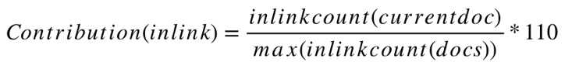

The denominator is the page having highest in-link value. So this page would be having a value of 110 which is the highest value possible by in-link feature.

The amount contributed by page rank was found in the following way:

## 

What this formula does is assign page with rank 1 a value of 110. The number 5000 is used as that is the number of pages crawled. Lower pageranks give lower scores.

The next important features are the length of the URL and number of slashes. Both of these features are penalty incurring i.e., they decrease relevance score of the page. Higher URL lengths leads to more penalty, similarly with number of slashes. This is crucial in identifying authority pages. The effect of this feature is explained in the next section.

All these weight values were assigned after several trial and error tests with a lot of queries. Other features mentioned in Table 1 have lower weight value as their contribution to the overall score is not clear. Hence, the other features in the list were arbitrarily assigned lower weights of 0.001. These features include the different term frequency and TF-IDF features.

Therefore, the final relevance of a page is given by the following formula:

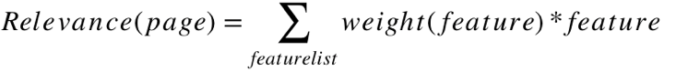

# EXPERIMENTS AND RESULTS

We list out the precision for the 5 queries given in Table 3 for both the intelligent and unintelligent method. The unintelligent method outputs the list of pages based on TF-IDF of each page according to the query. The intelligent method performs better; at least in the majority of the queries, as it takes both relevance of page and also importance of page.

Some queries are dependent on the keywords and not on importance of page: say we are searching for a person. The results of such a query are shown in Figure 2.

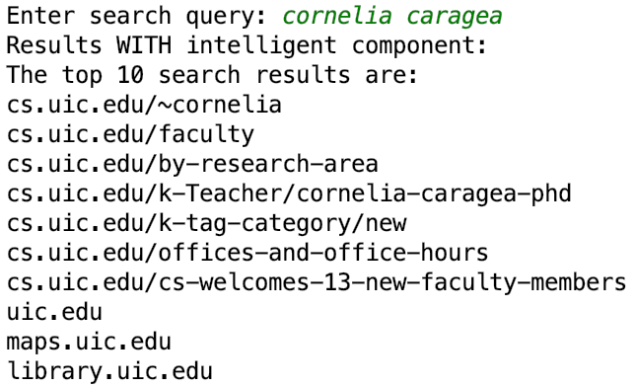

Figure 2. Intelligent engine output for “Cornelia Caragea”

This query is highly keyword dependent as it is the name of a person. Both the intelligent and unintelligent engines perform well for this query. When we search for a particular program, we get the following results:

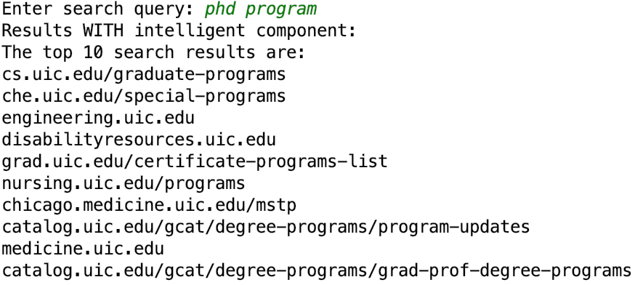

**Figure 3. Intelligent engine output for “phd program”**

This gives a satisfiable result with most results relating to web page listing the details of the PhD programs of several schools. The unintelligent search engine output results as shown in Figure 3.

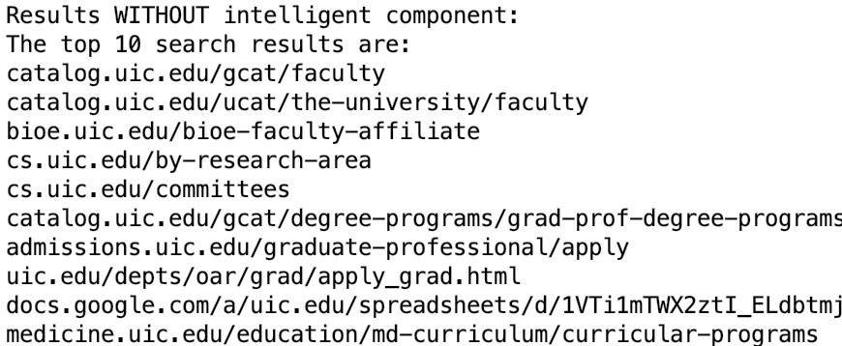**Figure 4. Unintelligent engine output for “phd program”**

There are some acceptable results, however a lot of them are irrelevant or are subpages of graduate programs which have the word “PhD” or “program” repeated several times. The reason why the intelligent search engine is performing well is because it incurs a penalty on the relevance score of the webpage depending on the URL length. Also, the covered query terms along with page rank helps in identifying “root” pages. Similarly, query “UIC” returns results as in Figure with intelligent component. This highlights the quality of the intelligent engine even better. The unintelligent search engine is stuck on pages which have high frequency of the term “UIC”, however this is not a desirable thing. The intelligent one on the other hand shows a good mix of pages, showing root pages of several parts of the UIC subdomain.

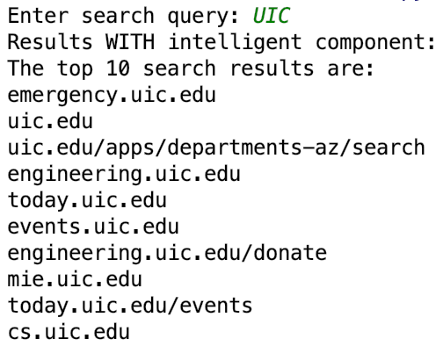

**Figure 5. Intelligent engine output for “UIC”**

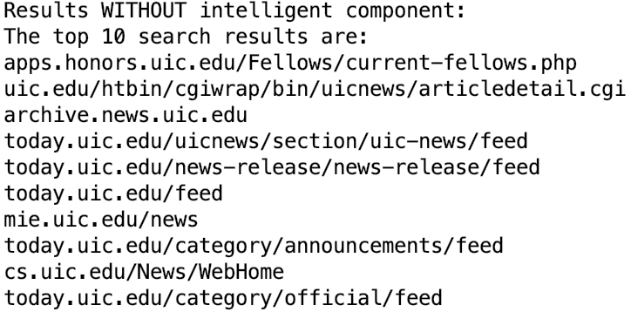

**Figure 6. Unintelligent engine output for “UIC”**

Table 3 shows the precision of 5 different queries for the top 10 results of both intelligent and unintelligent search engines.

Table 3. Precision values for top 10 query results

|  |  |  |  |
| --- | --- | --- | --- |
| **#** | **Query** | **Precision @10** | |
| **Intelligent** | **Unintelligent** |
| 1 | Cornelia Caragea | 0.7 | 0.6 |
| 2 | phd program | 0.7 | 0.3 |
| 3 | dentistry | 0.4 | 0.1 |
| 4 | uic | 0.8 | 0.2 |
| 5 | ui health | 0.7 | 0.3 |

It is clear from the table that the intelligent search engine performs better than the unintelligent one.

# PROBLEMS FACED:

The use of a properly trained neural network would have yielded better weights and would identify more complex connections between the features. However, since the basic regression model which was tried did not work, we had to resort to using manual weights as explained in Section 6. This required a lot of trial and error as a lot of plugging in of weights was done and a “right” mix of weights was to be found between the tf-idf and page rank features.

# CONCLUSION AND FUTURE WORKS:

The overall performance of the proposed search engine is decent enough. More research on neural networks and learning to rank methods could be done in order to extend the scope of this project and achieve better results. Microsoft uses an algorithm called SVM-MAP [7] instead of regression which is something I would possibly consider trying out in the vacation.

# REFERENCES:

|  |  |
| --- | --- |
| [1] | J. M. Kleinberg, "Authoritative Sources in a Hyperlinked Environment," [Online]. Available: https://www.cs.cornell.edu/home/kleinber/auth.pdf. |
| [2] | S. Brin and L. Page, "The PageRank Citation Ranking: Bringing Order to the Web," 29 January 1998. [Online]. Available: http://ilpubs.stanford.edu:8090/422/1/1999-66.pdf. |
| [3] | T. Qin, T.-Y. Liu, J. Xu and H. Li, "LETOR: A Benchmark Collection for Research on Learning to Rank for Information Retrieval," *Information Retrieval,* vol. 13, no. 4, pp. 346 - 374, August 2010. |
| [4] | S. Lei and X. Han, "Feature Selection and Model Comparison on Microsoft Learning-to-Rank Data Sets," University of California, Santa Barbara, December 2017. [Online]. Available: https://arxiv.org/pdf/1803.05127.pdf. |
| [5] | K. Dai, "PageRank Lecture Note," 22 June 2009. [Online]. Available: http://www.ccs.neu.edu/home/daikeshi/notes/PageRank.pdf. |
| [6] | C. Burges, T. Shaked and E. Renshaw, "Learning to Rank using Gradient Descent," *International Conference on Machine Learning,* 2015. |
| [7] | Y. Yue and T. Finley, "SVM Map," Microsoft, 31 October 2011. [Online]. Available: http://projects.yisongyue.com/svmmap/. |