**Advanced Database Management System Lab**

# Subject Code: 23CAP-502

**Student Name: Abhishek Sharma UID: 23MCC20083 Section/Group:23MCD-1/A Semester: 1st**

**Date of Performance:17/10/2023**

**Experiment No. 4**

**Aim/Overview of the practical:**

**EmployeeInfo Table:**

|  |  |  |  |  |  |  |  |  |
| --- | --- | --- | --- | --- | --- | --- | --- | --- |
| **EmpID** | **EmpFname** | **EmpLname** | **Department** | **Project** | **Address** | **DOB** | **Gender** | |
| 1 | Sanjay | Mehra | HR | P1 | Hyderabad(HYD) | 01/12/1976 | M |
| 2 | Ananya | Mishra | Admin | P2 | Delhi(DEL) | 02/05/1968 | F |
| 3 | Rohan | Diwan | Account | P3 | Mumbai(BOM) | 01/01/1980 | M |
| 4 | Sonia | Kulkarni | HR | P1 | Hyderabad(HYD) | 02/05/1992 | F |
| 5 | Ankit | Kapoor | Admin | P2 | Delhi(DEL) | 03/07/1994 | M |

**EmployeePosition Table:**

|  |  |  |  |
| --- | --- | --- | --- |
| **EmpID** | **EmpPosition** | **DateOfJoining** | **Salary** |
| 1 | Manager | 01/05/2022 | 500000 |
| 2 | Executive | 02/05/2022 | 75000 |
| 3 | Manager | 01/05/2022 | 90000 |
| 2 | Lead | 02/05/2022 | 85000 |
| 1 | Executive | 01/05/2022 | 300000 |

* Write a query to fetch the EmpFname from the EmployeeInfo table in the upper case and use the ALIAS name as EmpName.
* Write a query to fetch the number of employees working in the department ‘HR’.
* Write a query to get the current date.
* Write a query to retrieve the first four characters of EmpLname from the EmployeeInfo table.
* Write a query to fetch only the place name(string before brackets) from the Address column of EmployeeInfo table.
* Write a query to create a new table that consists of data and structure copied from the other table.
* Write q query to find all the employees whose salary is between 50000 to 100000.
* Write a query to find the names of employees that begin with ‘S’
* Write a query to fetch top N records.
* Write a query to retrieve the EmpFname and EmpLname in a single column as “FullName”. The first name and the last name must be separated with space.

**Task to be done:** Develop database using SQL concepts.

Apply different types of query to get different types of data.

Design queries using in-built SQL functions.

**Concept used:** firstly, we have to develop the given database using create table command and then insert data into the tables after that we have apply different types of query to performs tasks according to what is asked.

**Top of Form**

**Steps/Commands involved to perform experiment:**

create database ex4;

use ex4;

create table employeeinfo(

EmpID int(10) not null,

EmpFname varchar(100),

EmpLname varchar(100),

Department varchar(100),

Project varchar(100),

Address varchar(100),

DOB char(100),

Gender varchar(100)

);

Create table EmployeePosition(

EmpID int(10),

EmpPosition varchar(100),

Dateofjoining varchar(100),

Salary int(10)

);

desc employeeinfo;

insert into employeeinfo

values

(1,"Sanjay","Mehra","HR","P1","Hyderabad(HYD)","01/10/2000","M"),

(2,"Ananya","Mishra","Admins","p2","Delhi(DEL)","02/08/2019","F"),

(3,"Rohan","Diwan","Accounts","P3","Mumbai(BOM)","04/11/2000","M"),

(4,"Sonia","Kulkarni","HR","P1","Hyderabad(HYD)","01/12/1992","F"),

(5,"Ankit","Kapoor","Admins","P2","Delhi(DEL)","05/1/21994","M");

select * from employeeinfo;

insert into EmployeePosition

values

(1,"Manager","01/05/2022",500000),

(2,"Executive","02/05/2022",75000),

(3,"Manager","01/05/2022",90000),

(2,"Lead","02/05/2022",85000),

(1,"Executive","01/05/2022",300000);

**1.Query-** Write a query to fetch the EmpFname from the EmployeeInfo table in the upper case and use the ALIAS name as EmpName.

select upper(EmpFname) as EmpName from employeeinfo;

**output**

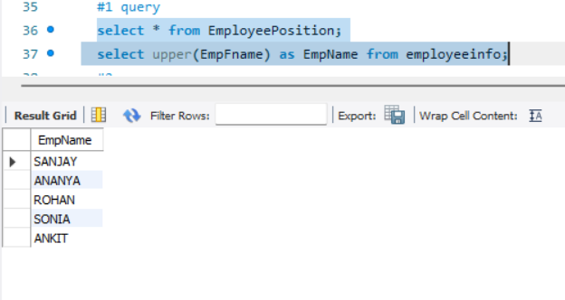

**2.Query:-** Write a query to fetch the number of employees working in the department ‘HR’.

select count(*) as number_of_employee from employeeinfo where department = "HR";

**output**

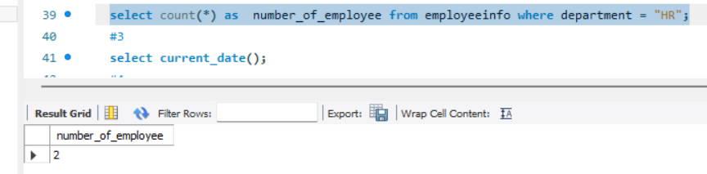

**3.Ouery:** Write a query to get the current date.

select current_date();

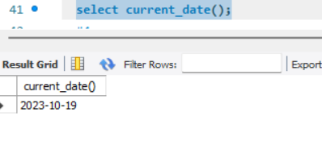

**4.Query:** Write a query to retrieve the first four characters of EmpLname from the EmployeeInfo table

select substring(EmpLname,1,4) from employeeinfo;

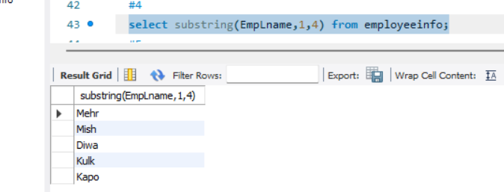

**5.Query:** Write a query to fetch only the place name(string before brackets) from the Address column of EmployeeInfo table.

select substring(Address,1,locate("(",Address)-1) as Place_name from employeeinfo;

**Output**

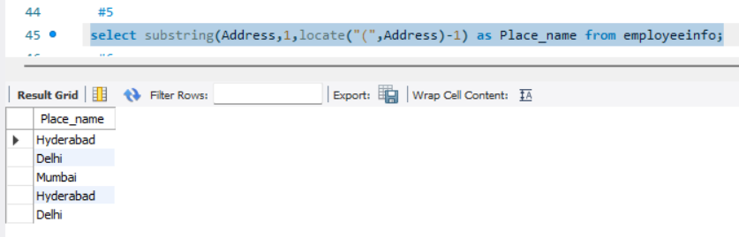

**6.Query:** Write a query to create a new table that consists of data and structure copied from the other table.

create table newemployeeinfo (select * from employeeinfo);

select * from newemployeeinfo;

**Output**

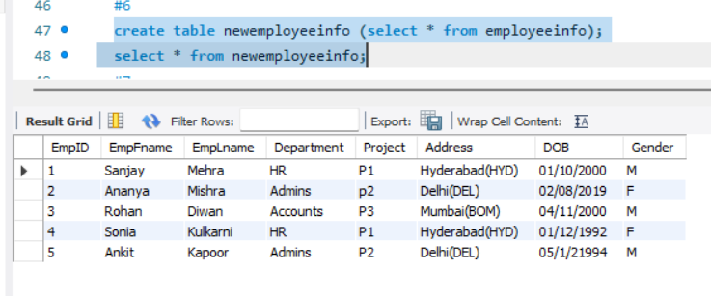

**7.Query:** Write q query to find all the employees whose salary is between 50000 to 100000.

select e1.EmpFname, e1.EmpLname, e2.Salary

from employeeinfo e1

inner join EmployeePosition e2 on e1.EmpID=e2.EmpID where e2.Salary between 50000 and 100000;

**Output:**

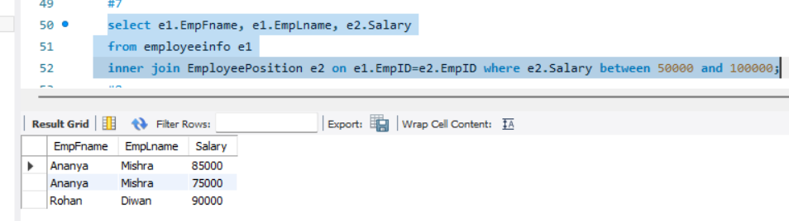

**8.Query:** Write a query to find the names of employees that begin with ‘S’

select EmpFname,EmpLname from employeeinfo where EmpFname like "S%";

**Output:**

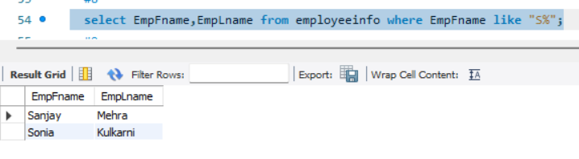

**9.Query:** Write a query to fetch top N records.

select * from employeeinfo limit 2;

**Output:**

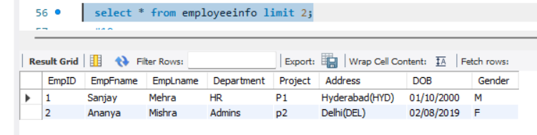

**10.Query:** Write a query to retrieve the EmpFname and EmpLname in a single column as “FullName”. The first name and the last name must be separated with space.

select concat(EmpFname," ",EmpLname) as Full_name from employeeinfo;

**Output:**

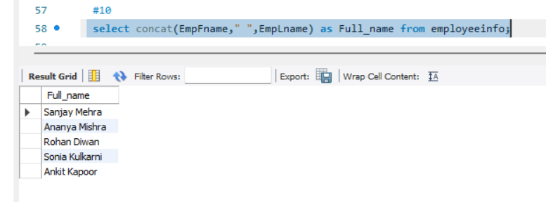

**Learning outcome:** I have learnt that how to create a database and by using that database how to apply query to get the specific data which required by applying the query.

**Evaluation Grid:**

|  |  |  |  |
| --- | --- | --- | --- |
| Sr. No. | Parameters | Marks Obtained | Maximum Marks |
| 1. | Demonstration and Performance (Pre Lab Quiz) |  | 5 |
| 2. | Worksheet |  | 10 |
| 3. | Post Lab Quiz |  | 5 |