**A**

**GUI ( TKINTER) PROJECT REPORT**

**ON**

**BILL MANAGEMENT**

*In partial fulfillment of*

***B.Tech I yr* (Computer Science & Engg.)**

Submitted To: Submitted by:

**Anju Jangid Ma'am** **Dipankar Kumar**

Assistant Professor Roll no-T21EJICS048

**Himanshu Singh**

Roll no-T21EJISC059

# Acknowledgment

I would like to acknowledge the contributions of the following people without whose help and guidance this project would not have been completed.

I respectfully thank **Mrs. Anju Jangid Ma’am**, for providing me an opportunity to do this project work and giving me all support and guidance, which made me complete the project up to very extent.

I am also thankful to **Mrs. Mamta Garg Ma’am** HoD of Computer Science and Engineering Department, Jodhpur Institute of Engineering and Technology, for his/her constant encouragement, valuable suggestions and moral support and blessings.

Although it is not possible to name individually, I shall ever remain indebted to the faculty members of Jodhpur Institute of Engineering and Technology, for their persistent support and cooperation extended during his work.

This acknowledgement will remain incomplete if I fail to express our deep sense of obligation to my parents and God for their consistent blessings and

encouragement.

# Table of Contents

Acknowledgment

Table of Contents

1. Introduction 1

2. Technology used in Project 2

3. Details of Project

3.1 Functions/Modules Details

3.2 Flow Chart

3.3 Project Code

3.4 Project Screenshots

4.Applications

5. conclusion and Future Work

6. References

# 1. Introduction

.

This project is basically a bill management system use in different restrunt system.

It helps the business owner's in a comprehensive manner to keep a track of multiple invoice and accounts just by few clicks on the mouse. It helps in managing chain of stores as well as multiple company billing system. It also provides recurring service and renting business billing solution.

Features and Functionalities

1. Accurate Data Processing

2. Faster Invoice Processing

3. Quicker Payment Approval

4. Save Time and Money

5. Real-time Insights

6. Secure Cloud Encryption

7. Easily Accessible Archives

8. Premade Professional Invoice Templates

# 2. Technology used in Project

**Python - GUI Programming (Tkinter)**

Tkinter is the standard GUI library for Python. Python when combined with Tkinter provides a fast and easy way to create GUI applications. Tkinter provides a powerful object-oriented interface to the Tk GUI toolkit.

Creating a GUI application using Tkinter is an easy task. All you need to do is perform the following steps −

1) Import the *Tkinter* module

2) Create the GUI application main window.

3) Add one or more of the above-mentioned widgets to the GUI application.

4) Enter the main event loop to take action against each event triggered by the user.

## Tkinter Widgets

Tkinter provides various controls, such as buttons, labels and text boxes used in a GUI application. These controls are commonly called widgets.

The widgets used in this project are presented below-

|  |  |
| --- | --- |
| **Sr.No.** | **Operator & Description** |
| 1 | [Button](https://www.tutorialspoint.com/python/tk_button.htm)  The Button widget is used to display buttons in your application. |
| 2 | [Entry](https://www.tutorialspoint.com/python/tk_entry.htm)  The Entry widget is used to display a single-line text field for accepting values from a user. |
| 3 | [Label](https://www.tutorialspoint.com/python/tk_label.htm)  The Label widget is used to provide a single-line caption for other widgets. It can also contain images. |
| 4 | [Message](https://www.tutorialspoint.com/python/tk_message.htm)  The Message widget is used to display multiline text fields for accepting values from a user. |
| 5 | [Text](https://www.tutorialspoint.com/python/tk_text.htm)  The Text widget is used to display text in multiple lines. |
| 6 | [Toplevel](https://www.tutorialspoint.com/python/tk_toplevel.htm)  The Toplevel widget is used to provide a separate window container. |
| 7 | [LabelFrame](https://www.tutorialspoint.com/python/tk_labelframe.htm)  A labelframe is a simple container widget. Its primary purpose is to act as a spacer or container for complex window layouts. |

# 3. Details of Project

In this section give the details of the work done during the training period. Following below details are required

## 3.1 Functions/Modules Details

Tkinter is the standard GUI library for Python. Python when combined with Tkinter provides a fast and easy way to create GUI applications. Tkinter provides a powerful object-oriented interface to the Tk GUI toolkit

Creating a GUI application using Tkinter is an easy task. All you need to do is perform the following steps −

1) Import the *Tkinter* module

2) Create the GUI application main window.

3) Add one or more of the above-mentioned widgets to the GUI application.

4) Enter the main event loop to take action against each event triggered by the user.

Bd -It represents the border width in pixels.

Bg- It represents the background color of the tkinter.Button.

Command It is set to the function call which is scheduled when the function is

called

Fg- Foreground color of the tkinter.Button.

Font -The font of the tkinter.Button text.

Height -The height of the tkinter.Button. The height is represented in the

number of text lines for the textual lines or the number of pixels for the

**3.3 Project Code**

from tkinter import*

import tkinter

top=Tk()

top.title("BILL MANAGMENT")

top.geometry("1400x600")

lbltitle=Label(top,text="BIG BITES FAST FOOD",bg="light green",fg="brown",bd=20,relief=RIDGE,font=("times new roman",30,"bold"),padx=2,pady=6)

lbltitle.pack(side=TOP,fill=X)

###MENU###

DataFrameLeft=LabelFrame(top,text="MENU",bg="light pink",fg="green",bd=20,relief=RIDGE,font=("times new roman",20,"bold"))

DataFrameLeft.place(x=2,y=97,width=455,height=350)

member2=Label(DataFrameLeft,text="MENU",bg="light pink",font=("times new roman",15,"bold"),padx=2,pady=6)

lb1=Label(DataFrameLeft,text="Chola bhutra...........R.s.80/plate",bg="light pink",font=("timesnew roman",15,"bold"),padx=2,pady=6)

Height1=StringVar()

lb1.grid(row=0,column=0,sticky=W)

lb1=Label(DataFrameLeft,text="Chow main...........R.s.40/plate",bg="light pink",font=("timesnew roman",15,"bold"),padx=2,pady=6)

Height1=StringVar()

lb1.grid(row=1,column=0,sticky=W)

lb1=Label(DataFrameLeft,text="Sandwich...........R.s.50/pic",bg="light pink",font=("timesnew roman",15,"bold"),padx=2,pady=6)

Height1=StringVar()

lb1.grid(row=2,column=0,sticky=W)

lb1=Label(DataFrameLeft,text="Pizza...........R.s.90/pic",bg="light pink",font=("timesnew roman",15,"bold"),padx=2,pady=6)

Height1=StringVar()

lb1.grid(row=3,column=0,sticky=W)

lb1=Label(DataFrameLeft,text="Burger...........R.s.45/pic",bg="light pink",font=("timesnew roman",15,"bold"),padx=2,pady=6)

Height1=StringVar()

lb1.grid(row=4,column=0,sticky=W)

lb1=Label(DataFrameLeft,text="Pasta...........R.s.60/plate",bg="light pink",font=("timesnew roman",15,"bold"),padx=2,pady=6)

Height1=StringVar()

lb1.grid(row=5,column=0,sticky=W)

lb1=Label(DataFrameLeft,text="Bread pakora...........R.s.20/pics",bg="light pink",font=("timesnew roman",15,"bold"),padx=2,pady=6)

Height1=StringVar()

lb1.grid(row=6,column=0,sticky=W)

###TOTAL ITEMS###

DataFrameLeft=LabelFrame(top,text="TOTAL ITEMS",bg="light pink",fg="green",bd=20,relief=RIDGE,font=("times new roman",20,"bold"))

DataFrameLeft.place(x=455,y=97,width=455,height=350)

member2=Label(DataFrameLeft,text="TOTAL ITEMS",bg="light pink",font=("times new roman",15,"bold"),padx=2,pady=6)

Cholabhutra=StringVar()

Chowmain=StringVar()

Sandwich=StringVar()

Pizza=StringVar()

Burger=StringVar()

Pasta=StringVar()

Breadpakora=StringVar()

lbl_Cholabhutra=Label(DataFrameLeft,font=("aria",15,'bold'),text="Cholabhutra",width=12,fg="blue",bg="light pink")

lbl_Cholabhutra.grid(row=1,column=1)

entry_Cholabhutra=Entry(DataFrameLeft,font=("aria",15,'bold'),textvariable=Cholabhutra,bd=4,width=8,bg="light pink")

entry_Cholabhutra.grid(row=1,column=2)

entry_Cholabhutra.insert(0,"0")

lbl_Chowmain=Label(DataFrameLeft,font=("aria",15,'bold'),text="Chowmain",width=12,fg="blue",bg="light pink")

lbl_Chowmain.grid(row=2,column=1)

entry_Chowmain=Entry(DataFrameLeft,font=("aria",15,'bold'),textvariable=Chowmain,bd=4,width=8,bg="light pink")

entry_Chowmain.grid(row=2,column=2)

entry_Chowmain.insert(0,"0")

lbl_Sandwich=Label(DataFrameLeft,font=("aria",15,'bold'),text="Sandwich",width=12,fg="blue",bg="light pink")

lbl_Sandwich.grid(row=3,column=1)

entry_Sandwich=Entry(DataFrameLeft,font=("aria",15,'bold'),textvariable=Sandwich,bd=4,width=8,bg="light pink")

entry_Sandwich.grid(row=3,column=2)

entry_Sandwich.insert(0,"0")

lbl_Pizza=Label(DataFrameLeft,font=("aria",15,'bold'),text="Pizza",width=12,fg="blue",bg="light pink")

lbl_Pizza.grid(row=4,column=1)

entry_Pizza=Entry(DataFrameLeft,font=("aria",15,'bold'),textvariable=Pizza,bd=4,width=8,bg="light pink")

entry_Pizza.grid(row=4,column=2)

entry_Pizza.insert(0,"0")

lbl_Burger=Label(DataFrameLeft,font=("aria",15,'bold'),text="Burger",width=12,fg="blue",bg="light pink")

lbl_Burger.grid(row=5,column=1)

entry_Burger=Entry(DataFrameLeft,font=("aria",15,'bold'),textvariable=Burger,bd=4,width=8,bg="light pink")

entry_Burger.grid(row=5,column=2)

entry_Burger.insert(0,"0")

lbl_Pasta=Label(DataFrameLeft,font=("aria",15,'bold'),text="Pasta",width=12,fg="blue",bg="light pink")

lbl_Pasta.grid(row=6,column=1)

entry_Pasta=Entry(DataFrameLeft,font=("aria",15,'bold'),textvariable=Pasta,bd=4,width=8,bg="light pink")

entry_Pasta.grid(row=6,column=2)

entry_Pasta.insert(0,"0")

lbl_Breadpakora=Label(DataFrameLeft,font=("aria",15,'bold'),text="Breadpakora",width=12,fg="blue",bg="light pink")

lbl_Breadpakora.grid(row=7,column=1)

entry_Breadpakora=Entry(DataFrameLeft,font=("aria",15,'bold'),textvariable=Breadpakora,bd=4,width=8,bg="light pink")

entry_Breadpakora.grid(row=7,column=2)

entry_Breadpakora.insert(0,"0")

def abc():

    s=()

    s=int(entry_Cholabhutra.get())*80

    l1=Label(DataFrameLeft,text="Cholabhutra",bg="lightpink",fg="black",font=("timesnew roman",15,"bold"))

    l1.grid(row=7,column=2)

    l=Label(DataFrameLeft,text=s,bg="lightpink",fg="black",font=("timesnew roman",15,"bold"))

    l.grid(row=7,column=5)

    t=()

    t=int(entry_Chowmain.get())*40

    l1=Label(DataFrameLeft,text="Chowmain",bg="lightpink",fg="black",font=("timesnew roman",15,"bold"))

    l1.grid(row=8,column=2)

    l=Label(DataFrameLeft,text=t,bg="lightpink",fg="black",font=("timesnew roman",15,"bold"))

    l.grid(row=8,column=5)

    d=()

    d=int(entry_Sandwich.get())*50

    l1=Label(DataFrameLeft,text="Sandwich",bg="lightpink",fg="black",font=("timesnew roman",15,"bold"))

    l1.grid(row=9,column=2)

    l=Label(DataFrameLeft,text=d,bg="lightpink",fg="black",font=("timesnew roman",15,"bold"))

    l.grid(row=9,column=5)

    e=()

    e=int(entry_Pizza.get())*90

    l1=Label(DataFrameLeft,text="Pizza",bg="lightpink",fg="black",font=("timesnew roman",15,"bold"))

    l1.grid(row=10,column=2)

    l=Label(DataFrameLeft,text=e,bg="lightpink",fg="black",font=("timesnew roman",15,"bold"))

    l.grid(row=10,column=5)

    f=()

    f=int(entry_Burger.get())*45

    l1=Label(DataFrameLeft,text="Burger",bg="lightpink",fg="black",font=("timesnew roman",15,"bold"))

    l1.grid(row=11,column=2)

    l=Label(DataFrameLeft,text=f,bg="lightpink",fg="black",font=("timesnew roman",15,"bold"))

    l.grid(row=11,column=5)

    g=()

    g=int(entry_Pasta.get())*60

    l1=Label(DataFrameLeft,text="Pasta",bg="lightpink",fg="black",font=("timesnew roman",15,"bold"))

    l1.grid(row=12,column=2)

    l=Label(DataFrameLeft,text=g,bg="lightpink",fg="black",font=("timesnew roman",15,"bold"))

    l.grid(row=12,column=5)

    h=()

    h=int(entry_Breadpakora.get())*20

    l1=Label(DataFrameLeft,text="Breadpakora\t",bg="lightpink",fg="black",font=("timesnew roman",15,"bold"))

    l1.grid(row=13,column=2)

    l=Label(DataFrameLeft,text=h,bg="lightpink",fg="black",font=("timesnew roman",15,"bold"))

    l.grid(row=13,column=5)

    l=Label(DataFrameLeft,text="Total",bg="lightpink",bd=0,fg="blue",relief=RIDGE,font=("times new roman",15,"bold"))

    l.grid(row=14,column=2)

    Total=s+t+d+e+f+g+h

    l0=Label(DataFrameLeft,text=Total,bg="lightpink",fg="black",font=("timesnew roman",15,"bold"))

    l0.grid(row=14,column=5)

    def tt():

        root=Toplevel(DataFrameLeft)

        root.title("BILL MANAGMENT")

        root.geometry("400x600")

        p=Frame(root,width="400",height="600",bg="lightpink").place(x=0,y=0)

        lbltitle=Label(root,text="BIG BITES FAST FOOD",bg="light green",fg="brown",bd=20,relief=RIDGE,font=("times new roman",16,"bold"),padx=65,pady=6)

        lbltitle.place(x=0,y=0)

        l1=Label(root,text="Cholabhutra",bg="lightpink",fg="black",font=("timesnew roman",15,"bold"))

        l1.place(x=10,y=120)

        l=Label(root,text=s,bg="lightpink",fg="black",font=("timesnew roman",15,"bold"))

        l.place(x=300,y=120)

        l1=Label(root,text="Chowmain",bg="lightpink",fg="black",font=("timesnew roman",15,"bold"))

        l1.place(x=10,y=150)

        l=Label(root,text=t,bg="lightpink",fg="black",font=("timesnew roman",15,"bold"))

        l.place(x=300,y=150)

        l1=Label(root,text="Sandwich",bg="lightpink",fg="black",font=("timesnew roman",15,"bold"))

        l1.place(x=10,y=180)

        l=Label(root,text=d,bg="lightpink",fg="black",font=("timesnew roman",15,"bold"))

        l.place(x=300,y=180)

        l1=Label(root,text="Pizza",bg="lightpink",fg="black",font=("timesnew roman",15,"bold"))

        l1.place(x=10,y=210)

        l=Label(root,text=e,bg="lightpink",fg="black",font=("timesnew roman",15,"bold"))

        l.place(x=300,y=210)

        l1=Label(root,text="Burger",bg="lightpink",fg="black",font=("timesnew roman",15,"bold"))

        l1.place(x=10,y=240)

        l=Label(root,text=f,bg="lightpink",fg="black",font=("timesnew roman",15,"bold"))

        l.place(x=300,y=240)

        l1=Label(root,text="Pasta",bg="lightpink",fg="black",font=("timesnew roman",15,"bold"))

        l1.place(x=10,y=270)

        l=Label(root,text=g,bg="lightpink",fg="black",font=("timesnew roman",15,"bold"))

        l.place(x=300,y=270)

        l1=Label(root,text="Breadpakora",bg="lightpink",fg="black",font=("timesnew roman",15,"bold"))

        l1.place(x=10,y=300)

        l=Label(root,text=h,bg="lightpink",fg="black",font=("timesnew roman",15,"bold"))

        l.place(x=300,y=300)

        l1=Label(root,text="Total",bg="lightpink",fg="black",font=("timesnew roman",15,"bold"))

        l1.place(x=10,y=350)

        l=Label(root,text=Total,bg="lightpink",fg="black",font=("timesnew roman",15,"bold"))

        l.place(x=300,y=350)

        l1=Label(root,text="THANKU FOR ORDER",bg="lightpink",fg="brown",font=("timesnew roman",18,"bold"))

        l1.place(x=70,y=400)

        root.mainloop()

    l=Button(DataFrameLeft,text="Print",bg="lightpink",fg="blue",command=tt,bd=8,relief=RIDGE,font=("times new roman",10,"bold"))

    l.grid(row=15,column=3)

b=Button(DataFrameLeft,text="Calculate",bg="lightpink",fg="blue",bd=8,relief=RIDGE,font=("times new roman",10,"bold"),command=abc)

b.grid(row=10,column=2)

###BILL###

DataFrameLeft=LabelFrame(top,text="BILL",bg="lightpink",fg="green",bd=20,relief=RIDGE,font=("times new roman",20,"bold"))

DataFrameLeft.place(x=910,y=97,width=455,height=350)

member2=Label(DataFrameLeft,text="BILL",bg="light pink",font=("times new roman",15,"bold"),padx=2,pady=6)

top.mainloop()

**# END OF THE PROGRAM**

## 3.4 Project Screenshots

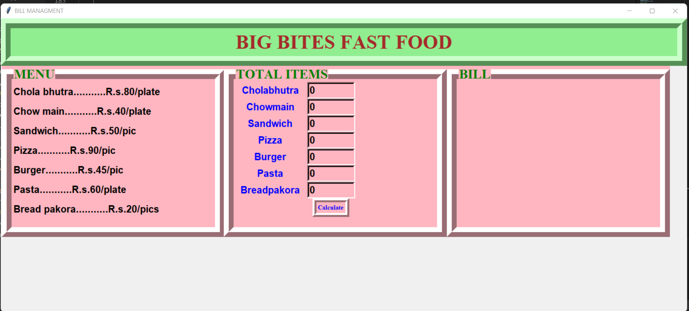

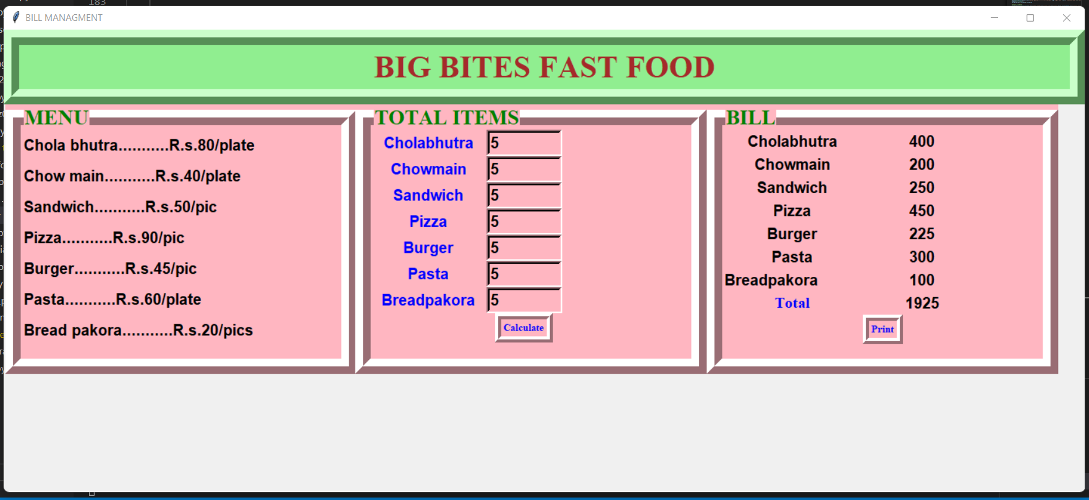

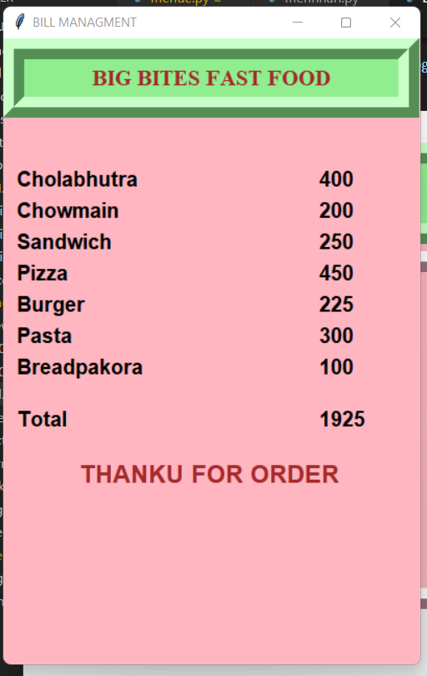

# 4. Applications

A bill data report is displayed based on the search criteria you provided. You may opt to display or download the report. Bill data downloaded from this report shows one bill per line. Each column heading shows the name of a field as it is recorded in the database. The report provides detailed bill information such as Account, various bill statuses, Item Key, Created By etc.

While Bills are for payables (received services or items to be paid later) Check and Expenses are for services or items paid on-the-spot

# Future Work and Conclusion

The project can be improved b adding the following items:-

### 1.Randomizing questions

It is significant more easy to randomize your question with just one click than to do it all manually. Randomizing questions and even answers of those questions is not a lot a of work to do with online quizzes. Besides the advantage of time saving, it also helps preventing students from [cheating](https://www.onlinequizcreator.com/knowledge-center/oline-exam-center/how-to-prevent-cheating-on-an-online-exams-and-tests/item10616)

### 2.Set timer

The creator is able to [set a timer](https://www.onlinequizcreator.com/features/online-test-maker-with-timer/item10236) for the whole quiz or to set a timer per question. This is possible to do with written quizzes, but is very time consuming for the instructor. Plus it’s almost impossible to do with a huge amount of participants.

### 3.Better overview

### It’s possible to show one question at the time with online quizzes. People are not able to skip a question, because you will get a reminder that you can’t leave the answer blank.

Conclusion

To conclude this is a simple bill application which is developed for billing purpose for the any shops which makes the shop keeper to easly calculate the bill in short period of time

# References

**Links:-**

[www.wikipedia.org](http://www.wikipedia.org)

<https://www.geeksforgeeks.org/what-are-widgets-in-tkinter/>

**Books-**

Python Programming by Shatish Jain

**Reference :-**

Aman Sharma

**Thank You**