1. Introduction
1.1 In computer science, a segment tree also known as a static tree is a tree data structure used for storing information about intervals, or segments. It allows querying which of the stored segments contain a given point. It is, in principle, a static structure; that is, it's a structure that cannot be modified once it's built.

1.2 Segment Tree is a basically a binary tree used for storing the intervals or segments. Each node in the Segment Tree represents an interval. Consider an array A of size N and a corresponding Segment Tree T:
a) The root of T will represent the whole array A[0: N-1].
b) Each leaf in the Segment Tree T will represent a single element A[i] such that 0<=i<=N .
c) The internal nodes in the Segment Tree represents the union of elementary intervals A[i:j]
where 0<=i<j<N.

The root of the Segment Tree represents the whole array A[0:N-1]. Then it is broken down into two half intervals or segments and the two children of the root in turn represent the A[0 : (N-1)/2] and
A[(N-1)/2+1 : (N-1)]. So in each step, the segment is divided into half and the two children represent those two halves. So the height of the segment tree will be logN . There are N leaves representing the N elements of the array. The number of internal nodes is N-1. So, a total number of nodes are 2x(N-1).

Once the Segment Tree is built, its structure cannot be changed. We can update the values of nodes but we cannot change its structure. Segment tree provides two operations:

Update: To update the element of the array and reflect the corresponding change in the Segment tree.
Query: In this operation we can query on an interval or segment and return the answer to the problem (say minimum/maximum/summation in the particular segment)

2. Construction of 1-d Segment Tree & 2-d Segment Tree

2.1 1-d Segment Tree

1-d segment tree can be used for different problems:
a) Range Sum Query(RSQ)
b) Range Min Query(RMQ)
c) Range Zero count
d) Kth zero count

We will be using RSQ to construct segment tree:

Given an array A of N integers. There will be 3 types of operations: UpdateSingle, UpdateRange and Query.
a. UpdateSingle operation consists of 2 integers: i and v. Set value v to index i.
b. UpdateRange operation consists of 3 integers: l, r and v. Set value v to all integers from index l to index r of the array.
c. Query operation consists of 2 integers: l and r. Print the sum of integers from index l to r of the array.
Example:[2,5,1,3]
Query(1, 2) -- output = 5+1 =6
UpdateRange(2, 3, 10) -- A = [2, 5, 10, 10]
Query(0, 3) -- Output = 2 + 5 + 10 + 10 = 27
UpdateSingle(0, 100) -- A = [100, 5, 10, 10]
Query(0, 3) -- Output = 100 + 5 + 10 + 10 = 125

2.2 Segment Tree Operations are given below:

build(int p, int l, int r)
This method will build segment tree from array A which is given initially. If there is no initial array or all values of the array is 0 then no need to execute this method to build segment tree.

updateSingle(int p, int l, int r, int i, int val)
This method will update value at index i by the given value val and the segment tree as well to make it consistent.

updateRange(int p, int l, int r, int i, int j, int val)
This method will update some range [i, j] of the array by the given value val and update the segment tree as well to make it consistent.

query(int p, int l, int r, int i, int j)
This method will return the desired result which we are interested to knowbetween the index i & j.

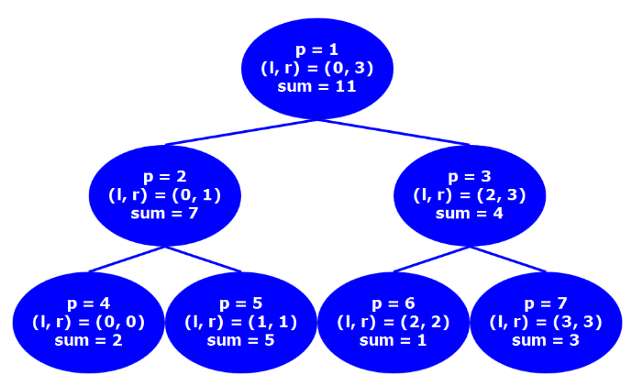

Diagram: Segment Tree for RSQ

2.3 Implementations

We are going to hold the segment in an array. So if parent is located at index p then left child will be placed at index 2*p and 2*p+1 for right child.

int build(int p, int l, int r) {
if (l == r) {
st[p] = A[l];
return st[p];
}
int mid = (l + r) >> 1;
st[p] = build(left(p), l, mid) + build(right(p), mid+1, r);
return st[p];
}

void updateSingle(int p, int l, int r, int i, int val) {
if (l == r) {
st[p] = arr[val];
return st[p];
}
int mid = (l + r) >> 1;
if (i <= mid) updateSingle(left(p), l, mid, i, val);
else updateSingle(right(p), mid+1, r, i, val);
return st[p];
}

Node query(int p, int l, int r, int i, int j) {
if (i == l && j == r) return st[p];
int mid = (l + r) >> 1;
if (j <= mid) return query(left(p), l, mid, i, j);
if (i > mid) return query(right(p), mid + 1, r, i, j);
return query(left(p), l, mid, i, mid) + query(right(p), mid+1, r, mid+1, j);
}

2.4 Lazy Propagation in Segment Tree

With lazy propagation we can run updateRange() method faster with O(lg N) complexity. How? Well while updating a range no need to go down until leaf nodes when it’s possible. For example, update range from index 0 to 2 with value 10:

void updateRangeLazy(int p, int l, int r, int i, int j, int val) {
if (i == l && j == r) {
st[p].setSum((ULL)(r - l + 1) * val);
if (l != r) st[p].lazy = val;
return;
}
pushDown(p, l, r);
int mid = (l + r) >> 1;
if (j <= mid) updateRangeLazy(left(p), l, mid, i, j, val);
else if (i > mid) updateRangeLazy(right(p), mid + 1, r, i, j, val);
else {
updateRangeLazy(left(p), l, mid, i, mid, val);
updateRangeLazy(right(p), mid + 1, r, mid + 1, j, val);
}
pushUp(p);
}

int queryLazy(int p, int l, int r, int i, int j) {
if (i == l && j == r) return st[p];
pushDown(p, l, r);
int mid = (l + r) >> 1;
if (j <= mid) return queryLazy(left(p), l, mid, i, j);
if (i > mid) return queryLazy(right(p), mid + 1, r, i, j);
return queryLazy(left(p), l, mid, i, mid)+queryLazy(right(p), mid + 1, r, mid+1, j);
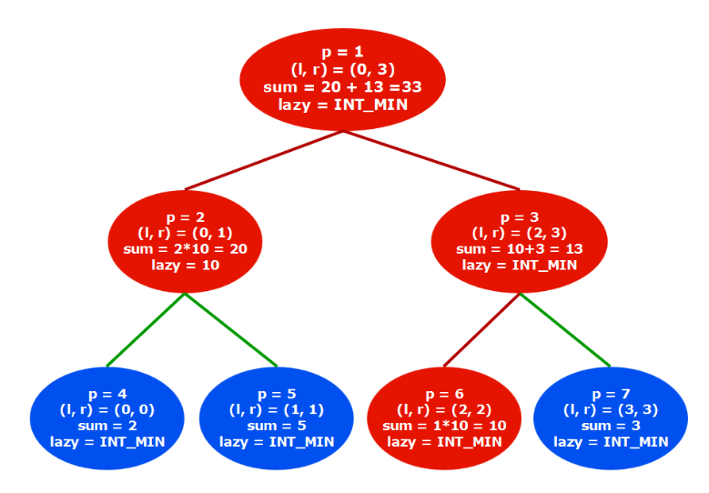
}

Diagram: Segment Tree for RSQ with Lazy Propagation

Notice in node p = 2, we kept lazy = 10 which will be propagated into it’s child when needed in next updateRange()/query() operation. In above diagram only red colored nodes are updated. Not all leaf nodes in the range 0~2 are updated and hence it’s complexity is O(ln N).

2.5 2-d Segment Tree

Given an 2D array A of N rows and M columns. There will be 3 types of operations: UpdateSinge and Query.

a) UpdateSingle operation consists of 3 integers: i, j and v.
Set value v to index [i, j].
b) Query operation consists of 4 integers: i, j, k, and l.
Print the sum of all integers from point [i, j] to [k, l]

Example:

A = [ 1 2 3 4
5 6 7 8
9 0 1 2
3 4 5 6 ]

Query(1, 1, 2, 2) -- Output = 6 + 7 + 0 + 1 = 14
UpdateSingle(2, 1, 10) -- A[2][1] = 10
Query(1, 1, 2, 2) -- Output = 6 + 7 + 10 + 1 = 24

2.5.1 Building a segment tree example

| 0 1 2 3
-----------
0 | 1 2 3 4
1 | 5 6 7 8
2 | 9 0 1 2
3 | 3 4 5 6
Above matrix has N = 4 rows and M = 4 columns.
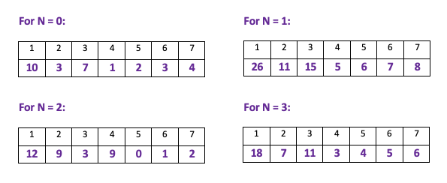
Segment Tree for each row

Now, we have to think each array as an element of another array because we have to build final segment tree using this segment trees. It will look like:
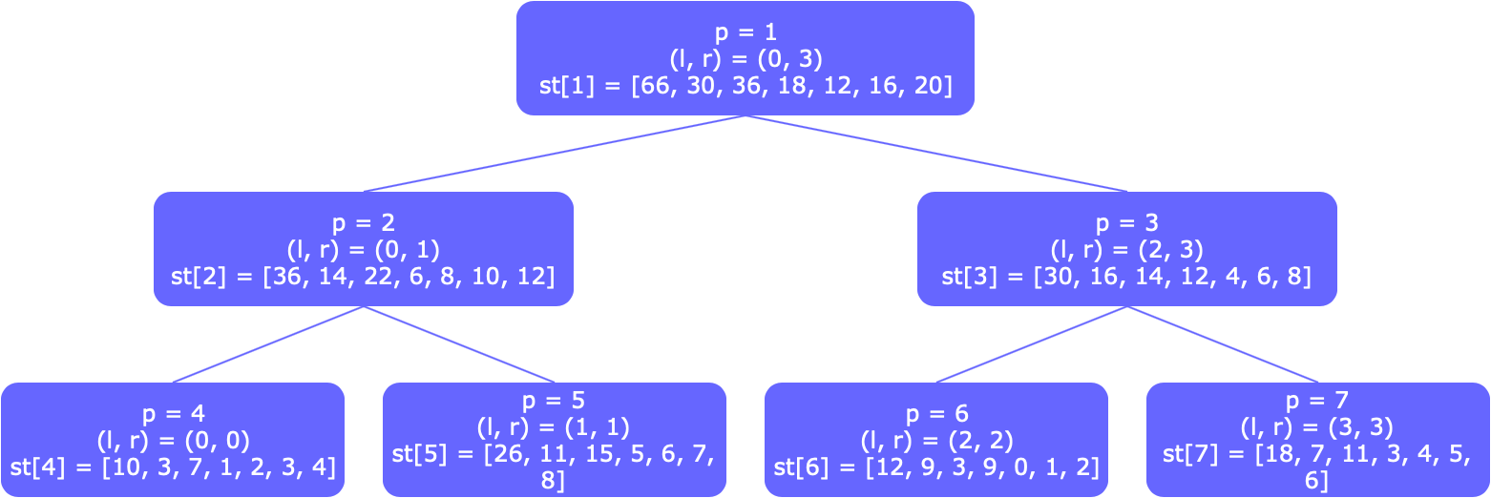

3. Comparision with other tree data structure which have similar functionalities

All the below data structure can have functionalities which are same as segment tree, however all have different functionalities and have different focus point of solving a problem.

Segment Tree – It stores intervals, and optimized for "which of these intervals contains a given point" queries.

Interval tree stores intervals as well, but optimized for "which of these intervals overlap with a given interval" queries. It can also be used for point queries - similar to segment tree.
Both segment and interval trees store intervals.

(Segment tree is mainly optimized for queries for a given point, and interval trees are mainly optimized for overlapping queries for a given interval).

Range tree stores points, and optimized for "which points fall within a given interval" queries.

Binary indexed tree stores items-count per index, and optimized for "how many items are there between index m and n" queries.

3.1 Time & Space complexity Analysis of Segment Tree

3.1.1 Space Complexity:
Let’s take the example of having the length of the array that you’re creating the segment tree as a power of 2 .
length of array, len=2^{x}
Now in this case the number of nodes in its segment tree is 1+2+4...2^{x}=2^{x+1}−1
Therefore number of nodes in segment tree = 2∗number of leaf nodes (Excluded the minus one since it’s just a constant)
Now let’s take the case when len is not a power of 2
In this case the segment number of leaf nodes = 2^{log(len)+1}
Therefore total number of nodes in the segment tree = 2∗number of leaf nodes = 2∗2^{log(len)+1} = 2^{log(len)+2} = 4∗len
Similary, it can be proved for 2-d Segment Tree, Space Complexity is O(4*m*n) (m=no of rows, m= no of columns)
3.1.2 Time Complexity:

a) Build Time Complexity – 1-d Segment Tree – O(2*n-1)) = O(n)
2-d Segment Tree – O((2*n-1)*(2*m-1)) = O(n*m)

b) Query Time Complexity - To query a sum, we process at most four nodes at every level and number of levels is O(Logn).
Proof by contradiction - The claim is that there are at most 2 nodes which are expanded at each level. We will prove this by contradiction.

Consider the segment tree given below.
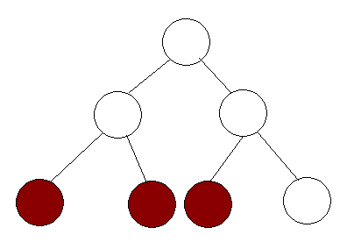

Let's say that there are 3 nodes that are expanded in this tree. This means that the range is from the left most colored node to the right most colored node. But notice that if the range extends to the right most node, then the full range of the middle node is covered. Thus, this node will immediately return the value and won't be expanded. Thus, we prove that at each level, we expand at most 2 nodes and since there are logn levels, the nodes that are expanded are 2*log(N) = O(logN).

Similary it can be proved for 2-d Segment tree query time complexity is O(logM*logN).

c) Update Time complexity - To update a leaf value, we process one node at every level and number of levels is O(Logn).

Similary it can be proved for 2-d Segment tree update time complexity is O(logM*logN).

3.2 Time & Space Complexity Analysis with other tree data structures.

| | Segment Tree |Interval Tree| Range Tree |Indexed Tree|
|--------------|---------------|-------------|----------------|------------|
|Preprocessing | nlogn | nlogn | nlogn | nlogn |
|Query | k+logn | k+logn | k+logn | logn |
|Space | n logn | n | n | n |
|Insert/Delete | logn | logn | logn | logn |

References -
Introduction to Algorithms 3rd Edition by Clifford Stein, Thomas H. Cormen, Charles E. Leiserson, Ronald L. Rivest
https://en.wikipedia.org/wiki/Interval_tree

