A document of the project and its learning that I have learnt in this E Commerce project

ER DIAGRAM

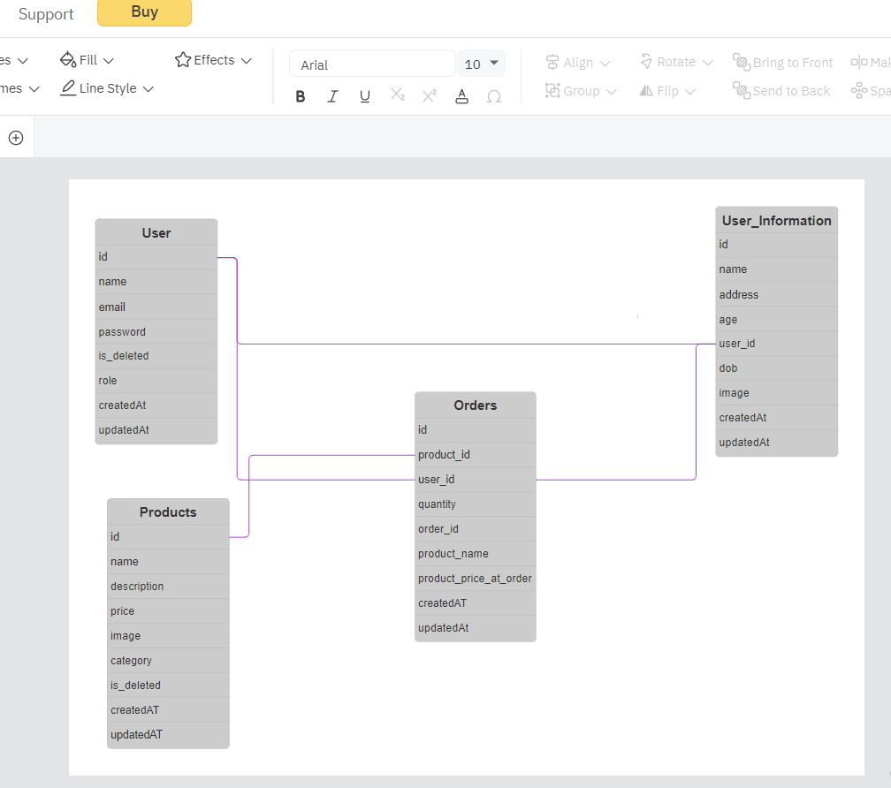

BACKEND