**ASSIGNMENT on Tree**

**DATA STRUCTURE**

**SUBMISSION DATE – 18 September**

**Submit ONLY QN No. 5, 14,15,16,17, 18 as Assignment on MS team**

1. Explain the concept of tree and discuss its application
2. What are two ways of representing binary tree in memory? Which one do you prefer and why?
3. List all possible non-similar binary trees having 4 nodes.
4. Draw the binary expression tree that represent the following postfix expression

AB+C*D-

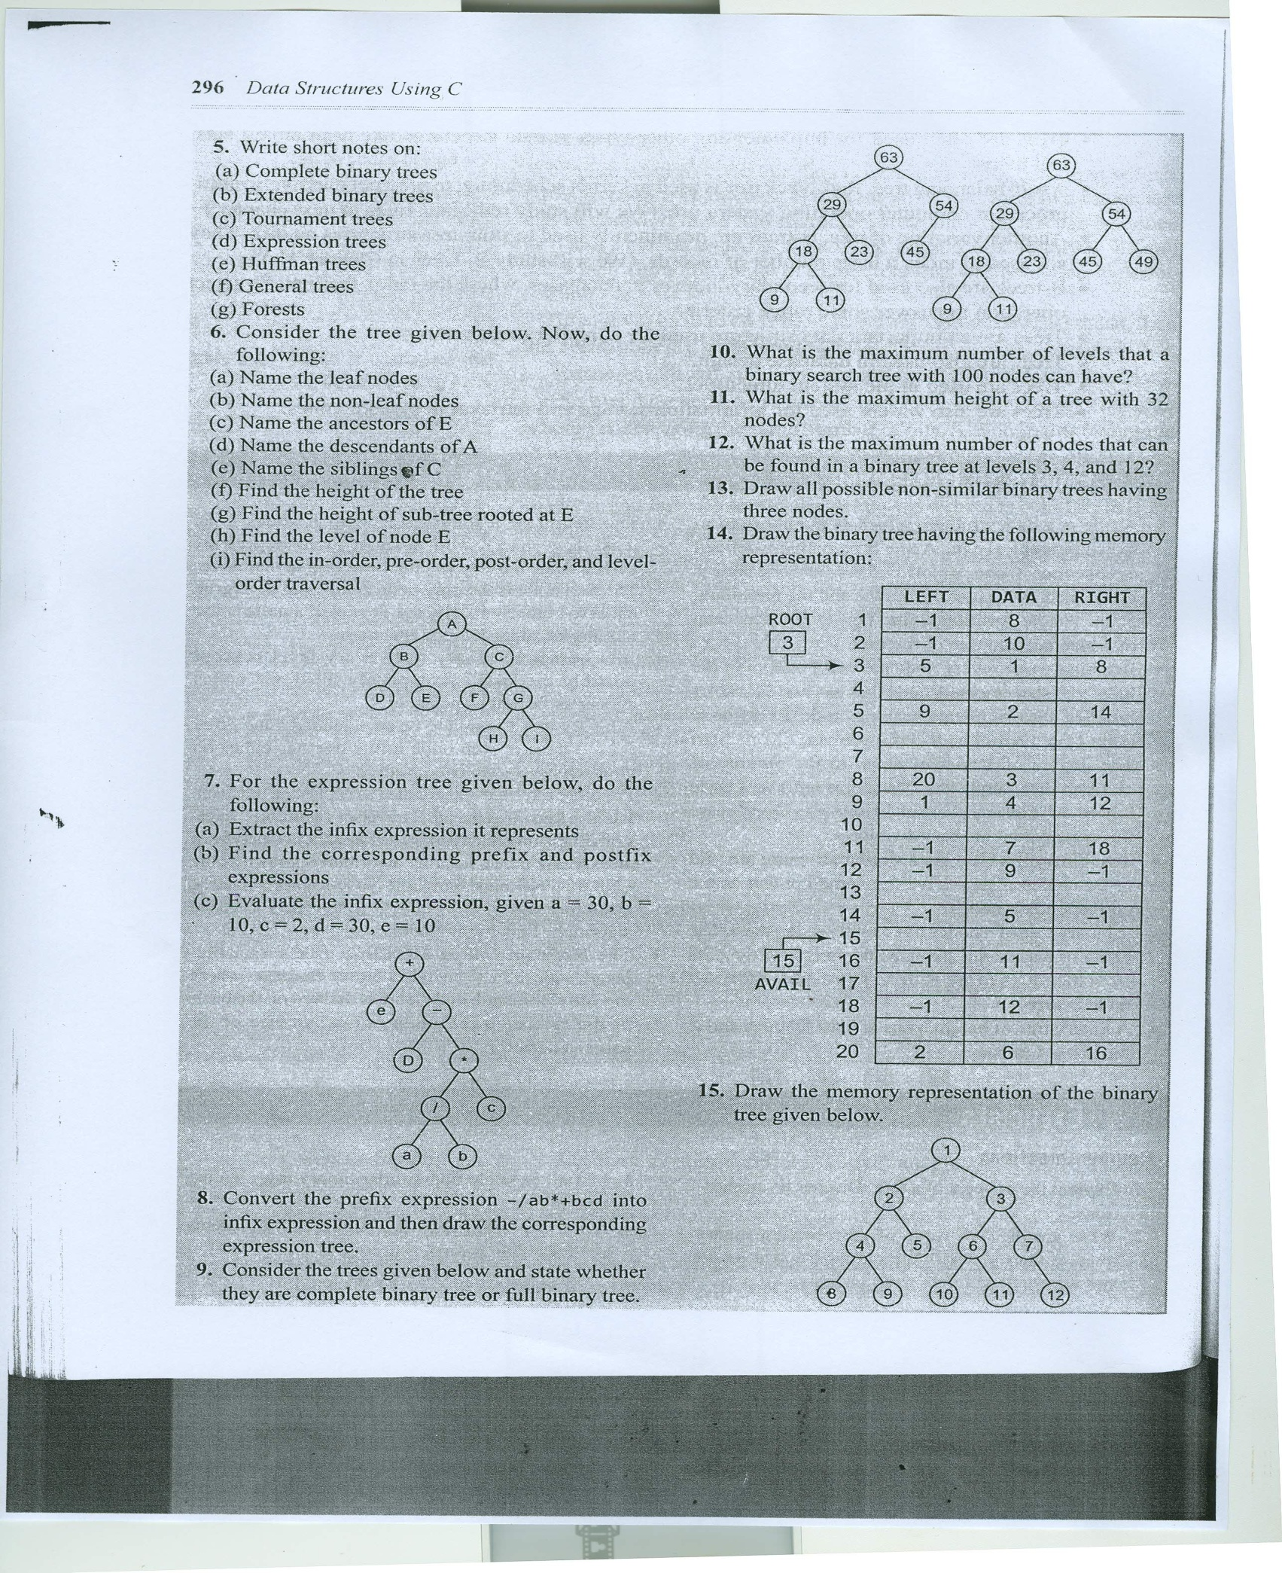

16. Convert following General tree into Binary Tree and performm (i) inorder traversal (ii) postorder traversal (iii) Preorder traversal

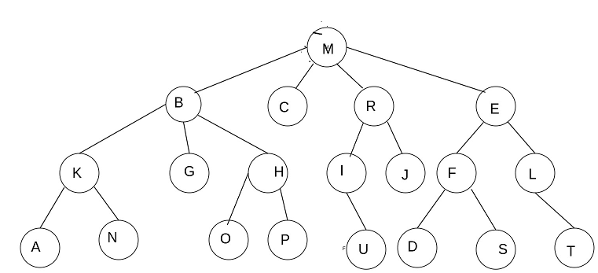

Also represent binary tree into memory using

(i) array (ii) linked List

17. Generate binary tree for the following pre order and in order traversals

Pre order 1 ,2, 4,7,3,,5,6,8,9

inorder 7,4,2,1 ,5,3,8,6,9

18 Convert following general Tree into

binary Tree & corresponding Memory Representation using

(i) array (ii) linked List

Binary search tree Corresponding Memory Representation

Then Perform Preorder Post order & inorder & level order traversal



.