**Assignment 4 (submission Date 10 oct 2020**

**Submit QN No. 4, 5,6,7,8,9 and 10 only**

Note: Write all assignment questions on a register and upload **ON MS team only**

1. Write a short note on threaded binary trees. ( one Page)
2. Why threaded binary trees are called efficient binary trees? Give the merits of using a threaded binary tree.
3. How is an AVL tree better than a binary search tree?
4. Create a binary search tree with the input given below: 98, 2, 48, 12, 56, 32, 4, 67, 23, 87, 23, 55, 46
   1. Insert 21, 39, 45, 54, and 63 into the tree
   2. Delete values 23, 56, 2, and 45 from the tree
5. Consider the binary search tree given below. Now do the following operations:
   * + Find the result of in-order, pre-order, and post-order traversals.
     + Show the deletion of the root node
     + Insert 11, 22, 33, 44, 55, 66, and 77 in the tree

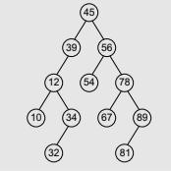

1. Consider the AVL tree given below and insert 18, 81, 29, 15, 19, 25, 26, and 1 in it. Delete nodes 39, 63, 15, and 1 from the AVL tree formed after solving the above question.

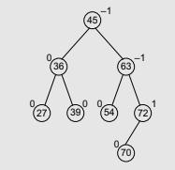

1. Provide the memory representation of the binary tree given below:
   * Find the result of one-way in-order, one-way pre-order, and two-way in-order threading of the tree.
   * In each case, draw the tree and also give its memory representation.

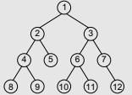

1. Balance the AVL trees given below.
2. Create an AVL tree using the following sequence of data: 16, 27, 9, 11, 36, 54, 81, 63, and 72.
3. Show the binary expression tree for the following preorder expression: /- + abc + d – e * f +gh
4. What do you understand by threaded binary tree? Represent the following tree as threaded binary tree.
5. A binary tree T has 11 nodes. The inorder and preorder traversals of T yield the ahead sequence of node. Find the tree

Inorder: D B H E A F C L J G K

Preorder: A B D E H C F G J L K

1. Draw the internal memory representation of the given binary tree using sequential, linked and threaded linked representations.
2. Convert the following general tree into binary tree:

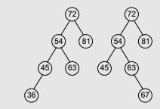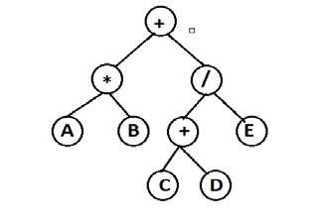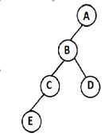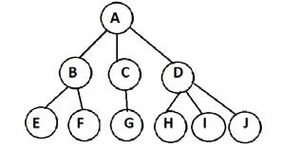

1. Following nodes are inserted into empty tree in order : 5, 16, 22, 45, 2, 10, 18, 30, 50, 12, 1

Construct:

* + Binary Search tree
  + AVL tree