**PRACTICAL 6**

**Aim:** **Overview of SQL Server 2012 Databases and Analysis Services. Create a Sample Database Schema using SQL Server Management Studio.**

**Theory:**

1. **To create a schema**

**Step1:** In Object Explorer, expand the Databases folder and right click to create a new database diagram.

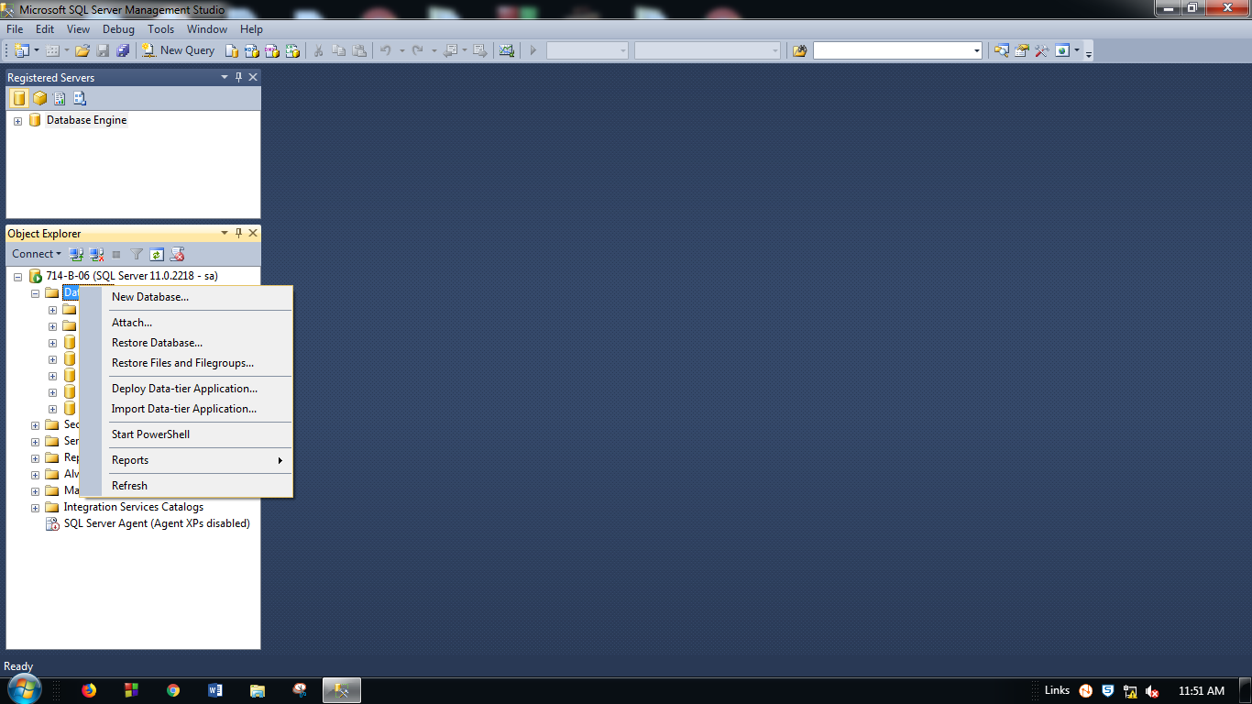

**Figure: 1** Create New Database Diagram

**Step2:**Name the database and click OK.

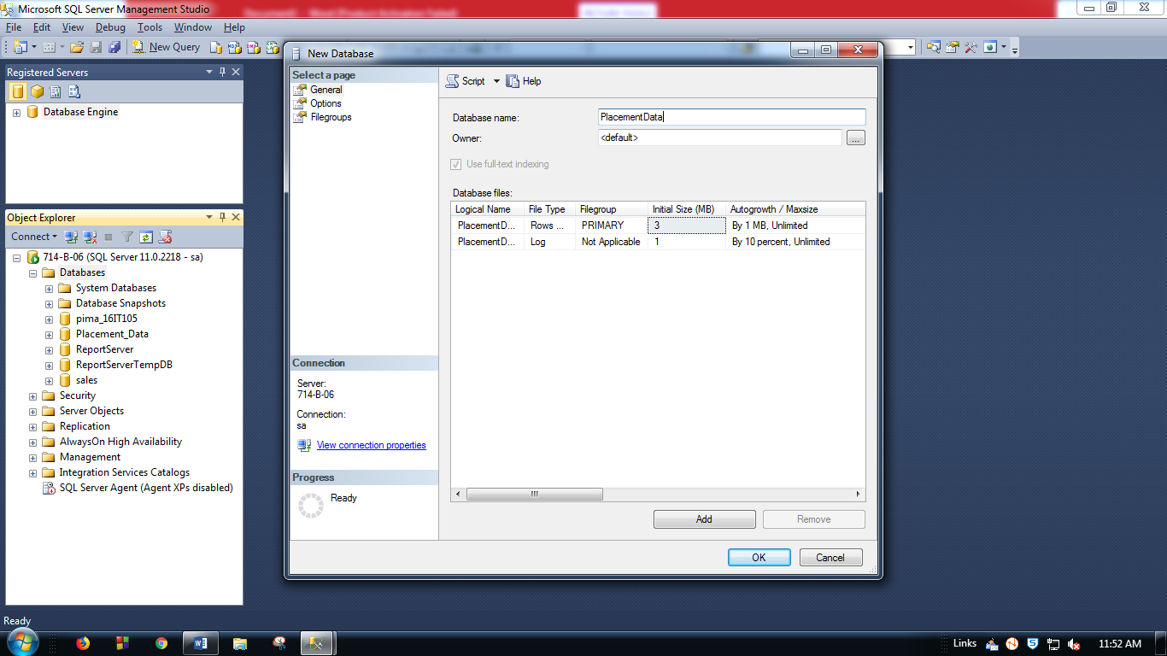

**Figure: 2** Name the Database Diagram

**Step3:** In Object Explorer, expand the Table folder and right click to create a new table.

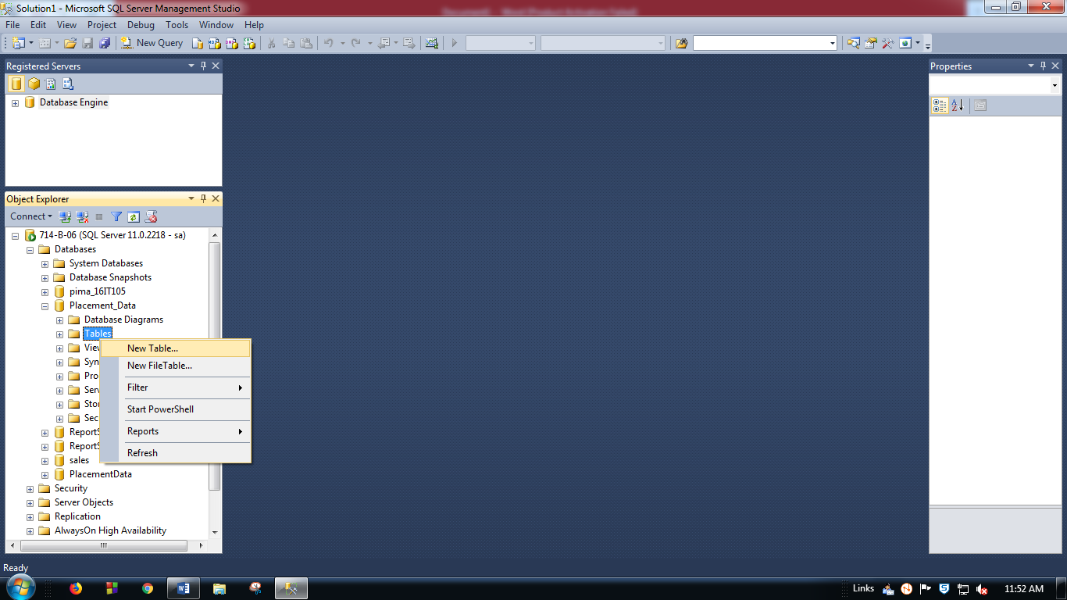

**Figure: 3** Create New Table

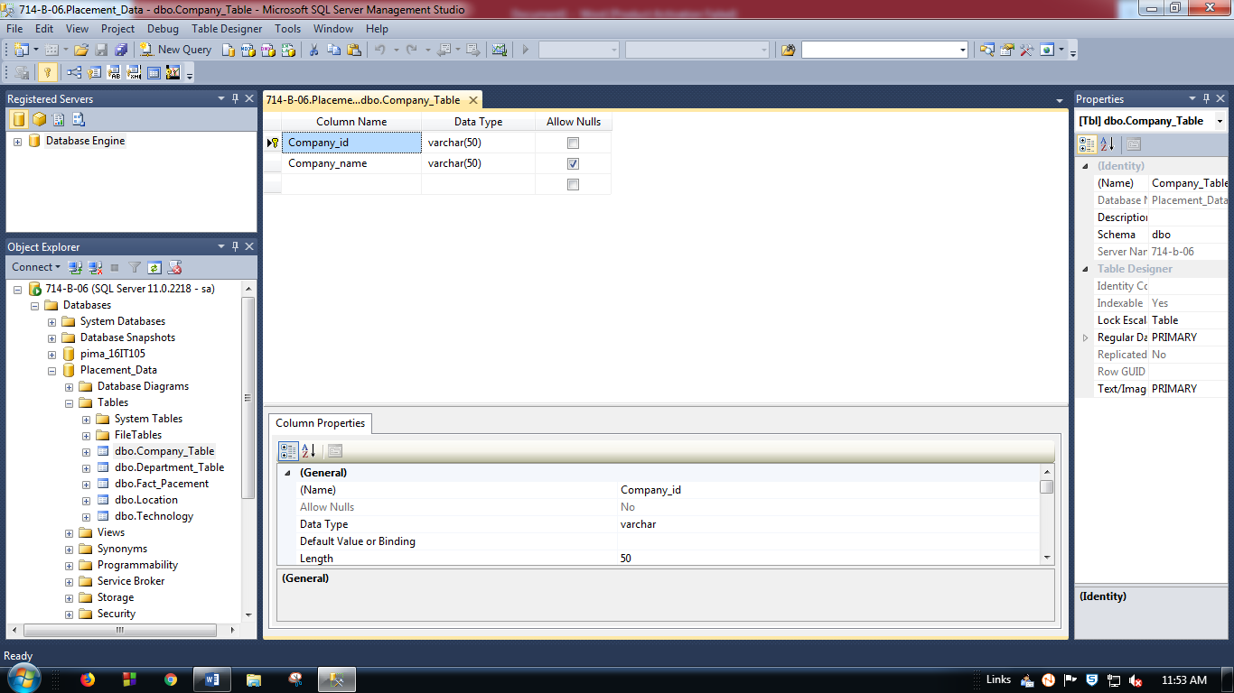

**Figure: 4** Company Table Design

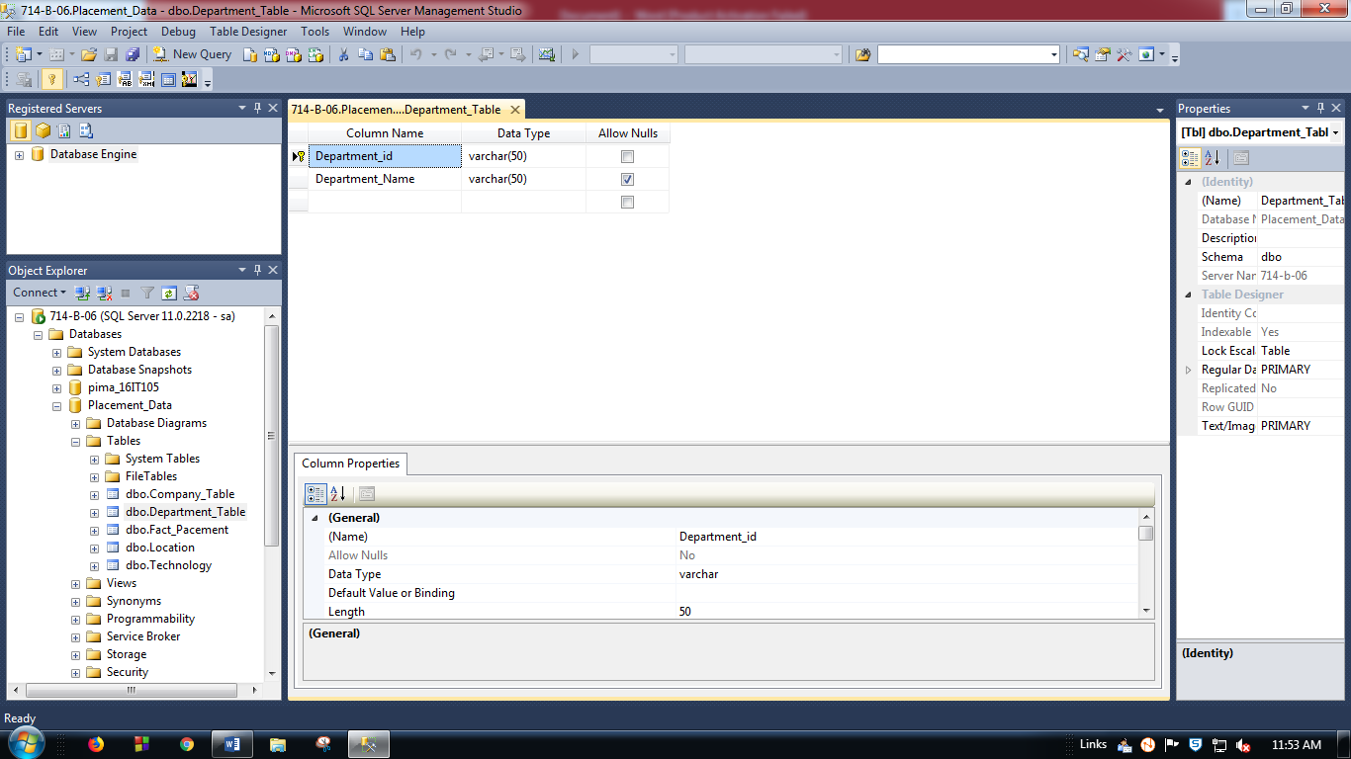

**Figure: 5** Department Table Design

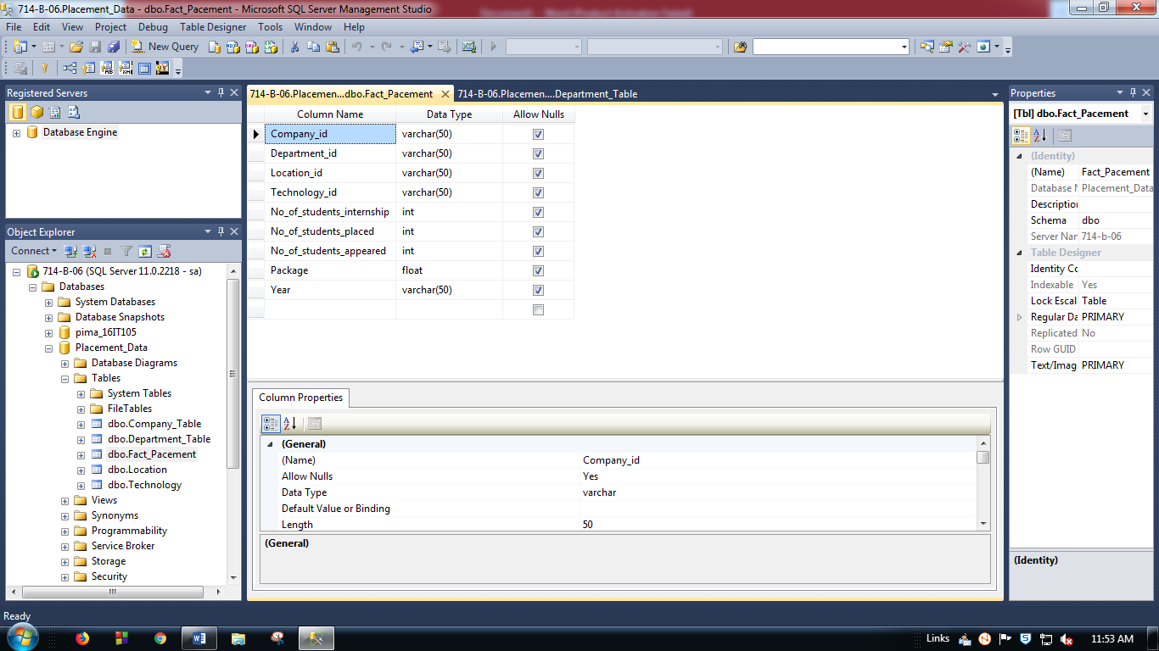

**Figure: 6** Placement Fact Table Design

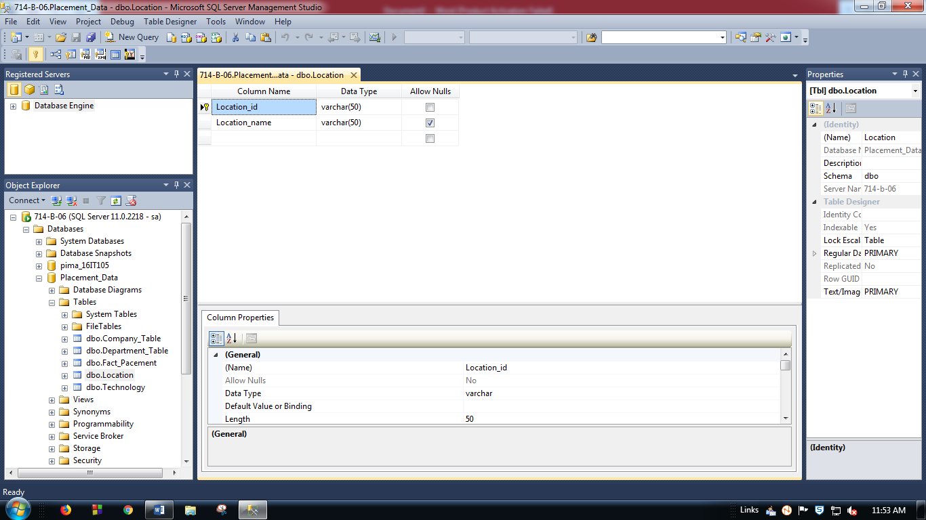

**Figure: 7** Location Table Design

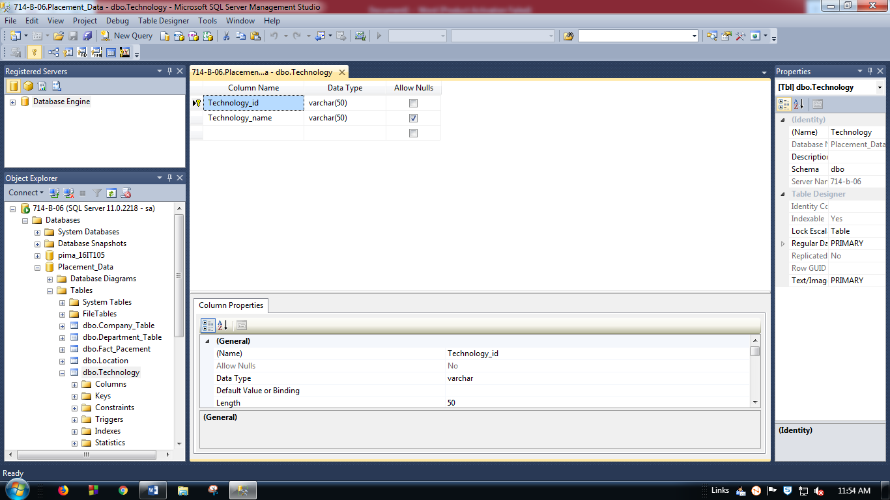

**Figure: 8** Technology Table Design

1. **To create a Database Diagram**

**Step1:** Right Click on Database Diagrams in “Object Explorer”.

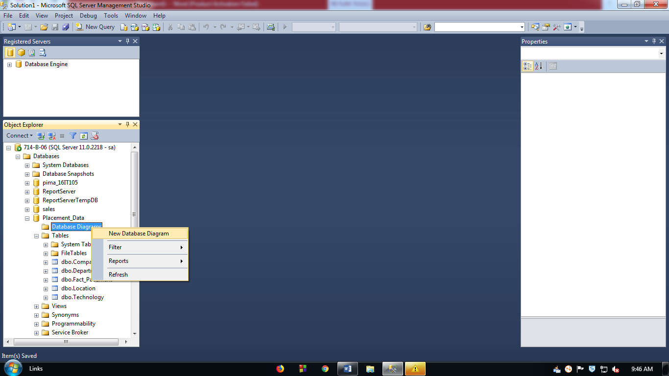

**Figure: 9** Create New Database Diagram

**Step2:** Select the Tables to add to crate a digram or relationship of tables.

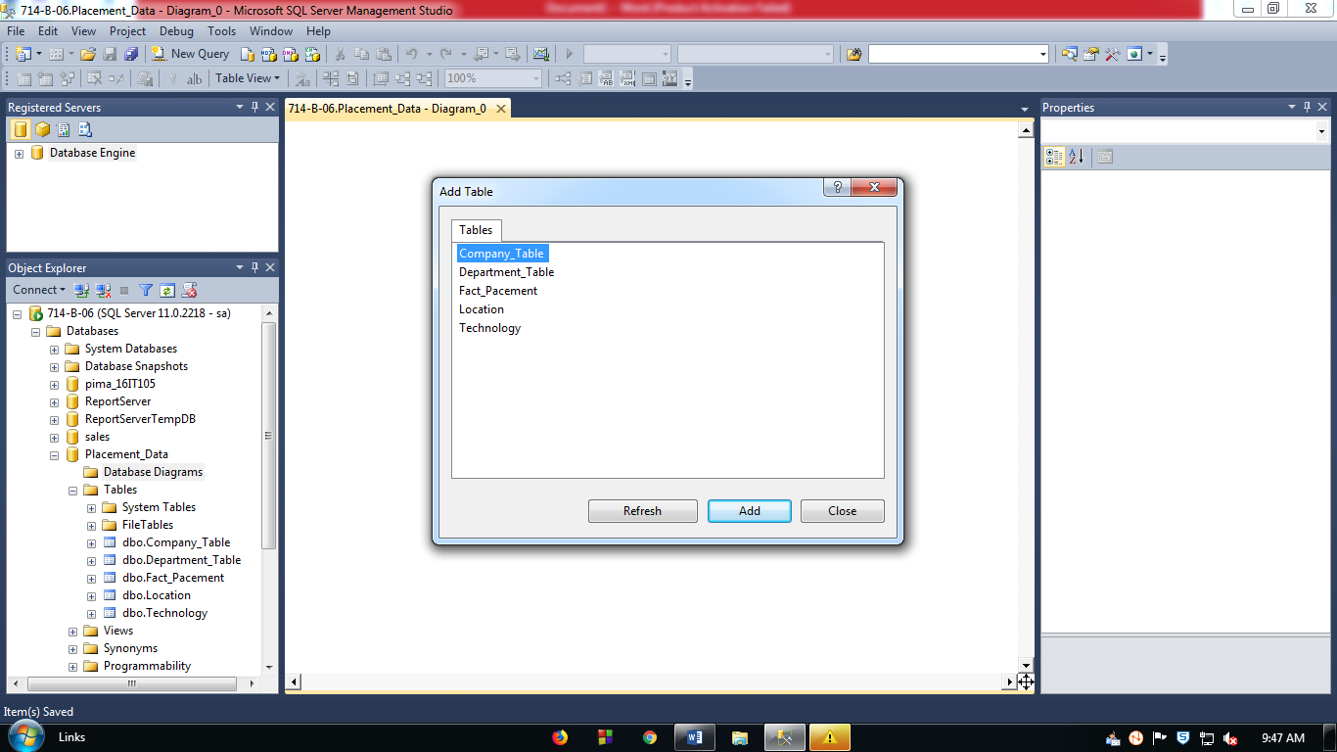

**Figure: 10** To Add Tables in Database Diagram

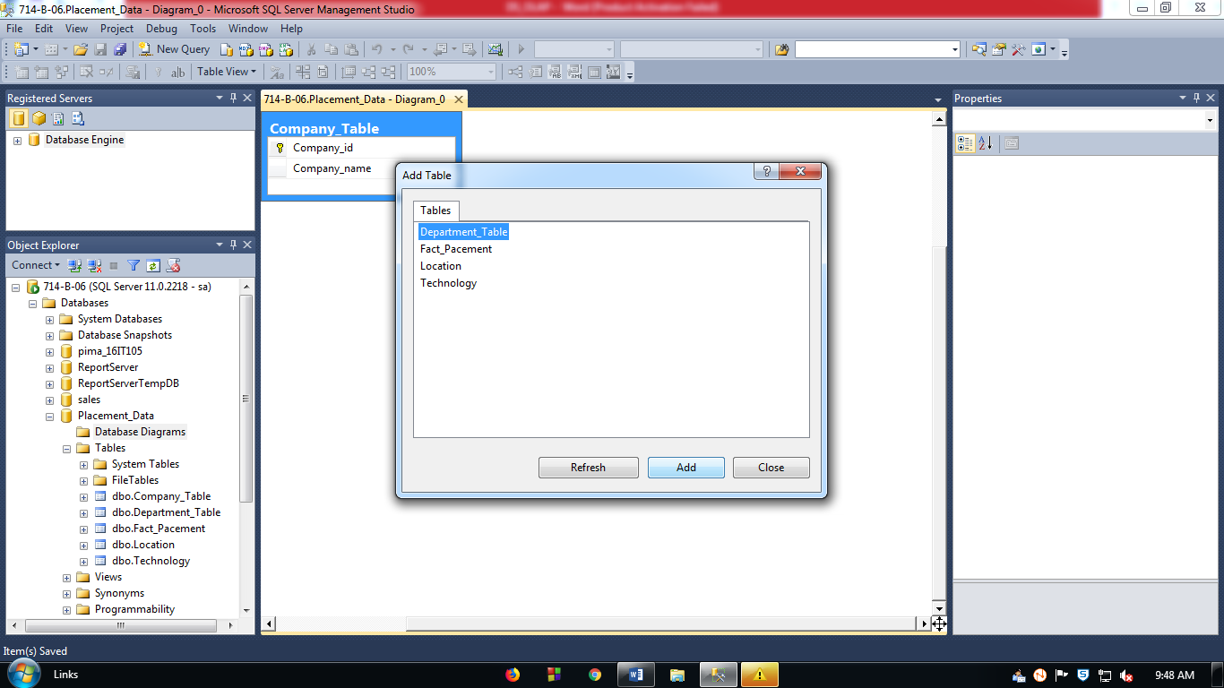

**Figure: 11** Similarly adding other Tables

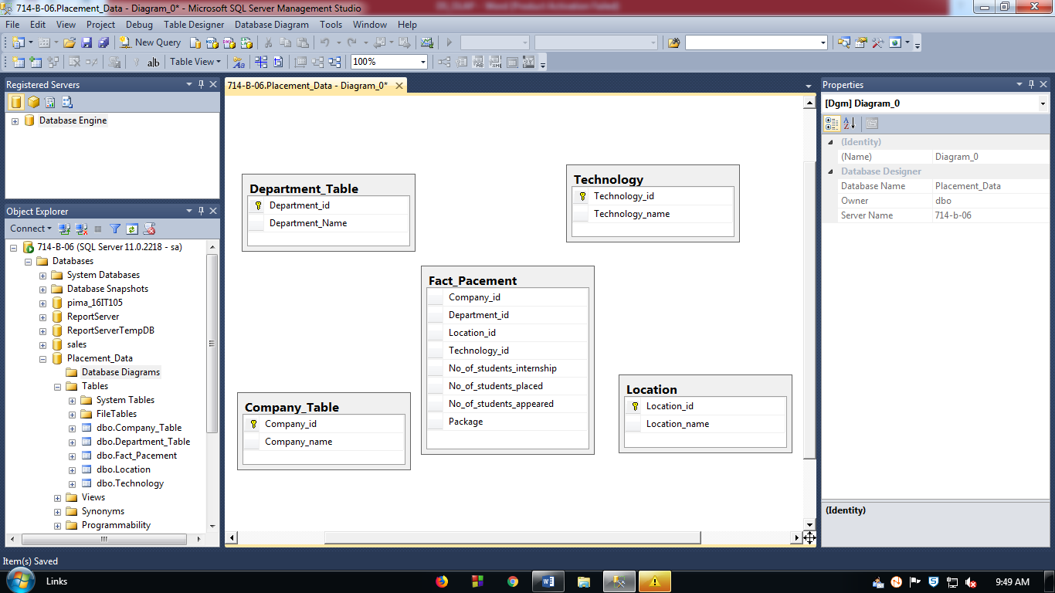

**Figure: 12** Creating Database Diagram

**Step3:** Drag the primary key to the fact table to create relationship among the tables.

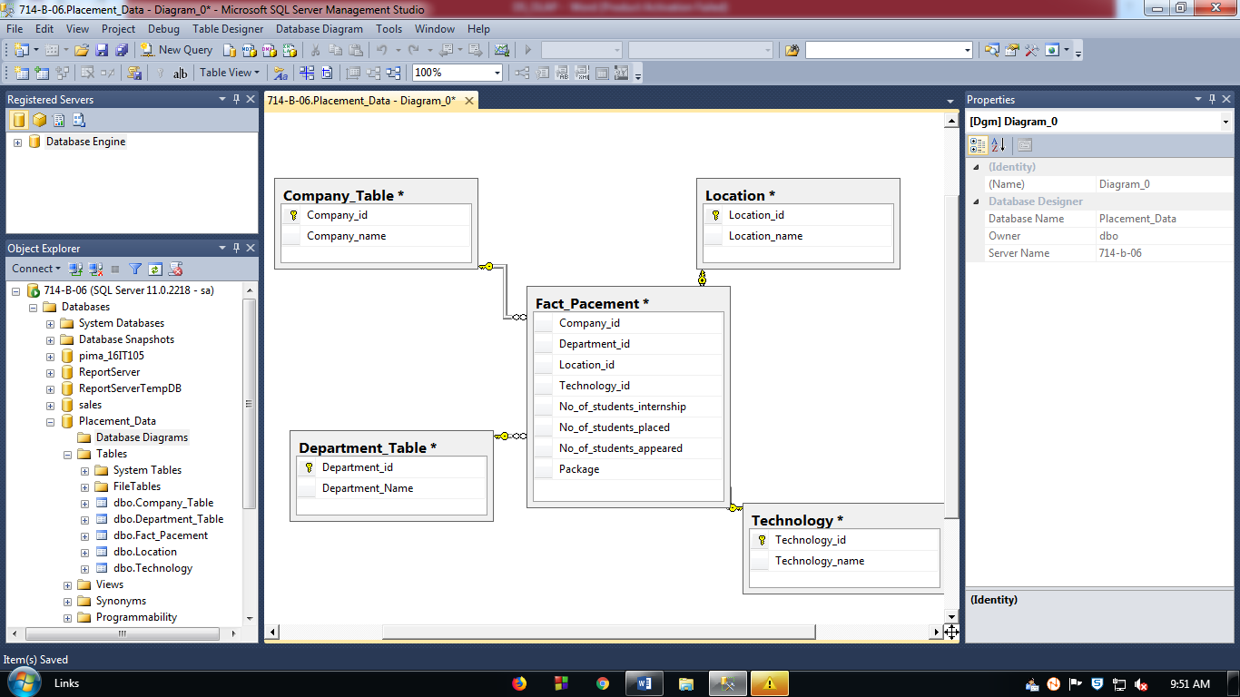

**Figure: 13** Database Diagram is created with Foreign Keys linked with their corresponding Primary Keys

**Step4:** Save the diagram with name “Design Training”.

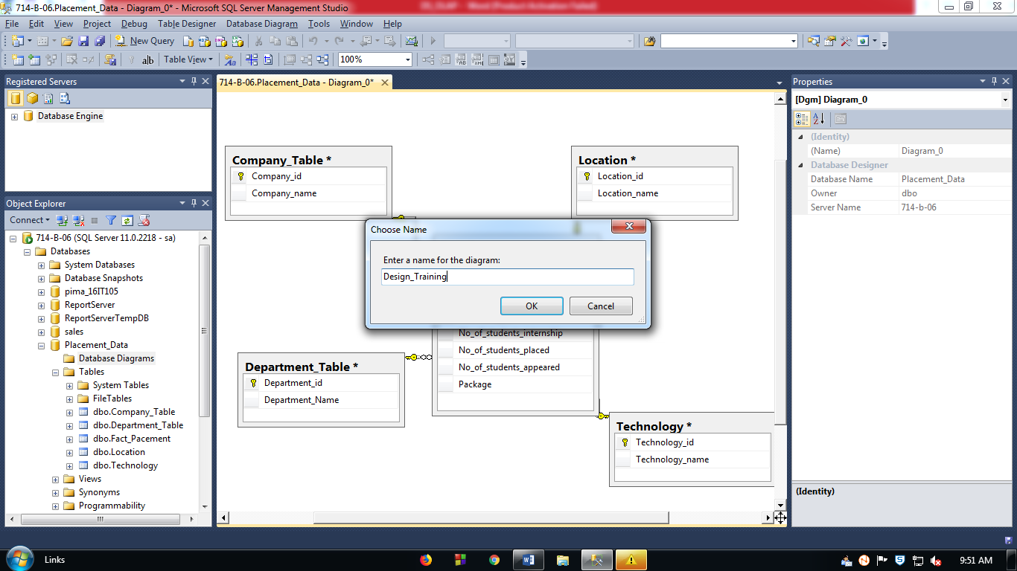

**Figure: 14** Naming the Database Diagram

**Step5:** Click Yes to save the diagram.

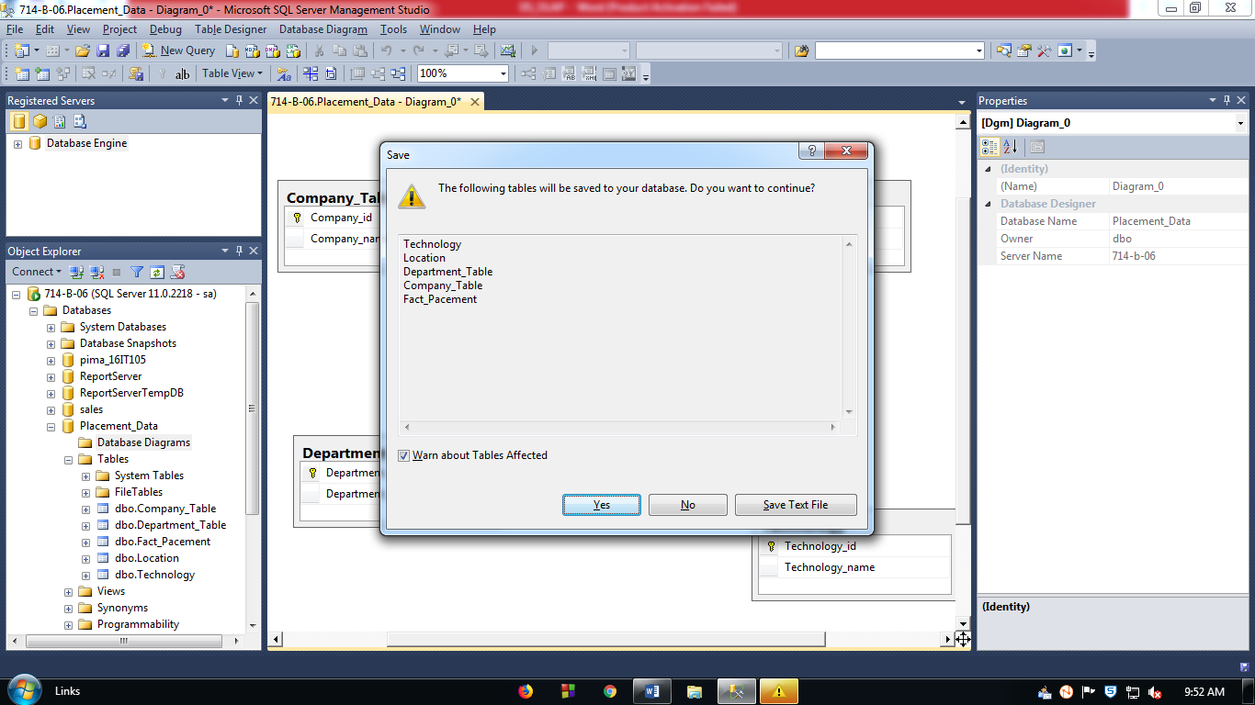

**Figure: 15** Saving the Database Diagram

1. **Insterting data to the database**

**Step1:** To edit rows, right click on the table name and click “Edit 200 rows”.

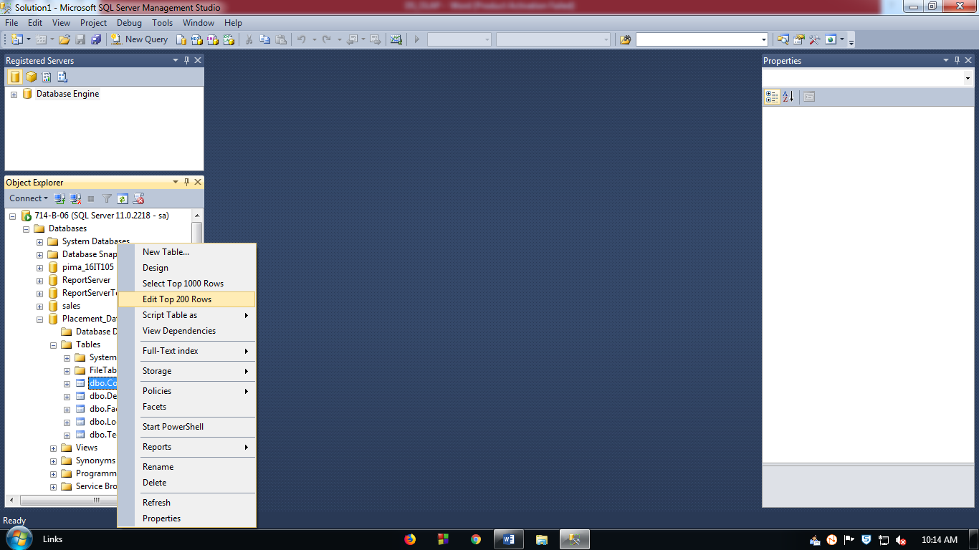

**Figure: 16** Editing rows in the tables to store data

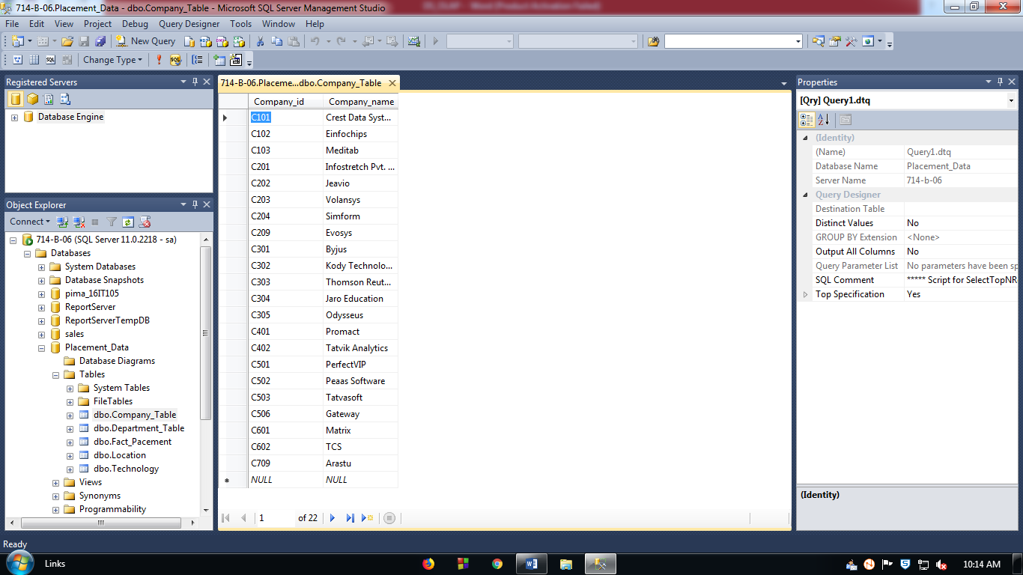

**Figure: 17** Company Table Data

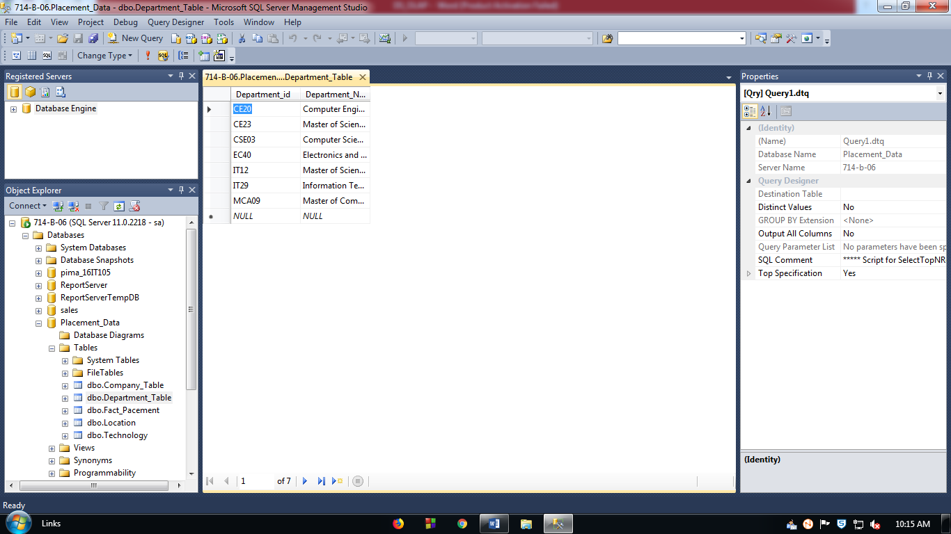

**Figure: 18** Department Table Data

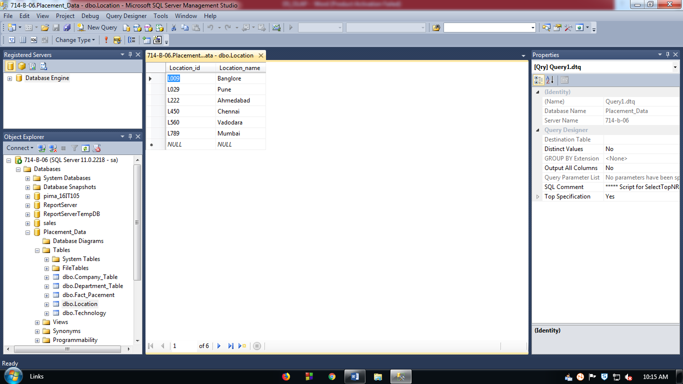

**Figure: 19** Location Table Data

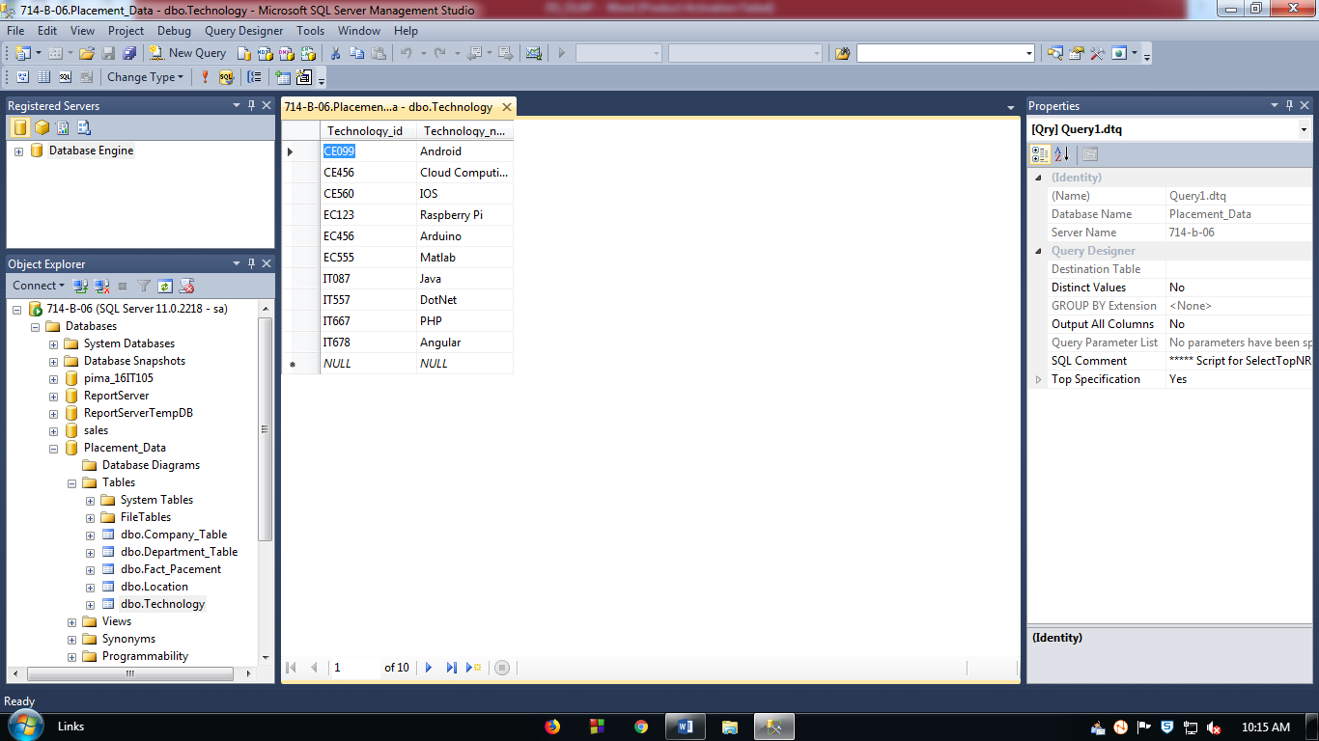

**Figure: 20** Technology Table Data

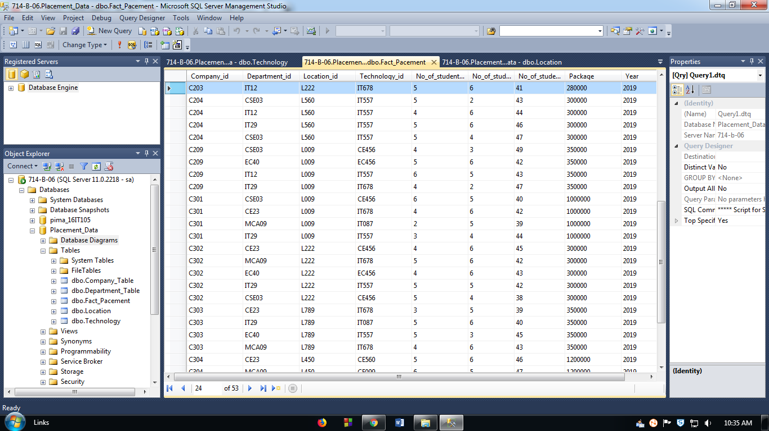

**Figure: 21** Fact Table Data

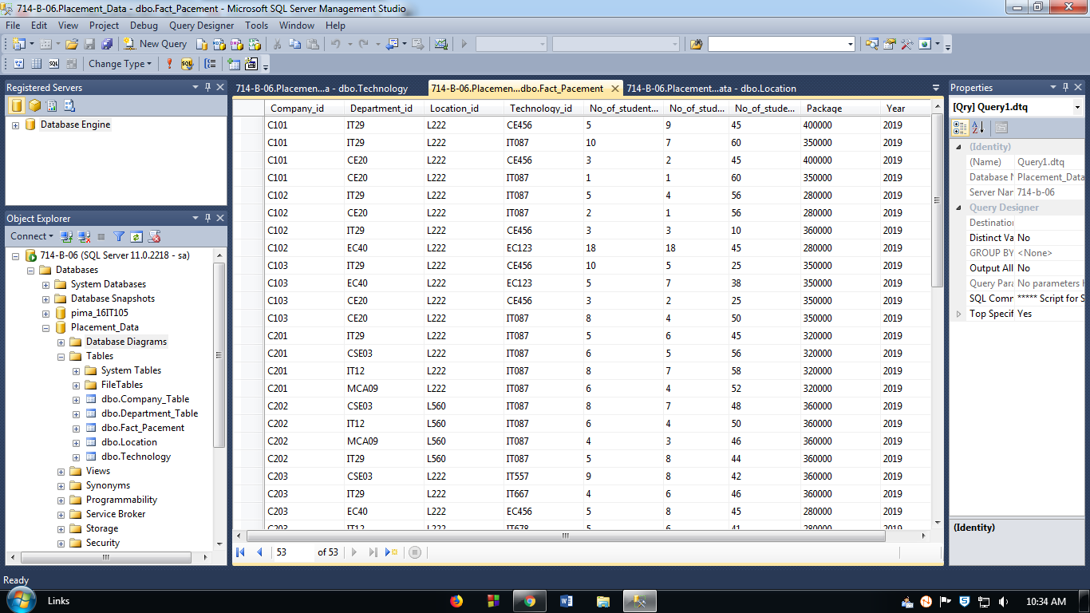

**Figure: 22** Fact Table Data

**Conclusion:** In this experiment we studied about SQL Server 2012 Databases and Analysis Services. We have created a simple Database Schema on Placement Data using SQL Server Management Studio.