**PRACTICAL 10**

**Aim:** **Story Telling using data: Demonstrative by student using any tools**

<https://towardsdatascience.com/storytelling-with-data-a-data-visualization-guidefor-business-professionals-97d50512b407>

**Theory:**

**What is Power BI**

Power BI is a business analytics service that delivers insights to enable fast, informed decisions.

* Transform data into stunning visuals and share them with colleagues on any device.
* Visually explore and analyze data—on-premises and in the cloud—all in one view.
* Collaborate on and share customized dashboards and interactive reports.
* Scale across your organization with built-in governance and security.

**Why choose Power BI**

Meet your self-service and enterprise analytics needs with one of the largest business intelligence clouds in the world. Explore how industry-leading AI and continuous user-driven innovation help you turn data into insights across your organization at scale.

**Why Power BI**

Explore the top reasons organizations choose Power BI to meet their self-service and enterprise business intelligence (BI) needs.

**Output:**

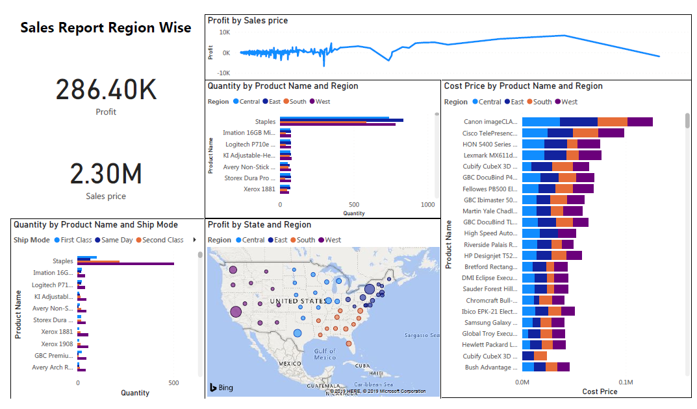

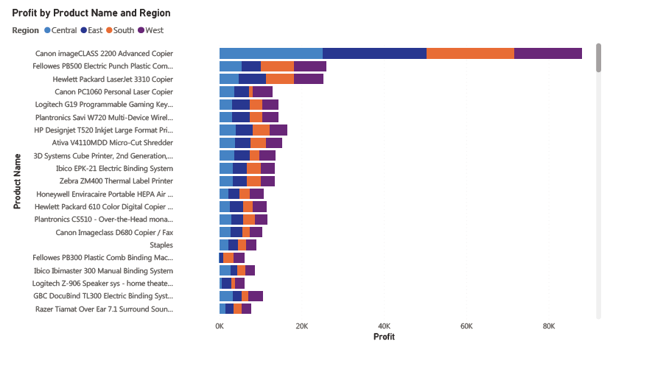**Conclusion:** In this practical I have generated Story using data using PowerBI.