Online service for local Brick-and-Mortar stores

Coding Complete Guidelines

Version 1.0 | 11-June-2020

Copyright Information
This document is the exclusive property of Mindtree Limited (Mindtree); the recipient agrees that they may not copy, transmit, use or disclose the confidential and proprietary information in this document by any means without the expressed and written consent of Mindtree. By accepting a copy, the recipient agrees to adhere to these conditions to the confidentiality of Mindtree's practices and procedures; and to use these documents solely for responding to Mindtree's operations methodology.

Revision History
Please keep the latest version on top
Ver | Change Description | Sections | Date | Author | Reviewer | Approver
1.0 | Initial Draft |  | 11-June-20 | Vittal

Table of Contents
1. Overview 5
2. Features (Functional Requirements) 5
2.1 User registration with 2-factor authentication & login 5
2.2 Welcome message with push notification service 6
2.3 Store search service & store listing based on user location 6
2.4 Product Information 6
2.5 Shopping cart service 6
2.6 Delivery address management 7
2.7 Store review and rating management 7
3. Non-Functional Requirements 7
3.1 Platforms 7
3.2 Device support 7
3.3 Architecture 7
3.4 Security 7
3.5 Configuration 7
3.6 Testability 7
3.7 Performance 7
3.8 Analytics 7
3.9 Accessibility 8
3.10 Build & deploy automation 8
4. Skills assessed 8
5. Deliverables 8
6. Acceptance Criteria for features and NFRs 8
7. Technical Notes 9
8. Reference Screens 10
9. Reference Links: 11
Mindtree Limited 12

Overview
Anything2Home is an online purchase and delivery company, which aggregates local Brick-and-mortar stores for inventory and collaborates with local delivery agents for delivery to home. The company currently has an ecommerce website (MVP) and provides services to people of one locality in Bangalore, India.

The company now plans to expand services to all metro cities in India with a mobile-first approach. The company has now decided to develop native mobile applications with following services –
- User registration with 2-factor authentication & login
- Product search service
- Product category search service
- Store search service
- Shopping cart service
- Shipping address management
- Payment service with support for credit card, net banking and major wallets
- Delivery status management with push notifications
- Customer service management
- Product review and rating management
- Store review and rating management

Scope of Release-1 includes following services –
- User registration with 2-factor authentication & login
- Welcome message with push notification service
- Store search service & store listing based on user location
- Product information
- Shopping cart service
- Delivery address management
- Store review and rating management
- Application menu services

You have been assigned as a sole mobile designer and developer for delivery of Release-1.

Features (Functional Requirements)

User registration with 2-factor authentication & login
In this service, customer can register in the app using mobile number and SMS message verification:
- Auto detect city
- Registration with mobile number, full name, city and email
- Login with mobile/email and password

Welcome message with push notification service
In this service:
- On successful registration, customer will receive a welcome message through mobile push notification.
- The message should read as - “Ready to order? Welcome to Anything2Home. Get free delivery on your first order with no minimum purchase value.”

Store search service & store listing based on user location (Offline Capable)
This service provides features like:
- Home screen with store search bar
- Top 10 store list on the home screen, based user location & store rating
- Search bar should provide suggestion as dropdown with just 3 input characters
- On selecting the store, store product list should be displayed
- Change user location manually by city and locality

Product Information (Offline Capable)
This service should help customers:
- To view product details with 2 or more images
- Ability to view image in full screen or zoom-in
- Show product cost
- Add to favorites
- Add product to cart and product count

Shopping cart service
This service should help customers:
- View the cart with total price
- Ability to delete products
- Ability to increase or decrease product count
- On confirmation, user is navigated to delivery address confirmation screen

Delivery address management (Offline Capable)
This service should help customers:
- View and edit shipping address
- Add up to 4 shipping addresses and one default address

Store review and rating management (Offline Capable)
This service should help customers:
- View store description page
- Show address, contact information
- Show customer sentiments as ratings on product quality, delivery quality and service quality
- Ability to give rating based on already purchased product from this store

Non-Functional Requirements

Platforms
- Build for iOS with N-2 version support
- Build for Android with 6.0v and above support
- Shall work on portrait mode

Device support
The application must be validated on iOS & Android simulator

Architecture
Application should be based on MVC/MVP/MVVM/Clean/VIPER architecture and design of separation.

Security
App PII (Personal Identifiable Information) must be encrypted during transmission over any network or communication link

Configuration
Project should be configured for test, qa and production environments

Testability
Application must be unit testable and achieve at least 70% code coverage.

Performance
Any screen should render with 5 seconds with API latency and 1 second without API latency

Analytics
Integrate crash analytics, API performance and user analytics

Accessibility
Platform default accessibility services will be supported like Select to Speak, Talk back and similar

Build & deploy automation
Build and deploy should be automated using Bitrise CI/CD platform

Skills assessed

1 | Standards, Conventions and Best Practices
 | 1.1 | Ensure the guidelines are followed: https://developer.apple.com/design/human-interface-guidelines/  https://developer.android.com/design
 | 1.2 | Ensure proper folder and module structures, use appropriate layers in the architecture to ensure the modular design, maintainability, readability, etc.
 | 1.2 | Ensure proper usage of coding standards and guidelines  https://www.dofactory.com/reference/csharp-coding-standards  https://www.mono-project.com/community/contributing/coding-guidelines/
2 | UI, Testing
 | 2.1 | Application should not crash.
 | 2.2 | Ensure usage of JSON files for all data and public apis where possible to retrieve data.  Ensure json structure is logical and well defined rest based api response is defined.
 | 2.3 | Ensure proper transition animation, state changes for buttons and other controls.
 | 2.4 | App must work in both Phones and tablet forms, though both can use the same UI layout. Separate layouts for Phones and tablets is not mandatory, but will be a plus if developed.
 | 2.5 | User Interface (Need not be with custom buttons or design but nice to have an attractive User Interface for screens)
 | 2.6 | Use of Unit testing frameworks and automated unit testing is a plus.
3 | Build
 | 3.1 | Builds can be successfully installed on Android and/or iOS devices, not just on the simulator.

Deliverables
- Mobile Application source code
- Mobile backend configurations / dump / source code
- PPT with slides for
  - App demo video (include push notifications, accessibility)
  - Code coverage report
  - Instrumentation report
  - Analytics reports with crashes, api performance, user analytics

Acceptance Criteria for features and NFRs
The final release must support following functional and non-functional requirements:

  - Functional Requirements:
Feature List
Registration & Login Services: Allow customers to register with phone number and login
Store Search and Listing: Allowing customers to search store and select based on location identified automatically
Delivery Address Management: Allowing customers to manage delivery address
Store Rating Services: Show customer sentiments and allow customer to rate the services
Notification services: Send push notifications of new customers (on simulator or device)

  - Non-Functional requirements
Feature List
Authentication: OAuth2 based with custom login server or social sign-in
Architecture: MVC/MVP/MVVM/Clean/VIPER
Configuration: test, qa and prod
Code Coverage: The final release must have code coverage report of 70%
Reports: Crashes, API performance, user analytics
Testing: 1 or 2 sample UI test cases

Technical Notes

Technology | Skills
DevOps Tools | Github, Jenkins / AppCenter / Bitrise
Authentication | OAuth from Firebase or similar
Analytics | Google or similar
Database | sqlite or similar
APIs, Push notification | Google Firebase / Backendless or similar

Reference Screens
These are for illustration only and to help you visualize the requirement.
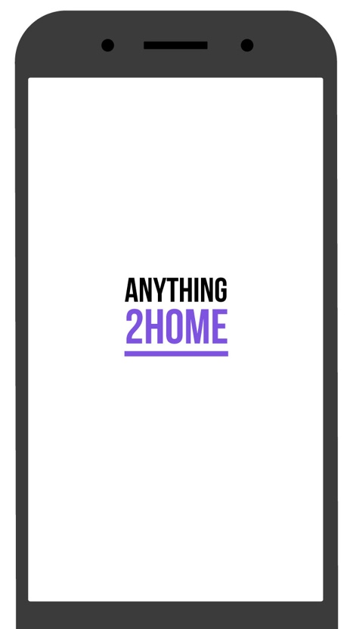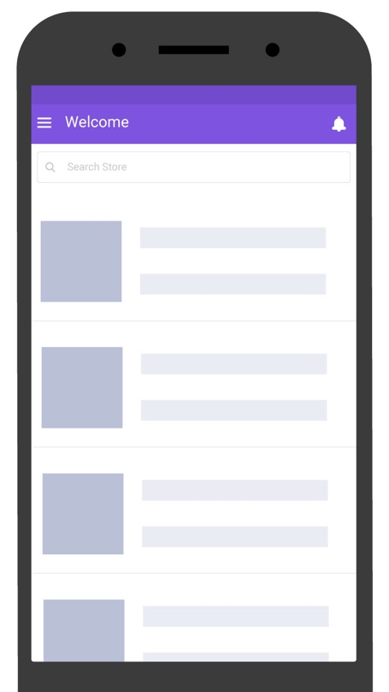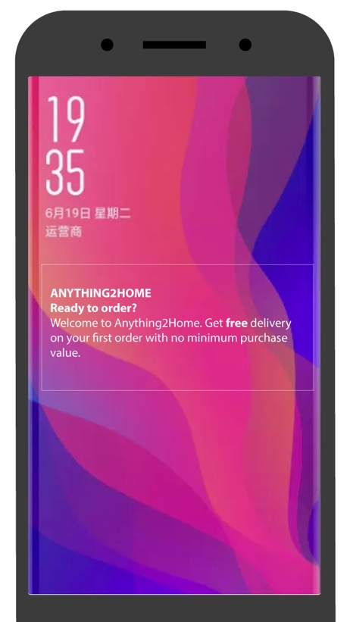

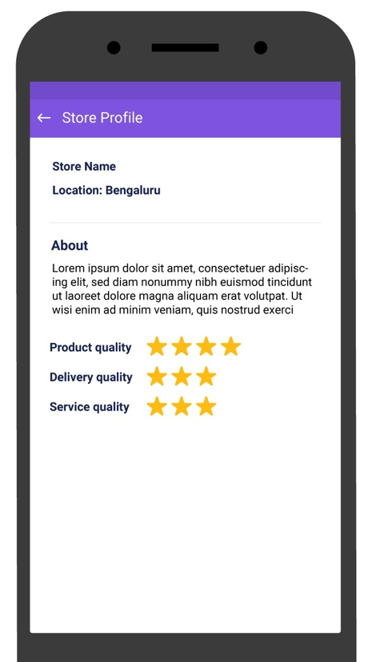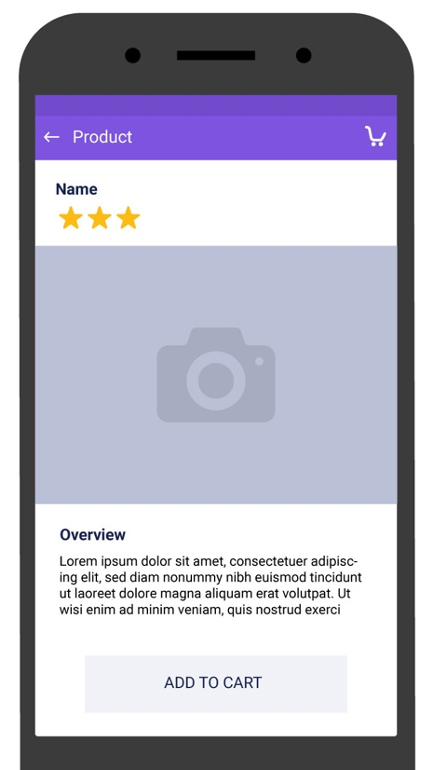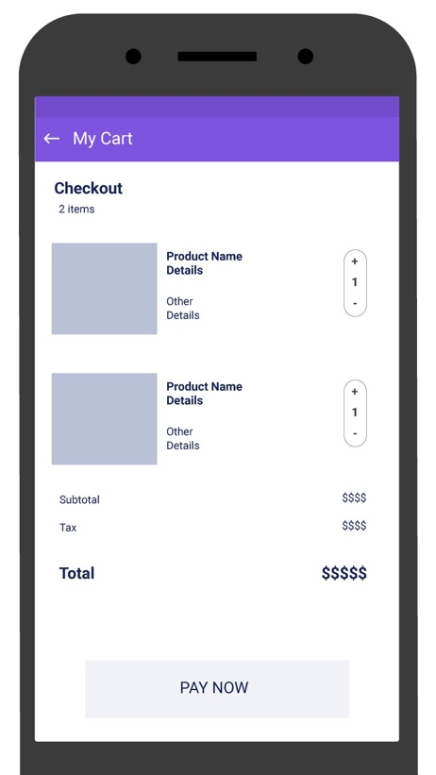
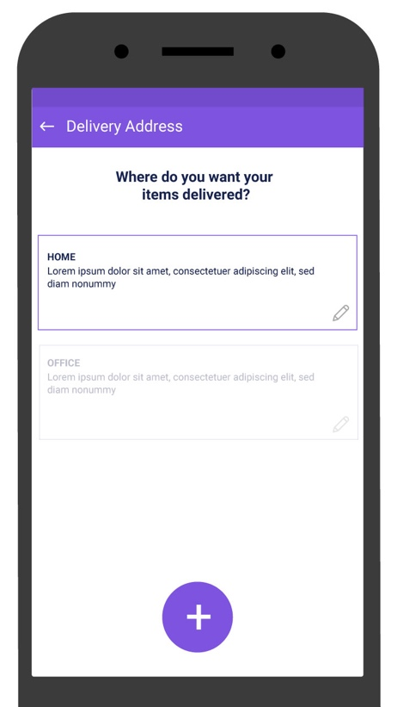

Mindtree Limited
Contact Information
<Specify Contact Name>
Email: <Specify Contact E-mail address>

Global Village, RVCE Post, Mysore Road,
Bangalore-560 059
INDIA
Phone- 91 (80) 6706 4000
Fax- 91 (80) 6706 4100
Web- www.Mindtree.com

