Report on
CertiChain – Tamper-Evident Academic Credential Registry
Advanced Java (INT3140)
Submitted in partial fulfilment of the requirements for the award of the degree
of
BACHELOR OF TECHNOLOGY (B. TECH)
in
Computer Science and Engineering
by
[Your Name]
(Reg. No: [Registration Number])
Section [ ]

Under the guidance of
[Faculty Name]
----------------------------
Signature of Faculty
Department of Computer Science and Engineering
Department of Computer Science and Engineering
Faculty of Engineering
Manipal University Jaipur, India
November 2026

Abstract
CertiChain is a certificate registry for a college or university. Every certificate it issues, whether a degree, a course completion, an internship or a hackathon award, is sealed into a SHA-256 hash chain that is stored in an ordinary relational database. An employer can check a certificate in a few seconds by scanning the QR code printed on it or by typing its number on the public portal.
The main point of the project is that the records cannot be changed quietly. Each ledger block holds the hash of the certificate data and the hash of the previous block. If anyone, including a database administrator, edits a grade, swaps a name, deletes a row or inserts a fake degree directly with SQL, the chain stops matching. The public page then shows the certificate as Tampered, and a background watchdog raises an alert in the registrar console.
The software is written in Java as three Maven modules. A shared core library holds the data model, the hashing code and a multithreaded chain verifier. A Spring Boot web application provides the verification portal and the registrar console using Servlets, filters, JSP and a REST API. A Swing desktop application uses plain JDBC for bulk issuing from CSV files, integrity audits and a live tampering demonstration. In testing, all four kinds of direct database attack that were tried were detected, and the ledger reported itself intact again once each change was undone.
List of Figures
Figure No. | Title | Page No.
Figure 3.1 | System architecture of CertiChain | 8
Figure 3.2 | Structure of the hash-chained ledger (real hashes from the demo data) | 9
Figure 3.3 | Issuing a certificate in one transaction | 10
Figure 4.1 | Public verification portal | 15
Figure 4.2 | Verification result for an authentic certificate | 16
Figure 4.3 | Printable certificate with QR code and REVOKED watermark | 16
Figure 4.4 | Registrar console dashboard | 17
Figure 4.5 | Verification result after a direct database edit | 18
Figure 4.6 | Breach banner and Fraud Radar after the edit | 18
Figure 4.7 | Registrar Desk sign-in | 19
Figure 4.8 | Registrar Desk dashboard | 19
Figure 4.9 | Issuing a certificate from the desktop client | 20
Figure 4.10 | Tamper Lab | 20
Figure 4.11 | Integrity audit on the desktop client | 21

Table of Contents
SL. No. | Title | Page No.
1 | Abstract | 2
2 | Introduction | 5
3 | Problem Statement | 7
4 | Methodology | 8
5 | System Implementation / Working | 15
6 | Future Scope / Enhancements | 22
7 | Conclusion | 23
8 | Comparison with Existing Systems | 24
9 | References | 25

1) Introduction
Checking whether a certificate is genuine is still slow in most places. A company that receives a degree or a course certificate from a candidate usually writes to the college and waits for the examination section to look up its records. This can take several days. Printed and PDF certificates are also easy to copy and edit, so a forged document can look exactly like a real one.
Most certificate management systems built as student projects store certificates in a database table and offer screens to add, edit and delete them. They make issuing faster, but they do not make the records trustworthy. Whoever can change the table can change a grade or add a degree that was never awarded, and nothing in the system shows that it happened.
CertiChain borrows one idea from blockchains, the hash chain, and uses it inside the college's own database. No mining, tokens or external network are involved. Every certificate and every revocation becomes a block that is linked to the block before it by a SHA-256 hash, so a change anywhere breaks the links from that point on.

1.1) Scope
The report covers the design of the ledger, the database, the web and desktop applications, the security measures and the tests that were run. The project is also used to apply each unit of the Advanced Java (INT3140) syllabus: OOP, collections, multithreading, JDBC, Swing, Servlets, JSP, session management, Spring and Spring Boot. Section 3.7 maps every topic to the class where it is used.
The system is meant for one institution running its own server. Publishing the ledger to outside parties, digital signatures and email delivery are discussed under future scope but are not part of this version.

1.2) Literature Survey
Hash chains and time-stamping. Haber and Stornetta (1991) showed that digital documents can be time-stamped by linking each record to the hash of the one before it. Back-dating or changing a record would then require changing every later record. The same linked structure was later used as the base of blockchain data structures.
Tamper-evident logs. Crosby and Wallach (2009) studied logs kept on a server that is not fully trusted, where an auditor must be able to detect changes to past entries. CertiChain uses a simpler linear chain, which the institution re-checks in full and which every public lookup checks around the certificate concerned.
Blockchain credentials. Blockcerts, an open standard that began at the MIT Media Lab, records certificate hashes on a public blockchain so that verification does not depend on the issuer's database. The cost is the need for a public network, wallets and transaction fees, which is a lot to ask of a single college department.
Government document repositories. In India, DigiLocker and the National Academic Depository give students digital copies of documents from participating boards and universities. They are central services; a college that wants instant checks for its own internal certificates, such as course completions, workshops and hackathon awards, still needs a system of its own.
Password storage and web security. The PBKDF2 key-derivation function (RFC 8018) and the OWASP cheat sheets on session management, CSRF and password storage guided the login and session design of the registrar console.

2) Problem Statement
An institution needs to issue certificates that a third party can verify instantly, and any later change to a certificate, including a change made directly in the database by someone with full access, must be detected. The data is protected by two hashes:
data_hash = SHA-256( certNo | name | rollNo | email | program |
type | title | grade | issueDate | issuedBy )

block_hash = SHA-256( seq | blockType | certNo | data_hash |
prev_hash | actor | createdAt )

prev_hash = block_hash of the previous block (64 zeros for block #1)
A certificate is authentic only if its current row still hashes to the data_hash sealed in its ISSUE block, that block still hashes to its stored block_hash, and the blocks on both sides still point to it. A certificate is revoked when a valid REVOKE block exists for it, whatever its row says.

2.1) Objectives
- To issue certificates with random, non-guessable numbers and a printable copy that carries a QR code.
- To seal every issue and every revocation into an append-only, hash-chained ledger in the same database.
- To show a public verification result (Authentic, Revoked, Tampered or Not found) together with the checks behind it.
- To re-audit the whole ledger in the background on several threads and raise an alert when data drifts from its seal.
- To record every administrative action and every verification attempt for later review.
- To provide a desktop client for bulk issuing from CSV files using JDBC transactions and batch inserts.
- To use each unit of the INT3140 syllabus in working code.

3) Methodology

3.1) System architecture
The project is a multi-module Maven build. The core module is a plain Java library that both applications use, so the hashing rules exist in exactly one place. The server module is a Spring Boot application packaged as a WAR. The desktop module is a Swing application that talks to the database directly over JDBC. Both applications open the same database at the same time: H2 in file mode with AUTO_SERVER enabled, or MySQL.
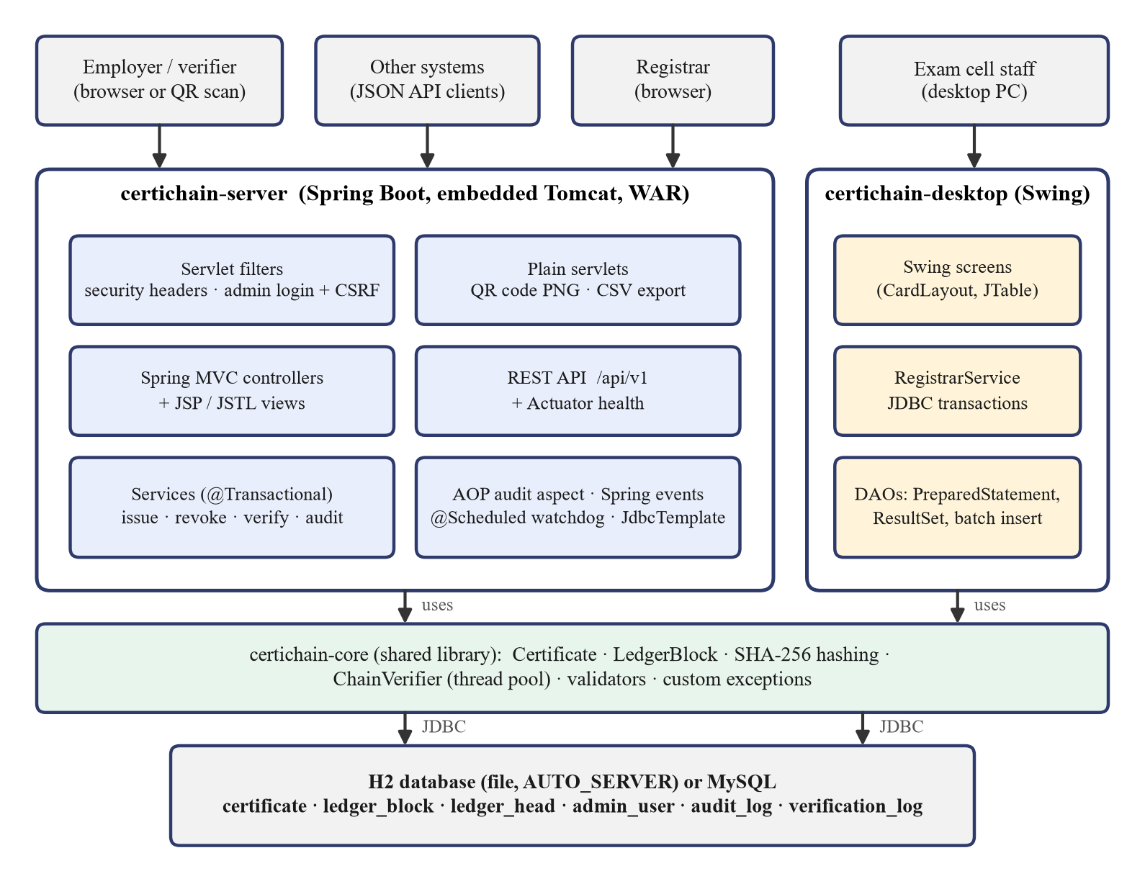
Figure 3.1: System architecture of CertiChain

3.2) The hash-chained ledger
The ledger is the table ledger_block. Issuing a certificate appends an ISSUE block carrying the certificate's data_hash; revoking appends a REVOKE block carrying the hash of the certificate number and the reason. The block_hash covers every other field of the block, including prev_hash, so a block cannot be edited, removed or moved without breaking the next link.
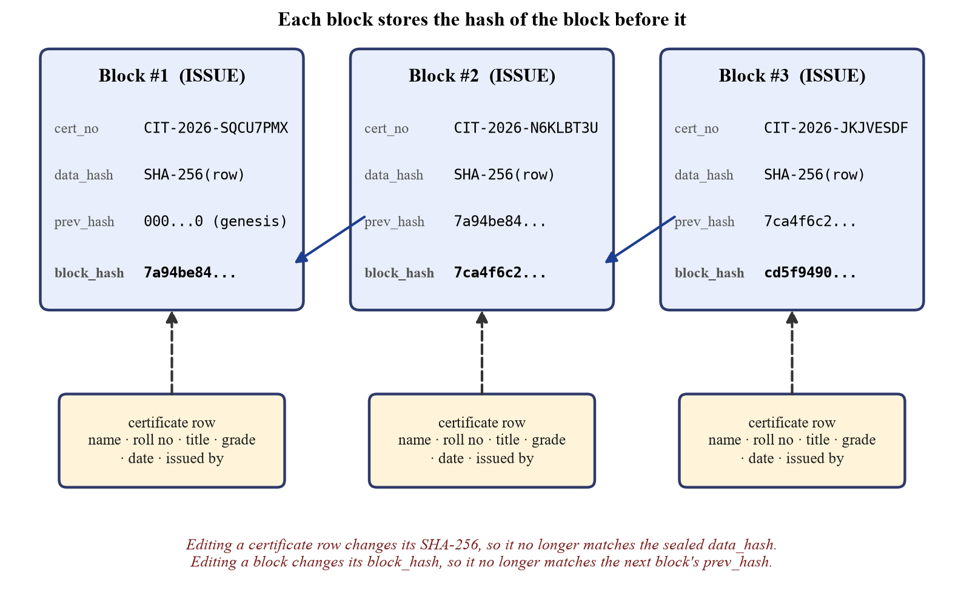
Figure 3.2: Structure of the hash-chained ledger (real hashes from the demo data)
A separate one-row table, ledger_head, stores the number and hash of the last block. Before a block is appended this row is locked with SELECT ... FOR UPDATE, so two writers (two browser requests, or the web server and the desktop client) wait for each other and can never create two different block #15s. If the head does not match the last block in the table, which happens when blocks are deleted from the end, all writes are refused with a LedgerTamperedException.

3.3) Database design
Table 3.1: Database tables
Table | What it stores | Main columns
certificate | One row per issued certificate | cert_no (PK), student_name, roll_no, title, grade, issue_date, status, data_hash
ledger_block | The append-only hash chain | seq (PK), block_type, cert_no, data_hash, prev_hash, block_hash
ledger_head | Pointer to the last block, locked while appending | last_seq, last_hash
admin_user | Registrar accounts | username, full_name, password_hash (PBKDF2), role
audit_log | Every administrative action from web and desktop | actor, action, detail, outcome, duration_ms, source
verification_log | Every public lookup | cert_no, result, channel, client_ip, user_agent

Timestamps are stored as epoch milliseconds (BIGINT) so that the value that was hashed is exactly the value read back; a database TIMESTAMP type could round it and break the hash. The same schema script is run by the server and by the desktop client, and a MySQL version of it is included.

3.4) Issuing and revoking in one transaction
Figure 3.3 shows the steps for issuing one certificate. The certificate row and its ledger block are written in a single transaction, so either both are stored or neither is. In the web application this is done with Spring's @Transactional; the ledger repository's append method is marked Propagation.MANDATORY so that it can never run outside a transaction. In the desktop application the same steps are written by hand with setAutoCommit(false), commit() and rollback().
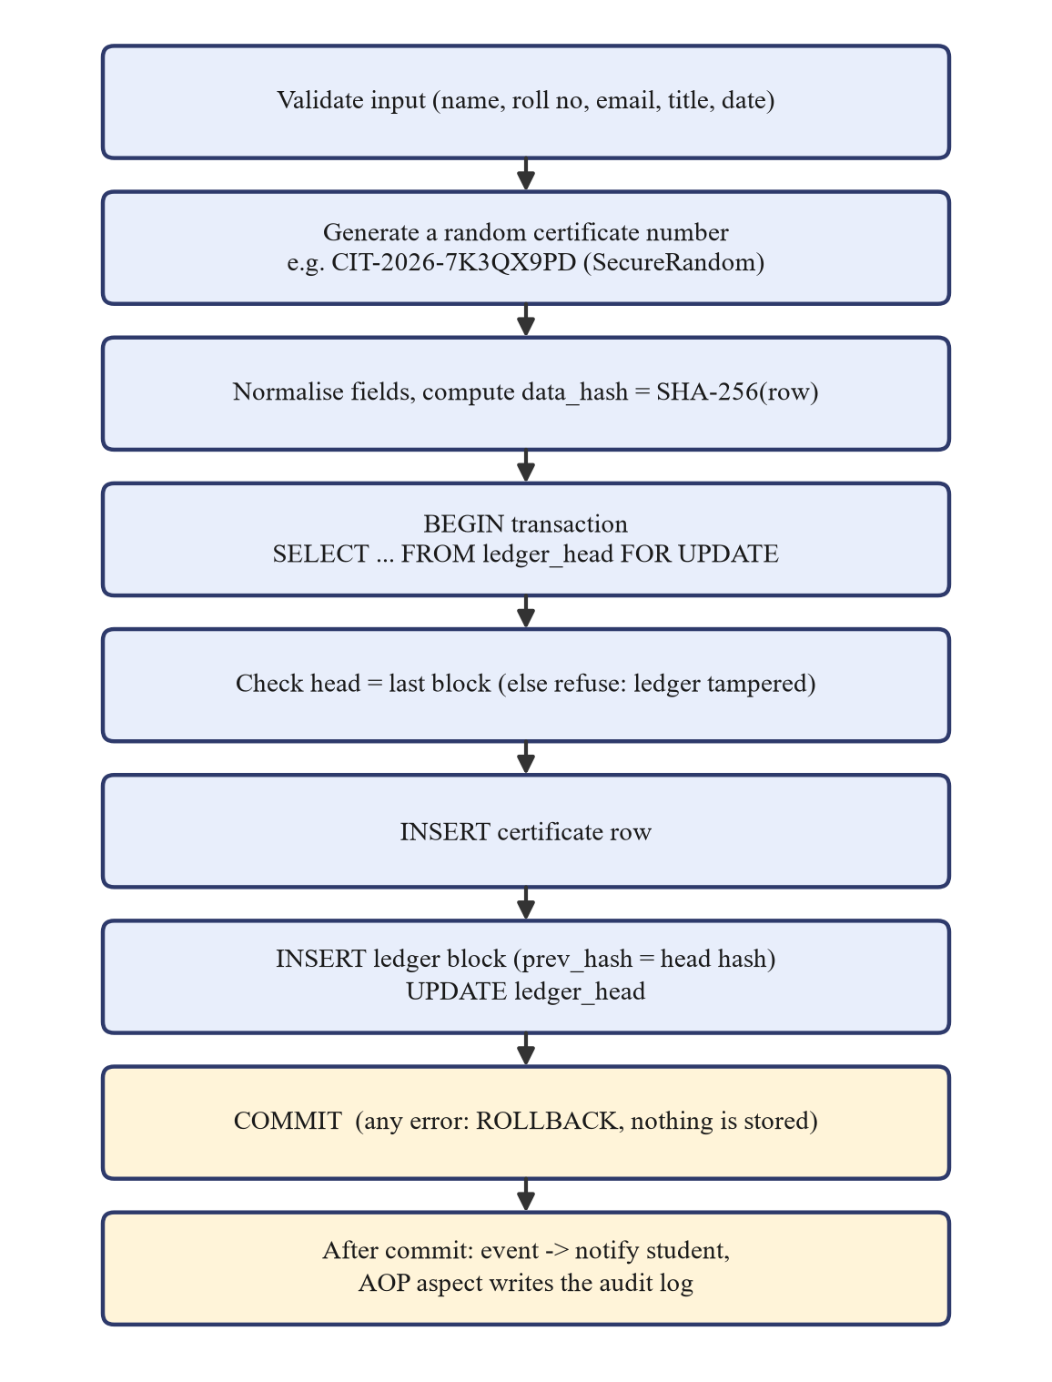
Figure 3.3: Issuing a certificate in one transaction
Bulk issuing from the desktop client validates every CSV line first and reports bad lines with their line numbers. The valid rows are then inserted with JDBC batches (addBatch and executeBatch) for both the certificate rows and the ledger blocks, inside one transaction. A single failure rolls back the whole batch. Revocation follows the same pattern, and a certificate that already has a REVOKE block cannot be revoked twice.

3.5) Verifying a certificate
A public lookup checks one certificate against its own blocks and the blocks next to its ISSUE block, which keeps it fast enough to run on every request. Table 3.2 lists the checks.
Table 3.2: Checks made for each verification
Check | What is compared | If it fails
Registered in the ledger | An ISSUE block exists for this number | Row was inserted outside the system
Ledger block unaltered | Stored block_hash and recomputed block hash | The block was edited
Chain links intact | prev_hash of this block and of the next block | A block was inserted, deleted or moved
Data matches seal | SHA-256 of the current row and the sealed data_hash | Name, grade or another field was edited
Revocation consistent | Row status and the presence of a REVOKE block | A revocation was hidden or faked

If any of the first four checks fails, the result is Tampered. A valid REVOKE block makes the result Revoked even if someone has set the row back to VALID, because the ledger, not the row, is trusted. A number that was never issued gives Not found; a number whose row was deleted while its block remains gives Tampered. Every lookup is written to the verification log, and a lookup that finds tampering also publishes a TamperDetectedEvent.

3.6) Multithreaded integrity audit
The full audit re-hashes every block and every certificate. The blocks are first read into a list, then split into chunks; each chunk is checked by a Callable on a fixed thread pool created with Executors.newFixedThreadPool, and the results are collected through Future.get(). Each task only reads the shared lists and returns its own list of findings, so no locking is needed, and an AtomicInteger counts the blocks checked. Checks that need the whole picture, such as finding certificate rows with no ISSUE block and comparing the head pointer, run afterwards on the calling thread.
For n blocks and m certificates the work is O(n + m) hash computations, divided across p threads. On the demo data (14 blocks, 13 certificates) the desktop client finished an audit on 12 threads in 11 ms. In the web application a @Scheduled watchdog runs the audit every 60 seconds and keeps the last report in a volatile field for the dashboard.
Table 3.3: Problems the integrity audit reports
Finding | Meaning
CERT_DATA_MODIFIED | Certificate data no longer matches what was sealed at issue time
STORED_HASH_MISMATCH | The data_hash column itself was edited
BLOCK_HASH_MISMATCH | A ledger block was edited after it was sealed
BROKEN_LINK | A block no longer points at the previous block
SEQUENCE_GAP | Block numbers are not continuous
CERT_MISSING | The ledger seals a certificate whose row was deleted
UNREGISTERED_CERT | A certificate row exists without any ledger block
REVOCATION_HIDDEN | The ledger says REVOKED but the row says VALID
REVOCATION_FORGED | The row says REVOKED but there is no REVOKE block
HEAD_MISMATCH | The head pointer does not match the last block

3.7) Use of Advanced Java concepts
Table 3.4: Mapping of syllabus topics to the project
Syllabus topic | Where it is used in CertiChain
OOP: inheritance, polymorphism, abstraction, encapsulation | Hashable interface with a default method, implemented by Certificate and LedgerBlock; exception hierarchy under CertiChainException; Refreshable screens; AbstractTableModel subclass
Packages and access modifiers | core.model, core.crypto, core.chain, server.web, server.service, desktop.dao, desktop.ui and others
Exception handling, custom exceptions | CertificateNotFoundException, InvalidCertificateException, LedgerTamperedException; @ControllerAdvice error pages; rollback in catch blocks
Collections | HashMap, HashSet and TreeSet in ChainVerifier; ArrayDeque undo stack in TamperLab; LinkedHashMap of CSV line errors
Multithreading and concurrency | ExecutorService, Callable, Future, AtomicInteger, ConcurrentHashMap (login lockout), volatile, @Async listeners, SwingWorker
JDBC: drivers, Statement, PreparedStatement, ResultSet | All desktop DAOs, through DriverManager and the Type 4 H2 or MySQL driver
JDBC transactions and batch processing | setAutoCommit(false), commit, rollback, addBatch, executeBatch, SELECT ... FOR UPDATE
Swing | JFrame, JDialog, CardLayout, GridBagLayout, JTable with TableRowSorter, JSpinner, JFileChooser, JProgressBar, custom cell renderer
Servlets, filters, listeners | QrCodeServlet, CsvExportServlet (init and Spring lookup), AdminSecurityFilter, SecurityHeadersFilter, HttpSessionListener
JSP and session management | JSP pages with JSTL, EL and static includes; login session, session-fixation defence, CSRF token, 30-minute timeout
Spring: beans, life cycle, DI, XML | Constructor injection; beans.xml with setter and constructor injection; init-method and destroy-method
Spring events, AOP, transactions | @TransactionalEventListener; @Audited annotation with an @Around aspect; @Transactional services over JdbcTemplate
Spring Boot and distributed applications | Auto-configuration, embedded Tomcat, profiles for H2 and MySQL, JSON REST API, Actuator health endpoint

3.8) Security measures
- Passwords: stored with PBKDF2-HMAC-SHA256, 120,000 iterations and a random salt, compared in constant time.
- Brute force: five wrong passwords lock an account for five minutes; unknown users take the same time as wrong passwords.
- Sessions: the old session is discarded at login (session-fixation defence); cookies are HttpOnly and SameSite.
- CSRF: every POST in the admin area must carry a per-session token, checked by a servlet filter.
- Injection: every query uses bound parameters; JSP output is escaped with c:out and fn:escapeXml; a Content-Security-Policy blocks inline scripts.
- Other: certificate numbers come from SecureRandom; the CSV export guards against spreadsheet formulas; the post-login redirect only accepts admin paths.

3.9) Testing and validation
The tests below were run on the finished code. Table 3.5 summarises the results.
Table 3.5: Test summary
Test | What was done | Result
Unit tests (JUnit 5) | 7 tests on a 300-block ledger: untouched chain, edited grade, deleted block, forged row, single verification, hidden revocation, password hashing | All 7 passed
Desktop services | Issued 1 certificate, then a sample CSV (4 valid rows, 1 rejected at line 6), then revoked one | Audit: ledger intact, 6 blocks, 5 certificates
Tamper attacks | Changed a grade, changed a name, hid a revocation, inserted a forged row, each followed by an audit and an undo | Detected as CERT_DATA_MODIFIED, CERT_DATA_MODIFIED, REVOCATION_HIDDEN, UNREGISTERED_CERT; intact after each undo
Rollback | Submitted a batch containing one invalid certificate | Rejected with 6 validation messages; no rows written
Both apps together | Edited a grade from the desktop side while the web server ran on the same database | Web page showed Tampered; watchdog raised the breach banner; intact after undo (14 blocks, 13 certificates)
Web and API | Login redirect, issuing through the form, QR servlet, JSON API, Actuator health | All worked as expected

4) System Implementation / Working
The public portal is the page an employer sees. It explains the service, shows how many certificates have been issued and the current ledger head, and has a box for entering a certificate number.
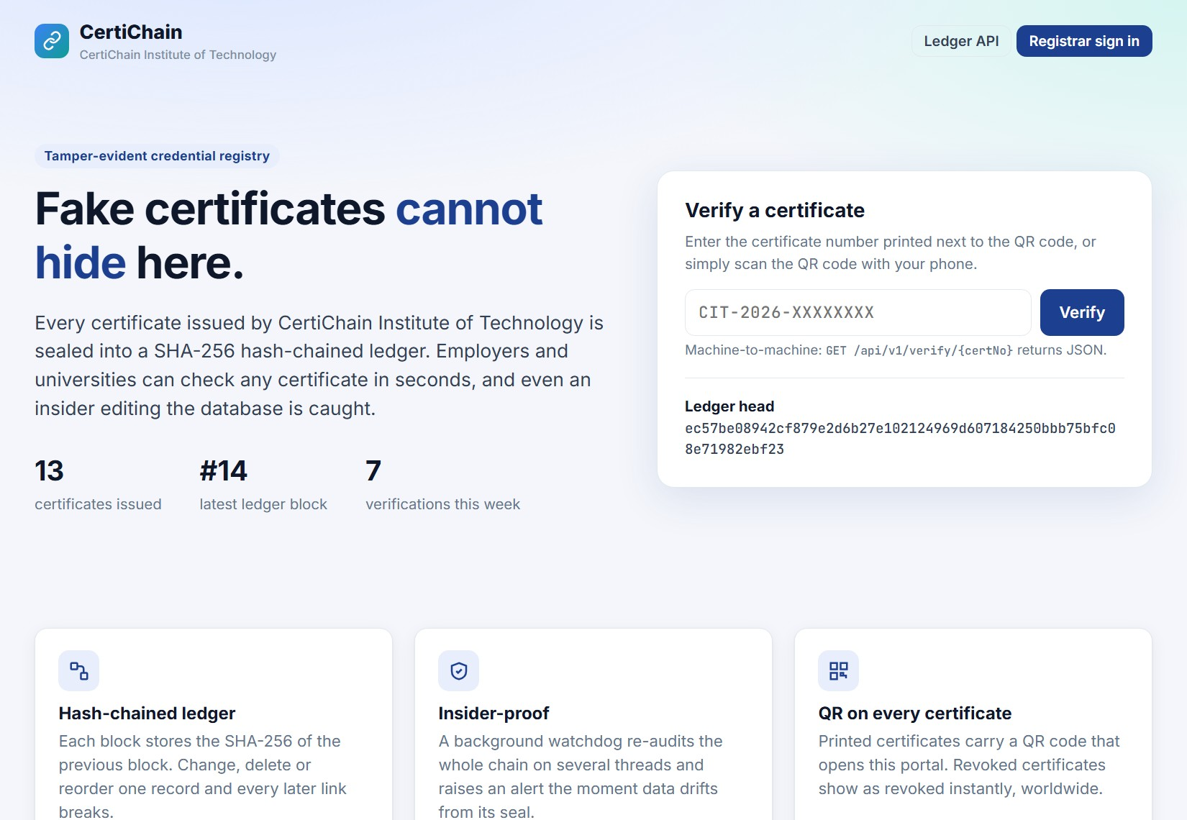
Figure 4.1: Public verification portal
Entering a genuine number, or scanning the QR code, shows the result in green with the certificate details, the ledger proof and the five checks.
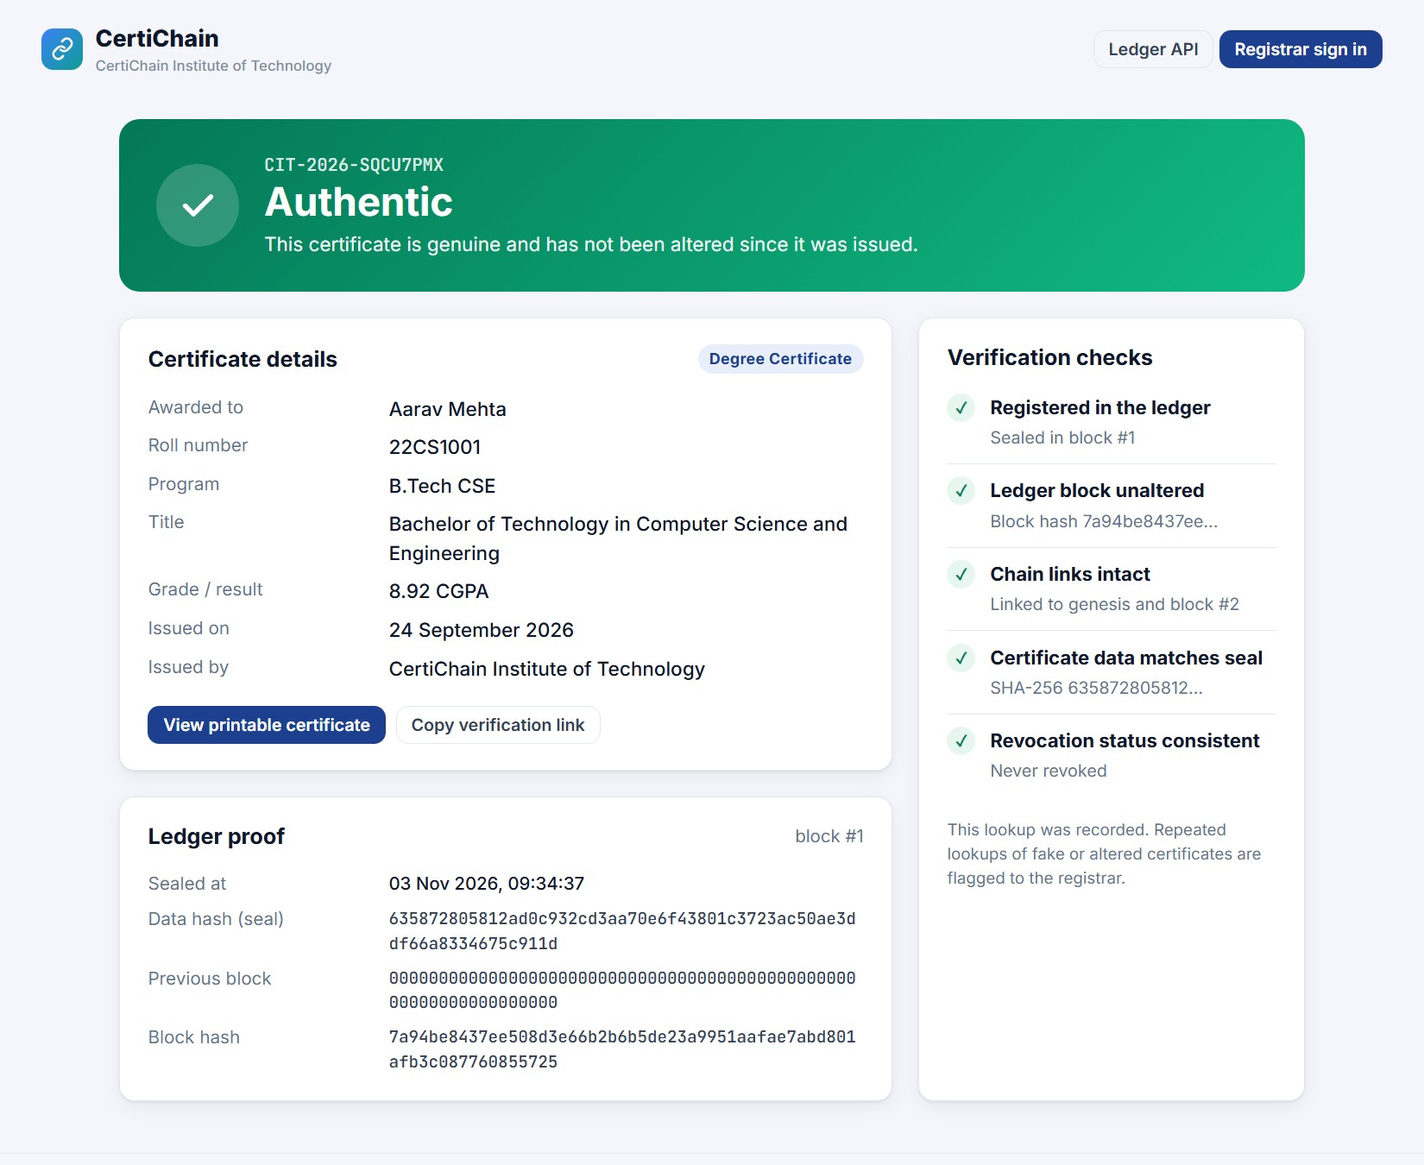
Figure 4.2: Verification result for an authentic certificate
Each certificate has a printable page with a QR code produced by a plain servlet. A revoked or altered certificate is printed with a watermark, so a stale printout cannot be passed off as current.
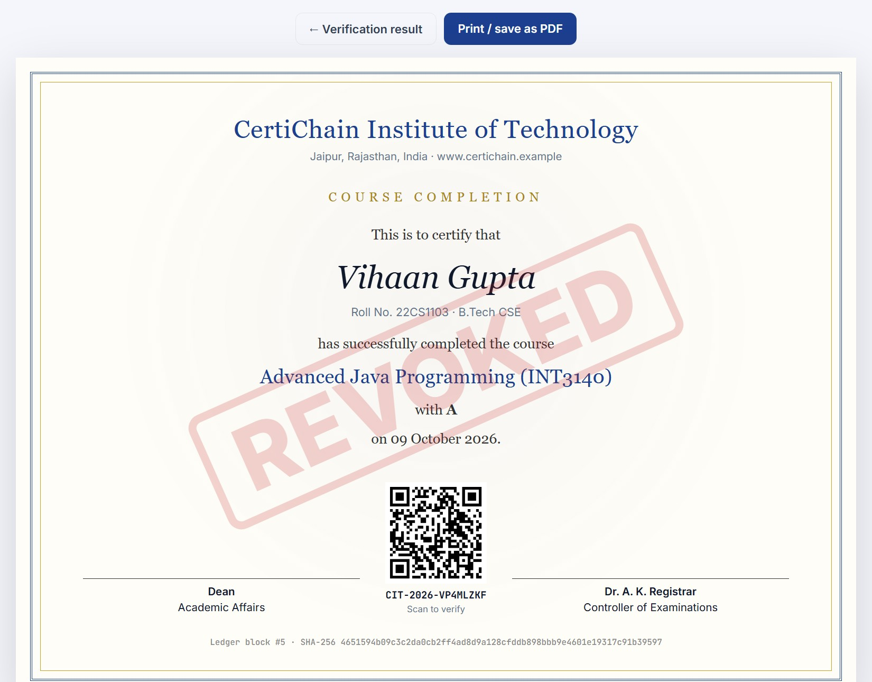
Figure 4.3: Printable certificate with QR code and REVOKED watermark
Registrars sign in to the console. The dashboard shows the number of certificates, the ledger length, verification traffic for the last seven days, a Fraud Radar count of fake or altered certificates that people tried to verify, and the ledger health.
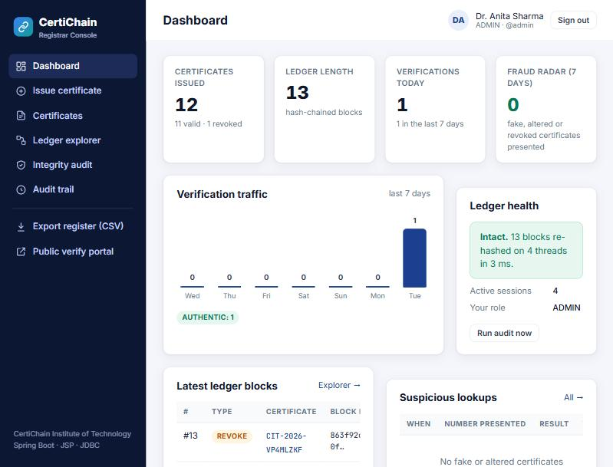
Figure 4.4: Registrar console dashboard
Figures 4.5 and 4.6 show what happened when a grade was changed directly in the database during testing. The public page turned red and pointed at the failed check, and within a minute the watchdog put a breach banner on every console page.
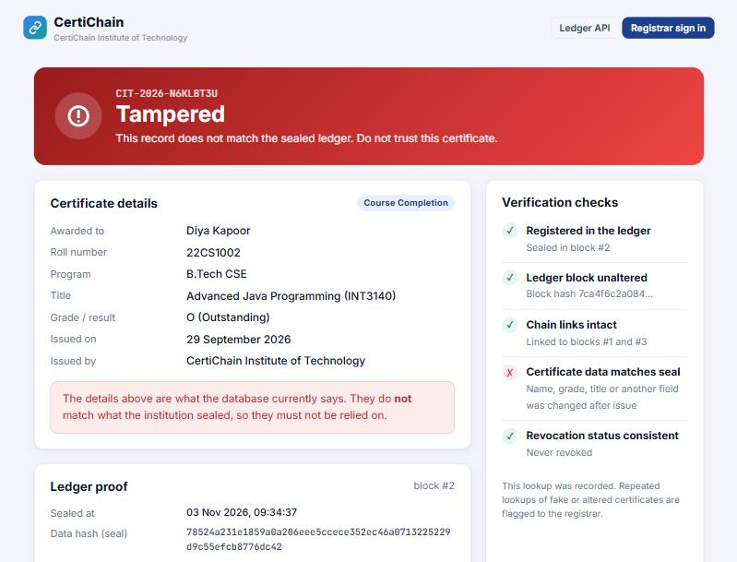
Figure 4.5: Verification result after a direct database edit
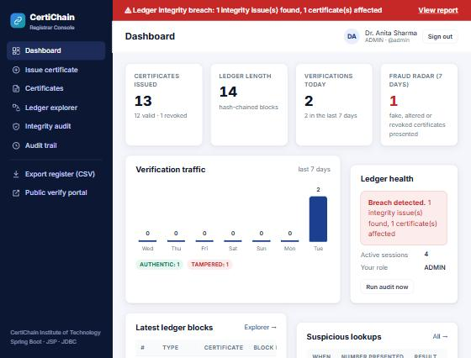
Figure 4.6: Breach banner and Fraud Radar after the edit
The Registrar Desk is the Swing client used in the examination section. It signs in against the same accounts as the web console and shows the live state of the shared database.
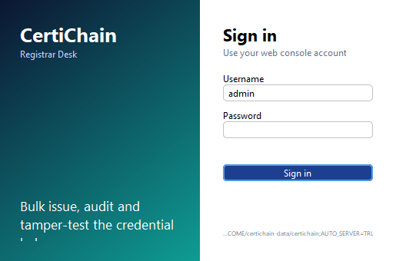
Figure 4.7: Registrar Desk sign-in
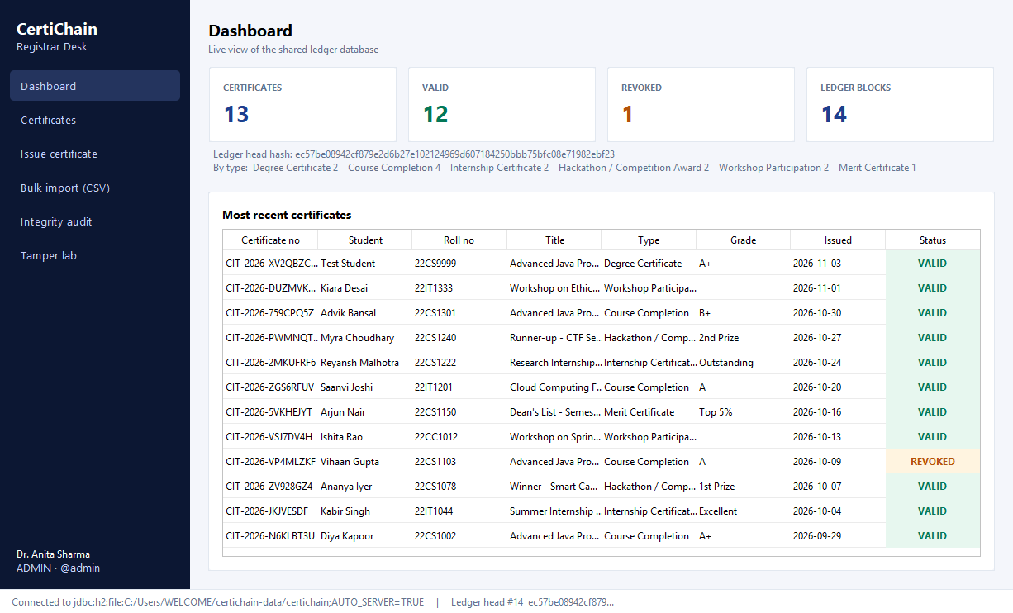
Figure 4.8: Registrar Desk dashboard
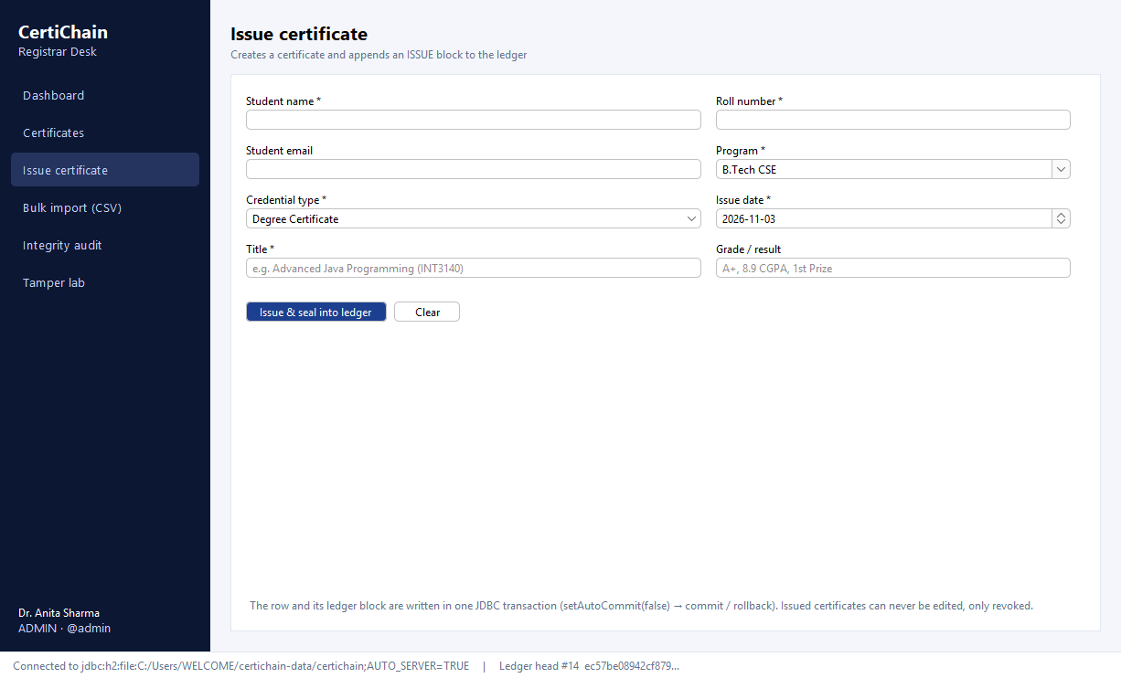
Figure 4.9: Issuing a certificate from the desktop client
The Tamper Lab plays the part of a dishonest database administrator. It runs raw SQL against the database, bypassing CertiChain completely, and keeps an undo stack so the demo data can be restored. The integrity audit screen then lists what was found.
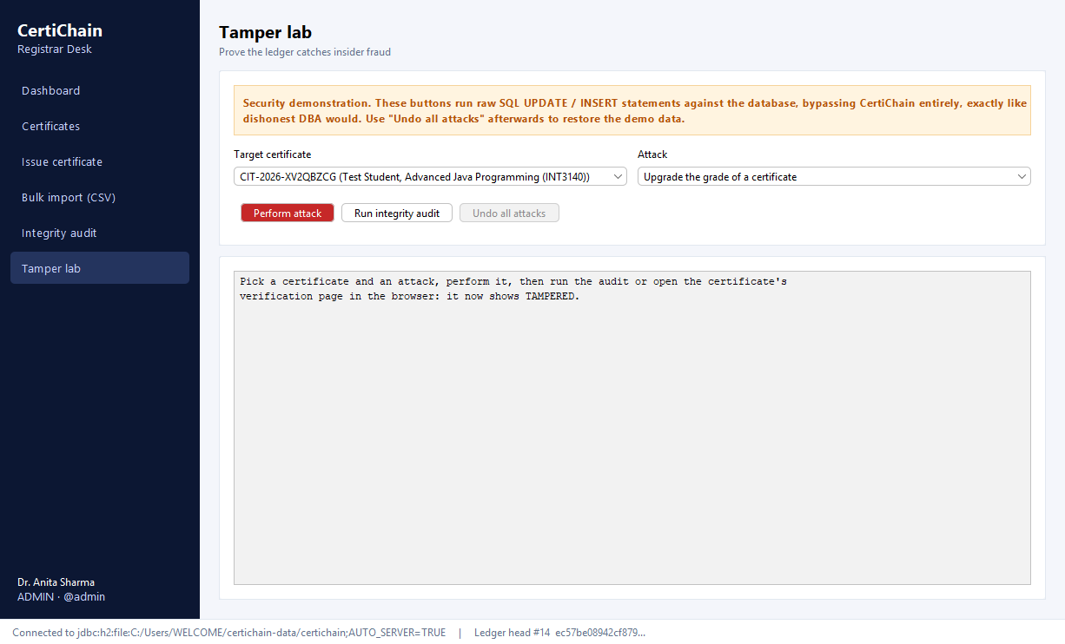
Figure 4.10: Tamper Lab
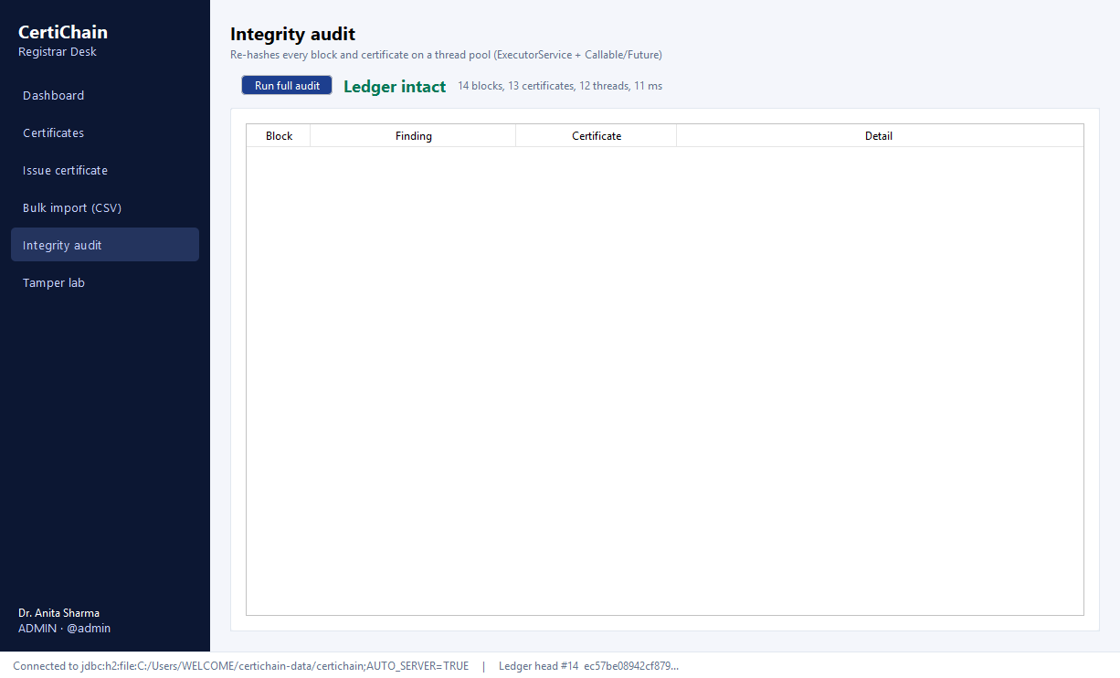
Figure 4.11: Integrity audit on the desktop client

5) Future Scope / Enhancements
- Publishing the head hash: post the latest block hash every day in a public place, such as the college website or a public Git repository, so that even the institution cannot rewrite the whole chain without being noticed.
- Digital signatures: sign each block with the registrar's private key using java.security.Signature, so a block also proves who issued it.
- Email delivery: connect the existing post-commit event listener to an SMTP server to send students their verification links.
- Microservices: move verification into its own Spring Cloud service behind a gateway with service discovery, so lookups can scale separately from the console.
- Wider adoption: let several departments or colleges run their own ledgers and verify each other's certificates through the JSON API.

6) Conclusion
CertiChain shows that a well-known weakness of certificate systems, trusting whoever controls the database, can be fixed with a simple idea: chain every record to the one before it with a hash and keep checking the chain. The result works on an ordinary database, needs no external network and lets anyone verify a certificate in seconds.
The project also gave practical experience with every part of the Advanced Java course. JDBC transactions and batches, Swing, Servlets, filters, JSP, sessions, Spring's dependency injection, events, AOP and transactions, and Spring Boot are all used for real tasks rather than as separate exercises. Testing confirmed that direct edits to the database were detected each time and that the ledger returned to intact once the changes were undone.

7) Comparison with Existing Systems
Table 7.1 compares CertiChain with the usual ways of checking certificates.
Table 7.1: CertiChain compared with existing approaches
Feature | Manual checking | Typical CRUD system | Public blockchain | CertiChain
Time to verify | Days | Seconds | Seconds | Seconds
Detects insider edits | Depends on staff | No | Yes | Yes
Shows revocation at once | No | Sometimes | Yes | Yes
Runs on college servers | Yes | Yes | No | Yes
Cost per certificate | Staff time | None | Network fees | None
Machine-readable API | No | Rarely | Yes | Yes

The comparison describes these approaches in general terms; it is not a claim about any particular product.

8) References
- S. Haber and W. S. Stornetta, “How to Time-Stamp a Digital Document,” Journal of Cryptology, vol. 3, no. 2, pp. 99–111, 1991.
- S. A. Crosby and D. S. Wallach, “Efficient Data Structures for Tamper-Evident Logging,” Proc. 18th USENIX Security Symposium, 2009.
- National Institute of Standards and Technology, FIPS PUB 180-4: Secure Hash Standard (SHS), 2015.
- K. Moriarty, B. Kaliski and A. Rusch, RFC 8018: PKCS #5: Password-Based Cryptography Specification Version 2.1, IETF, 2017.
- B. Basham, K. Sierra and B. Bates, Head First Servlets and JSP, O’Reilly Media.
- J. Keogh, J2EE: The Complete Reference, Tata McGraw Hill.
- H. Schildt, Java: The Complete Reference, 13th ed., McGraw Hill, 2024.
- Blockcerts, open standard for blockchain credentials – https://www.blockcerts.org/
- OWASP Cheat Sheet Series (session management, CSRF, password storage) – https://cheatsheetseries.owasp.org/
- Spring Boot Reference Documentation – https://docs.spring.io/spring-boot/
- Spring Framework Reference Documentation (AOP, transactions, events) – https://docs.spring.io/spring-framework/reference/
- Jakarta Servlet and Jakarta Server Pages specifications – https://jakarta.ee/specifications/
- H2 Database Engine – https://h2database.com/

