Experiment-5: Develop a program for Bias, Variance, Remove duplicates , Cross Validation

**#bias, variance**

import numpy as np # linear algebra

from mlxtend.evaluate import bias_variance_decomp

import pandas as pd # data processing, CSV file I/O (e.g. pd.read_csv)

from sklearn.model_selection import train_test_split

from sklearn.preprocessing import StandardScaler

from sklearn.neighbors import KNeighborsClassifier

from sklearn.neighbors import KNeighborsRegressor

from sklearn.metrics import confusion_matrix

from sklearn import metrics

from sklearn.linear_model import LinearRegression

import matplotlib.pyplot as plt

%matplotlib inline

data=pd.read_csv('/content/sample_data/heart.csv')

# separate into inputs and outputs

data = data.values

X, y = data[:, :-1], data[:, -1]

# split the data

X_train, X_test, y_train, y_test = train_test_split(X, y, test_size=0.33, random_state=1)

# define the model

model = LinearRegression()

# estimate bias and variance

mse, bias, var = bias_variance_decomp(model, X_train, y_train, X_test, y_test, loss='mse', num_rounds=200, random_seed=1)

# summarize results

print('MSE: %.3f' % mse)

print('Bias: %.3f' % bias)

print('Variance: %.3f' % var)

#Output



**#Removing duplicates**

The datasets are first merged into a single dataframe, 'iris_df', using the concat() method. Then, the duplicates are removed from the merged dataset using the drop_duplicates() method.

**#Removing duplicates**

import pandas as pd

from sklearn.datasets import load_iris

iris_data = load_iris()

iris_df = pd.DataFrame(iris_data.data, columns=iris_data.feature_names)

print('Shape\n',iris_df.shape)

print('Null\n',iris_df.isnull().sum())

print('Duplicates\n',iris_df.duplicated().sum())

print('Duplicates\n',iris_df.duplicated().sum())

print('after removing Duplicates\n',iris_df.duplicated().sum().shape)print('Describe\n',iris_df.describe())

Output:

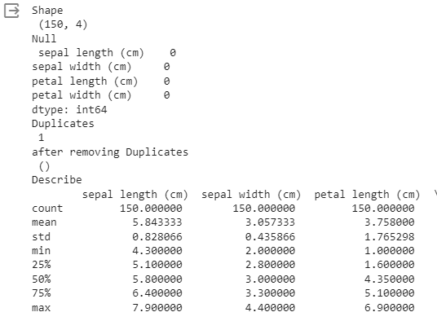

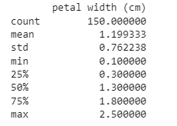

**#k-fold Cross Validation**

from sklearn import datasets

from sklearn.tree import DecisionTreeClassifier

from sklearn.model_selection import KFold, cross_val_score

X, y = datasets.load_iris(return_X_y=True)

clf = DecisionTreeClassifier(random_state=42)

k_folds = KFold(n_splits = 5)

scores = cross_val_score(clf, X, y, cv = k_folds)

print("Cross Validation Scores: ", scores)

print("Average CV Score: ", scores.mean())

print("Number of CV Scores used in Average: ", len(scores))



**#stratified cross fold**

from sklearn import datasets

from sklearn.tree import DecisionTreeClassifier

from sklearn.model_selection import StratifiedKFold, cross_val_score

X, y = datasets.load_iris(return_X_y=True)

clf = DecisionTreeClassifier(random_state=42)

sk_folds = StratifiedKFold(n_splits = 5)

scores = cross_val_score(clf, X, y, cv = sk_folds)

print("Cross Validation Scores: ", scores)

print("Average CV Score: ", scores.mean())

print("Number of CV Scores used in Average: ", len(scores))



**#Leave-one-out-cut**

from sklearn import datasets

from sklearn.tree import DecisionTreeClassifier

from sklearn.model_selection import LeaveOneOut, cross_val_score

X, y = datasets.load_iris(return_X_y=True)

clf = DecisionTreeClassifier(random_state=42)

loo = LeaveOneOut()

scores = cross_val_score(clf, X, y, cv = loo)

print("Cross Validation Scores: ", scores)

print("Average CV Score: ", scores.mean())

print("Number of CV Scores used in Average: ", len(scores))

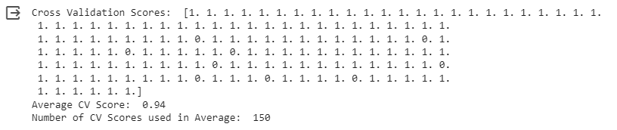

#Leave-P-out cross validation

from sklearn import datasets

from sklearn.tree import DecisionTreeClassifier

from sklearn.model_selection import LeavePOut, cross_val_score

X, y = datasets.load_iris(return_X_y=True)

clf = DecisionTreeClassifier(random_state=42)

lpo = LeavePOut(p=2)

scores = cross_val_score(clf, X, y, cv = lpo)

print("Cross Validation Scores: ", scores)

print("Average CV Score: ", scores.mean())

print("Number of CV Scores used in Average: ", len(scores))

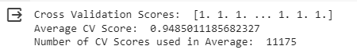

**#Shuffle_split cross validation**

from sklearn import datasets

from sklearn.tree import DecisionTreeClassifier

from sklearn.model_selection import ShuffleSplit, cross_val_score

X, y = datasets.load_iris(return_X_y=True)

clf = DecisionTreeClassifier(random_state=42)

ss = ShuffleSplit(train_size=0.6, test_size=0.3, n_splits = 5)

scores = cross_val_score(clf, X, y, cv = ss)

print("Cross Validation Scores: ", scores)

print("Average CV Score: ", scores.mean())

print("Number of CV Scores used in Average: ", len(scores))

