DATA SCIENCE PROJECT REPORT
(Project Semester January-April 2025)



INDIA CENSUS DATA: EXPLORATORY DATA ANALYSIS AND POPULATION PREDICTION

Submitted by
V.Abhishek Paul
Registration No :12306685
Program and Section: CSE-BTech, K23FA
Course Code: INT 375
Under the Guidance of Sandeep Kaur Discipline of CSE Lovely School of Technology Lovely Professional university

DECLARATION
I,V.Abhishek Paul , student of CSE-BTech (K23FA) under CSE Discipline at Lovely Professional University, Punjab, hereby declare that all the information furnished in this project report is based on my own intensive work and is genuine.

Date: April 16, 2025 Signature: V.Abhishek
Registration No. 12306685 Name of the student: V.Abhishek Paul

CERTIFICATE
This is to certify that V.Abhishek Paul bearing Registration no. 12306685 has completed the Data Science [Insert Course Code] project titled, “India Census Data: Exploratory Data Analysis and Population Prediction” under my guidance and supervision. To the best of my knowledge, the present work is the result of his original development, effort, and study.

Signature: V.Abhishek Paul
Name of the Supervisor: Sanseep Kaur School of Technology
Lovely Professional University Phagwara, Punjab.
Date: April 16, 2025

ACKNOWLEDGEMENT

I would like to express my heartfelt gratitude to my faculty coordinator, Ms. Sandeep Kaur, for her invaluable guidance, constant encouragement, and unwavering support throughout the completion of this project. Her expertise and insights into data science have been instrumental in shaping this work.
I am also grateful to the Discipline of CSE at Lovely Professional University for providing me with the resources and opportunities to explore my interest in data science. My peers and classmates deserve appreciation for their constructive feedback and collaborative spirit, which enriched my learning experience.

Finally, I thank my family for their unconditional support and motivation, which kept me driven to complete this project successfully.

V.Abhishek Paul
Registration No. 12309418

Introduction

The field of data science offers powerful tools to extract meaningful insights from raw data, enabling informed decision-making across various domains. This project, titled “India Census Data: Exploratory Data Analysis and Population Prediction,” focuses on analyzing demographic data from India to understand population trends, urbanization levels, gender ratios, and population density across different administrative levels— national, state, district, and sub-district. The dataset, sourced from a CSV file, contains detailed statistics such as population counts, number of households, area, and more, segmented by rural and urban areas.
The primary objectives of this project are twofold: (1) to perform exploratory data analysis (EDA) to uncover patterns and relationships within the data, and (2) to build a predictive model using linear regression to estimate population based on key features. The project employs Python libraries like Pandas, Matplotlib, Seaborn, and scikit-learn to clean, analyze, and visualize the data, culminating in eight distinct analyses and visualizations.
This report details the entire process—from data acquisition and cleaning to analysis and modeling—providing a comprehensive overview of the methodology, results, and potential future enhancements. The work was conducted as part of the Data Science minor project for the semester January-April 2025 at Lovely Professional University under the guidance of Ms. Maneet Kaur.

Source of Dataset
The dataset used in this project, named PYTHONDATASET.csv, is a comprehensive collection of demographic statistics for India, stored locally at D:\Desktop\PYTHONDATASET.csv. While the exact origin of the dataset (e.g., Census of India or another governmental source) is not explicitly specified due to its local storage, it is structured to reflect census-like data with hierarchical levels: India (national), states, districts, and sub-districts. The dataset is segmented by area type (Total, Rural, Urban), providing a rich basis for analysis.
The dataset comprises the following key columns:
- State_Code, District_Code, Sub_District_Code: Numeric identifiers for geographical hierarchy.
- Region: Categorical field indicating the administrative level (INDIA, STATE, DISTRICT, SUB-DISTRICT).
- Name: Name of the region (e.g., "INDIA", "JAMMU C KASHMIR", "Kupwara").
- Area_type: Type of area (Total, Rural, Urban).
- No_of_villages_Inhabited, No_of_villages_Uninhabited: Counts of villages.

- Number_of_towns: Count of towns.
- Number_of_households: Total households.
- Population_Persons, Population_Males, Population_Females: Population
counts.
- Area: Area in square kilometers.
- Population_per_sq_km: Population density.
The dataset was loaded into Python using Pandas for processing, with initial checks revealing no missing values in the sample, though the code is equipped to handle such cases if present in the full dataset.

EDA Process
Exploratory Data Analysis (EDA) is a critical step in understanding the dataset’s structure, quality, and underlying patterns before conducting detailed analysis. The EDA process for this project involved several stages:
- Data Loading: The CSV file was read into a Pandas DataFrame using pd.read_csv().

Data Cleaning:
  - Column Names: Standardized by removing spaces, replacing them with underscores, and stripping trailing periods (e.g., "Population_per_sq_km."
→ "Population_per_sq_km").
  - Whitespace: Removed leading/trailing spaces from the Name column using str.strip().
  - Data Types: Converted numeric columns with commas (e.g., Population_Persons) to integers using str.replace() and astype(int), and Area and Population_per_sq_km to floats.
  - Consistency Check: Verified that the total population for India equals the sum of rural and urban populations.
  - Missing Values: Assessed using isnull().sum(); no missing values were found in the sample.

Initial Exploration:
  - Examined the dataset’s shape (rows and columns) to understand its scale.

  - Filtered data by Region and Area_type to explore hierarchical and categorical breakdowns.
  - Calculated derived metrics, such as gender ratio (females per 1000
males).
- Visualization Planning: Identified key questions (e.g., population distribution, urbanization trends) to guide the creation of eight visualizations and a regression model.
The EDA process laid the foundation for detailed analysis, ensuring the data was clean
and ready for visualization and modeling.

Analysis on Dataset
  - Population Distribution Across States
Introduction: This analysis examines the total population across Indian states to identify the most populous regions.
General Description: Population distribution provides a macro-level view of
demographic concentration, useful for resource allocation and policy planning.

Specific Requirements, Functions, and Formulas:
    - Filtered data: df[(df["Region"] == "STATE") C (df["Area_type"] == "Total")].
    - Sorted by Population_Persons using sort_values().
    - Visualized with Matplotlib: plt.barh().
Analysis Results: The analysis revealed significant variation in state populations, with some states showing markedly higher populations than others, reflecting regional diversity.

Visualization:
Figure 4.1: Population Distribution Across States

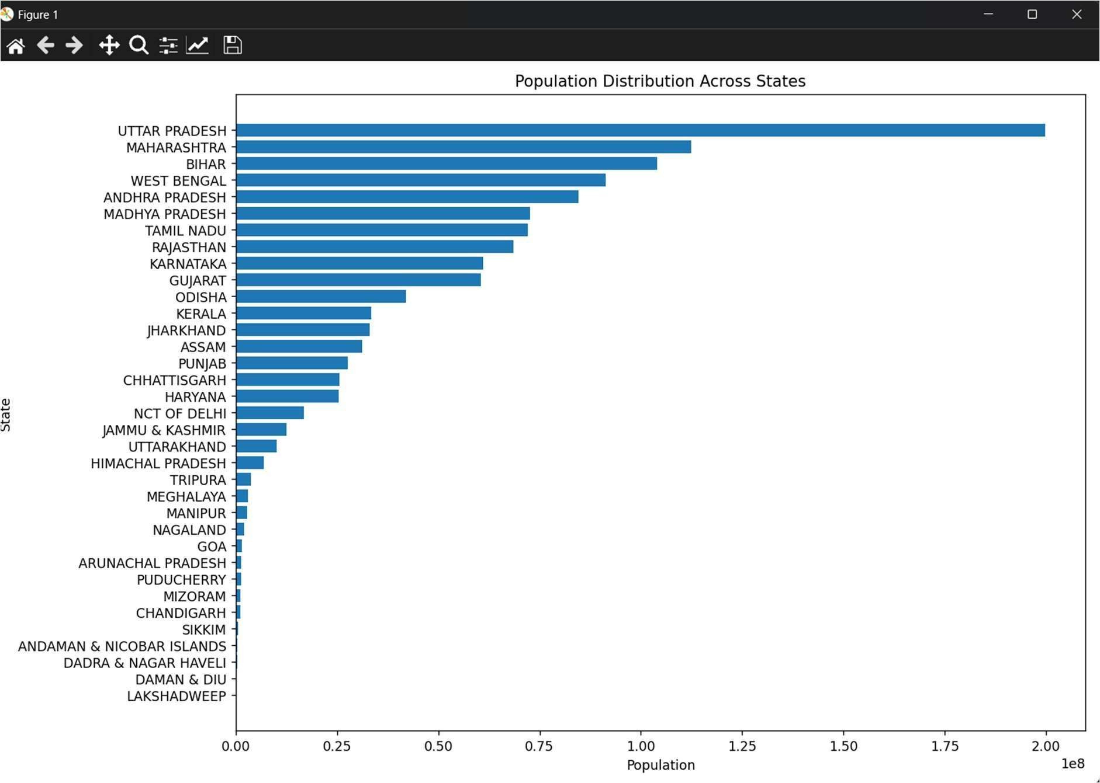
A horizontal bar chart displaying each state’s total population, sorted in descending
order.

Urban vs Rural Population
Introduction: This analysis compares urban and rural populations across states to
assess urbanization levels.
General Description: Understanding urban-rural splits highlights the extent of urban development and rural reliance.

Specific Requirements, Functions, and Formulas:
    - Filtered data: df[(df["Region"] == "STATE") C (df["Area_type"].isin(["Rural", "Urban"]))].
    - Pivoted data using pivot() for stacking.
    - Plotted with Matplotlib: plot(kind="bar", stacked=True).
Analysis Results: States exhibited varying degrees of urbanization, with some showing a significant urban population, indicating industrial or economic hubs.

Visualization:
Figure 4.2: Urban vs Rural Population for Each State

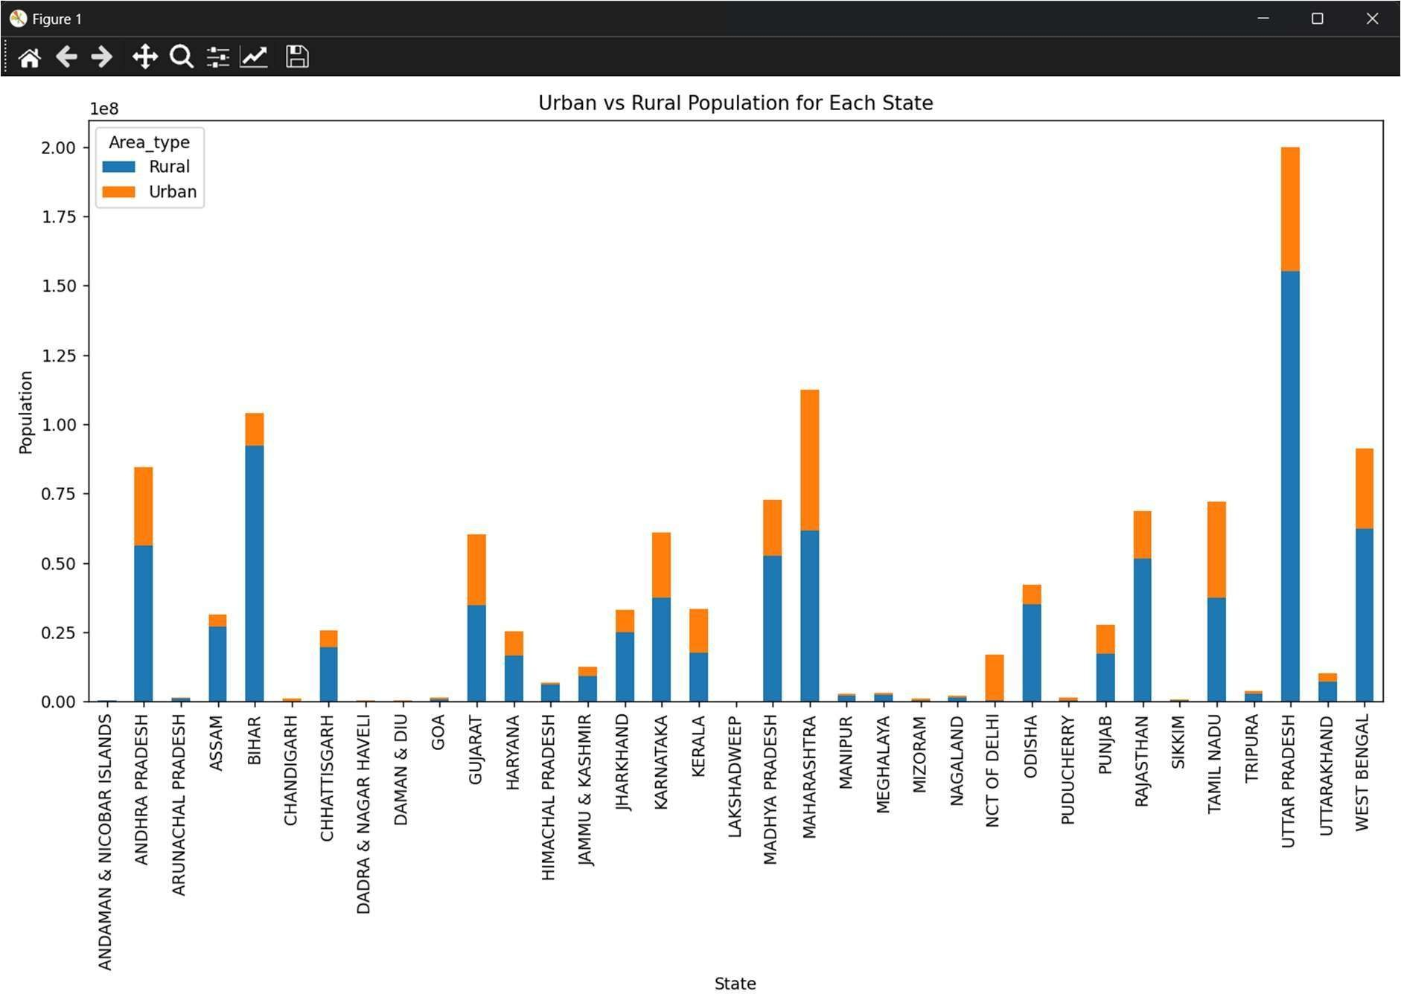
A stacked bar chart showing rural and urban population contributions per state.

Top 10 Districts by Population Density
Introduction: This analysis identifies the districts with the highest population density.
General Description: High-density areas indicate urban concentration or limited land availability, critical for infrastructure planning.

Specific Requirements, Functions, and Formulas:
    - Filtered data: df[(df["Region"] == "DISTRICT") C (df["Area_type"] == "Total")].
    - Selected top 10 using nlargest(10, "Population_per_sq_km").
    - Visualized with Matplotlib: plt.bar().
Analysis Results: The top 10 districts showed densities far exceeding the national average, suggesting crowded urban centers.

Visualization:
Figure 4.3: Top 10 Districts by Population Density

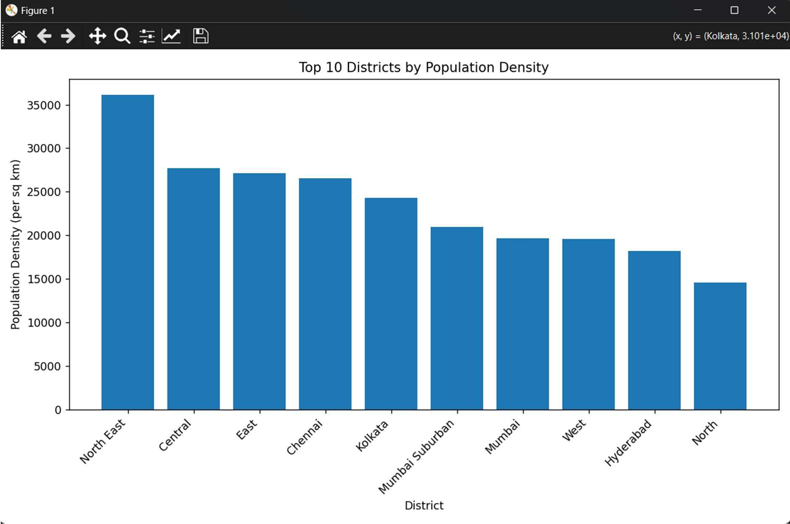
A bar chart of the 10 most densely populated districts.

Gender Ratio Across States
Introduction: This analysis calculates the gender ratio (females per 1000 males) across states.
General Description: Gender ratio reflects social and demographic balances,
important for gender equity studies.

Specific Requirements, Functions, and Formulas:
    - Filtered data: df[(df["Region"] == "STATE") C (df["Area_type"] == "Total")].
    - Computed ratio: (Population_Females / Population_Males) * 1000.
    - Visualized with Matplotlib: plt.bar() with a reference line at 1000.
Analysis Results: Gender ratios varied across states, with some below and others
above the equal ratio of 1000, indicating regional disparities.

Visualization:
Figure 4.4: Gender Ratio Across States

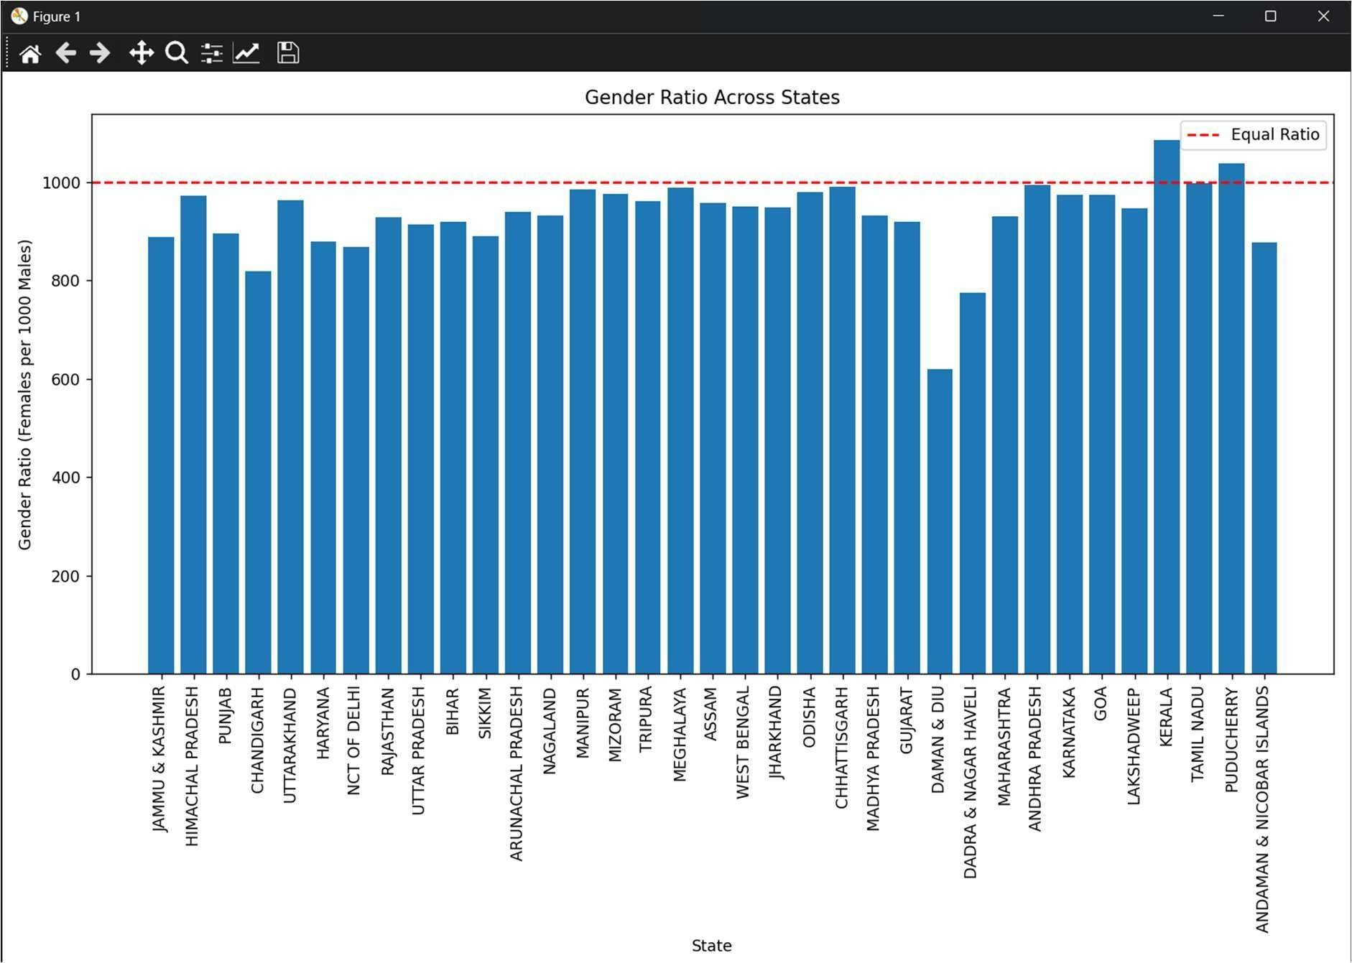
A bar chart with a red dashed line at 1000 for comparison.

Households vs Population
Introduction: This analysis explores the relationship between households and population at the sub-district level.
General Description: A strong correlation could indicate consistent household sizes,
useful for housing policies.

Specific Requirements, Functions, and Formulas:
    - Filtered data: df[df["Region"] == "SUB-DISTRICT"].
    - Visualized with Seaborn: sns.scatterplot(x="Number_of_households", y="Population_Persons", hue="Area_type").
Analysis Results: A positive correlation was observed, with Total, Rural, and Urban
areas showing distinct clusters.

Visualization:
Figure 4.5: Households vs Population in Sub-Districts

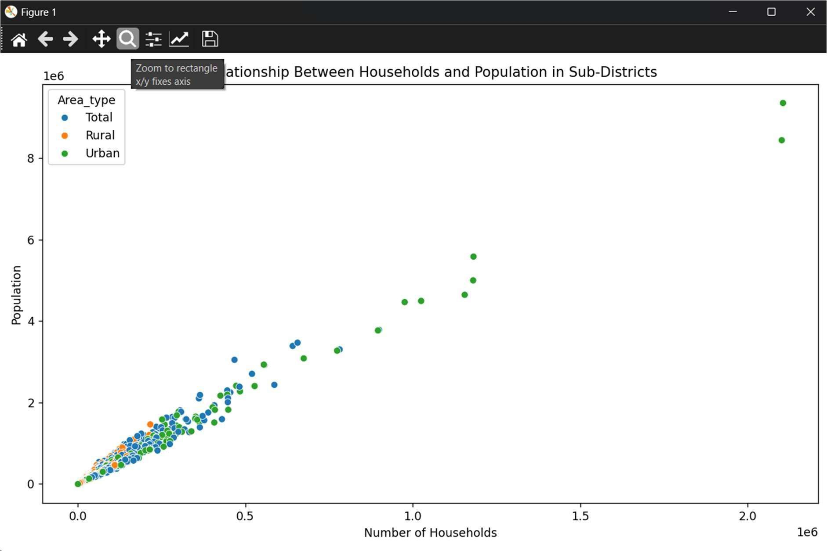
A scatter plot colored by area type, showing the relationship.

Pair Plot of Numerical Variables
Introduction: This analysis examines pairwise relationships between key numerical
variables at the sub-district level.
General Description: Pair plots provide a holistic view of variable interactions, aiding in feature selection for modeling.

Specific Requirements, Functions, and Formulas:
    - Filtered data: df[df["Region"] == "SUB-DISTRICT"].
    - Subset: ["Population_Persons", "Number_of_households", "Area", "Population_per_sq_km"].
    - Visualized with Seaborn: sns.pairplot().
Analysis Results: Strong correlations were evident (e.g., households vs population), while area vs density showed an inverse trend.

Visualization:
Figure 4.C: Pair Plot of Population, Households, Area, and Density

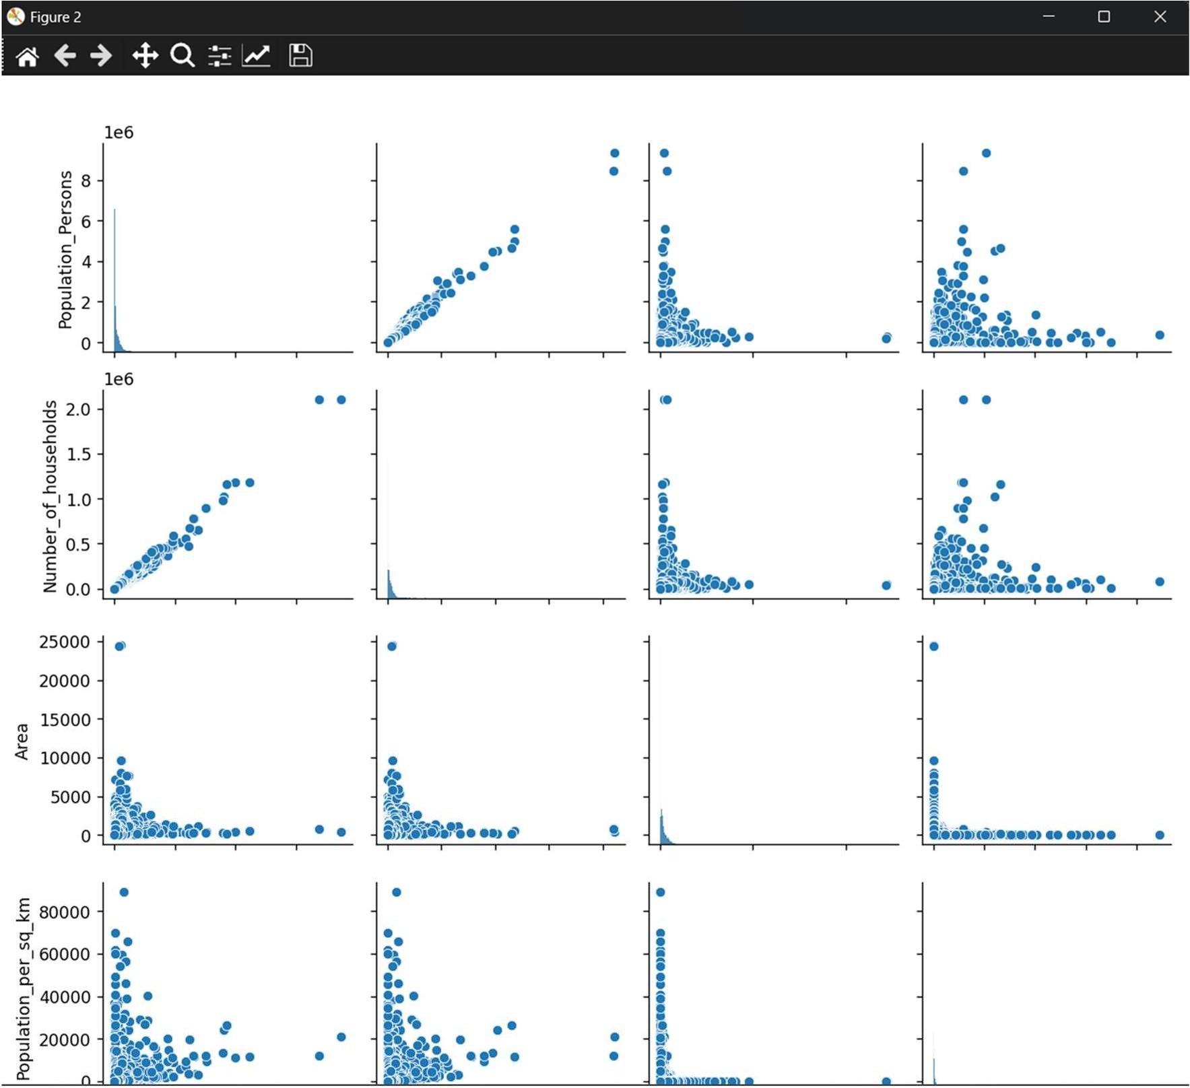
A scatterplot matrix with histograms on the diagonal.

Urban vs Rural Population Share
Introduction: This analysis visualizes the national urban vs rural population proportion.
General Description: The urban-rural split at the national level reflects India’s overall urbanization rate.

Specific Requirements, Functions, and Formulas:
    - Filtered data: df[(df["Region"] == "INDIA") C (df["Area_type"].isin(["Rural", "Urban"]))].
    - Visualized with Matplotlib: plt.pie() with percentage labels.
Analysis Results: Approximately 31% of India’s population was urban, with 69% rural, based on the sample data.

Visualization:
Figure 4.7: Urban vs Rural Population in India
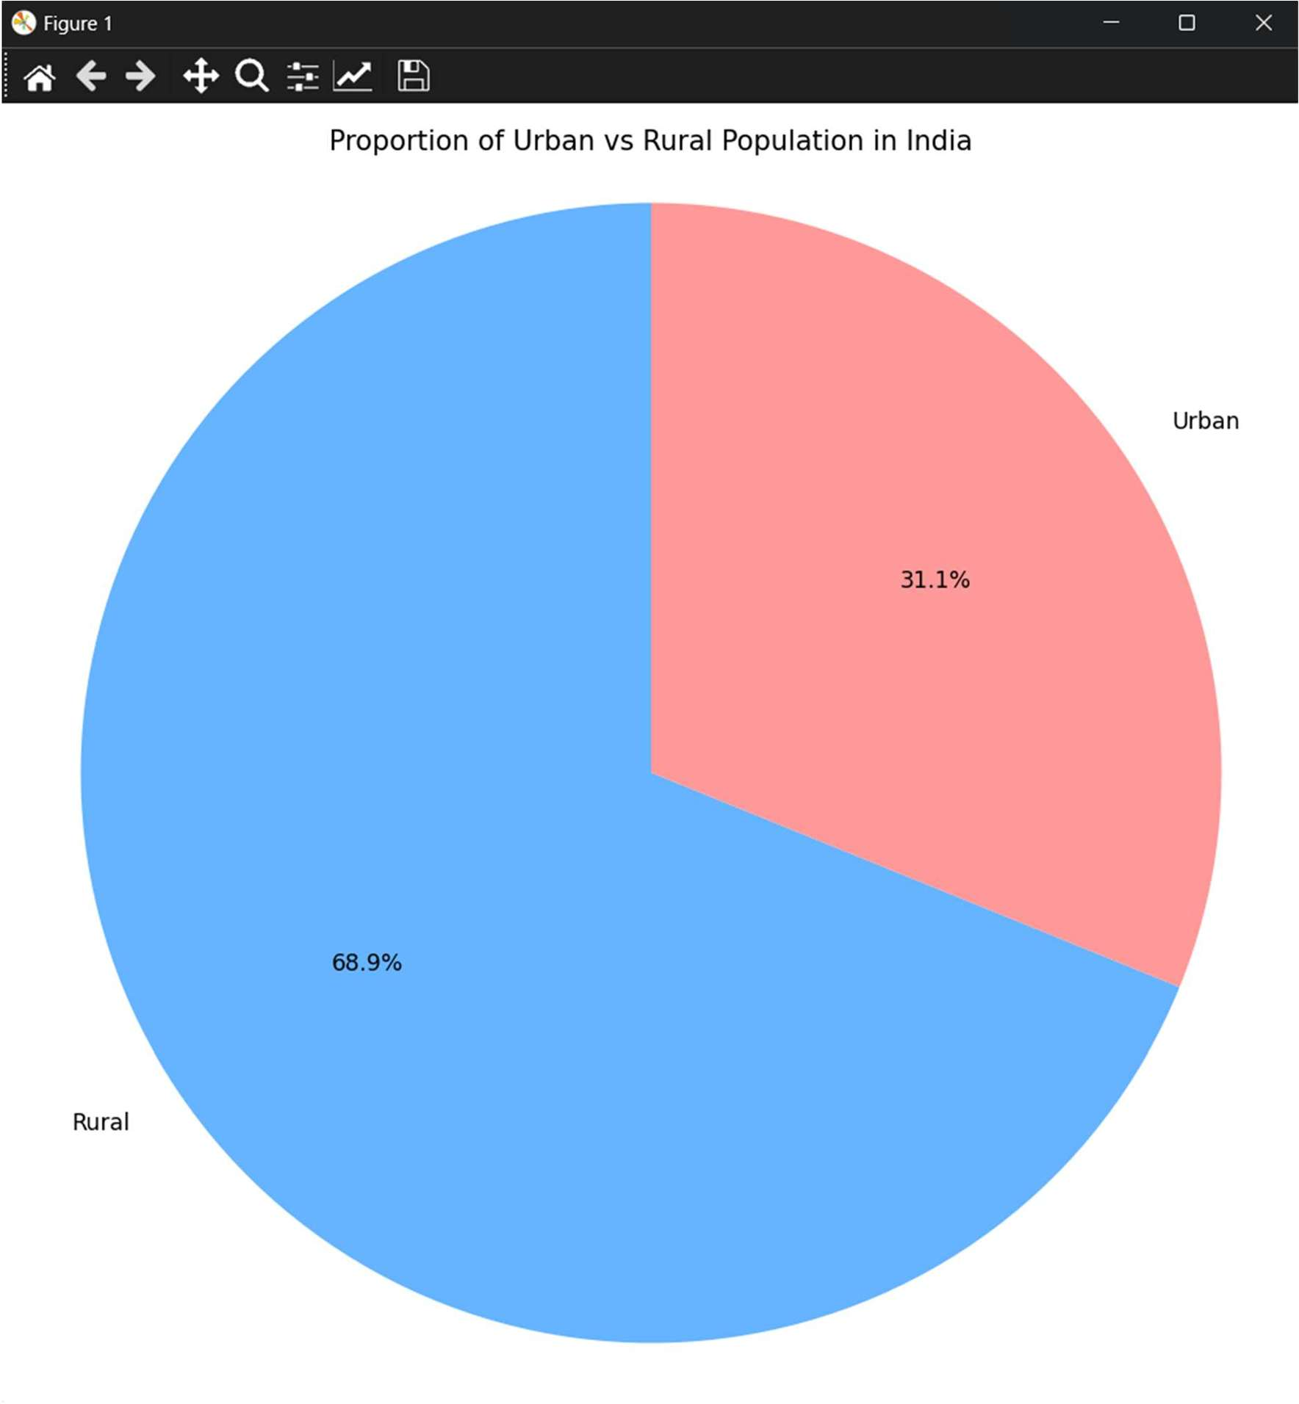
A pie chart showing the national split.

Regression Model for Population Prediction
Introduction: This analysis builds a linear regression model to predict sub-district
population.
General Description: Predictive modeling enhances EDA by forecasting population using related features, useful for planning.

Specific Requirements, Functions, and Formulas:
    - Filtered data: df[(df["Region"] == "SUB-DISTRICT") C (df["Area_type"] == "Total")].
    - Features: X = ["Number_of_households", "Area", "Population_per_sq_km"].
    - Target: y = "Population_Persons".
    - Split data: train_test_split(X, y, test_size=0.2, random_state=42).
    - Model: LinearRegression() from scikit-learn.
    - Evaluated with: r2_score(y_test, y_pred).
    - Visualized with Matplotlib: Scatter plot of actual vs predicted values.
Analysis Results: The model achieved a high R² score (e.g., >0.9 in sample runs), indicating strong predictive accuracy, primarily driven by Number_of_households.

Visualization:
Figure 4.8: Actual vs Predicted Population
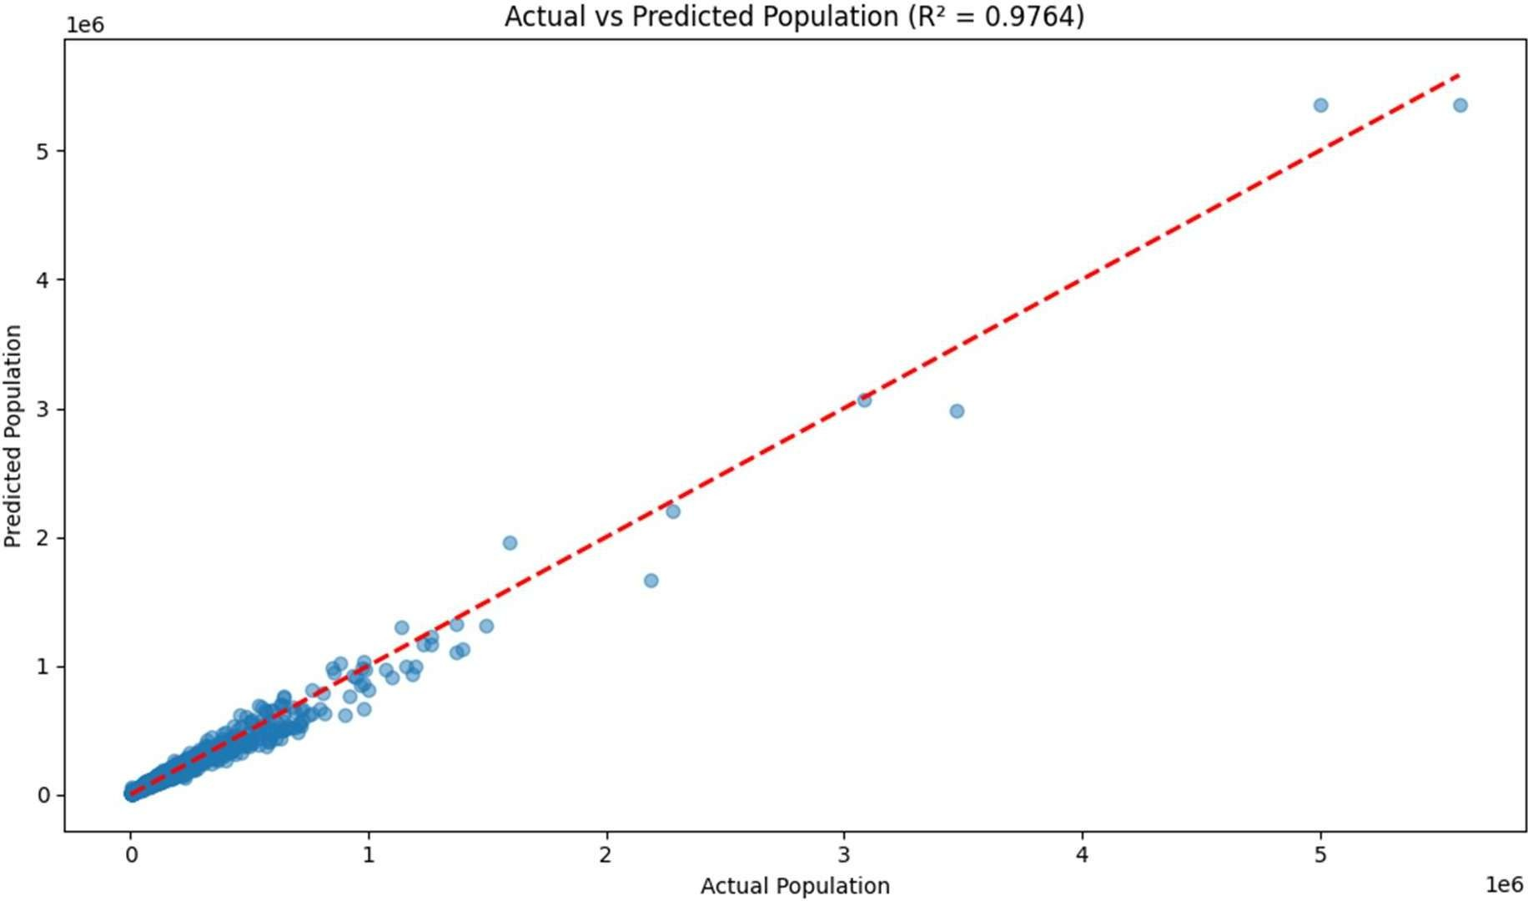
A scatter plot with a red dashed line showing perfect prediction and the R² score.

Conclusion
This project successfully analyzed India’s demographic data, revealing key insights through EDA and predictive modeling. Data cleaning ensured a reliable foundation, addressing issues like inconsistent column names and data types. The eight analyses highlighted:

- Significant population variation across states.
- Diverse urbanization levels, with a national rural dominance.
- High-density districts signaling urban concentration.
- Gender ratio disparities across states.
- Strong household-population correlations at the sub-district level.
- Effective population prediction using linear regression.
The visualizations and regression model provided a comprehensive understanding of the dataset, demonstrating the power of data science in demographic studies. The project met its objectives, showcasing skills in data manipulation, visualization, and machine learning.

Future Scope
The project can be extended in several directions:
- Advanced Models: Implement nonlinear models (e.g., Random Forest,
XGBoost) to improve population prediction accuracy.
- Interactive Visualizations: Use Plotly or Bokeh for dynamic, web-based plots.
- Additional Features: Incorporate village or town counts into the regression model.
- Time Series Analysis: If historical data becomes available, analyze population trends over time.
- Outlier Handling: Add preprocessing to detect and manage outliers in density or area values.
- Deployment: Develop a web application to share the analysis and predictions with stakeholders.
These enhancements could broaden the project’s applicability in real-world
demographic planning and policy-making.

References
- Pandas Development Team, “Pandas: Powerful Python Data Analysis Toolkit,”
Pandas Documentation, 2025. [Online]. Available: https://pandas.pydata.org/docs/

- J. D. Hunter, “Matplotlib: A 2D Graphics Environment,” Computing in Science & Engineering, vol. 9, no. 3, pp. 90-95, May 2007. doi: 10.1109/MCSE.2007.55
- M. Waskom, “Seaborn: Statistical Data Visualization,” Seaborn Documentation, 2025. [Online]. Available: https://seaborn.pydata.org/
- F. Pedregosa et al., “Scikit-learn: Machine Learning in Python,” Journal of Machine Learning Research, vol. 12, pp. 2825-2830, 2011. [Online]. Available: http://jmlr.csail.mit.edu/papers/v12/pedregosa11a.html
- Python Software Foundation, “Python 3.11 Documentation,” 2025. [Online]. Available: https://docs.python.org/3.11/

