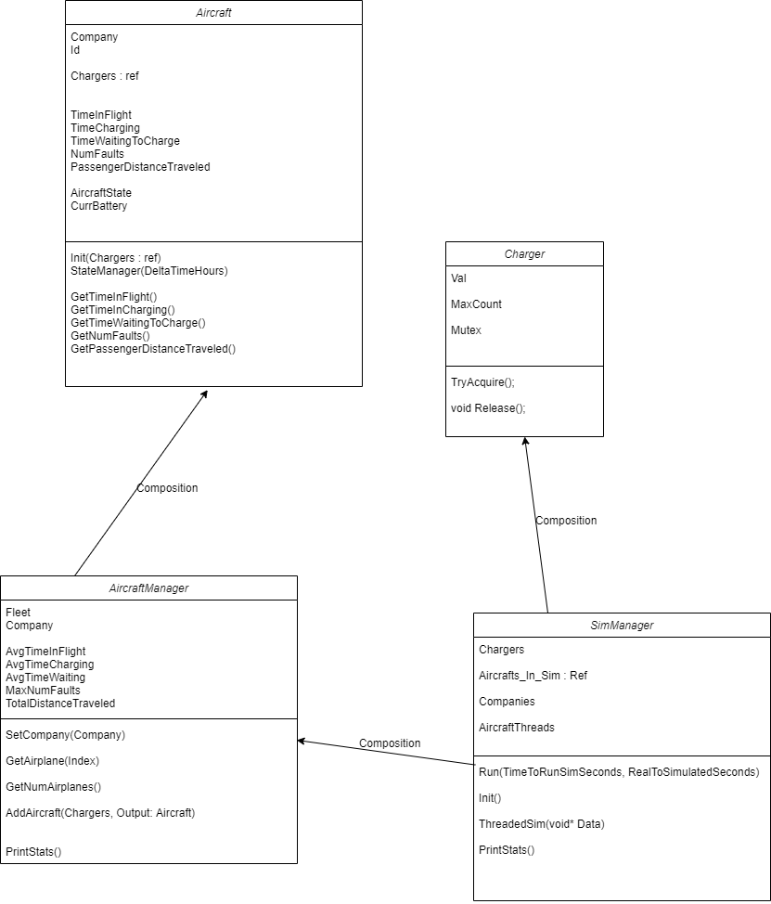

Figure 1: Class diagram showing the interactions for the test assignment

The are four main classes of the assignment:

1. SimManager: This class runs the simulation and acts as a central resource to delegate tasks.
2. AircraftManager: This class manages all the aircrafts of a particular company.
3. Aircraft: This class handles the state changes as an aircraft goes through different stages of operation. Currently, this class manages states using a switch statement. It would be scalable better if this would be replaced by a behavior tree.
4. Charger: This class controls the simulation resource: chargers ; using the semaphore methodology.

Instructions to run the program:

1. Open terminal and navigate to the project`s root directory.
2. Type in mkdir build
3. Type cd build
4. Type cmake ..
5. Type make
6. Type ./binary

**NOTE:**

1. The folder test has a class that handles unit tests. It has not been included in the build setup yet.
2. There is a file named SimConstants.h in the include folder. This file has the constants that control the simulation. Feel free to change them in order to alter the simulation.