# Assignment 2

Compilation Steps:

* I would recommend to open (3 to 4) terminals, one for the server side and the others for the client side.
* First execute the server side(server.c) and assign a port number to the server.
* Then you can execute the (client.c) in multiple terminals to check the multiple client connections.
* Once the connection is accepted from the server. I added a print statement about the clients address and port number, which will be printed in the terminal screen on the servers side about which client is connected.

Server side: Client side:

make server make client

or or

gcc server.c -o server gcc client.c -o client

./server ./client

Server side:

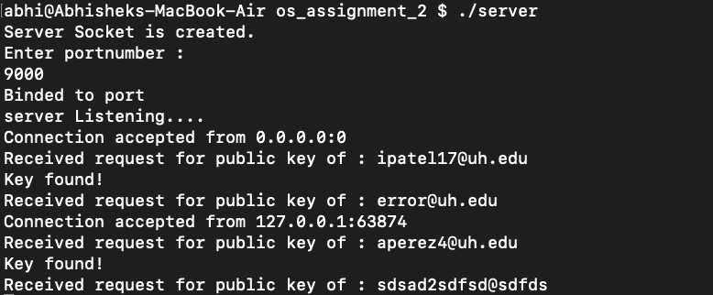

Client side:

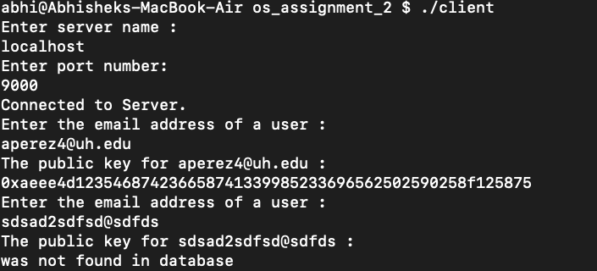

Client side 2:

