Attackers Arena
The Ultimate Gamified Productivity System



1. Welcome to the Arena
Attackers Arena isn't just a to-do list; it's a high-performance ecosystem designed to turn your productivity into an immersive experience. By combining habit science, AI coaching, and RPG-style gamification, we help you build unstoppable discipline.

2. Mastery of Tasks
Our task management engine is built on 'Horizons' to help you balance immediate action with long-term vision.
Feature | Description
Daily Tasks | Tactical actions for today. Features automatic rollover of pending tasks.
Monthly Planning | Strategic goals for the month to keep you on track.
Yearly Vision | Visionary milestones that define your long-term success.
Smart Tags | Categorize by Energy Level, Priority, and Category (Work, Health, etc.).
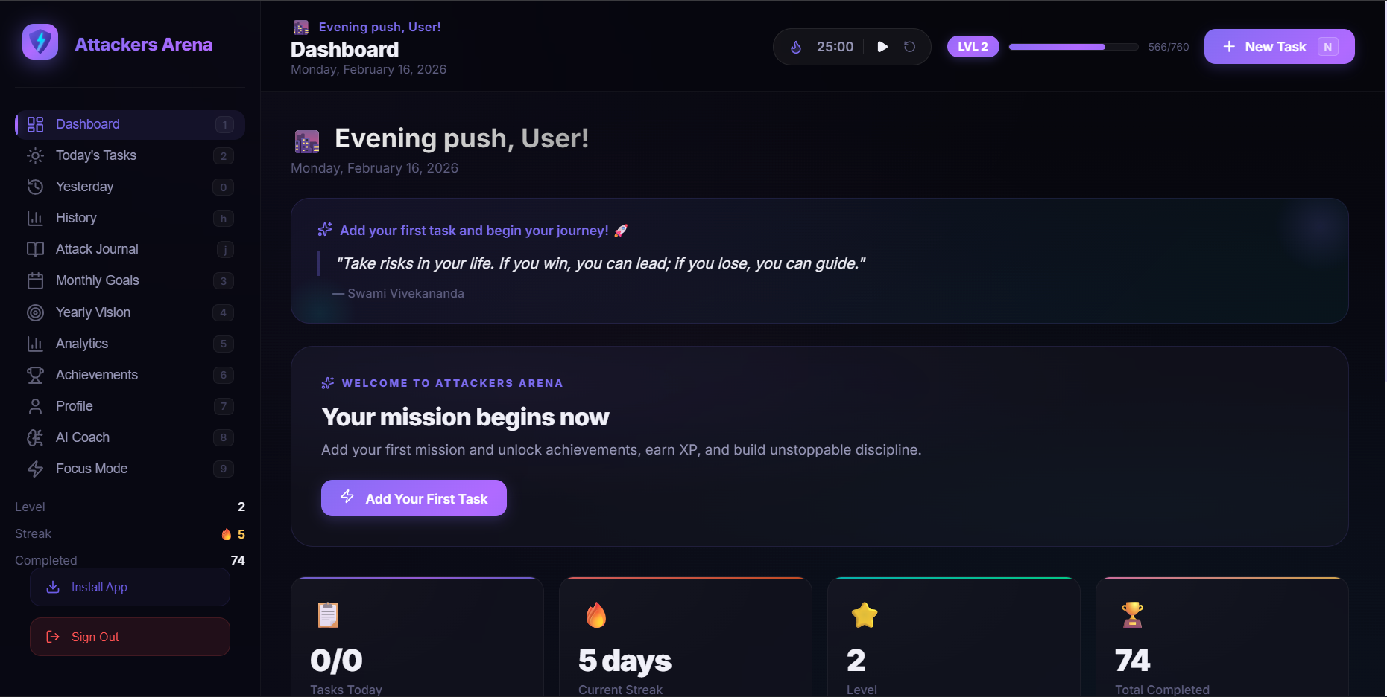

3. AI Coach Aries
Meet Coach Aries, your personal productivity mentor. Powered by advanced AI, Aries helps you break down complex projects, provides motivational nudges, and analyzes your productivity patterns to give you personalized advice.
- Capabilities include:
- Breaking down large tasks into manageable subtasks.
- Suggesting strategies to overcome procrastination.
- Analyzing your chat history to provide context-aware guidance.
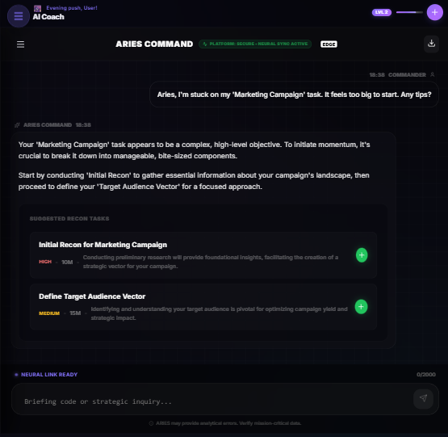

4. Gamification & Ranks
Level up as you get things done. Every task completed grants XP, moving you through ranks from Aspirant to Grandmaster.
- Key Mechanics:
- XP System: Earn more XP for High-Priority and Critical tasks.
- Streak System: Maintain a daily habit to keep your 🔥 flame alive.
- Achievements: Earn badges for milestones like a 7-day streak or 100 tasks completed.

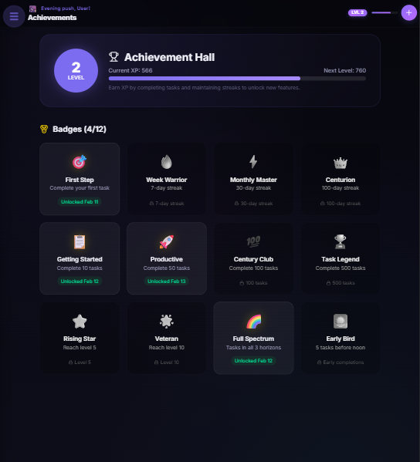

5. Performance & Focus
Success is measured by data. Use our built-in tools to refine your performance.

Analytics Dashboard
Visual charts show your completion trends, category distribution, and productivity scores. Learn exactly when you are most productive.

Focus Timer
Deep work is the key to mastery. Our Pomodoro focus timer helps you stay locked in for 25, 45, or 60-minute sessions.
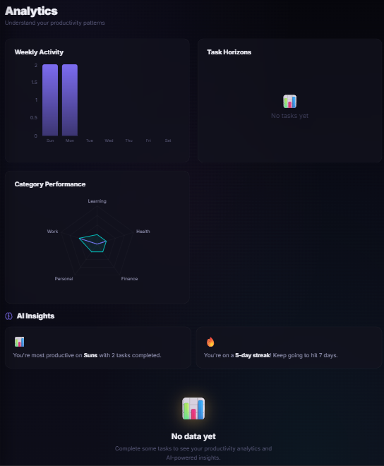

6. Getting Started: Step-by-Step
- Create an Account: Sign up and verify your email to unlock the full potential of the Arena.
- Set Your Vision: Start by adding 1-2 Yearly Vision tasks.
- Plan Your Day: Add tasks to your Daily list and assign them a Priority and Energy Level.
- Engage Aries: If you're stuck, click the AI Assistant tab and ask, 'How should I start my day?'
- Maintain the Streak: Complete at least one task every day to build momentum.

Join the elite. Master the Arena.

