ADVANTAGES AND CHALLENGES IN IMAGE RESOLUTION FROM COMPRESSED SENSING OBSERVATIONS

ABHISHEK SARKAR
Department of SITE
Vellore Institute of Technology, Chennai
Tamil Nadu, India

Guided by Dr.Nandhini R
Vellore Institute of Technology, Chennai
Tamil Nadu, India

Abstract— This research work propose a framework to obtain High Resolution (HR) pictures from Compressed Sensing (CS) imaging frameworks catching different Low Resolution (LR) pictures of a similar scene. The proposed CS Super Resolution (SR) approach consolidates existing CS recreation calculations. In this work proposed a structure to recuperate SR pictures from numerous CS down inspected and distorted perceptions of a similar scene the proposed approach demonstrates preferred execution over calculations managing SR without CS. For proportions underneath one, it likewise delivers great recreated pictures. The proposed structure can be stretched out to compressive video for the estimation of both intra-outline and interframe SR
Keywords— super resolution; medical images; MRI; CT

- A. Introduction
Image processing can't avoid being processing of images using logical operations by using any sort of banner processing for which the data is an image, a movement of images, or a video, for instance, a photograph or video diagram; the yield of image processing may be either an image or a game plan of characteristics or parameters related to the image. Image processing commonly insinuates mechanized image processing, however optical and straightforward image processing in like manner are possible. This article is about general techniques that apply to each one of them. There are a wide range of procedures utilized as a part of naturally examining images. Every system might be valuable for a little scope of errands, however there still aren't any known techniques for image investigation that are sufficiently nonexclusive for wide scopes of assignments, contrasted with the capacities of a human's image breaking down abilities. Super Resolution revamping produces one or an arrangement of high-assurance pictures from a course of action of low-assurance diagrams. This article reviews a variety of Super-Resolution systems proposed over the latest 20 years, and gives some comprehension into, and an abstract of, our present duties regarding the general Super-Resolution issue. At the same time, an unmistakable examination of a couple of key parts of Super-Resolution, routinely slighted in the written work, is shown. In particular, we take a gander at control, treatment of shading, and segment operation modes. Novel strategies for looking out for these issues are joined by test occur on copied and genuine information. At long last, some future inconveniences in Super-Resolution are laid out and examined

B. SUPER-RESOLUTION AS AN INVERSE
Super-assurance counts attempt to isolate the high-assurance picture demolished by the restrictions of the optical imaging structure. This sort of issue is an instance of an inverse issue, wherein the wellspring of information (high-assurance picture) is evaluated from the watched data (low-assurance picture or pictures. Disentangling an inverse issue when all is said in done requires first building up a forward show. By far, the most understood forward model for the issue of Super-Resolution is immediate in outline:
Yt = M(t)X(t) +V(t) -- (I)
Where Y is the consider data (single or assembling of pictures), M addresses the imaging structure, X is the dark high-assurance picture or pictures, V is the subjective clatter natural to any imaging framework, and t addresses the period of picture acquisition. We use the underscore documentation, for instance, X to demonstrate a vector. In this arrangement, the photo is addressed fit as a fiddle by looking at the 2D picture in a raster or some other sifting association TO 1D
2. LITERATURE SURVEY
2.1 author name et at H. Chen, S. Lee, R. Rao, M. Slamani, and P. Varshney[1]
Because of their qualities, MMW pictures are utilized as a bit of employments like climate operations, low perceptible quality course, andthe imaging of individuals for secured dispute and danger region , just to name a few.Based on their use, picture preparing strategies haverecently began to be related with these photographs. For instance,Passive Millimeter Wave (PMMW) picture change has been tended to In the high rehash parts of those photographs were reestablished utilizing a MAP estimator, and they were then added to the information picture to influence a HR to picture. Selection and blend of clear and MM pictures as well as division of MMW pictures have been kept an eye out for n This paper has been upheld by The European Union, Erasmus Mundus program, the Spanish Ministry of Economy and Competitiveness under meander TIN2013-43880-R, the European Regional Development Fund (FEDER), the CEI Biotic at the Universidad de Granada, and the Department of Energy (DE-NA0002520). Unfortunately PMMW frameworks have two guaranteed inadequacies: the long securing time expected that would make a PMMW picture and the poor confirmation of got pictures. CS structures, with its reduced picture getting time, have been related with PMMW imaging, . In the producers use Hadamard cover to reduce the securing time. In [ a PMMW imaging structure with broadened centrality offield that can pass on pictures with diminished number of tests is introduced. CS and Blind Image DE convolution have been hardened in . By end huge the confirmation of MMW pictures is near nothing, thusly making their examination a testing errand. In this paper we propose a novel progress structure to get HR PMMW pictures from different LR acknowledgments found utilizing a copied CS imaging framework in light of the ADMM to interface the CS and SR issues.

2.2 author et at. S. Villena, M. Vega, S.D. Babacan, R. Molina, and A.K.Katsaggelos[2]
Reverse manufactured opening radar (ISAR) can supply high assurance pictures of spotlights on for the duration of the day, all-atmosphere and over long division, so it has found wide applications in military and for consistent subject use. The certified solicitations of antiinterference, moving target imaging and super assurance imaging advance the investigation of ISAR imaging utilizing limited heartbeats. Compacted identifying (CS), a noteworthy idea in hail taking care of field, can reproduce motions in light of limited estimations by using the sparsity of signs . As ISAR targets can be depicted by a few strong scattering centers, which is unsurprising with the sparsity need of CS, applying CS into ISAR imaging can upgrade ISAR pictures quality in perspective of CS, an imaging estimation in light of log-total minimization is proposed in the paper. Differentiated and standard, log-add up to discipline limit can assessed standard better Although the streamlining issue in perspective of log-entire discipline limit is non-bended, it can be clarified effectively by majorization-minimization (MM) count Compared with the present procedures, the proposed figuring has three ideal conditions. The foremost favored viewpoint is that it is fundamental and has low computational cost.

2.3 Author at et S.D. Babacan, R. Molina, and A.K.[3]
Katsaggelos,
In this paper, we address the super assurance (SR) issue from a course of action of spoiled low assurance (LR) pictures to get a high assurance (HR) picture. Exact estimation of the sub-pixel development between the LR pictures out and out impacts the execution of the repeated HR picture. In this paper, we propose novel super assurance systems where the HR picture and the development parameters are evaluated at the same time. Utilizing a Bayesian arrangement, we show the dark HR picture, the acquirement system, the development parameters and the dark model parameters in a stochastic sense. Using a variational Bayesian examination, we make two novel computations which commonly gage the movements of all inquiries. The proposed framework has the going with good conditions: 1) Through the joining of helplessness of the evaluations, the figurings keep the expansion of goofs between the examinations of the distinctive inquiries;

2.4 Author at et N. Gopalsami, TW. Elmer, S. Liao, R. Ahern, A. Heifetz[4]
We propose a novel outwardly weakened picture deconvolution (BID) regularization structure for compressive disengaged millimeter-wave (PMMW) imaging systems. The proposed structure relies upon the variable-part progression framework, which empowers us to utilize existing compressive identifying revamping computations in compressive BID issues. Moreover, a non-curved lp semi standard with 0 <; p <; 1 is used as a regularization term for the photo, while a simultaneous auto-in reverse (SAR) regularization term is utilized for the cloud. Additionally, the proposed framework is greatly wide and it can be adequately acclimated to other bleeding edge BID approaches that utilization differing picture/darken regularization terms. Test comes to fruition, gotten with reenactments using a built picture and honest to goodness PMMW pictures, show the advantage of the proposed approach appeared differently in relation to existing ones

2.5 Author at et ZHANG, L.—DUAN [5].
This paper proposes another figuring to facilitate picture enlistment into picture super-assurance (SR). Picture SR is a strategy to imitate a high-assurance (HR) picture by interweaving different low-assurance (LR) pictures. An essential walk in picture SR is exact selection of the LR pictures or, by the day's end, fruitful estimation of development parameters. General SR figurings expect either the assessed development parameters by existing enlistment methods to be without botch or the development parameters are known from the before. This assumption, regardless, is unlikely in various applications, as most existing enrollment estimations still experience distinctive degrees of bumbles, and the development parameters among the LR pictures are all things considered darken from the before. In context of this, this paper presents another structure that performs synchronous picture enrollment and HR picture amusement. Rather than other current methods that treat picture selection and HR entertainment as disjoint strategies, the new framework enables picture enlistment and HR proliferation to be assessed in the meantime and improved coherently. Further, not in the slightest degree like most figurings that consideration on the transnational development show, the proposed procedure gets a more dull development exhibit that fuses both translation and furthermore turn. An iterative arrangement is made to understand the developing nonlinear least squares issue. Trial occurs show that the proposed procedure is capable in performing picture selection and SR for repeated and what's more real pictures.

2.6 Author at et R. Koller, L. Schmid, N. Matsuda, T. Niederberger,L. Spinoulas[6]
In this work we propose a novel structure to get high confirmation pictures from compacted recognizing imaging frameworks getting different low affirmation photographs of a near scene. The proposed approach of Compressed Sensing Super Resolution (CSSR), cements existing squeezed recognizing changing calculations with a low-confirmation to high-affirmation approach in context of the utilization of a super Gaussian regularization term. The changing substitutes between compacted recognizing stimulation and super confirmation age, including determination parameter estimation. The photograph estimation sub problem is appreciated utilizing memorization-minimization while the compacted recognizing expansion changes into a l1-minimization subject to a quadratic target. The performed tests grayscale and dishonestly compacted veritable millimeter wave pictures, demonstrate the limit of the proposed system to give mind boggling quality super settled pictures from different low confirmation stuffed acquisitions.

3. Existing Work
The quantity of images to be investigated depleting. For example, accepting a remote case endoscope takes two images for every second amid two hours of going through the small digestive system, the aggregate number of caught images surpasses 50,000. The caught images experience the ill effects of different debasements, because of undesired commotions, for example, warm ones in CCD/CMOS chips, and subsequently their image quality is excessively corrupted. Aside from CCD/CMOS warm clamors, a portion of the real reasons for dissatisfactory quality in endoscopic images are inhomogeneous shine and poor difference, which are unavoidable because of the convoluting, bowing and waving nature of the gastric organs. Restorative images for the most part have the accompanying issues:Low resolution (in the spatial and frequency domains)
- High level of noise
- Low contrast images
- Geometric deformations
- Presence of imaging artefacts

Compressive Sensing (CS) imaging at the same time gains and packs images, subsequently lessening the securing time.

The major disclosure is that, if a N-test flag x is scanty and has a decent K-term estimation in some premise, at that point it can be reproduced utilizing
M =O(K log(N/K)) << N --(2)
Linear projections of x onto another basis. Furthermore, x can be reconstructed using linear programming, which has polynomial complexity.
MMW images are used in applications like weather operations, low visibility navigation, and the imaging of people for concealed object and threat detection
We also assume that the LR observations zq are related to an HR image x we seek to estimate by

3.1 ALGORITHMS USED FOR IMAGE PROCESSING TO SOLVE THE ISSUES
a) Compressive Sensing(CS) imaging simultaneously acquires and compresses images, thus reducing the acquisition time.
B.) MMW images are used in applications like weather operations, low visibility navigation, and the imaging of people for concealed object and threat detection

4. PROPOSED ARCHITECTURE
- The proposed methodology of our paper is to
To make the noisy data clear
- Presentation of the images clear and make it eligible to see clearly
- To check whether the data have compressed way to make a new image
- Using mat lab we can assume how much the data is been used to clear the noisiness of an image
- The main motive of our paper is to get an image and threshold it into many stages so that it is easier for the doctor to recognize the image when there will be splitting of an image
- Solving complex images and making them clear and finding out what issues are there in the image and and fix it
- Combining the images we can find a clear image and with multiple fixed combination

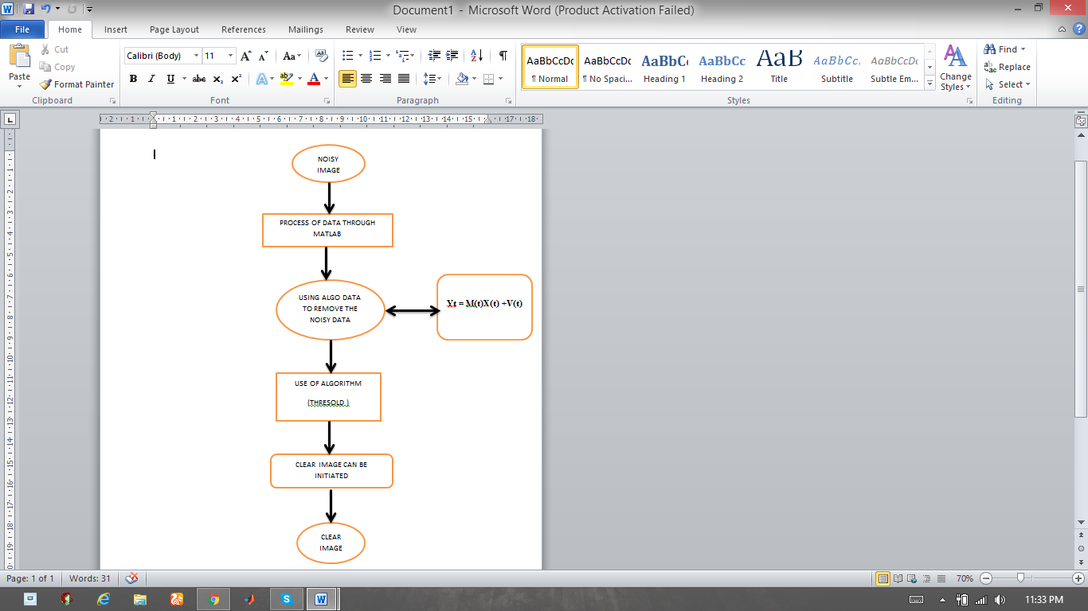

5. Implementation/methodology
This paper implements about how the image is been preprocessed by the noisy data and it is seen that how much the data is been by using the matrices we can conclude that the picture that using super solution can be found by using threshold function and by the function we can find how much the function can remove the noisy data from the image

5.1Algorithm-1
Step 1: import the image from the extended files
Step 2: i/p raw image imported
Step 3: apply threshold function
Step 4: noisy data will be initialized
Step 5: raw image will be changed
Step 6: o/p clear image found

5.1 (A). ORIGINAL PICTURE

Before
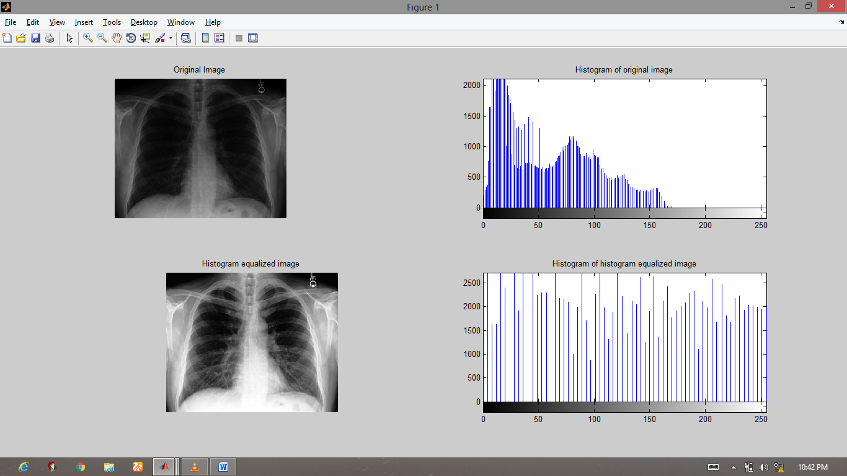

After

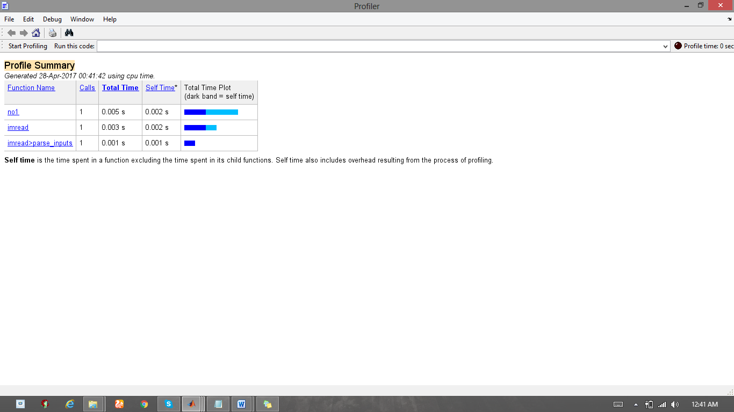

5.1(B) AFTER THRESOLD FORMULAS IS APPLIED
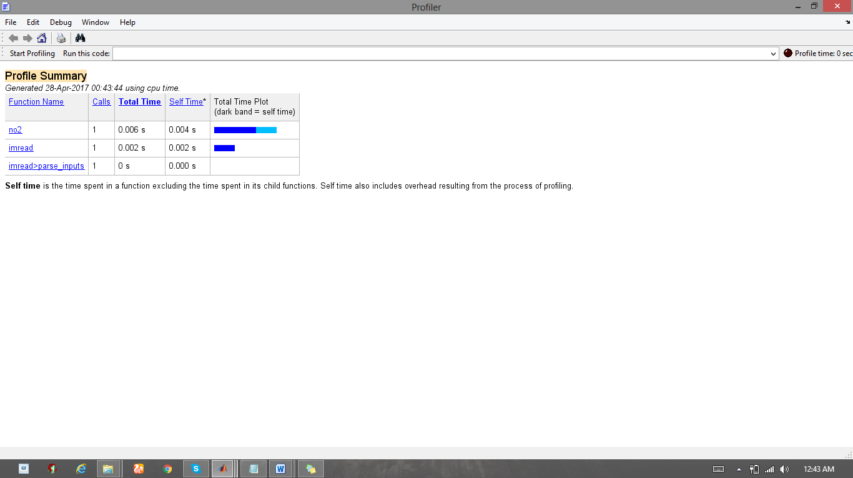

title('Restoration of Blurred, Quantized Image - Estimated NSR');
ans = double
GRAPH PLOTED FOR THE NOICY DATA
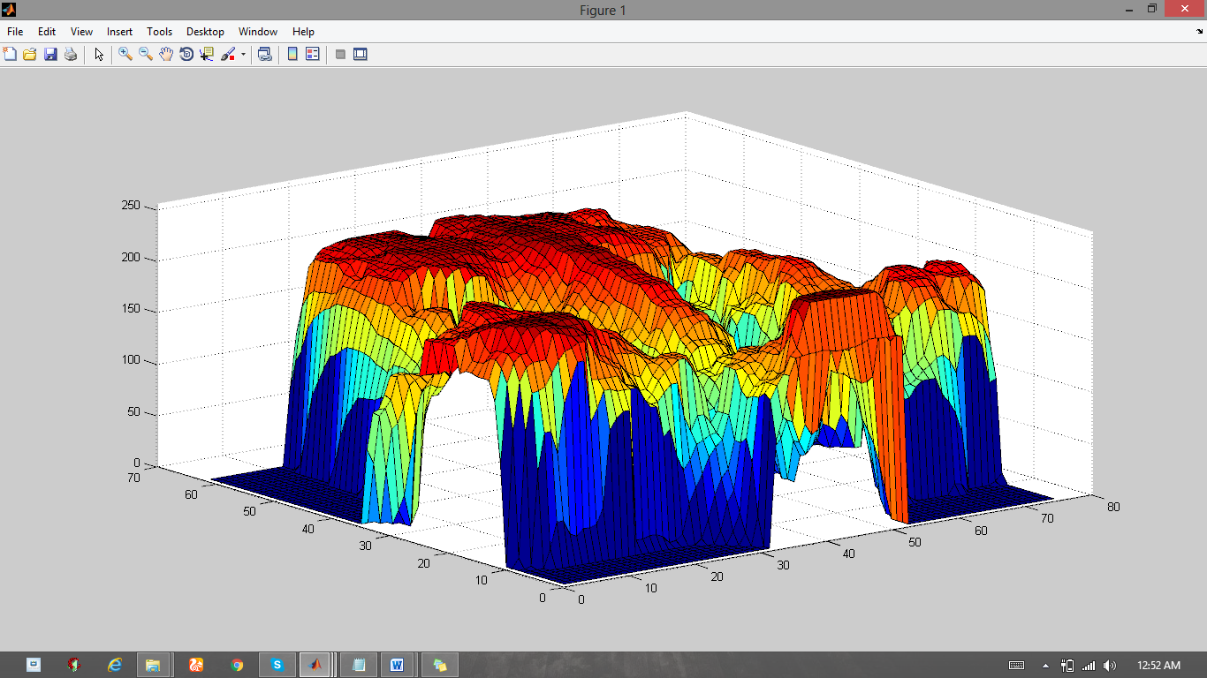

The proposed work to make the image clear and make the picture in a sensitive way so that the image can be visualized in a perfect manner with different sides to make the image split into different qualities for the medical term so that it can be understood by the doctor after xray can be done by
- Roberts operator
- Prewitt operator
- Sobel operator
- Canny edge detector
5.2 Algorithm 2:
Step 1: import the clear image as the new file
Step 2: make the image as i/p
Step3: if we want the image to combine and form a new image
Step 4: Use 4 algorithms for configuring the image and make a new image
Step5: After the image is combined in mat lab we will be getting a new image and clear image
Step6: new image is formed

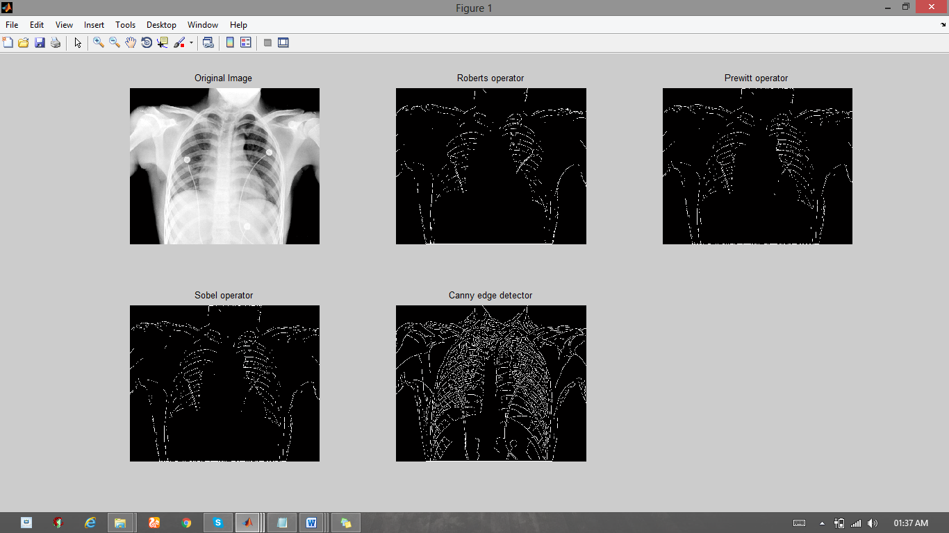

6. Historiography representation of the image
Histogram( X ) makes a histogram plot of X . The histogram work utilizes a programmed binning calculation that profits receptacles with a uniform width, secured the scope of components in X and uncover the basic state of the appropriation. ... Histogram( X , nibs ) utilizes various receptacles indicated by the scalar
.

7. Results & Discussion
The data that is performed is cleared and it is performed in a form of matrix and have a clear image to the noisy data

MATRIX FOR IMAGES
a=imread(CHEST.jpg');

imshow(a);
imshow(a(:,:,1));
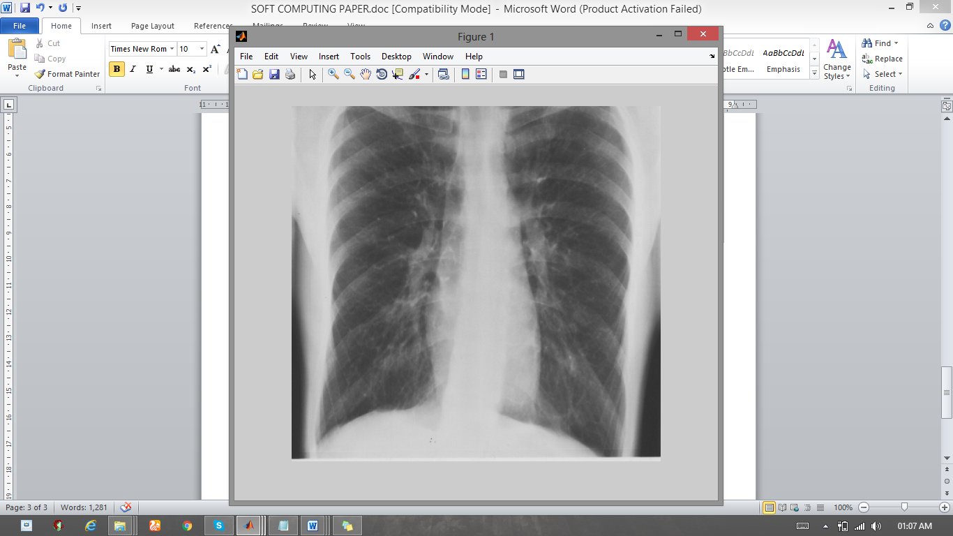

matrix = impixel(a);

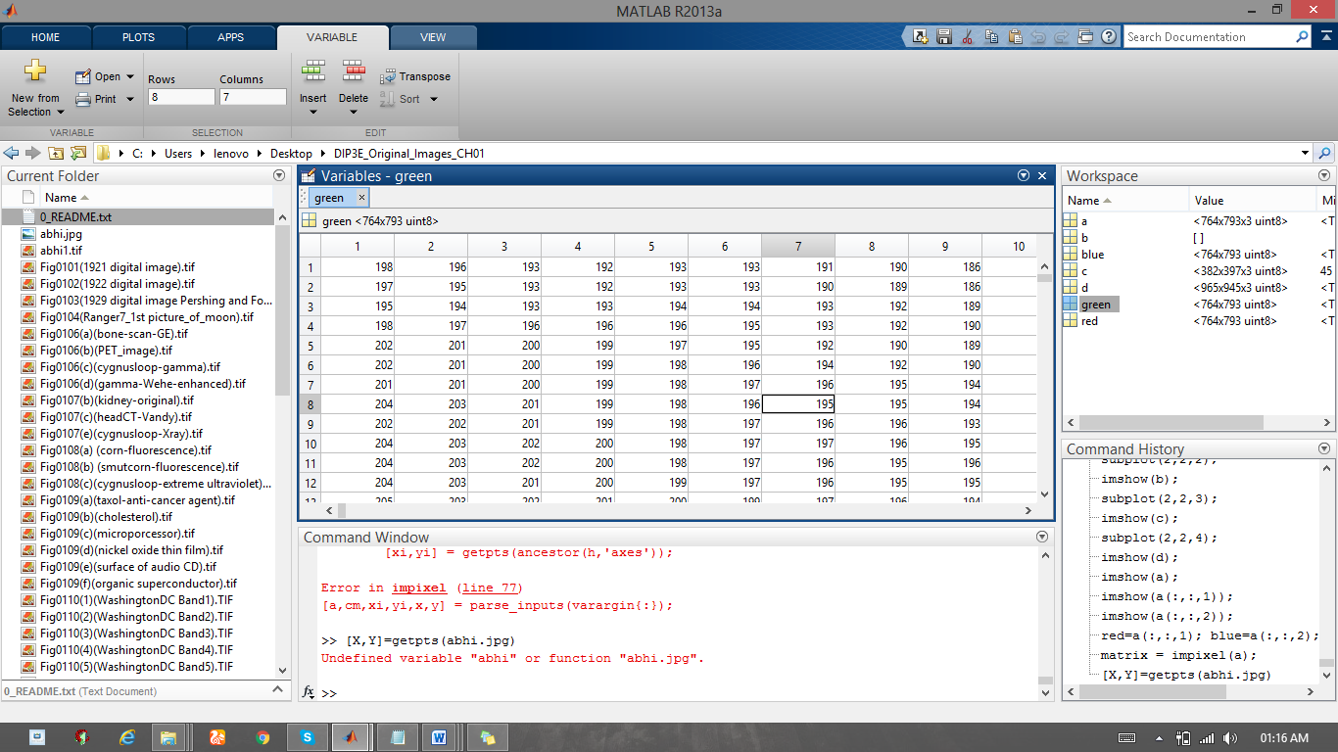

8. Conclusion
It is directly incredibly clear to us that the creation and improvement of Medical Imaging has been fundamental to momentum medication and helpful research. Without remedial imaging, nothing would be contemplated the human body or issues incorporating it without dubious surgery. It is the preface of present day arrangement, examination of particular things would be close freakish without Medical Imaging advancements like X-Ray, Computer Tomography and MRI checks, unless hazardous surgery would be driven. With Medical Imaging, sicknesses can be less demanding to cure than any time in recent memory. The advancement of Medical Imaging appears as though it can just enhance later on. With so impelled development like Free-electron Lasers and the synchrotron, you couldn't express that its absolutely impossible any disease can't be cured. Therapeutic Imaging has and will save a large number lives, possibly billions.

9. References
- H. Chen, S. Lee, R. Rao, M. Slamani, and P. Varshney, “Imaging for concealed weapon detection: a tutorial overview of development in imaging sensors and processing,” Signal Processing Magazine, IEEE, vol. 22, no. 2, pp. 52–61, 2005.
- S. Villena, M. Vega, S.D. Babacan, R. Molina, and A.K.Katsaggelos, “Bayesian combination of sparse and nonsparse priors in image super resolution,” Digital Signal
Processing, vol. 23, no. 2, pp. 530–541, 2013.
- S.D. Babacan, R. Molina, and A.K. Katsaggelos, “Variational bayesian super resolution,” IEEE Transactions
on Image Processing, vol. 20, no. 4, pp. 984–999, 2011.
- N. Gopalsami, TW. Elmer, S. Liao, R. Ahern, A. Heifetz, A. Raptis, M. Luessi, D. Babacan, and AK. Katsaggelos, “Compressive sampling in passive millimeter-wave
imaging,” in SPIE Defense, Security, and Sensing.
- ZHANG, L.—DUAN, J.—QIAO, Z. J.—XING, M. D.—BAO, Z. : Phase Adjustment and ISAR Imaging of Maneuvering Targets with Sparse Apertures, IEEE Transactions on Aerospace and Electronic System 50 No. 3 (2014), 1955–1973.
- ZHANG, L.—XING, M. D.—QIU, C. W.—LI, J.—SHENG, J. L.—LI, Y. C.—BAO, Z. : Resolution Enhancement for Inversed Synthetic Aperture Radar Imaging under Low SNR via Improved Compressive Sensing, IEEE Transactions on Geoscience and Remote Sensing 48 No. 10 (2010), 3824–3838
- R. Koller, L. Schmid, N. Matsuda, T. Niederberger,
L. Spinoulas, O. Cossairt, G. Schuster, and A. K. Katsaggelos, “High spatio-temporal resolution video with compressed
sensing,” Opt. Express, vol. 23, no. 12, pp. 15992–16007, Jun
2015.
- W. AlSaafin, S. Villena, M. Vega, R. Molina, and A.K. Katsaggelos, “Compressive sensing super resolution from multiple observations with application to passive millimeter wave
images,” Digital Signal Processing, pp. 180–190, 2016.
- Michael B Wakin, Jason N Laska, Marco F Duarte, Dror
Baron, Shriram Sarvotham, Dharmpal Takhar, Kevin F Kelly, and Richard G Baraniuk, “An architecture for compressive
imaging,” in Image Processing, 2006 IEEE International Conference on. IEEE, 2006, pp. 1273–1276.
- Y. He, KH. Yap, L. Chen, and L-P Chau, “A nonlinear
least square technique for simultaneous image registration andsuper-resolution,” Image Processing, IEEE Transactions on, vol. 16, no. 11, pp. 2830–2841, 2007.

